advanced_lesson_01_family _grammar_part_2
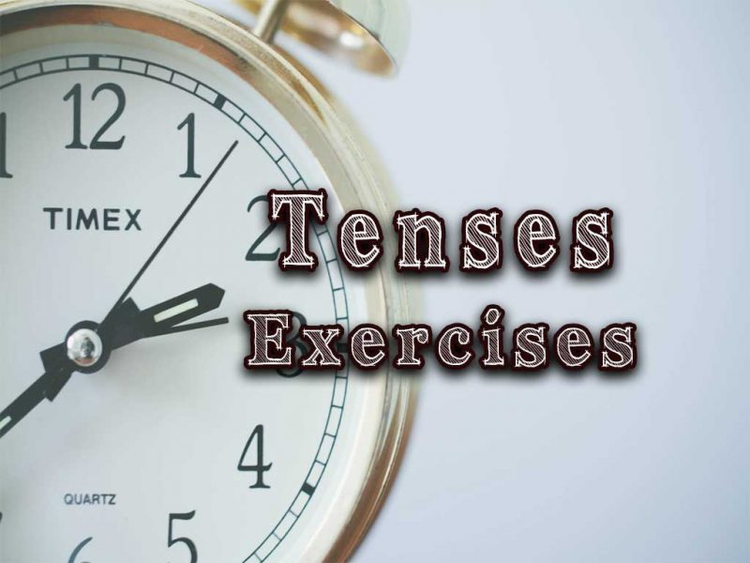
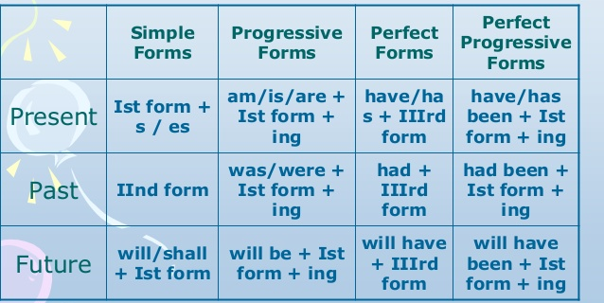

Exercise 1
Complete the sentences using Present Simple or Present Continuous (Progressive)

- Look! He (leave) the house.
- Quiet please! I (write) a test.
- You _____ (to look) great today!
- ______ he often (go) to the cinema?
- We (play) Monopoly at the moment.
- This dish ____ (to smell) amazing.
- I (not / do) anything at the moment.
- (watch / he) the news regularly?
- Marc (know) that apples (be) good for his health.
- The bus (leave) at 5.30 in the morning and (return) at 8.15 in the evening.
- I (not / meet) Francis tonight.
- They (not / fly) to London tomorrow.
- I (not / work) this week.
- Your sister ______ (to be) so quiet today.

Exercise 2
Put the verbs into Present Perfect

- She (just) ; she will speak to you in a minute. (come)
- We her since she arrived to our city. (know)
- This order to many misunderstandings. (lead)
- She a new job. (find)
- The children the whole pudding. (eat)
- My little daughter her finger with a knife. (cut)
- Marta (finish) her homework.
- I (meet) Anna once.
- _______ you (see) him before.
- (How many times / you / visit Scotland)?
- (we / not / hear that song already)

Exercise 3
Put the verbs into Present Perfect Continuous (Progressive)
- He (work) in this company since 1985.
- I (wait) for you since two o'clock.
- Mary (live) in Germany since 1992.
- Why is he so tired? He (play) tennis for five hours.
- How long (learn / you) English?
- We (look for) the motorway for more than an hour.
- I (live) without electricity for two weeks.
- The film (run / not) for ten minutes yet, but there's a commercial break already.
- How long (work / she) in the garden?
- You look dirty. What all day? (you/to do)
- The children videos for two hours. (to watch)
- He his essay all day, but he yet. (to write) (not/to finish)

Exercise 4
Choose the most appropriate answer

1. She can't come to the phone now because she _______ for tomorrow's test.
studies is studying has studied has been studying

2. They must be at the sports ground now. They usually ______ basketball on Fridays.
play are playing have played have been playing

3. I ____ my work already. I'm ready to go for a walk with you.
finish am finishing have finished have been finishing

4. I ______ breakfast right now. Can you call a little later?
cook am cooking have cooked have been cooking

5. I ____ this book. Can I borrow it for a week or so?
don't read am not reading haven't read haven't been reading

6. Maria is good at languages. She _____ French, Spanish and German.
speaks is speaking has spoken has been speaking

7. So far, he ________ five stories for children.
writes is writing has written

8. We _______ for their answer for two months already.
wait are waiting have been waiting

9. She _______ since Monday.
is sick is being sick has been sick has been being sick

10. She _______ since noon. Should we wake her up?
sleeps is sleeping has been sleeping

Exercise 5
Choose the correct answer

1) _________ my bag anywhere? I can't find it. a) Did you see/ b) Have you seen
2) Larry ________ his novel for the last two years. a) is writing/ b) has been writing
3) From the minute he got up this morning Gary ______ silly questions! a) has asked b) has been asking
4) Have you given Helen my message when you _______ her? A) have seen b) saw
5) The police think that they _______ your wallet, so call this number. A) found b) have found
6) a) Did you two meet b) Have you two met before? Eric, this is Amanda

Exercise 6
Make up sentences or situations using the tenses in the brackets

- Present Continuous (at the moment)

- Present Simple (at 7.30)

- Present Perfect (just)

4) Present Perfect Continuous (for 2 hours)

5)Present Continuous (Look!)

6) Present Simple (seldom)

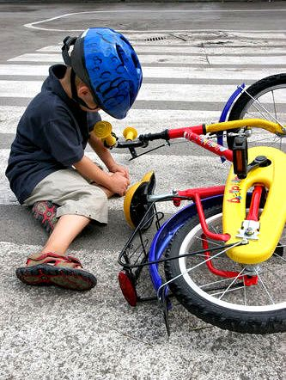
7) Present Perfect

8) Present Continuous

9) Present Perfect Continuous

10) Present Perfect

