advanced_lesson_02_family _grammar_part_2



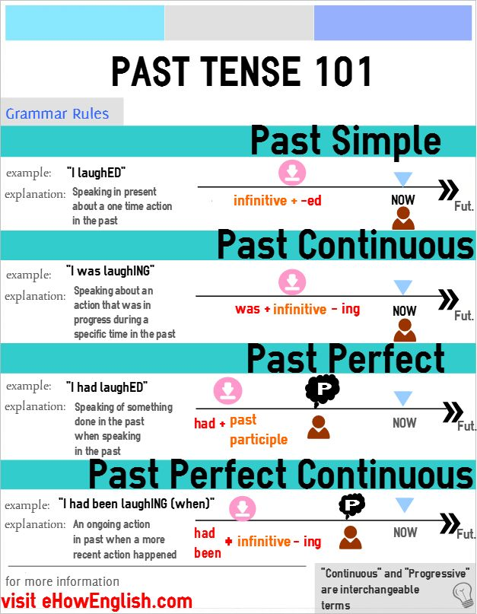

**Exercise 1**

**Choose the correct answer**

1)  The plane _______ at New York three hours late.

a) has arrived b) was arriving. c) did arrive d) arrived



2) I ________ in London since I was a little child. a) lived b) was living c) have lived d) did live



3)  As soon as I saw the man, I realised that we  ______ before, in Caracas.

a) metb) were meeting c) have met d) had met



4)     Where can he be? I can only imagine that he  ________  an accident somewhere.

a) had   b) was having c) has had  d) did have



5)   He had worked in the company for 15 years before he  ________ promoted

a) got   b) was gettingc)  has got    d) had got



6)  Hi, I'm really pleased to see you again, but I'm afraid I  _______ your name

a) forgot   b) was forgetting c) have forgotten   
d) had forgotten



**Exercise 2**

**Open the brackets using Past Simple or Past Perfect**

1. Jane  (not see) the lunch that her mum  (make) for her, because the dog  (eat) it all up.  
  
2. John  (miss) his school bus this morning, because his mum  (forget) to wake him up.  
  
3. My lunch  (be) cold because mum  (make) it for me earlier.  
  
4. After the young boy  (walk) for miles he  (be) very tired.  
  
5. Tom  (say) that he  (see) a robber walk into the bank.  
  
6. After John  (see) the film, he  (go) home.



7. I went to the box office at lunch-time, but they (already, sell)  all the tickets.

8. We didn't really want to go and see the musical again. We (already see) it twice - so we said "no" and we went to a restaurant instead!

**Exercise 3**

**Open the brackets using Past Continuous or Past Perfect Continuous**

1. I was exhausted at the end of the exam. I  (write) for over two hours.

2. Please step out of the car, Mr. Jones. Do you realise you  (drive) at over 90mph?

3. I arrived over an hour late to the office and everyone was working. Actually, they (work) for over two hours on the new project and I felt really guilty.

4. The kitchen was full of steam when we arrived. Joan was in the kitchen and she (cook) a huge meal for everyone at the party.

5. It was a bit embarrassing to arrive at their house and find Mary looking so sad. I think she  (cry) before we got there.

6. No one even noticed when I got home. They  (all watch) the big game on TV.

**Exercise 4**

**Put the verbs into correct past tenses**

1. A plumber (come)  to our house yesterday.



1. He (want)  to repair our washing machine that (break)  a few days before.



1. Before he (ring)  at my door, he (look)  for a parking space for about ten minutes.



1. While the plumber (repair)  the washing machine, I (watch)  the news.



1. Suddenly, I (realise)  that they (show)  our street on TV.



1. The reporter (say)  that a car (crash)  into a stop sign just before reaching the crossroads.



1. While I (listen)  carefully to what (happen) , someone (knock)  at my door.



1. I (open)  the door and (see)  a police officer standing there.



1. He (ask)  for the plumber.



1. As it (turn)  out, it (be)  our plumber’s car that (roll)  down the street.



1. In his haste, the plumber (forget)  to put the handbrake on.



**Exercise 5**

**Guess three forms of the verbs**

**(presentation)**