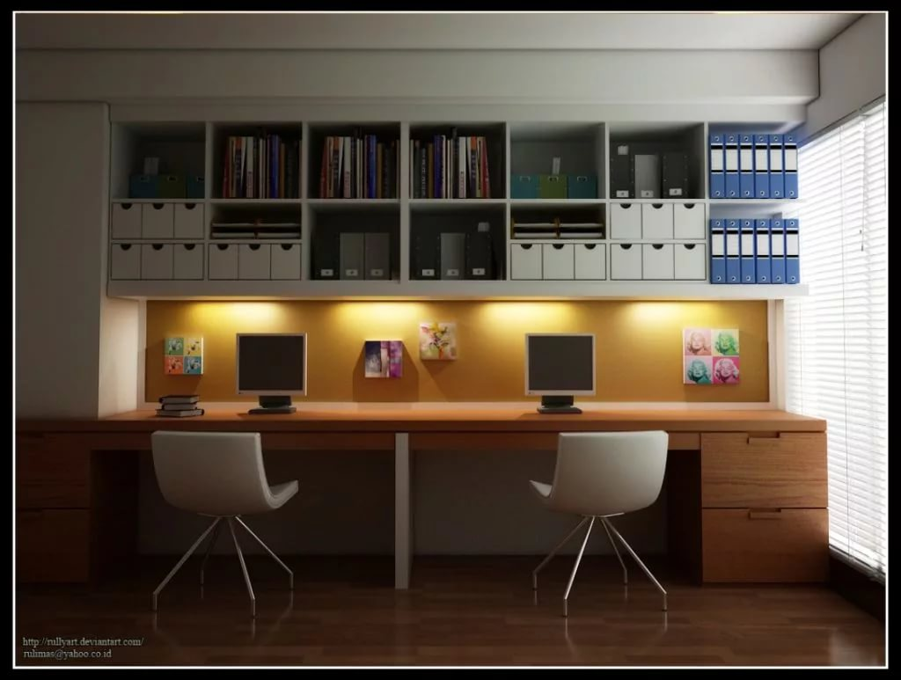

Task 1
Look through the words in Quizlet:
Home
https://quizlet.com/304766505/flashcards

Task 2
Match the home/house-related words on the left with the definitions on the right.
1. chimney, 2. façade, 3. detached, 4. cottage, 5. bungalow, 6. basement, 7. studio, 8. loft
a.old detached house, often in country
b.single floor house, often for older people
c.single room apartment
d.room in roof of house/building
e.allows smoke to escape
f.area/floor below the ground
g.not connected to other buildings
h.front of house, old building

Task 3
Choose the most appropriate word:
pantry,bungalow,landing,terrace,shed,loft,waste bin,coaster,power point,cellar
- I've got a dark room in the … where I develop films. It's perfect because there are no windows down there.
- Is there a … where I can plug in this radio?
- You'd better have a … under your drink in case you mark that side table. It's an antique.
- The … is full again. I'll empty it.
- We keep our skis up in the … during the summer. They are out of the way up there.
- You'll find the the garden chairs in the … at the bottom of the garden. Bring them up and we'll have a drink on the … and watch the sunset.
- The light-switch for the stairs is on the … as you come out of your bedroom.
- I've moved to a … now as I found I couldn't manage the stairs any more at my age.
- People use … to store their food in the flat.

Task 4
Choose the most appropriate word:
grater,microwave,saucepans,kitchen scale,work surface,crockery,cutlery,roasting tin,free standing,fitted kitchen
- Nancy has bought a … . All its units have been bought together. She didn't want to buy a … kitchen because she thought it wouldn't fit her apartment.
- You can use a … to cook food.
- The … include knives, forks and spoons.
- The … include cups, plates, bowls, etc. They are used to serve food and drink.
- The … is a place in the kitchen where you can prepare food.
- You can measure and weigh food with a … .
- To cook pasta, people use a … .
- Put the fish in the … and it'll only take 5 minutes.
- People use the … to cut food into very small pieces.

Task 5
Choose the most appropriate word:
1. My mother asked me to do the (dishes/plates).
2. My father asked me to (make/do) my bed.
3. My brother asked me to (wet/water) the plants.
4. My grandmother asked me to (cleanse/clean) the litter box.
5. My roommate asked me to do the (clothes/laundry).
6. My wife asked me to (mow/cut) the lawn.
7. My boyfriend asked me to (vacuum/vacate) the living room.
8. My mother asked me to (scrub/scrape) the toilet.
9. My parents asked me to (tidy/tighten) up my room.
10. My grandfather asked me to (take/make) out the trash.

Task 6
Choose the most appropriate word:
1. A sliding door that lets air in, but keeps bugs out: A ___________ door.
net
screen
2. A couch that also functions as a bed: A ________ bed.
sofa
king-size
3. This prevents the bathroom from getting wet when you take a shower: A shower ________.
cap
curtain
4. A closet which is big enough for you to walk inside to get clothes, etc.: A ________ closet.
walkable
walk-in
5. A flight of stairs leading to the second floor: A ________.
staircase
stairs
6. An appliance that cools your house in the summer: An air ________ .
cooler
conditioner
7. You use this to open a door: A door ________.
knob or handle
hand or handle
8. You hang this on a wall to know what time it is: A ________.
clock
watch
9. We don't have a TV ___________, so we put our TV on top of a milk crate. ( = plastic containers used to transport milk)
shelf
stand
10. Most people keep their books on a bookshelf, also known as a ________.
book-closet
bookcase

Task 7
https://bogglesworldesl.com/quizgames/toolsquiz.php

ANSWERS
Task 2
Match the home/house-related words on the left with the definitions on the right.
4. cottage- a.old detached house, often in country
5. bungalow- b.single floor house, often for older people
7. studio- c.single room apartment
8. loft- d.room in roof of house/building
1. chimney- e.allows smoke to escape
6. basement- f.area/floor below the ground
3. detached- g.not connected to other buildings
2. façade- h.front of house, old building

Task 3
Choose the most appropriate word:
pantry,bungalow,landing,terrace,shed,loft,waste bin,coaster,power point,cellar
- I've got a dark room in the cellar where I develop films. It's perfect because there are no windows down there.
- Is there a power point where I can plug in this radio?
- You'd better have a coaster under your drink in case you mark that side table. It's an antique.
- The waste bin is full again. I'll empty it.
- We keep our skis up in the loft during the summer. They are out of the way up there.
- You'll find the the garden chairs in the shed at the bottom of the garden. Bring them up and we'll have a drink on the terrace and watch the sunset.
- The light-switch for the stairs is on the landing as you come out of your bedroom.
- I've moved to a bungalow now as I found I couldn't manage the stairs any more at my age.
- People use pantry to store their food in the flat.

Task 4
Choose the most appropriate word:
grater,microwave,saucepans,kitchen scale,work surface,crockery,cutlery,roasting tin,free standing,fitted kitchen
- Nancy has bought a fitted kitchen. All its units have been bought together. She didn't want to buy a free standing kitchen because she thought it wouldn't fit her apartment.
- You can use a roasting tin to cook food.
- The cutlery include knives, forks and spoons.
- The crockery include cups, plates, bowls, etc. They are used to serve food and drink.
- The work surface is a place in the kitchen where you can prepare food.
- You can measure and weigh food with a kitchen scale.
- To cook pasta, people use a saucepan.
- Put the fish in the microwave and it'll only take 5 minutes.
- People use the grater to cut food into very small pieces.

Task 5
Choose the most appropriate word:
1. My mother asked me to do the (dishes/plates).
2. My father asked me to (make/do) my bed.
3. My brother asked me to (wet/water) the plants.
4. My grandmother asked me to (cleanse/clean) the litter box.
5. My roommate asked me to do the (clothes/laundry).
6. My wife asked me to (mow/cut) the lawn.
7. My boyfriend asked me to (vacuum/vacate) the living room.
8. My mother asked me to (scrub/scrape) the toilet.
9. My parents asked me to (tidy/tighten) up my room.
10. My grandfather asked me to (take/make) out the trash.

Task 6
Choose the most appropriate word:
1. A sliding door that lets air in, but keeps bugs out: A ___________ door.
net
screen
2. A couch that also functions as a bed: A ________ bed.
sofa
king-size
3. This prevents the bathroom from getting wet when you take a shower: A shower ________.
cap
curtain
4. A closet which is big enough for you to walk inside to get clothes, etc.: A ________ closet.
walkable
walk-in
5. A flight of stairs leading to the second floor: A ________.
staircase
stairs
6. An appliance that cools your house in the summer: An air ________ .
cooler
conditioner
7. You use this to open a door: A door ________.
knob or handle
hand or handle
8. You hang this on a wall to know what time it is: A ________.
clock
watch
9. We don't have a TV ___________, so we put our TV on top of a milk crate. ( = plastic containers used to transport milk)
shelf
stand
10. Most people keep their books on a bookshelf, also known as a ________.
book-closet
bookcase

