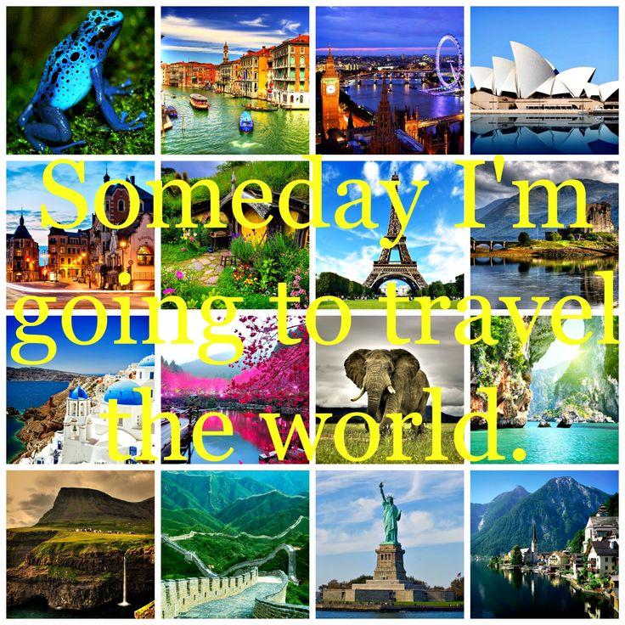

Task 1
Look through the words in Quizlet
https://quizlet.com/304839765/city-l-11-advanced-flash-cards/

Task 2
Choose the right word:
pollution,recycle,deforestation,windmill,warming,gases,effect,used up,biodiversity,protection
- There is a growing concern over the … of species habitat and … .
- The earth's resources are being … at an alarming rate.
- The greenhouse … is an increase in the amount of carbon dioxide and other … in the atmosphere which is believed to be the cause of a gradual … of the surface of the Earth.
- The energy generated by the … is both very efficient and clean.
- There have been many reports about … which is destroying large areas of tropical rain forest.
- The Japanese … more than half their waste paper.
- We're not doing enough to protect the environment from … .

Task 3
Complete each of the sentences below using the following words:
trash, ticket, office buildings, ATM, subway, hail, crosswalk, car, post office, homeless
1. I need to mail a letter, so I'm going to the… .
2. Is there an … around here? I need to take out some money.
3. Don't cross the street here. There's a … right over there.
4. You can walk there, but you can also take the … (= metro).
5. Tom volunteers at an organization that helps … people.
6. Downtown is full of modern … .
7. I got rid of my … because the traffic here is so horrible.
8. The police officer gave me a … because I didn't stop at a stop sign.
9. Don't throw your … in the street. Put it in a garbage can.
10. You can't just … a cab anymore. You have to call/order one.

Task 4
Complete the sentences with the words.
kerb,motorway,crossing,signpost,police officer,roundabout,traffic lights,ambulance,junction,pavement
1. The … is on the side of a street. People can walk here.
2.A … is where two or more streets or roads come together.
3. … carry sick or injured people to the hospital.
4. … tell drivers when to stop or go. They are usually green, yellow and red.
5. A … is a junction where you go around a circle.
6. If you are lost or need help, you can ask a … . They also catch criminals and direct traffic.
7. A … tells you where a road goes.
8. A … is the place where you can safely walk across a street or road.
9. A … is a road only for cars, lorries and motorbikes. Don't walk here!
10. The … is where the pavement and the street meet. It is higher than the street.
Task 5
https://bogglesworldesl.com/quizgames/transportationquiz.php

ANSWERS
Task 2
Choose the right word:
pollution,recycle,deforestation,windmill,warming,gases,effect,used up,biodiversity,protection
1. There is a growing concern over the protection of species habitat and biodiversity.
2. The earth's resources are being used up at an alarming rate.
3. The greenhouse effect is an increase in the amount of carbon dioxide and other gases in the atmosphere which is believed to be the cause of a gradual warming of the surface of the Earth.
4. The energy generated by the windmill is both very efficient and clean.
5. There have been many reports about deforestation which is destroying large areas of tropical rain forest.
6. The Japanese recycle more than half their waste paper.
7. We're not doing enough to protect the environment from pollution.

Task 3
Complete each of the sentences below using the following words:
trash, ticket, office buildings, ATM, subway, hail, crosswalk, car, post office, homeless
1. I need to mail a letter, so I'm going to the post office.
2. Is there an ATM around here? I need to take out some money.
3. Don't cross the street here. There's a crosswalk right over there.
4. You can walk there, but you can also take the subway (= metro).
5. Tom volunteers at an organization that helps homeless people.
6. Downtown is full of modern office buildings.
7. I got rid of my car because the traffic here is so horrible.
8. The police officer gave me a ticket because I didn't stop at a stop sign.
9. Don't throw your trash the street. Put it in a garbage can.
10. You can't just hail a cab anymore. You have to call/order one.

Task 4
Complete the sentences with the words.
kerb,motorway,crossing,signpost,police officer,roundabout,traffic lights,ambulance,junction,pavement
1. The pavement is on the side of a street. People can walk here.
2.A junction is where two or more streets or roads come together.
3. Ambulances carry sick or injured people to the hospital.
4. Traffic lights tell drivers when to stop or go. They are usually green, yellow and red.
5. A roundabout is a junction where you go around a circle.
6. If you are lost or need help, you can ask a police officer. They also catch criminals and direct traffic.
7. A signpost tells you where a road goes.
8. A crossing is the place where you can safely walk across a street or road.
9. A motorway is a road only for cars, lorries and motorbikes. Don't walk here!
10. The kerb is where the pavement and the street meet. It is higher than the street.

