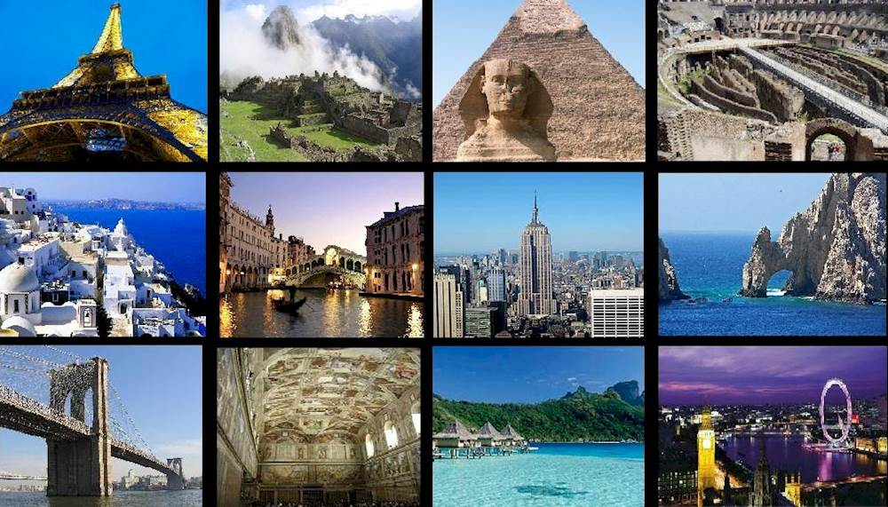

Task 1
Look through the words in Quizlet:
https://quizlet.com/304841830/flashcards

Task 2
Choose the right words:
baggage,one-way,delayed,flights,journey,embark,platform,depart,land,take off
- We will travel from Spain to France by plane. The plane will … at 10 am and will … at 11:00 am in Paris.
- The train for Cambridge will … from … number 9.
- Anne and Joe will travel by sea. They will … at Liverpool for New York.
- I'd love to go on a long … .
- All … to New York today are … because of bad weather.
- How much is a … ticket to New York?
- We had to pay extra for our excess … .

Task 3
Complete each of the sentences below using the following words:
renting, supermarket, bank, pedestrians, campus, quality, suburbs, light, restaurants, dangerous
1. The main … of the university is very close to here.
2. I have to find another branch of my … . Mine closed down last week.
3. This neighborhood used to be …, but it's quite safe now.
4. Many cities in the United States are very unfriendly to … . Many areas don't even have sidewalks.
5. The air … has actually improved over the las 10 years.
6. Many people work downtown, but live in the … .
7. Are you … your apartment or do you own it?
8. I've been waiting forever for this … to change.
9. Robert went to buy some groceries at the … .
10. This a popular area for going-out. There are lots of cafes, bars, and … .

Task 4
Write the best word or words to complete the definitions.
1. The thing in the middle of a road that cars drive around is called a … .
2. The place on the road where people can cross to the other side is called a … .
3. The place where four roads meet is called a … .
4. The object by the side of the road that shows a red or green light is called a … .
5. The object near the pavement which shows the direction we should take is called a … .
6. The things that make the street brighter at night are called … .
7. The place near the road or in the park that people can walk along is called the … .
8. The place that cars and buses drive along is called the … .
9. The flat and empty area in the centre of town where people often meet is called the… .
10. The place where people stand to wait for their bus is called the … .

Task 5
Complete the sentences with the words.
kerb,motorway,crossing,police officer,signposts,roundabout,ambulance,traffic lights,junction,pavement
1. Don't walk on the street! Walk on the …, where there are no cars.
2. Two or more streets come together in a … . Sometimes there are … there to tell drivers when to go and when to stop.
3. When an … has its lights on, this means it is taking someone to hospital.
4. At a …, you must drive around the circle until you get to the street you want.
5. There were no … so we got lost. Then a kind … came and helped us to find the train station.
6. The safest place to go across a street or road is at a … .
7. You can't ride a bicycle or walk on a … .
8. The … is the part of the pavement that touches the street.

Task 6

https://bogglesworldesl.com/quizgames/cityplacesquiz.php

ANSWERS

Task 2
Choose the right words:
baggage,one-way,delayed,flights,journey,embark,platform,depart,land,take off
1. We will travel from Spain to France by plane. The plane will take off at 10 am and will land at 11:00 am in Paris.
2. The train for Cambridge will depart from platform number 9.
3. Anne and Joe will travel by sea. They will embark at Liverpool for New York.
4. I'd love to go on a long journey.
5. All flights to New York today are delayed because of bad weather.
6. How much is a one-way ticket to New York?
7. We had to pay extra for our excess baggage.

Task 3
Complete each of the sentences below using the following words:
renting, supermarket, bank, pedestrians, campus, quality, suburbs, light, restaurants, dangerous
1. The main campus of the university is very close to here.
2. I have to find another branch of my bank. Mine closed down last week.
3. This neighborhood used to be dangerous, but it's quite safe now.
4. Many cities in the United States are very unfriendly to pedestrians. Many areas don't even have sidewalks.
5. The air quality has actually improved over the las 10 years.
6. Many people work downtown, but live in the suburbs.
7. Are you renting your apartment or do you own it?
8. I've been waiting forever for this light to change.
9. Robert went to buy some groceries at the supermarket.
10. This a popular area for going-out. There are lots of cafes, bars, and restaurants.

Task 4
Write the best word or words to complete the definitions.
1. The thing in the middle of a road that cars drive around is called a roundabout.
2. The place on the road where people can cross to the other side is called a crossing.
3. The place where four roads meet is called a crossroads.
4. The object by the side of the road that shows a red or green light is called a traffic light.
5. The object near the pavement which shows the direction we should take is called a signpost .
6. The things that make the street brighter at night are called street lights.
7. The place near the road or in the park that people can walk along is called the pavement.
8. The place that cars and buses drive along is called the road.
9. The flat and empty area in the centre of town where people often meet is called the square.
10. The place where people stand to wait for their bus is called the bus stop.

Task 5
Complete the sentences with the words.
kerb,motorway,crossing,police officer,signposts,roundabout,ambulance,traffic lights,junction,pavement
1. Don't walk on the street! Walk on the pavement, where there are no cars.
2. Two or more streets come together in a junction. Sometimes there are traffic lights there to tell drivers when to go and when to stop.
3. When an ambulance has its lights on, this means it is taking someone to hospital.
4. At a roundabout, you must drive around the circle until you get to the street you want.
5. There were no signposts so we got lost. Then a kind police officer came and helped us to find the train station.
6. The safest place to go across a street or road is at a crossing.
7. You can't ride a bicycle or walk on a motorway.
8. The kerb is the part of the pavement that touches the street.

