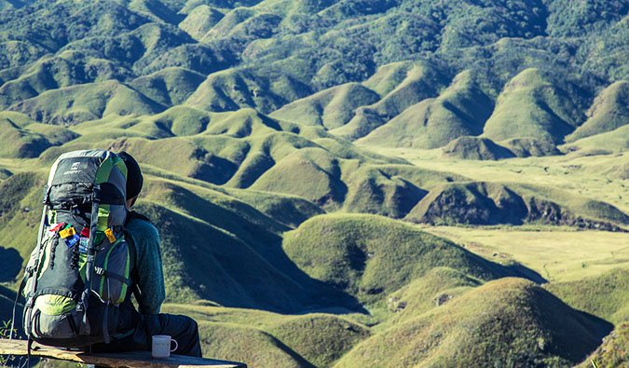

Ex. 1. Look at the presentation. On the first slide you can see the beginning of a quote. You need to make up the ending of this quote. On the next slide you will see how this quote actually ends. Discuss the quotes.

https://docs.google.com/presentation/d/119BBxhzXf5Tj3gx-d15EP_I7BI9K04wuWcM_HaSq0DM/edit?usp=sharing

Ex. 2 You can see pictures of different sightseeing around the world. Match the picture with the name and the description of the place. (названия в том же порядке, что и картинки. Поменяй, пожалуйста, на сайте)

1.
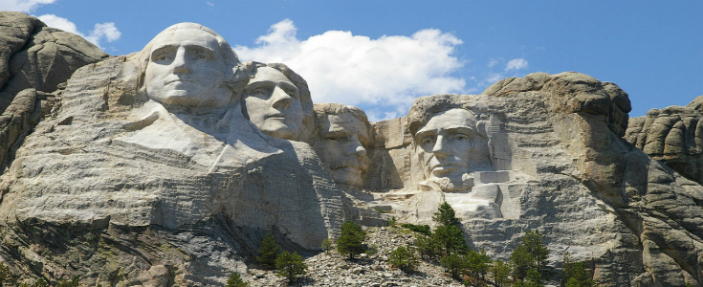

2.
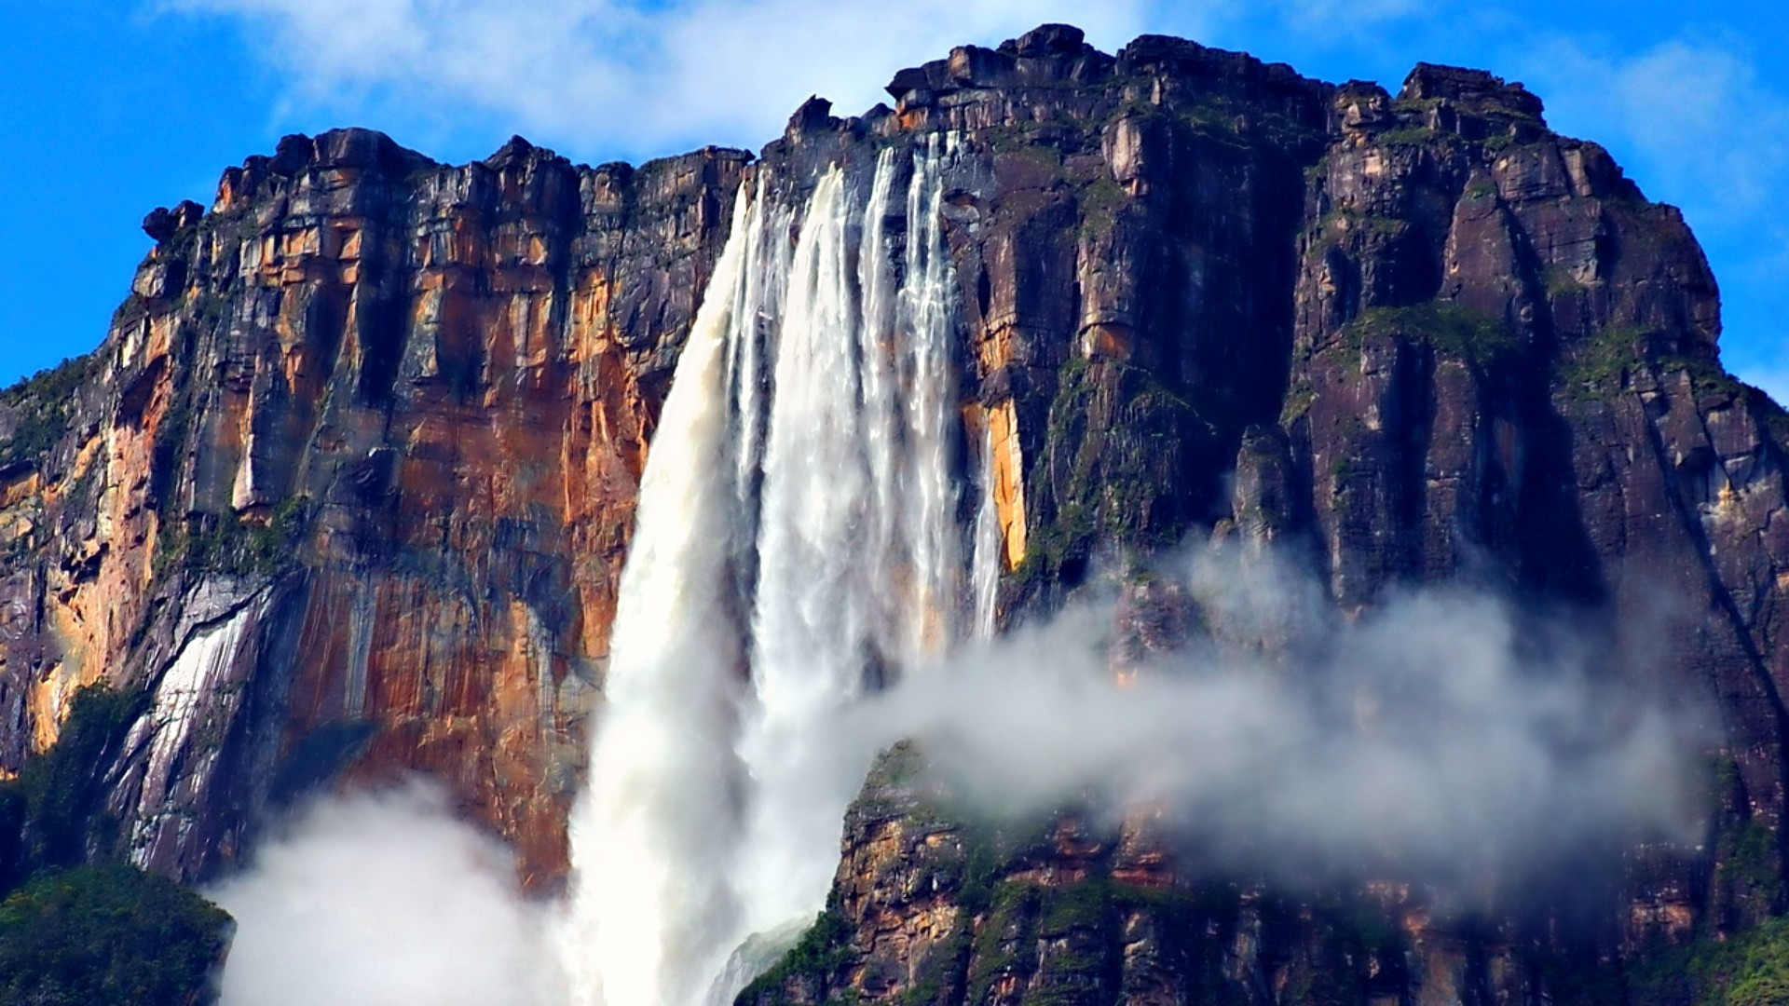

3.
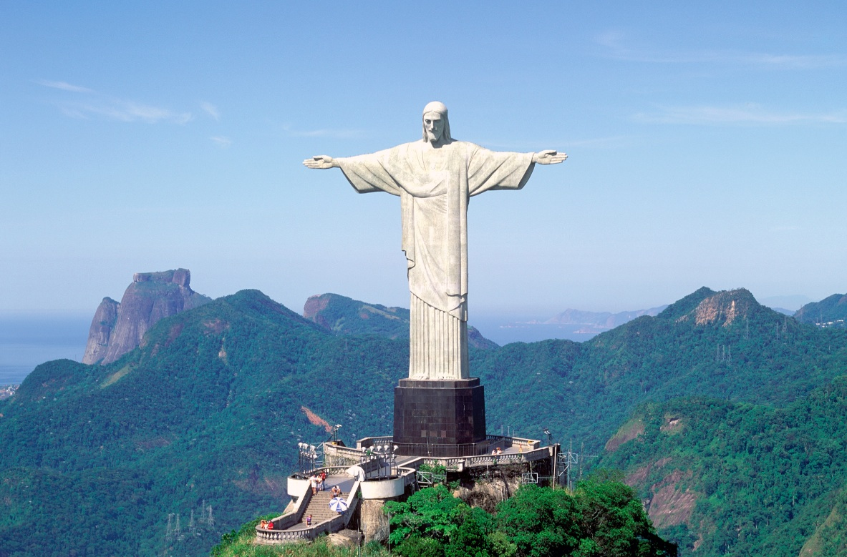

4.
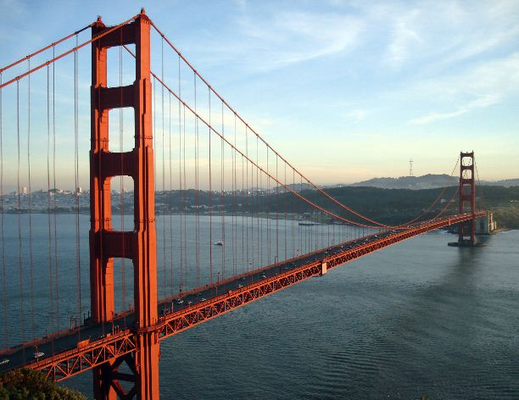

5.
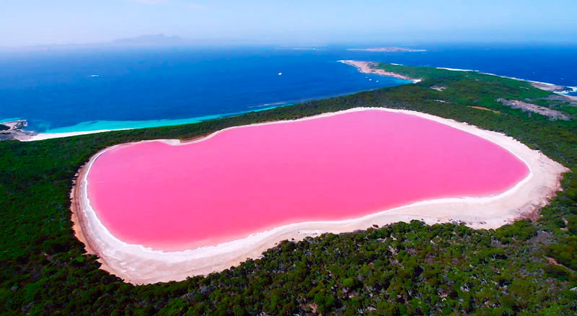

6.
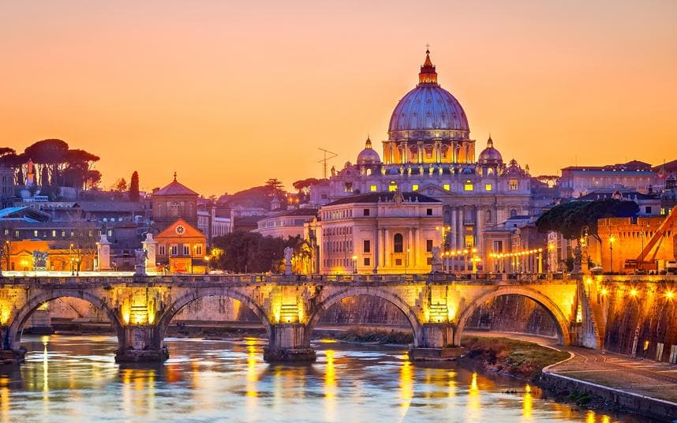

7.
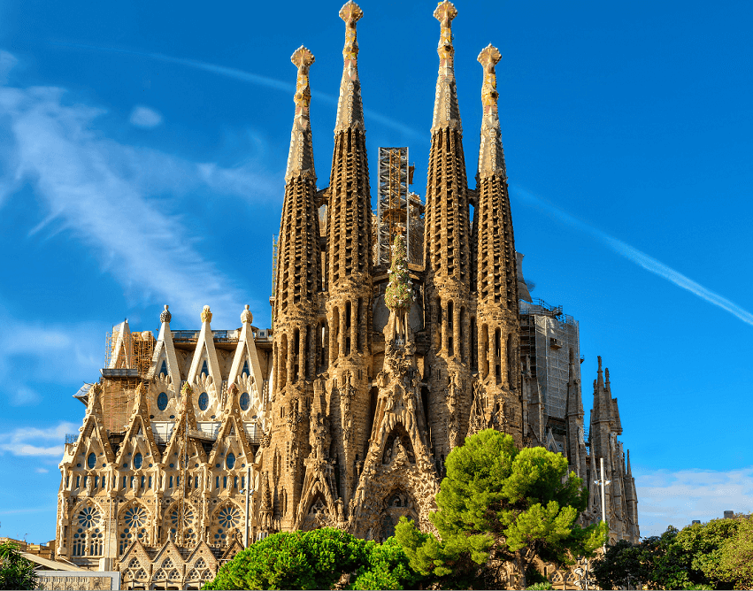

8.
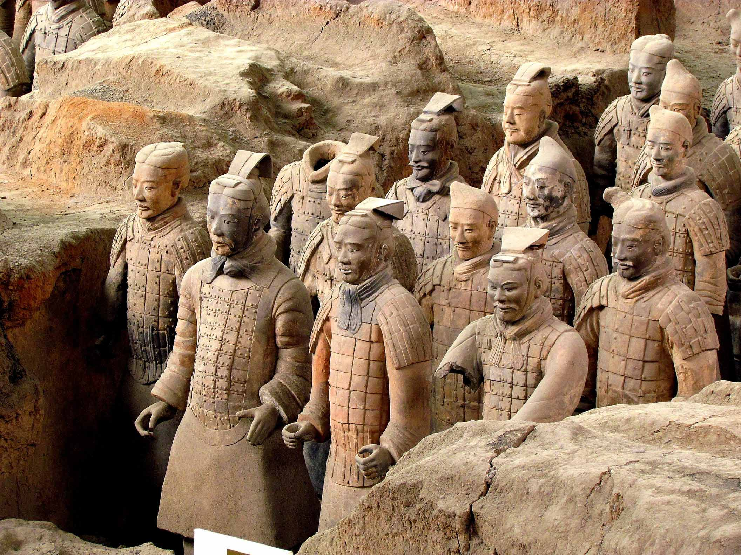

9.
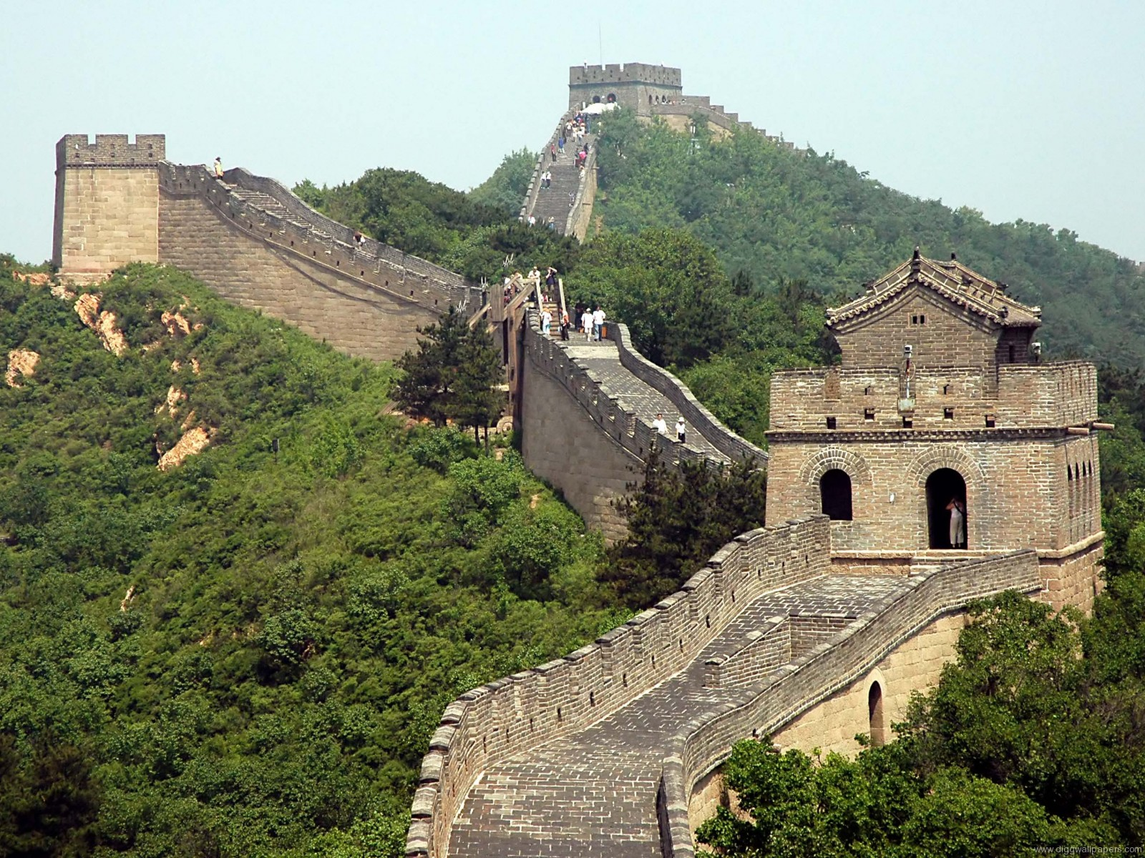

a) Mount Rushmore National Memorial
a sculpture of the heads of four United States presidents carved into the granite face of Mount Rushmore. It was credited in order to promote tourism in the region of South Dakota.

b) Angel Falls
the world's highest uninterrupted waterfall in Venezuela. The waterfall has been known as the Angel Falls since the mid-20th century; they are named after Jimmie Angel, a US aviator, who was the first person to fly over the falls. Angel's ashes were scattered over the falls on 2 July 1960.

c) Christ the Redeemer
an Art Deco statue of Jesus Christ in Rio de Janeiro, Brazil. The statue is 30 metres (98 ft) high, excluding its 8-metre (26 ft) pedestal. The arms stretch 28 metres (92 ft) wide. A symbol of Christianity across the world, it is listed as one of the New7Wonders of the World.

d) Golden Gate Bridge
At the time of its opening in 1937, it was both the longest and the tallest suspension bridge in the world. the most photographed, bridge in the world. The Bridge’s official hue is not gold but International Orange. The Bridge is actually named for the Golden Gate Strait, the narrow entrance between the Pacific Ocean and the San Francisco Bay.

e) Lake Hillier
a saline lake on the edge of Middle Island, notable for its pink colour. The vibrant colour is permanent, and does not alter when the water is taken in a container. The pink colour is considered to be due to the presence of the organism Dunaliella salina. At one point in its history the lake was used to collect salt.

f) The Papal Basilica of St. Peter in the Vatican
the largest church in the world. many Popes have been interred at St. Peter's since the Early Christian period it is regarded as the greatest building of its age. St. Peter's is one of the four churches in the world that hold the rank of Major Basilica, all four of which are in Rome. Contrary to popular misconception, it is not a cathedral because it is not the seat of a bishop

g) Church of the Holy Family
a large and the most famous unfinished Roman Catholic church in Barcelona, designed by Catalan architect Antoni Gaudí. The building of the Basilica is funded only by donations. It is anticipated that the building can be completed by 2026—the centenary of Gaudí's death.

h) The Terracotta Army
a collection of terracotta sculptures depicting the armies of Qin Shi Huang, the first Emperor of China. It is a form of funerary art buried with the emperor in 210–209 BCE and whose purpose was to protect the emperor in his afterlife. The figures vary in height according to their roles, with the tallest being the generals. The figures include warriors, chariots and horses. Other terracotta non-military figures were found in other pits, including officials, acrobats, strongmen and musicians.

i) The Great Wall of China
a series of fortifications made of stone, brick, tamped earth, wood, and other materials built to protect the country against the raids and invasions of the various nomadic groups. Apart from defense, other purposes of the fortifications have included border controls, allowing the imposition of duties on goods transported along the Silk Road, regulation or encouragement of trade and the control of immigration and emigration.

