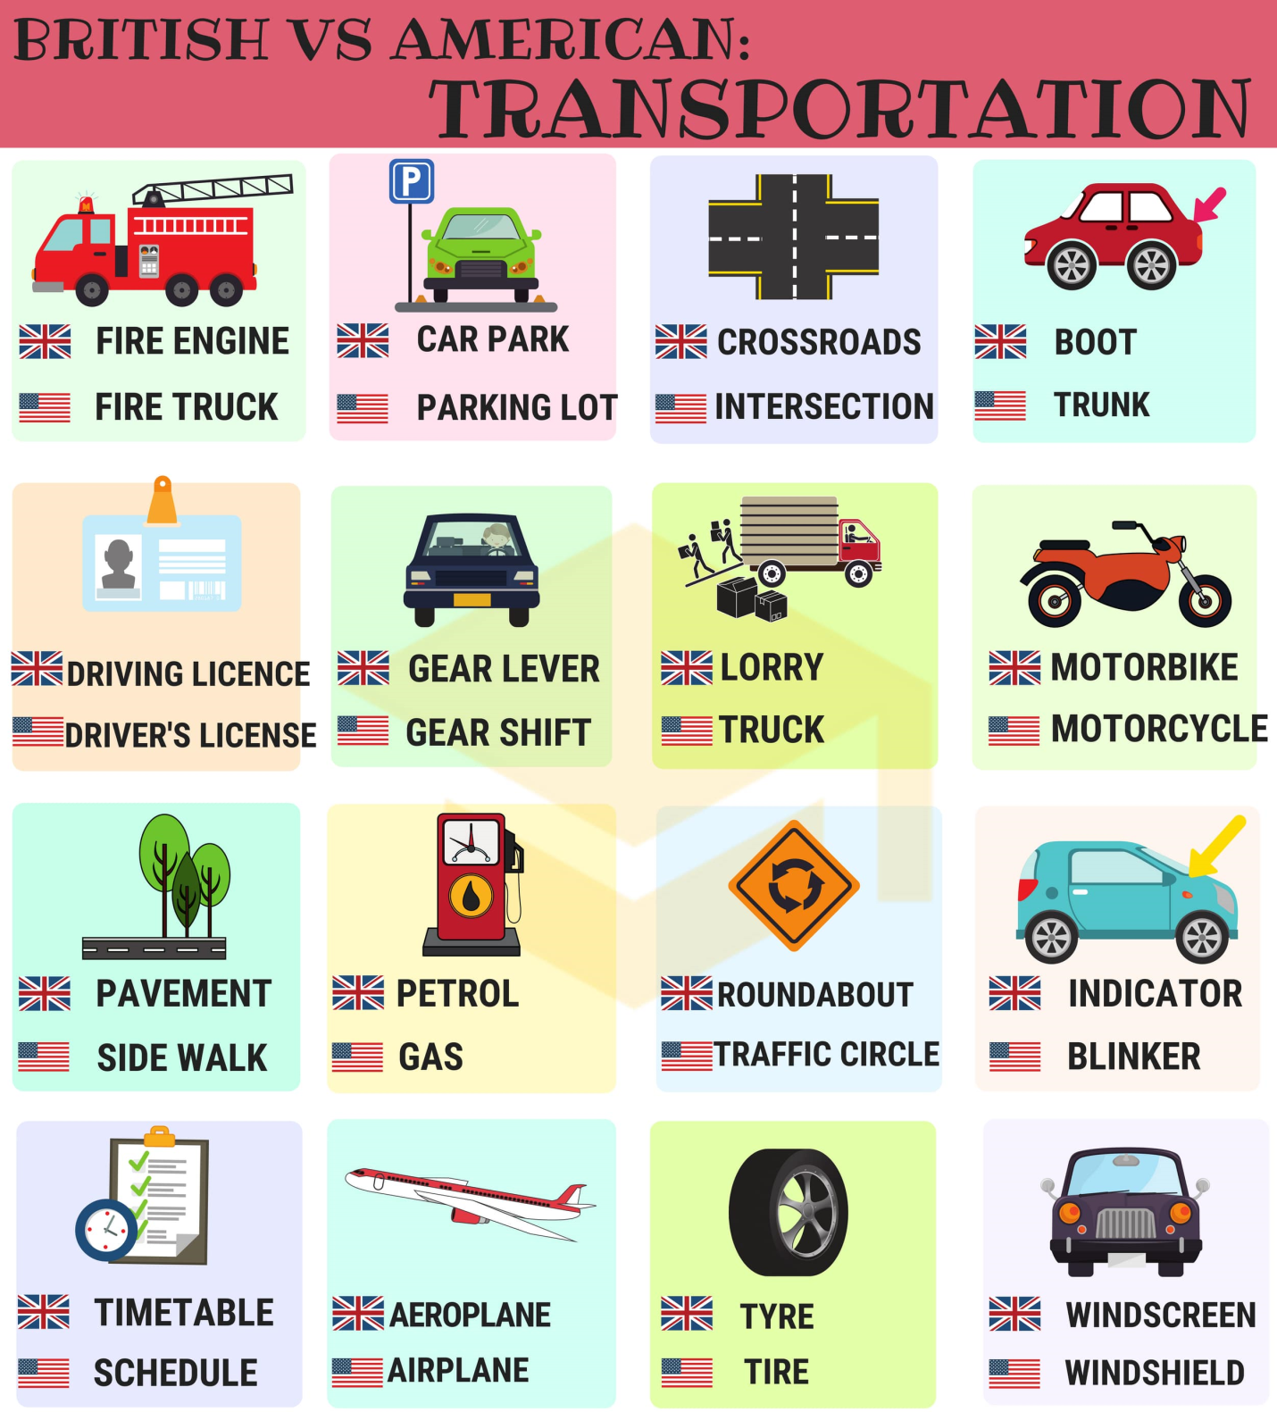
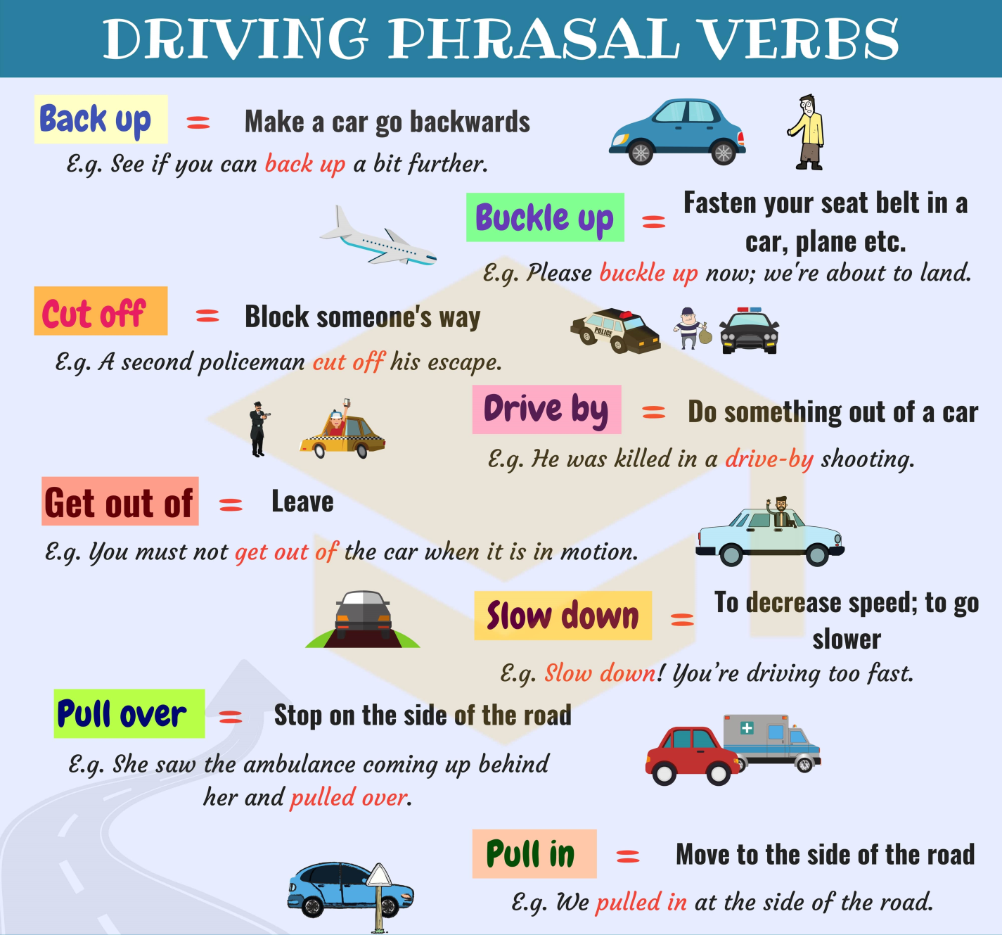

I. Listen to the conversation and answer the questions.
1. Where has the man been practicing for his road test this past week?
A. at a driving school
B. on streets around town
C. at home

2. In what part of town do they begin the road test?
A. in a commercial area
B. in a residential district
C. in a school zone

3. What was the situation with the vehicle in front of them?
A. Mr. Smith is following too closely.
B. The driver of the other car is tailgating them.
C. The car ahead of them is driving below the speed limit.

4. What did Mr. Smith almost hit in the road?
A. another vehicle
B. a person
C. a street sign

5. What does the driving officer suggest Mr. Smith do at the end of the conversation?
A. He should come back on Friday to take the test.
B. He had better take more driving lessons before trying the test again.
C. He ought to take the test with another driving officer.

II. Listen to the mp3 file and choose the best answer for each question.
1. What does Neil say about the American Road accident figures?
They have improved recently.
A minority of accidents are caused by aggressive driving.
Some form of Road rage causes about one third of these casualties.
2. Why does Neil believe cars are being used more often as weapons?
People preferred this to one-to-one physical confrontation.
Cars are getting faster and more powerful.
People are afraid of carjacking.
3. Why does Beth mention her father and how driving was in his day?
To demonstrate that Road rage existed in the past but on a smaller scale.
To demonstrate that people drove very well in the past.
To demonstrate that people's reactions to bad driving have changed remarkably.
4. Which of these does Neil not mention as a contributing factor towards an increase in road rage?
New Road construction has not kept up with increase in traffic quantity.
A lack of proper education of young drivers to prepare them for modern driving.
High traffic periods being concentrated in the mornings and evenings.
People being increasingly in a rush and not leaving enough time for journeys.
5. What does the expression "unforeseen circumstances" mean in the context of this radio program?
People are surprised at the destructive force of a car.
People are surprised by the aggressiveness of other drivers.
People don't expect such heavy sentences for traffic offences.
6. What basic advice does Neil give at the end of his talk with Beth?
Drive slower.
Get to work earlier.
Leave home earlier.

III. Listen to the audio passage and answer the question.
1. What did the man recently buy?
a) a small car
b) a truck
c) a sports car
d) a huge car

2. Why can't he drive fast near his house?
a) he lives near a school zone
b) he is scared
c) he lives near a police station
d) his car is slow

3. What did the man do when he saw the cop?
a) he peeled out
b) he revved the engine
c) he slammed on his brakes
d) he swerved out of the way

4. The cop flashed his brights and made him ________.
a) rev the engine
b) pull over
c) peel out
d) go to jail

5. The cop said that the man ____________ another driver.
a) cut off
b) crashed into
c) annoyed
d) killed

Answers:
I. Listen to the conversation and answer the questions.
1. Where has the man been practicing for his road test this past week?
A. at a driving school
B. on streets around town
C. at home

2. In what part of town do they begin the road test?
A. in a commercial area
B. in a residential district
C. in a school zone

3. What was the situation with the vehicle in front of them?
A. Mr. Smith is following too closely.
B. The driver of the other car is tailgating them.
C. The car ahead of them is driving below the speed limit.

4. What did Mr. Smith almost hit in the road?
A. another vehicle
B. a person
C. a street sign

5. What does the driving officer suggest Mr. Smith do at the end of the conversation?
A. He should come back on Friday to take the test.
B. He had better take more driving lessons before trying the test again.
C. He ought to take the test with another driving officer.

II. Listen to the mp3 file and choose the best answer for each question.
1. What does Neil say about the American Road accident figures?
They have improved recently.
A minority of accidents are caused by aggressive driving.
Some form of Road rage causes about one third of these casualties.
2. Why does Neil believe cars are being used more often as weapons?
People preferred this to one-to-one physical confrontation.
Cars are getting faster and more powerful.
People are afraid of carjacking.
3. Why does Beth mention her father and how driving was in his day?
To demonstrate that Road rage existed in the past but on a smaller scale.
To demonstrate that people drove very well in the past.
To demonstrate that people's reactions to bad driving have changed remarkably.
4. Which of these does Neil not mention as a contributing factor towards an increase in road rage?
New Road construction has not kept up with increase in traffic quantity.
A lack of proper education of young drivers to prepare them for modern driving.
High traffic periods being concentrated in the mornings and evenings.
People being increasingly in a rush and not leaving enough time for journeys.
5. What does the expression "unforeseen circumstances" mean in the context of this radio program?
People are surprised at the destructive force of a car.
People are surprised by the aggressiveness of other drivers.
People don't expect such heavy sentences for traffic offences.
6. What basic advice does Neil give at the end of his talk with Beth?
Drive slower.
Get to work earlier.
Leave home earlier.

III. Listen to the audio passage and answer the question.
1. What did the man recently buy?
a) a small car
b) a truck
c) a sports car
d) a huge car

2. Why can't he drive fast near his house?
a) he lives near a school zone
b) he is scared
c) he lives near a police station
d) his car is slow

3. What did the man do when he saw the cop?
a) he peeled out
b) he revved the engine
c) he slammed on his brakes
d) he swerved out of the way

4. The cop flashed his brights and made him ________.
a) rev the engine
b) pull over
c) peel out
d) go to jail

5. The cop said that the man ____________ another driver.
a) cut off
b) crashed into
c) annoyed
d) killed

