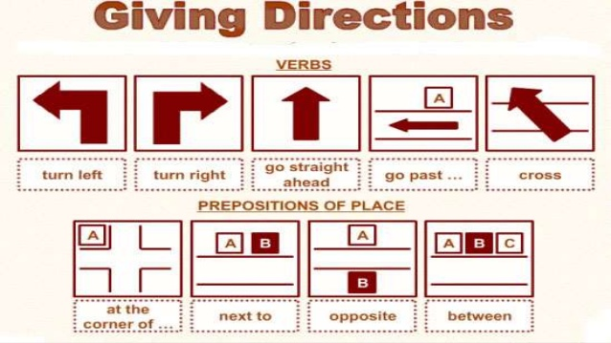
advanced_lesson_13_grammar_part_2
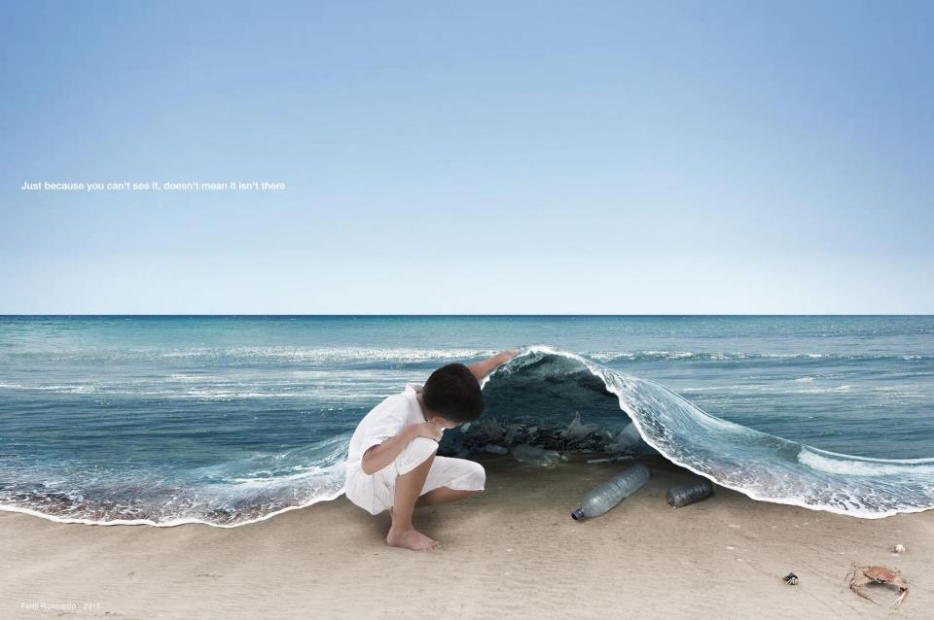
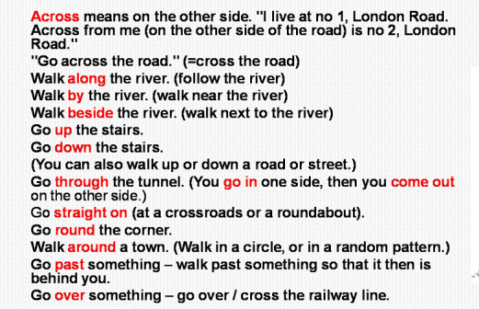
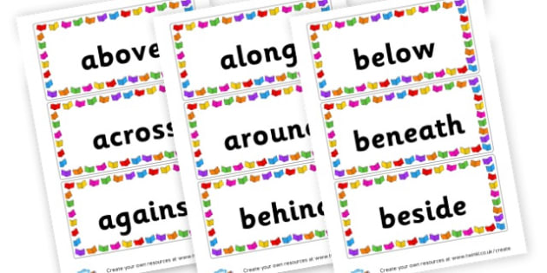

Exercise 1
Match each preposition with the correct meaning
towards - beneath - against - among - beyond - alongside
- a position next to something -
- touching something directly; having contact or being supported by –
- close to; near; in the direction of –
- further away in the distance -
- means ‘at a lower level than’, formal way to say ‘under’ –
- in the middle or included in a larger group of people or things –

Exercise 2
Choose the correct answer
- The plane landed ______ the runway. A) onto b) between c) to
- The dog jumped ______ the lake. A) over b) into c) among
- We cried to the man on the ladder, "Hang ______!" a) in b) on c) near
- John fell ______ the floor. A) onto b) in c) to
- They drove _______ the German border. A) towards
- Mariam jumped ______ the stage and danced. A) over b) along c) up
- Drive __________ the city limits and turn north. A) beneath b) down c) beyond
- Sarah took the bus that was heading ______ the university. A) at b) in c) for
- I walk ______ the amusement park. A) along b) against c) under
- Bordeaux wine is cultivated ___ the Atlantic coast. A) over b) alongside c) against

Exercise 3
Choose the correct answer
between – under - beneath – along - over - beyond - among - against
- Don't leave your bicycle leaning ______ the car again! (against)
- He could see the horse in the field, just _______ the hedge. (beyond)
- I’m not worried about her. She’s living _______ friends. (among)
- A beautiful white bird flew ______ the lake. (over)
- Paul and Simon shared the sweets ______ each other. (between)
- Archaeologists discovered a gold cup just ______ the ground surface. (beneath)
- The little boy ran _____ the road. (along)
- Alcohol is not sold if you are _______ 18. (under)

Exercise 4
Read the situations and look at the picture. Give directions how to get there.
- How would you get to the church if you are at the art gallery?
- How would you get to the art gallery if you are at the bank?
- How would you get to the public library being at the chemist?
- How would you get to the bus stop being at school?
- How would you get to the shopping center if previously you were strolling in the park?

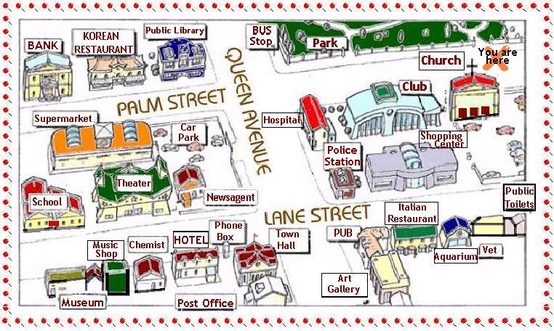

Exercise 5
Describe the pictures using as many prepositions of direction as possible

