Lesson 14 Vocabulary-2 Transport
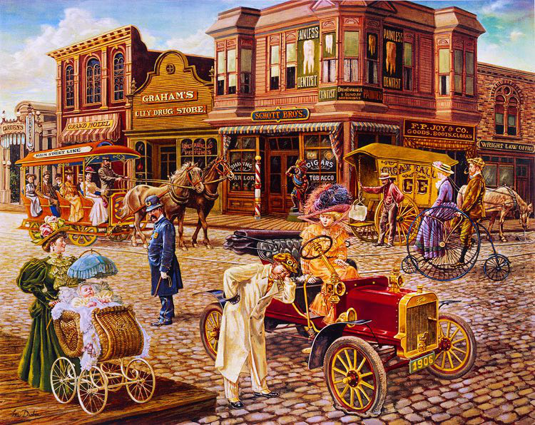
Exercise 1.
Translate the following words and expressions.
https://quizlet.com/305308243/flashcards
Exercise 2.
Choose the version which sounds more natural.
- He has travelled_______ .
- Far and wide
- Wide and far
- We have been _________.
- There and here
- Here and there
- She keeps flying ________.
- To and fro
- Fro and to
- Good to see you ________.
- About and out
- Out and about
- Right then. ___________.
- Onwards and upwards
- Upwards and onwards
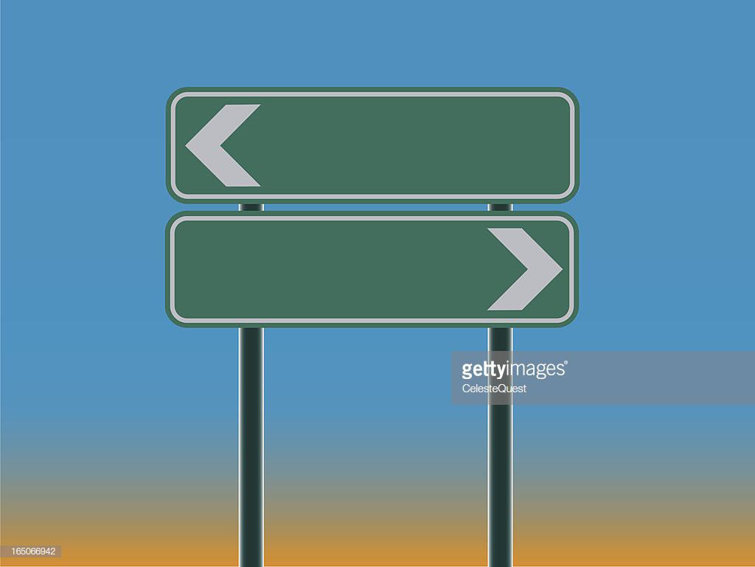
Exercise 3.
Choose the right word to complete these collocations.
- I don’t have a very good sense of ________.
- Direction
- Directions
- We didn’t have a map, so we had to stop the car to ask for _______.
- Direction
- Directions
- You are going in the right _______ - just keep going straight on, and you will see the sign.
- Direction
- Directions
- Just look at your hair! It’s going in all _______ because of the wind.
- Direction
- Directions
- Could you give me _______ while I’m driving? I’ve no idea how to get there.
- Direction
- Directions
- If you follow my _______ you will have no problem finding the place.
- Direction
- Directions
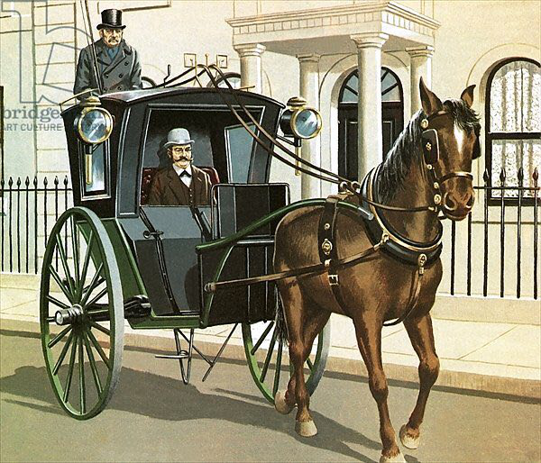
Exercise 4.
Which of the expressions is NOT possible to complete the sentence?
- The dog was running _______ in the park.
- Side to side
- Round and round
- Up and down
- He has travelled _______ in the last two weeks.
- Far distances
- Great distances
- A long way
- Excuse me, I’ve _______. Could you tell me the way to the station, please?
- Lost my way
- Lost myself
- Lost my bearings
- Don’t worry about your dog. I’m sure he will _______.
- Find his way home
- Make his own way back
- Return homewards
- Where are we, anyway? We seem to be _______.
- At the end of the world
- In the back of beyond
- In the middle of nowhere
- I think we might have _______ a couple miles back.
- Taken a wrong turning
- Gone the wrong way
- Mistaken our path
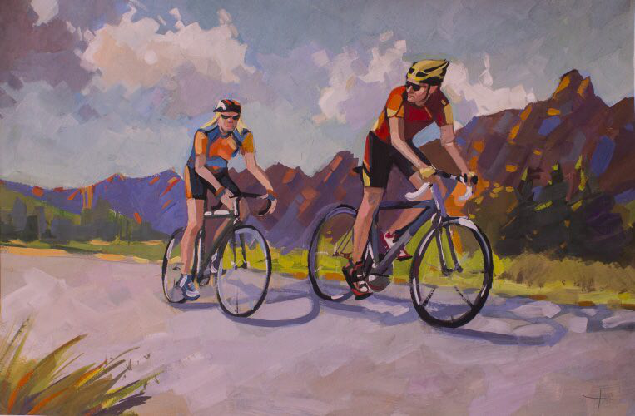
Exercise 5.
Choose the most natural-sounding words.
- Tickets can be purchased from any station _____ ticket office/window or can be _____ booked/paid online.
- I caught the _____ last/final train back. It’s a good thing I didn’t _____ lose/miss it.
- I’ll meet you_____ at/in the station. I’ll be at/on platform 3.
- To arrive in/ get to Cardiff, you have _____ to move to another train/ change at Bristol.
- The _____ fast/quick trains from Edinburgh don’t _____ visit/stop at this station.
- You can save money if you book your _____ seat/chair more than seven days_____ early/ in advance.
- The ferry leaves the ferry _____ terminal/station at 6 am. I hope it isn’t a rough _____ journey/ crossing.
- It’s usual to pay a taxi _____ fare/ bill at the end of the _____ journey/ ride.
Exercise 6.
Which is NOT natural English?
- The train ______ London at 10:35
- Gets to
- Gets into
- Arrives in
- Arrives at
- It is sometimes cheaper to travel _______ .
- Off-peak
- Non-rush hour
- Outside rush hour
- Everybody who travels by train has to _______.
- Pay the ticket
- Buy a ticket
- Pay the fare
- I _______ the train at Birmingham.
- Joined
- Got on
- Boarded
- Entered
- I love travelling _______.
- By rail
- On the rails
- By train
- I came out of the station and _______ a taxi.
- Hailed
- Got into
- Boarded
- Got
- Took
- I usually _______ bus to work.
- Get the
- Take a
- Go by
- Catch a
- Hail a
- We had a meal _______ the ferry.
- In
- On
- On board
- Aboard
- The sea was very _______.
- Rough
- Calm
- flat
Key
Exercise 2.
Choose the version which sounds more natural.
- He has travelled_______ .
a)Far and wide
b)Wide and far
- We have been _________.
a)There and here
b)Here and there
- She keeps flying ________.
a)To and fro
b)Fro and to
- Good to see you ________.
- About and out
b)Out and about
5. Right then. ___________.
a)Onwards and upwards
- Upwards and onwards
Exercise 3.
- I don’t have a very good sense of ________.
- Direction
- Directions
- We didn’t have a map, so we had to stop the car to ask for _______.
- Direction
- directions
- You are going in the right _______ - just keep going straight on, and you will see the sign/
- Direction
- directions
- Just look at your hair! It’s going in all _______ because of the wind.
- Direction
- Directions
- Could you give me _______ while I’m driving? I’ve no idea how to get there.
- Direction
- directions
- If you follow my _______ you will have no problem finding the place.
- Direction
- directions
Exercise 4.
Which of the expressions is NOT possible to complete the sentence?
- The dog was running _______ in the park.
- Side to side
- Round and round
- Up and down
- He has travelled _______ in the last two weeks.
- Far distances
- Great distances
- A long way
- Excuse me, I’ve _______. Could you tell me the way to the station, please?
- Lost my way
- Lost myself
- Lost my bearings
- Don’t worry about your dog. I’m sure he will _______.
- Find his way home
- Make his own way back
- Return homewards
- Where are we, anyway? We seem to be _______.
- At the end of the world
- In the back of beyond
- In the middle of nowhere
- I think we might have _______ a couple miles back.
- Taken a wrong turning
- Gone the wrong way
- Mistaken our path
Exercise 5.
Choose the most natural-sounding words.
- Tickets can be purchased from any station _____ ticket office/window or can be _____ booked/paid online.
- I caught the _____ last/final train back. It’s a good thing I didn’t _____ lose/miss it.
- I’ll meet you_____ at/in the station. I’ll be at/on platform 3.
- To arrive in/ get to Cardiff, you have _____ to move to another train/ change at Bristol.
- The _____ fast/quick trains from Edinburgh don’t _____ visit/stop at this station.
- You can save money if you book your _____ seat/chair more than seven days_____ early/ in advance.
- The ferry leaves the ferry _____ terminal/station at 6 am. I hope it isn’t a rough _____ journey/ crossing.
- It’s usual to pay a taxi _____ fare/ bill at the end of the _____ journey/ ride.
Exercise 6.
Which is NOT natural English?
- The train ______ London at 10:35
- Gets to
- Gets into
- Arrives in
- Arrives at
- It is sometimes cheaper to travel _______ .
- Off-peak
- Non-rush hour
- Outside rush hour
- Everybody who travels by train has to _______.
- Pay the ticket
- Buy a ticket
- Pay the fare
- I _______ the train at Birmingham.
- Joined
- Got on
- Boarded
- Entered
- I love travelling _______.
- By rail
- On the rails
- By train
- I came out of the station and _______ a taxi.
- Hailed
- Got into
- Boarded
- Got
- Took
- I usually _______ bus to work.
- Get the
- Take a
- Go by
- Catch a
- Hail a
- We had a meal _______ the ferry.
- In
- On
- On board
- Aboard
- The sea was very _______.
- Rough
- Calm
- flat

