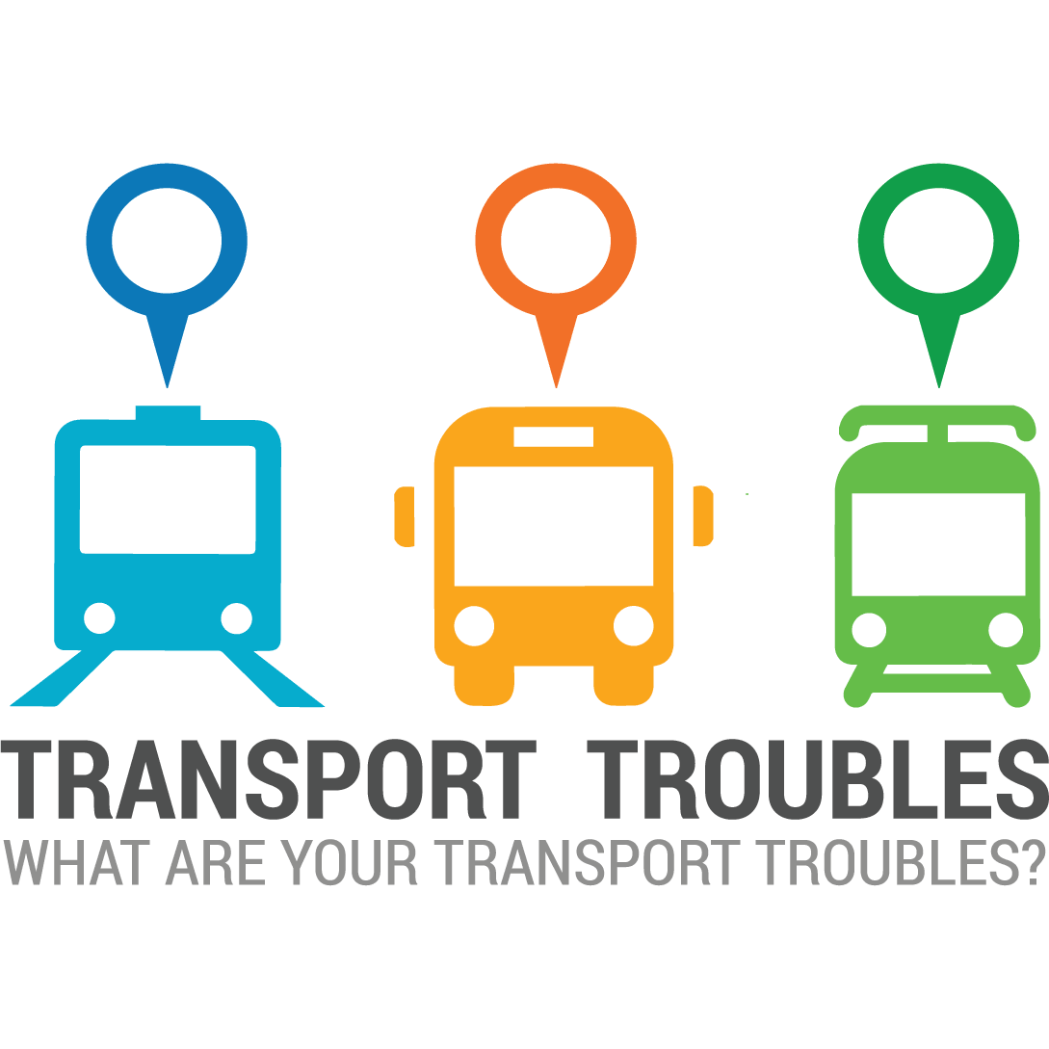

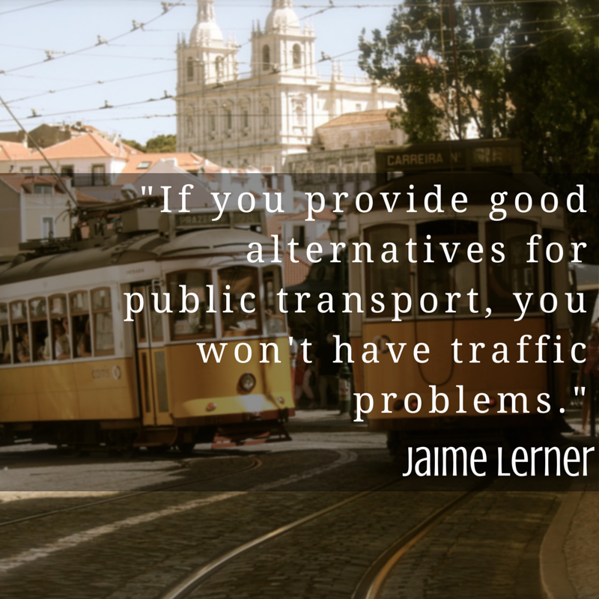
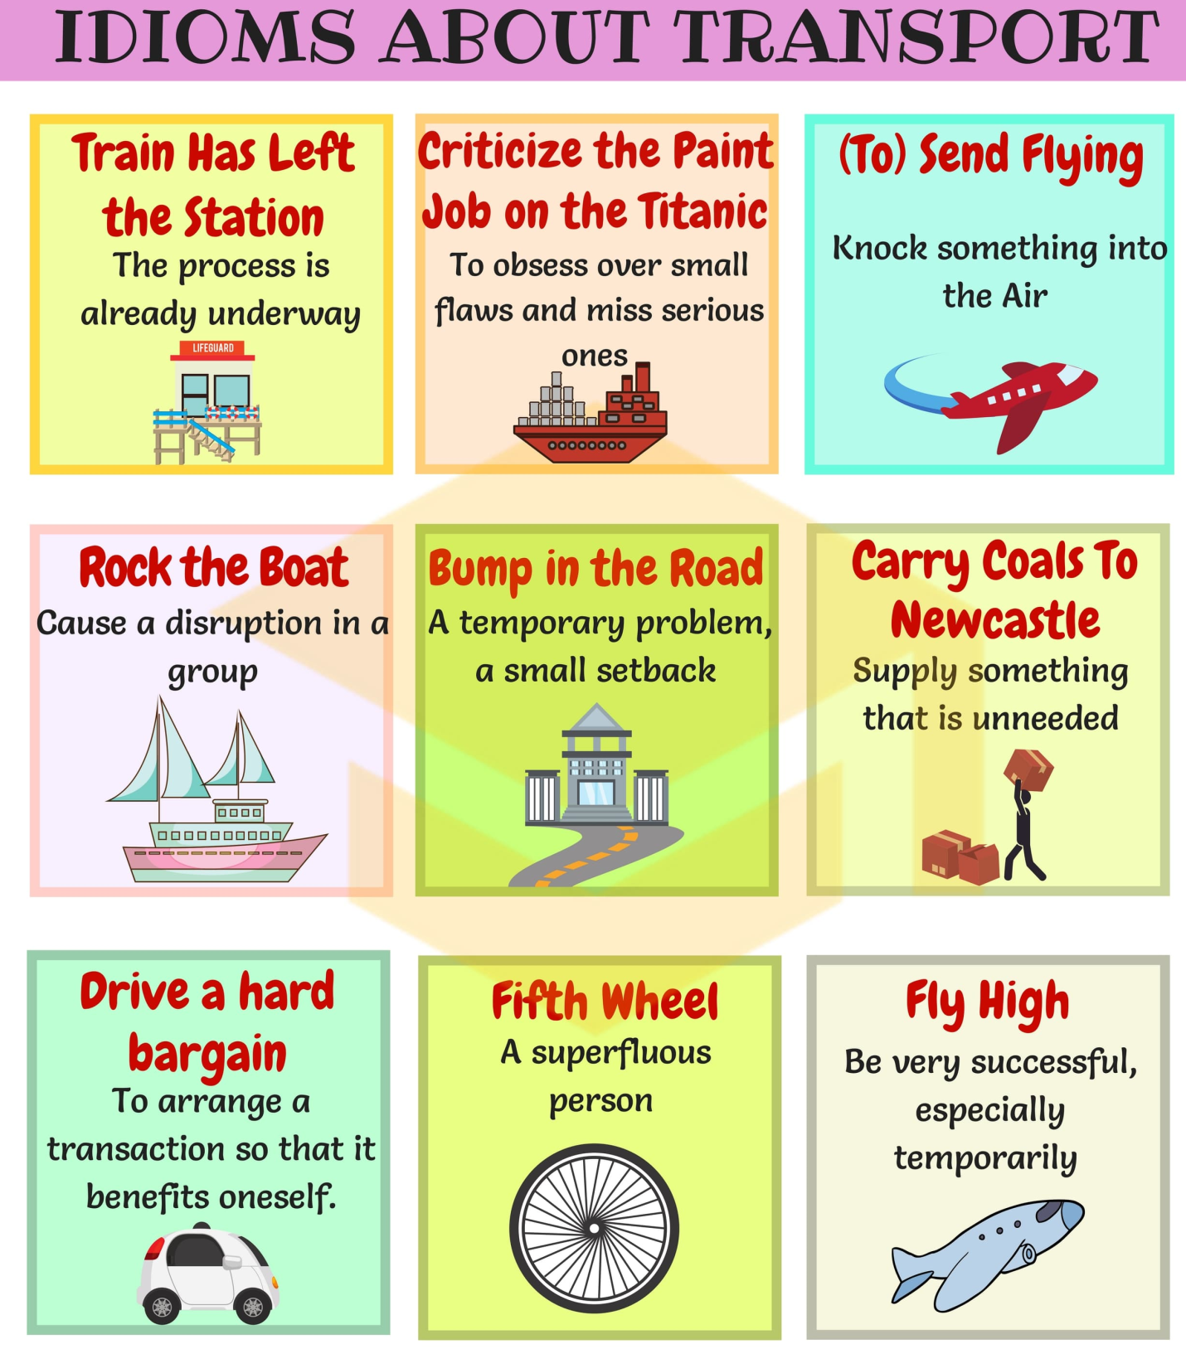
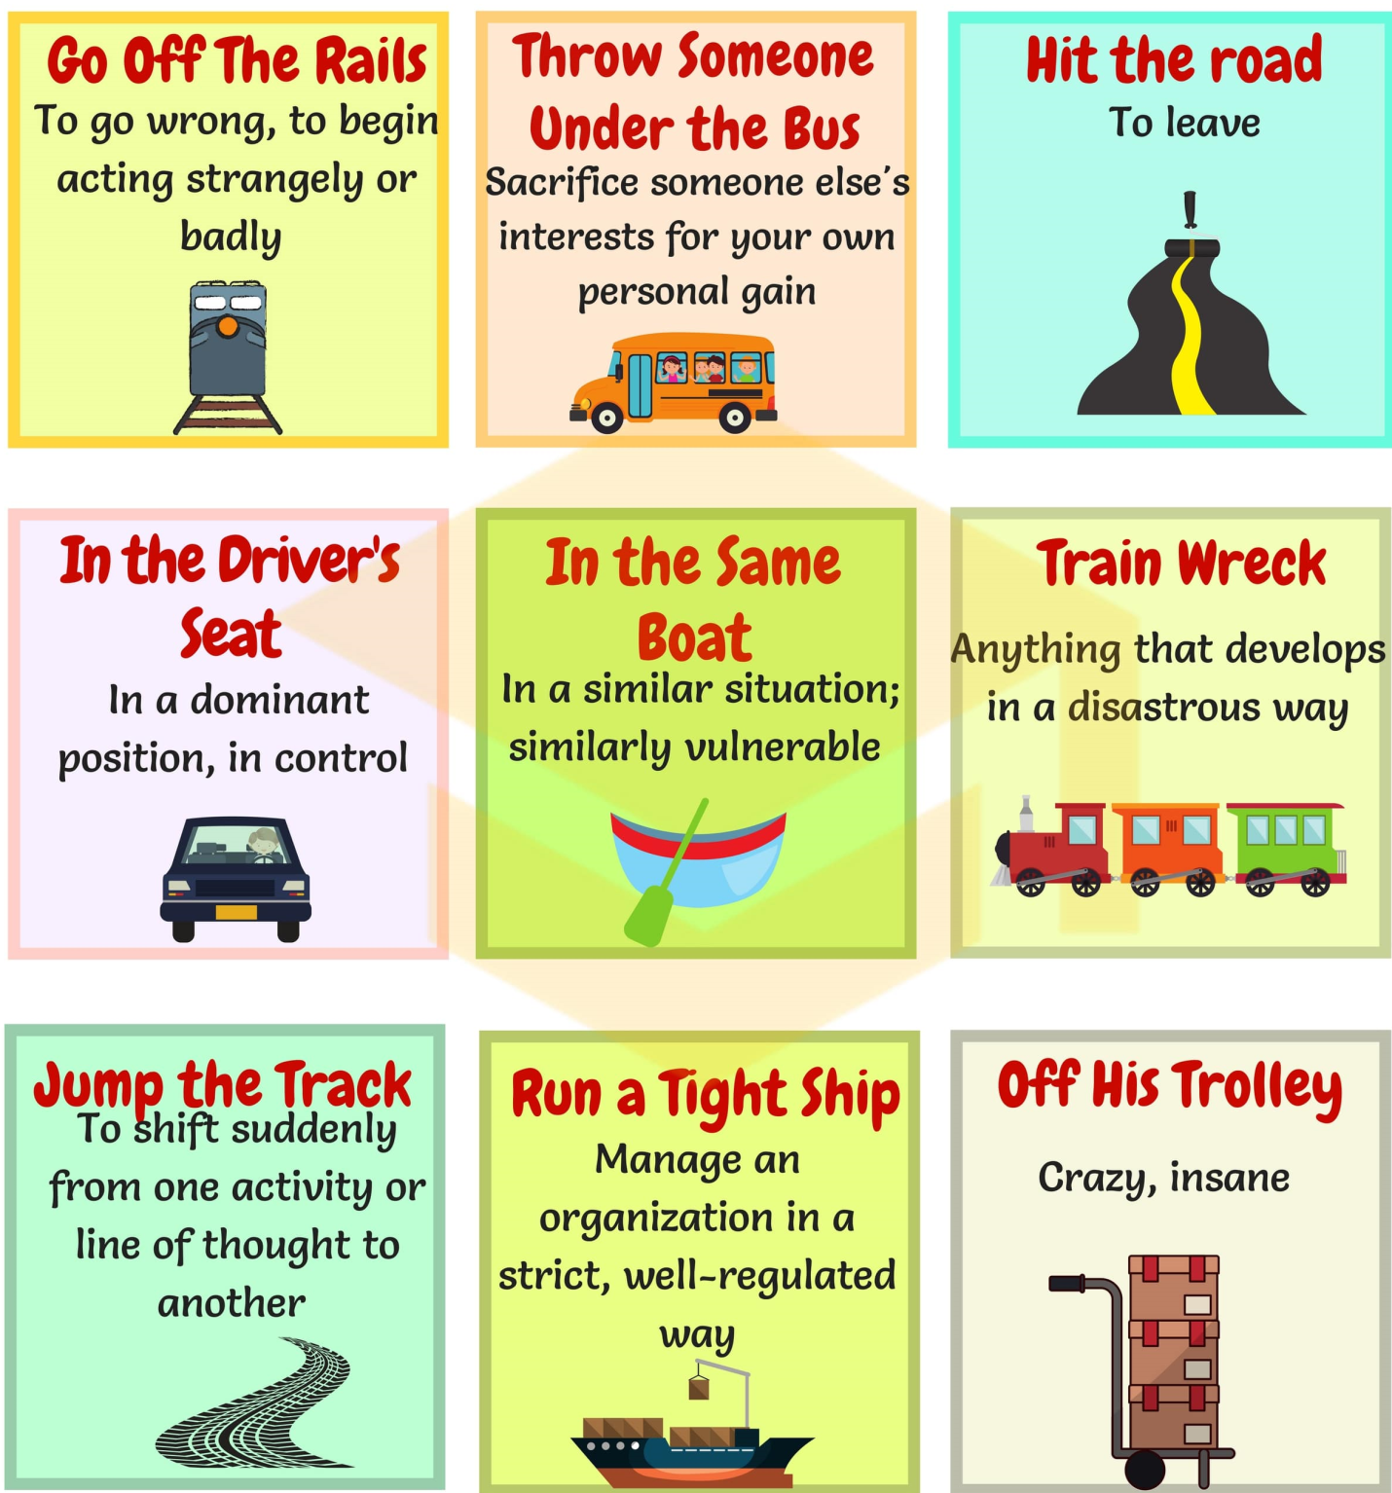

I. Watch the video and answer the question.
<iframe width="560" height="315" src="https://www.youtube.com/embed/VdZd5zYTKAw" frameborder="0" allow="autoplay; encrypted-media" allowfullscreen></iframe>

1. In what year was the world’s first subway line completed?
- 1763
- 1840
- 1863
- 1893
- 1963
2. How long was the first line?
- 1 mile
- 2 miles
- 4 miles
- 5 miles
- 23 miles

3. On the first day, how many people traveled on the line?
- 250
- 1,000
- 10,000
- 25,000
- 30,000

4. The first line was built using what method?
- Trench digging
- Pneumatic drilling
- Dynamite explosion
- Deep tube digging
- Cut and cover
5. After 30 years, London’s subway system had extended to _______.
- 10 kilometers
- 15 kilometers
- 50 kilometers
- 80 kilometers
- 180 kilometers

What factors led to London becoming the site of the first subway?

Why are two different methods used to build subways?

Why did the world have to wait until the mid-19th century to get its first subway?
In what ways does a subway system help a city and its population?

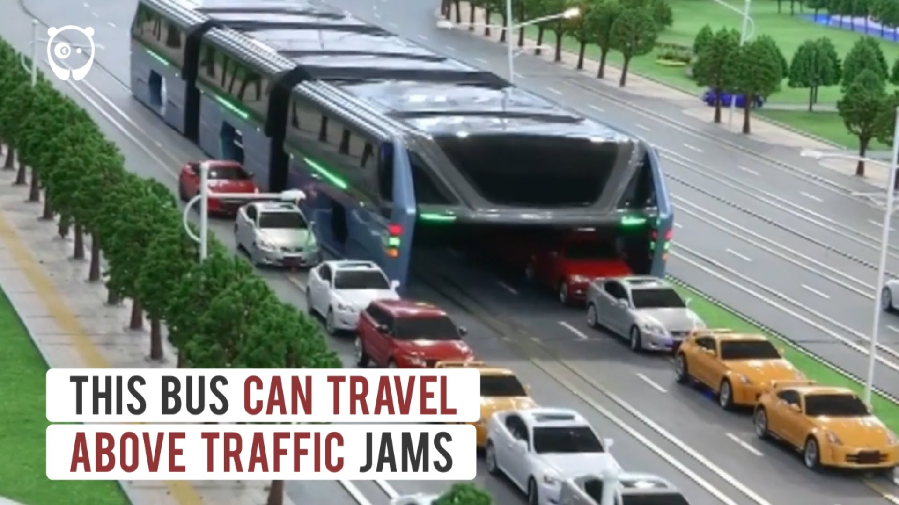
II. Watch the video and answer the questions.

- How will people be transported in the future?
- What is the advantage of futures transportation?
- How do you envision the future of transportation?
- What is the future of technology in transportation?
- What is the best transportation?

III. Watch thr video and answer the questions.
<iframe width="560" height="315" src="https://www.youtube.com/embed/Q8Cn47L8FRQ" frameborder="0" allow="autoplay; encrypted-media" allowfullscreen></iframe>

(1) | What comes to mind when you hear the word ‘transportation’?
(2) | What will the transportation of the future be like?
(3) | What would life be like if all public transportation in your country stopped?
(4) | What's your favorite method of transportation?
(5) | What transportation problems are there in your country?
(6) | Are you happy with transportation services in your country?
(7) | What do you think of the transportation in other countries?
(8) | How many different kinds of transportation have you been on?
(9) | Will the quality of transportation in your country get better or worse?
(10) | What was transportation like when you were a kid?

Answers:
1. In what year was the world’s first subway line completed?
- 1763
- 1840
- 1863
- 1893
- 1963
2. How long was the first line?
- 1 mile
- 2 miles
- 4 miles
- 5 miles
- 23 miles

3. On the first day, how many people traveled on the line?
- 250
- 1,000
- 10,000
- 25,000
- 30,000

4. The first line was built using what method?
- Trench digging
- Pneumatic drilling
- Dynamite explosion
- Deep tube digging
- Cut and cover
5. After 30 years, London’s subway system had extended to _______.
- 10 kilometers
- 15 kilometers
- 50 kilometers
- 80 kilometers
- 180 kilometers

