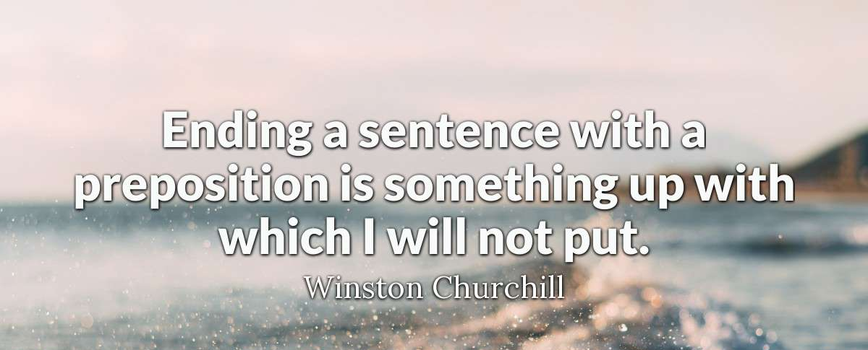
advanced_lesson_14_grammar_part_2

Look at the picture and say what is incorrect.

Quizlet

https://quizlet.com/305368614/lesson-14-gram-advanced-flash-cards/

Exercise 1

Choose the correct answer

- I bumped into Tim ______ party I went to the other evening. A) in b) at c) on
- He was undoubtedly the best player ___________ the pitch in the first half. A) over b) in c) on
- Although he has been singing for ages, it will be the first time he has appeared ______ the Opera House. A) at b) on c) in
- They live _______ the main road , so there's a lot of traffic going past. A) in b) on at)
- I was sitting ______ the table working on my report. A) on b) in c) at
- He put his hand ______ the pocket and took out some coins. A) in b) into c) at
- He turned up early to make sure he had a seat _____ the plane. A) in b) at c) on
- We got ______ the train and headed for Florence. A) on b) in c) at
- We were stuck ______ the plane for hours in Jakarta. A) in b) at c) on
- Talks are to be held _____ Downing Street, chaired by the Prime Minister. A) at b) on c) in
- They cycled ______America from the Pacific to the Atlantic. A) between b) over c) on
- After the children's party, sweets and cakes were scattered all ______ the kitchen floor. A) among b) behind c) over
- The thieves broke the window and climbed _______ it a) across b) over c)through.
- There was so much traffic, I was fortunate to get ______the road without being knocked over. a) across b) along c) through
- The fog was so thick, it was like walking ______ a cloud. a) over b) along c) through

Exercise 2

Define if the prepositions Among and Between are used correctly or incorrectly

1)During that period, the Atlantic Ocean was a narrow lake between what is now
Africa and North America.
2) There was no one from Japan between the many tourists on the coach.
3) I had a pain among my eyes.
4) She looked among all the coats on the rack until she found her own.

5) I took my seat between Toni and Ingrid.

Exercise 3

Find the necessary preposition for each picture

far and wide - clockwise - anticlockwise - to and fro - onwards and upwards

2)

1)
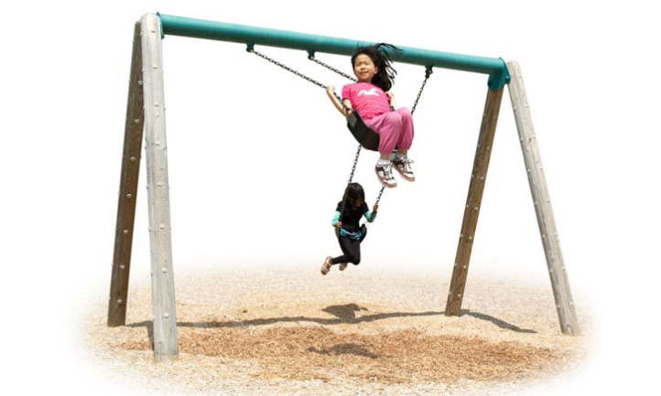

3)
4) 5)

Exercise 4

Choose the correct answer

towards - across – beyond - into - alongside – over- against – beyond - onto

- The mechanic announced that the engine was _______ repair. (it can`t be repaired)
- _______ the end of the journey I got really tired.
- _______ the door was a narrow corridor that led off to the right.
- She leaned ________ the door.
- The two runners ran ______ each other as they approached the finish line.
- The dog ran ________ the road and nearly got hit by a car.
- He got ______ the car and closed the door.
- Move the kettle ______ the counter.
- The cat jumped ______ the fence.

Exercise 5

Choose the correct word Direction or Directions

- I don`t have a very good sense of ________ and I always get lost in new cities.
- You are going in the right _______ just keep going straight on.
- Just look at your hair! It`s going in all ______, because of the wind.
- Could you give me ______ while I`m driving? I`ve no idea how to get there.
- I told him where to go but he set off in the opposite ________.

