Lesson 15 Vehicles – Transport – Vocabulary-3 Part 1
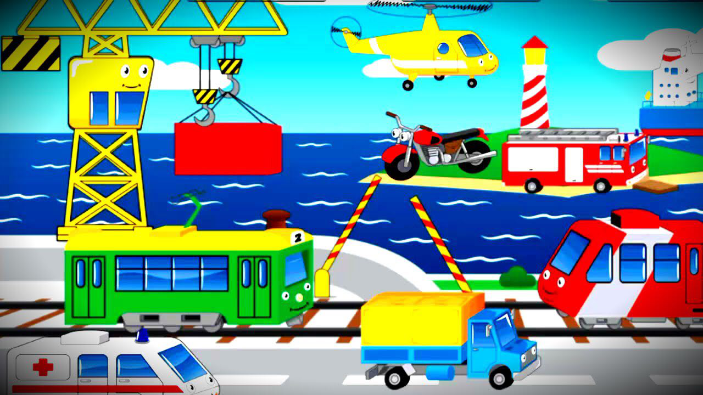
Exercise 1
Translate the following words and expressions
https://quizlet.com/305378596/flashcards
Exercise 2
Complete the sentence with a word from the box
traffic warden cyclist pedestrian crew chauffeur guard flight attendant mechanic captain motorist driver conductor
- The company chairman has a Rolls-Royce driven by a ______.
- When my car broke down a passing ______ towed it to a garage.
- The police wanted me to describe the ______ of the car.
- The four passengers on the ship had dinner with the ______.
- The train couldn’t leave until the ______ waved his green flag.
- Hilary was given a parking ticket by a ______.
- Before take-off, the ______ told me to fasten my seat belt.
- When I got on the ship, one of the ______ helped me to find my cabin.
- There isn’t a ______ on this bus, you pay the driver.
- Eddie is a keen ______ and rides his bike to work every day.
- The bus mounted the pavement and injured a ______.
- Jim works as a ______ in a local garage.
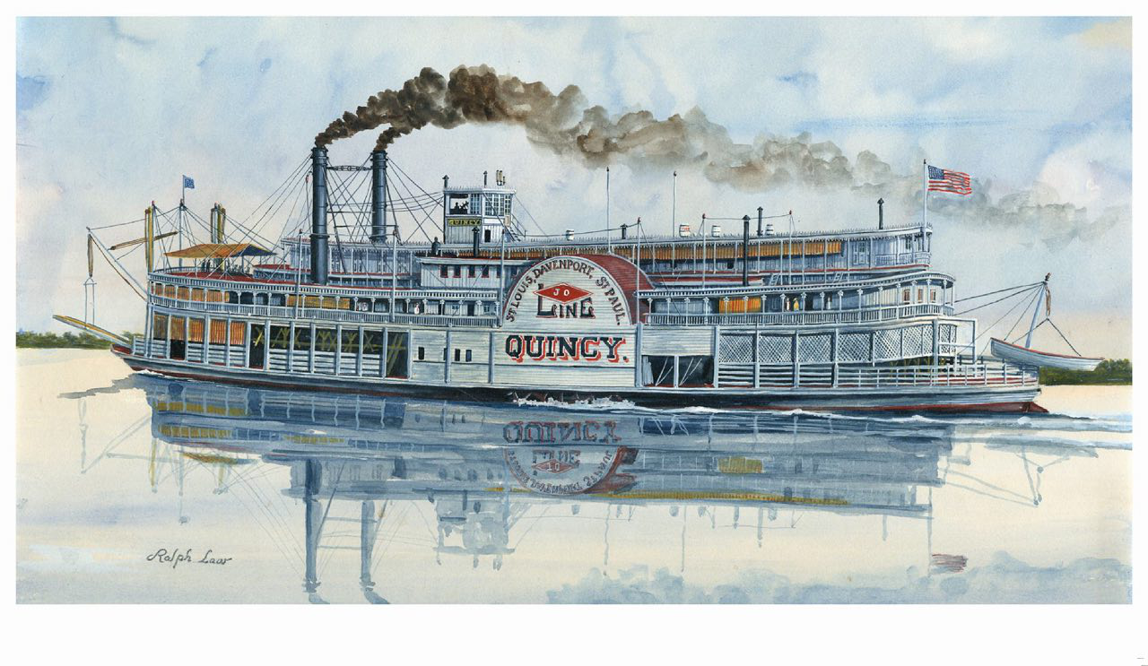
Exercise 3
Choose the most suitable word or phrase to complete each sentence
- The ship stopped because two passengers had fallen ______.
- Upside down
- Overboard
- Underground
- Inside out
- The ______ was crowded with passengers waiting for the train.
- Platform
- Quay
- Runway
- Pavement
- We had to stop for petrol at a filling ______.
- Garage
- Service
- Pump
- Station
- Mary looked up the fastest train to Glasgow in the ______.
- Catalogue
- Timetable
- Dictionary
- Programme
- The train was very crowded because there were only four ______.
- Coaches
- Wagons
- Trucks
- Cars
- Peter’s car ______ off the icy road and fell into a ditch.
- Crashed
- Collided
- Hit
- Skidded
- I dropped my wallet from the boat but luckily it ______.
- Drifted
- floated
- sank
- rescued
- Everything went dark when the train entered a/an ______.
- Underground
- Tunnel
- Tube
- Metro
- David missed his train because of the queue in the ticket ______.
- Office
- Agency
- Room
- Lounge
- To get to our hotel we had to cross the railway ______.
- Road
- Route
- Rails
- Line

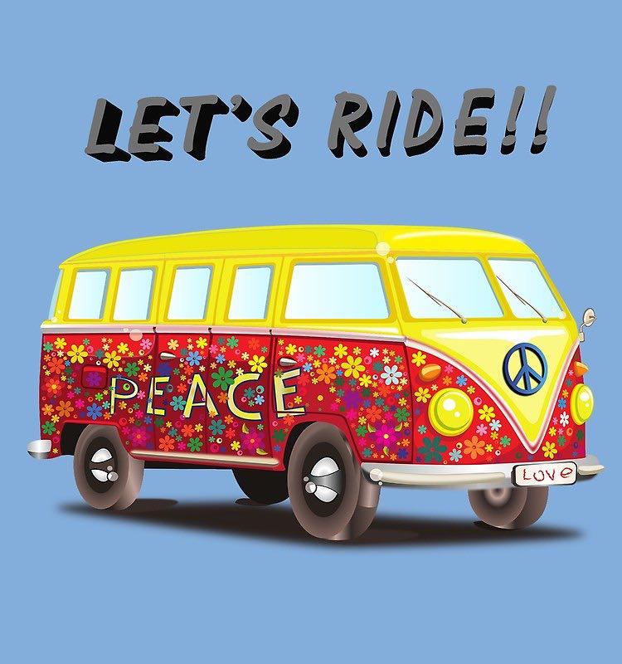Exercise 4.
Complete each sentence with one suitable word.
trying showing dealing looking made/headed
put pick take put keep/catch
- I’m really ______ forward to sailing in Jean’s new yacht.
- In cities, cars and other vehicles ______ up most of the space.
- We’ll come with the van and ______ up the rest of the furniture.
- When the storm began, the small boat ______ for nearest harbor.
- How can you ______ up with all those exhaust fumes!
- We can’t ______ up with that speedboat in this rowing boat!
- Jane likes ______ off by driving her sports car at 100 miles an hour.
- A fire engine arrived and soon ______ out the fire.
- Little Johnny is in the garden ______ out his new tricycle.
- One way of ______ with pollution is to use unleaded petrol.
Exercise 5
Watch the video
https://m.youtube.com/watch?v=v1vvLQd53Ps
Fill in the gaps in the text with suitable words
airport site glove compartment shuttle bus parking zone off-site options
two minutes’ short heading issued turn up
If you’re planning any sort of trip from Birmingham Airport one of the top things to consider is parking. Can you just 1. ______ and pay on the day, or do you need to book in advance to secure a space? How do you book? And can you get a space close to the terminal if you're 2. ______ on time? And there's that all-important question of how much will it cost? And it's always worth considering whether there are any 3. ______ which are cheaper. There are seven car parks. Some are multi-storeys just 4. ______ walk from the terminal building. There’s also a free 5. ______ every ten minutes. All those car parks are on the main 6. ______. Tickets are 7. ______ by the machine at the entry barrier when you go into the car park, whether you have pre-booked or not. The tickets will be needed when you leave the car park. Keep it in the 8. ______ or in your wallet. If you did not pre-book, then pay for your parking at one of the payment machines before driving to the exit barrier. Remember to make a note of where you have parked so you can easily find your car when coming back from your holiday. Write down the 9. ______ on a piece of paper and put it your wallet before 10. ______ to the terminal for your flight.
Key
Exercise 2
Complete the sentence with a word from the box
- The company chairman has a Rolls-Royce driven by a ______ chauffeur.
- When my car broke down a passing ______ motorist towed it to a garage.
- The police wanted me to describe the ______ driver of the car.
- The four passengers on the ship had dinner with the ______ captain.
- The train couldn’t leave until the ______ guard waved his green flag.
- Hilary was given a parking ticket by a ______ traffic warden.
- Before take-off, the ______ flight attendant told me to fasten my seat belt.
- When I got on the ship, one of the ______ crew helped me to find my cabin.
- There isn’t a ______ conductor on this bus, you pay the driver.
- Eddie is a keen ______ cyclist and rides his bike to work every day.
- The bus mounted the pavement and injured a ______ pedestrian.
- Jim works as a ______ mechanic in a local garage.
Exercise 3
Choose the most suitable word or phrase to complete each sentence
- The ship stopped because two passengers had fallen ______.
- Upside down
- Overboard
- Underground
- Inside out
- The ______ was crowded with passengers waiting for the train.
- Platform
- Quay
- Runway
- Pavement
- We had to stop for petrol at a filling ______.
- Garage
- Service
- Pump
- Station
- Mary looked up the fastest train to Glasgow in the ______.
- Catalogue
- Timetable
- Dictionary
- Programme
- The train was very crowded because there were only four ______.
- Coaches
- Wagons
- Trucks
- Cars
- Peter’s car ______ off the icy road and fell into a ditch.
- Crashed
- Collided
- Hit
- Skidded
- I dropped my wallet from the boat but luckily it ______.
- Drifted
- floated
- sank
- rescued
- Everything went dark when the train entered a/an ______.
- Underground
- Tunnel
- Tube
- Metro
- David missed his train because of the queue in the ticket ______.
- Office
- Agency
- Room
- Lounge
- To get to our hotel we had to cross the railway ______.
- Road
- Route
- Rails
- line
Exercise 4.
Complete each sentence with one suitable word.
- I’m really ______ looking forward to sailing in Jean’s new yacht.
- In cities, cars and other vehicles ______ take up most of the space.
- We’ll come with the van and ______ pick up the rest of the furniture.
- When the storm began, the small boat ______ made/headed for nearest harbor.
- How can you ______ put up with all those exhaust fumes!
- We can’t ______ keep/catch up with that speedboat in this rowing boat!
- Jane likes ______ showing off by driving her sports car at 100 miles an hour.
- A fire engine arrived and soon ______ put out the fire.
- Little Johnny is in the garden ______ trying out his new tricycle.
- One way of ______ dealing with pollution is to use unleaded petrol.
Exercise 5
If you’re planning any sort of trip from Birmingham Airport one of the top things to consider is parking. Can you just 1. ______ turn up and pay on the day, or do you need to book in advance to secure a space? How do you book? And can you get a space close to the terminal if you're 2. ______ short on time? And there's that all-important question of how much will it cost? And it's always worth considering whether there are any 3. ______ off-site options which are cheaper. There are seven car parks. Some are multi-storeys just 4. ______ two minutes’ walk from the terminal building. There’s also a free 5. ______ shuttle bus every ten minutes. All those car parks are on the main 6. ______ airport site. Tickets are 7. ______ issued by the machine at the entry barrier when you go into the car park, whether you have pre-booked or not. The tickets will be needed when you leave the car park. Keep it in the 8. ______ glove compartment or in your wallet. If you did not pre-book, then pay for your parking at one of the payment machines before driving to the exit barrier. Remember to make a note of where you have parked so you can easily find your car when coming back from your holiday. Write down the 9. ______ parking zone on a piece of paper and put it your wallet before 10. ______ heading to the terminal for your flight.

