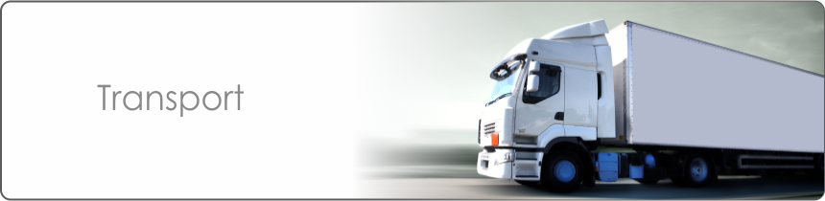
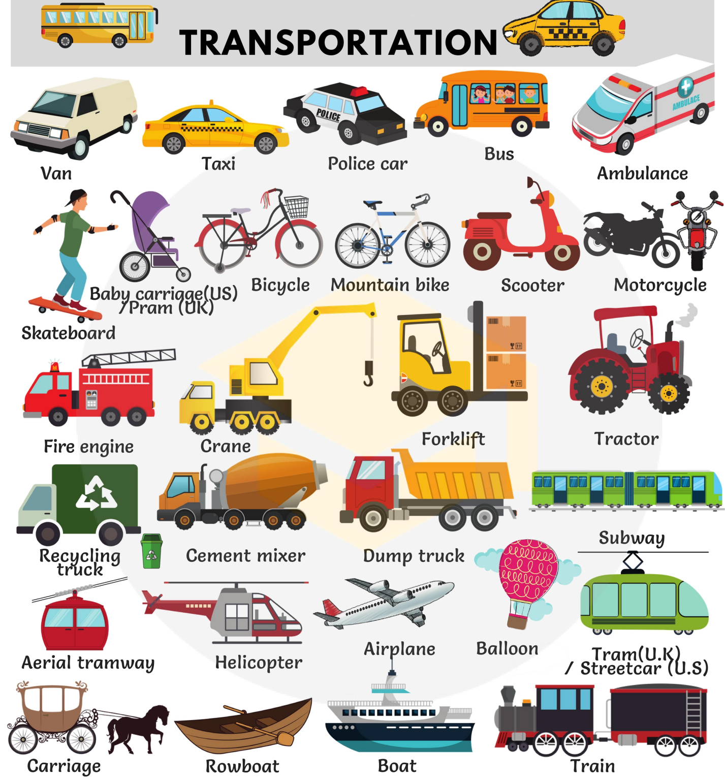
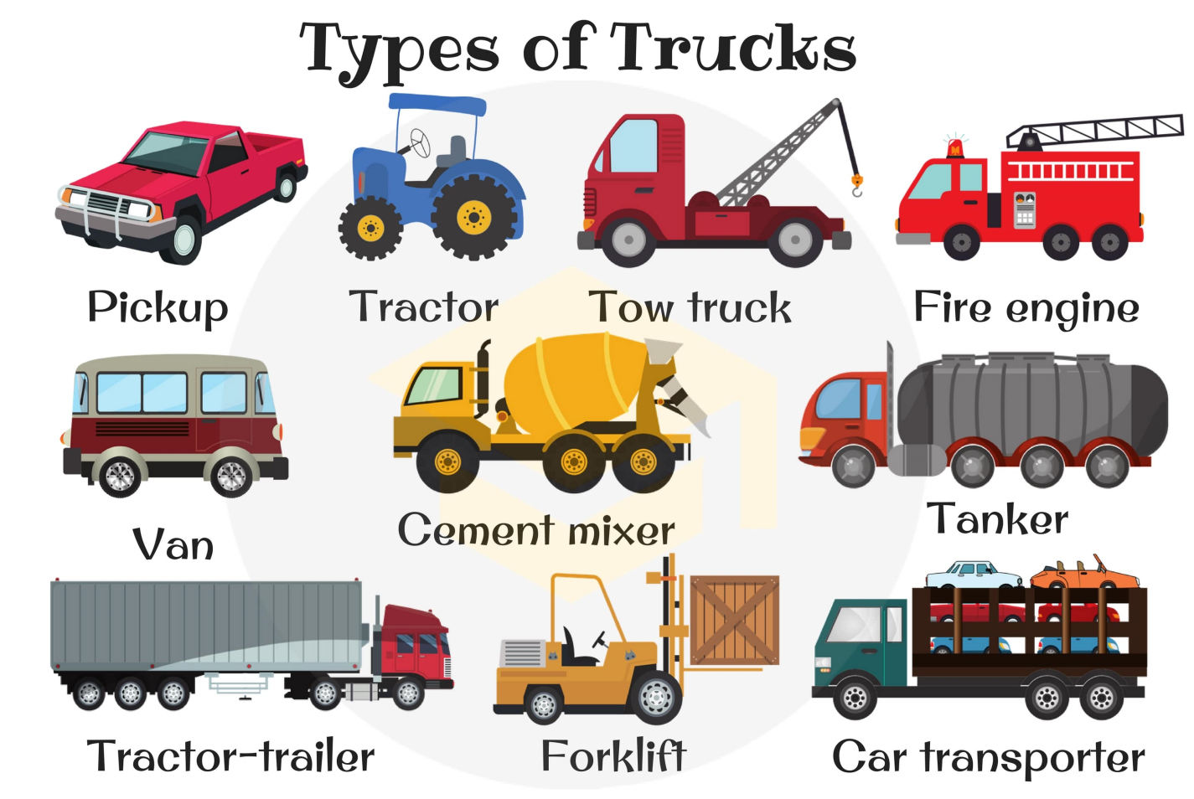

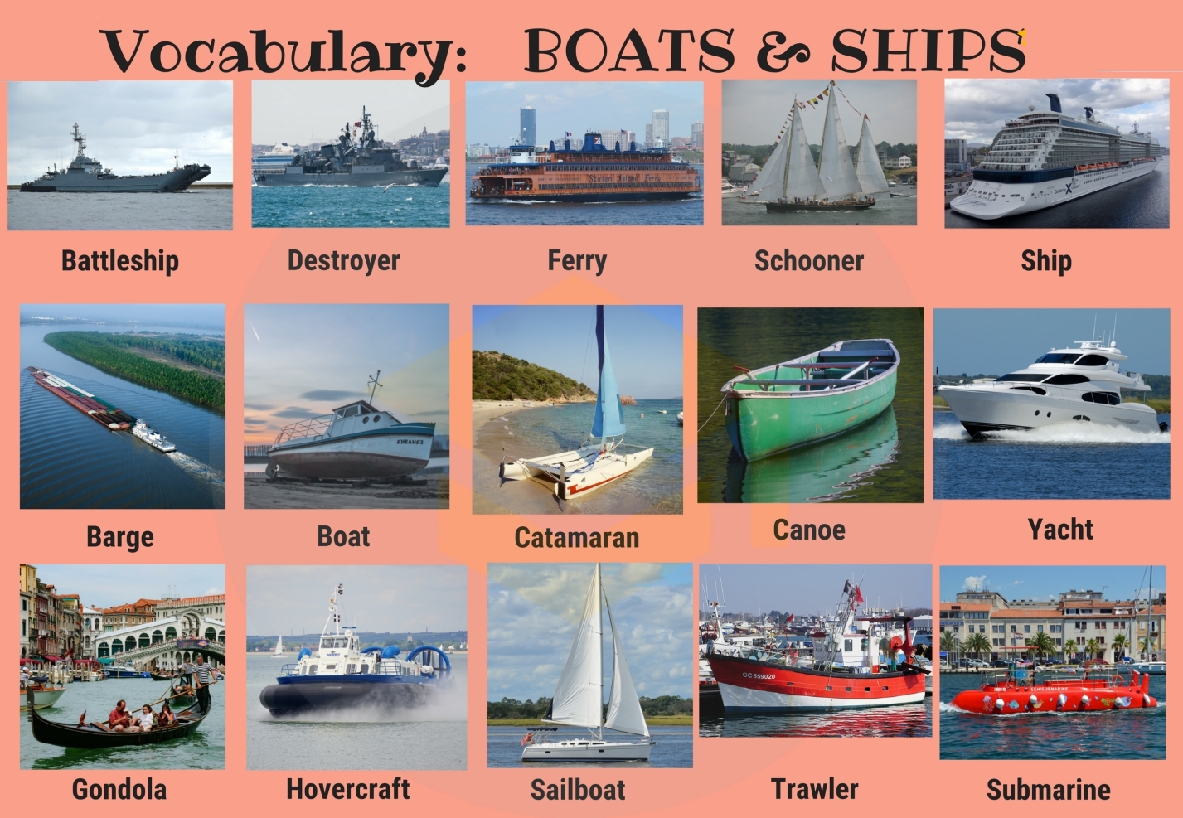

Quizlet
https://quizlet.com/309645569/flashcards

I. Read and translate the text.
Means of Transport
There are different types of transport for various reasons in diverse
regions such as donkeys, trains and planes in countries with developed
economies.
Donkeys are needed in remote areas as they are easy to look after and
keep working. Private railways started in Ancient Greece in 600BC. They
covered short distances and carried heavy raw materials and finished
goods. In the early 19 th century, passengers first travelled in horse-drawn
carriages. By the 1850s, steam engines used the railways which
connected the major cities in Britain. Airplanes were developed in the 20
th century and carry passengers, cargo and provide courier services with
varying levels of service and prices.
There are different means of transport which are important to the
economy. Some are costly but are needed in today’s world.

Text 1 The Donkey
In today’s modern world of articulated lorries, high-speed railways and
super-efficient courier services, it is easy to forget that many rural
communities and villages across the world would disappear if there were
no donkeys.
Much of the world is dependent on donkeys moving food from farms to
small towns. Donkeys generally work very hard in rural and mountainous
areas where there aren’t any modern transport facilities. They carry huge
amounts of food from the villages to the towns and bring fertilizers and
other supplies back to the village. If a lorry runs out of diesel or petrol, it
cannot be used, but the donkey just needs grass, water and rest and is
ready to work again for long hours.

Text 2 The Railways
Many countries have an effective network of railways to help transport
different types of goods, mostly imperishable goods.
The earliest recorded system was in Ancient Greece in 600BC. Since
then, rail-links were built to connect short distances. In the 19 th century,
this changed dramatically. Many countries developed their own network
with private links between different towns with Germany and Britain
leading the way. These links provided the capacity to carry heavy goods
such as coal, iron ore and wood. Building a railway was tremendously
hard work for labourers. Railways are extremely expensive to construct
but essential for transporting raw materials and finished goods such as
textiles quickly and cheaply. In the early 19 th century, the first
passengers travelled on the railways with horse-drawn carriages. From
1840 -1850, Britain was completely connected by railways and used
steam engines to pull carriages.

Text 3 Air Travel
Air-travel is the most modern form of public transport and it was
developed in the 20 th century. Millions of people use airplanes for a
variety of reasons. It is also extremely expensive to set up air-travel
facilities. Some travel for business, others go on holiday by air and others
use cargo planes to move their products from country to country very
quickly. Some courier companies now have their own fleet of planes
ready to carry parcels and post more efficiently. There are different types
of passenger services – some are cheap and provide a ‘no-frills’ service
which is good for short journeys. Other airlines provide passengers with a
luxurious flying experience.
Airports are getting busier and it is evident that more passengers and
businesses than ever are using airplanes to get to their destinations.

II. Read the statements below and then decide if they are True (T) or False (F)
1. Donkeys are not needed in today’s economy.
2. The Ancient Greeks had a railway system in 800BC.
3. The very early railways connected a lot of cities.
4. British passengers first travelled on trains in the 1820s.
5. ‘No-frills’ airlines are popular because they are costly.
6. Some courier services use their own convoys of planes.

III. Join the first half of the sentence in Column A to the correct ending in
Column B.
Column A |  | Column B
1 | Many remote communities need  mules | A | to transport non-food goods.
2 | British railway networks developed | B | but are needed by industry and  governments for quick transport.
3 | Many countries have an effective network of railways | C | because they can deliver a more  efficient service.
4 | Railways are extremely expensive to  construct | D | because more passengers and  businesses are using air transport.
5 | Some courier companies now have their own fleet of planes | E | to transport food, raw  materials and essentials.
6 | Airports are getting busier | F | extremely quickly during the  mid-19th century.

IV. Read and translate the text.
The whole journey was a complete nightmare. I’d only been going five minutes on the motorway when somebody cut in on me and I had to brake really quickly to avoid an accident, but that was only the start of it. A bit further on I pulled out to overtake a big lorry but as I did, my engine just died. I tried revving the engine and after a couple of seconds it started again, but I had to change down and get back
into the slow lane and go very slowly indeed. Because I was so slow, I was flagged down by a police officer who checked the car and told me that one of my tires was worn. He said it wasn’t illegal and let me continue but warned me to get it hanged. The car started again without any problems, so I set off again, picked up speed, and after a couple of miles, guess what, the worn tire blew out! The police were right. So I changed the tire, which was another half hour wasted. Then I picked up a student who was hitch-hiking — I felt sorry for him. After a while we branched off the motorway and I left him where he wanted to be and went to a nearby cafe for a cup of tea. When I came out, someone had blocked me in. Then to cap it all, I realized the student had stolen my camera from the back seat!

V. Choose the correct word to complete these sentences.
1 The train started slowly but soon revved / picked / pulled up speed.

2 I hate drivers who cut / block / ﬂag in on you when you’re driving on a motorway.

3 You pull/ blow / change down when you want to reduce your speed.

4 I wish my neighbor wouldn’t rev/ blow / change up outside my window early in the morning.

5 Take care when you blow / change / pull out to overtake.

Answers:
II. Read the statements below and then decide if they are True (T) or False (F)
1. Donkeys are not needed in today’s economy. F
2. The Ancient Greeks had a railway system in 800BC. F
3. The very early railways connected a lot of cities. F
4. British passengers first travelled on trains in the 1820s. T
5. ‘No-frills’ airlines are popular because they are costly. F
6. Some courier services use their own convoys of planes. T

III. Join the first half of the sentence in Column A to the correct ending in
Column B.
Column A |  | Column B
1 | Many remote communities need  mules | A | to transport non-food goods.
2 | British railway networks developed | B | but are needed by industry and  governments for quick transport.
3 | Many countries have an effective network of railways | C | because they can deliver a more  efficient service.
4 | Railways are extremely expensive to  construct | D | because more passengers and  businesses are using air transport.
5 | Some courier companies now have their own fleet of planes | E | to transport food, raw  materials and essentials.
6 | Airports are getting busier | F | extremely quickly during the  mid-19th century.

1. E 2. F 3. A 4. B 5. C 6. D

V. Choose the correct word to complete these sentences.
1 The train started slowly but soon revved / picked / pulled up speed.

2 I hate drivers who cut / block / ﬂag in on you when you’re driving on a motorway.

3 You pull/ blow / change down when you want to reduce your speed.

4 I wish my neighbor wouldn’t rev/ blow / change up outside my window early in the morning.

5 Take care when you blow / change / pull out to overtake.

