Lesson 16 – Transport – Vocabulary (part 3)

Exercise 1
Translate the following words and expressions
https://quizlet.com/305434382/flashcards
Exercise 2.
Fill in the gaps in the text with suitable words
unparalleled estimated operate track allocate scale holistic approach unmanned aircraft collaborating
Boeing has announced that it is 1. _______ with artificial intelligence (AI) technology leader, SparkCognition, to deliver 2. _______ system traffic management solutions.
Boeing and SparkCognition will use artificial intelligence and blockchain technologies to 3. _______ unmanned air vehicles in flight and 4. _______ traffic corridors and routes to ensure safe, secure transportation. 5. _______ by some analysts at $3 trillion, the urban aerial mobility opportunity will lead to the creation of the largest new market in our lifetimes. The world’s number one aviation leader partnering with the world’s most innovative industrial AI company means that 6. _______ experience in safety, innovation, 7. _______, and reliability will be brought to bear to address this monumental opportunity. “By taking a 8. _______ that combines Boeing’s strength in technological innovation with new business models and nontraditional partnerships, we are laying the foundation for the future commercial mobility ecosystem,” said Steve Nordlund, who will lead Boeing NeXt in addition to his role as vice president of Boeing HorizonX. “We are shaping the physical and connectivity infrastructure to ensure new air vehicles safely 9. _______ in the global air space”.
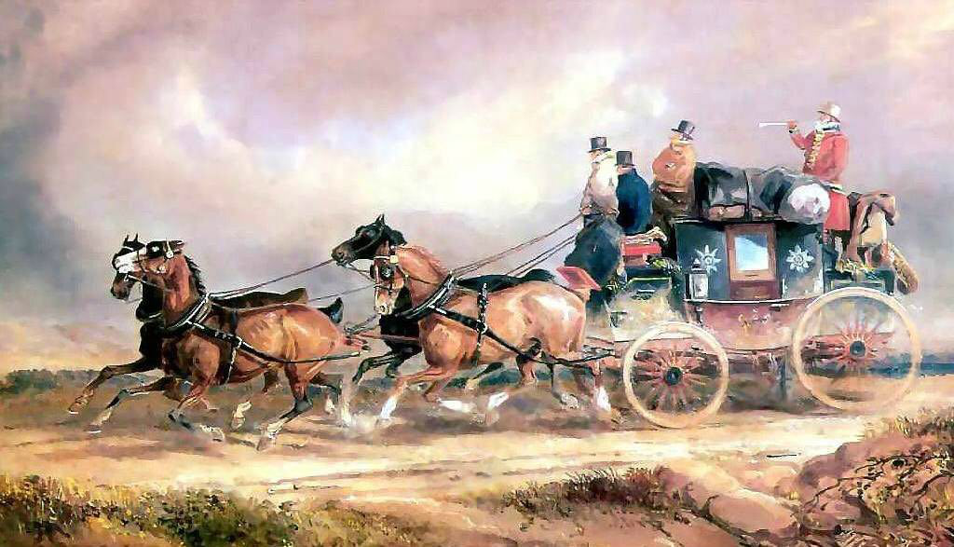
Exercise 3
Choose the most suitable word to fill each space
- A hundred years ago, most people travelled ______ foot, by train, pr on horseback.
- By
- On
- With
- To
- ______ had made it possible to travel rapidly over long distances.
- Tracks
- Lines
- Ways
- Railways
- Bicycles were also becoming ______after the invention of the air-filled tire.
- Popular
- Invented
- Then
- Handlebars
- Buses, trams and ______railways had already been invented.
- Metro
- Buried
- Underground
- Submerged
- Cities all over the world had traffic ______.
- Blocks
- Sticks
- Knots
- Jams
- There were very few private cars, and city ______ were still full of horses.
- Streets
- Pavements
- Lawns
- Carts
- What a difference a hundred years have ______!
- Taken
- Done
- Made
- Got
- ______ we have got used to the problem of private cars.
- Presently
- Nowadays
- Then
- later
- Some cities are so noisy and ______.
- Even
- Polluted
- So
- Poisoned
- In many places ______ have been banned from the city centre.
- Vehicles
- Traffic
- Transport
- Trips
- Perhaps ______ then there will be only personal helicopters.
- Cars
- By
- Even
- Transport
- There may be no need to ______ to work or school in the future, since everyone will have a computer at home.
- Have
- Transport
- Decide
- Commute
- There might even be more people walking and horse-riding, for pleasure and ______.
- Exercise
- Keep fit
- Energy
- Healthy
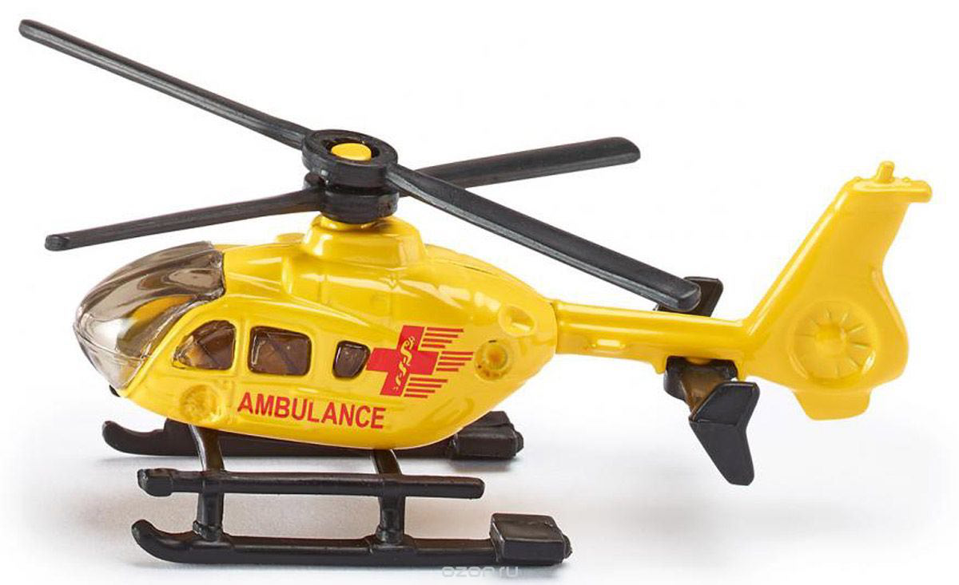
Exercise 4
Choose the right answer
Where is the nearest filling station?
will be marked with crowds and frequent traffic jams
than the recent sights of platforms crowded with disconsolate commuters
there are many startups and established aerospace companies competing to develop
in the first six months of the year,
are at the scene of a head-on
was among the cars involved in the pile-up,
I have been here and there,
He was walking to and fro,
- Cargo shipping has seen positive growth _______ with 254.8 million tonnes handled via the country’s seaports, up 17 per cent on last year.
- nervously looking at his phone every second.
- A poorly considered or mistakenly implemented railway timetable can have serious consequences, worse even _______ who wait for trains that run late or never come at all.
- We have run out of gas. _____
- Although _______ electric vertical take-off and landing taxis – including Uber, Airbus and Boeing – Kitty Hawk and Joby are among the furthest along.
- Four weekends in front of us ______ on our roads.
- A six-vehicle crash blocked the A2 for around 30 minutes. A Lamborghini sports car _______ which happened at Watling Street.
- Emergency services ______ collision in Polegate this afternoon (Saturday).
- ______ but I like being home most of all.
Exercise 5
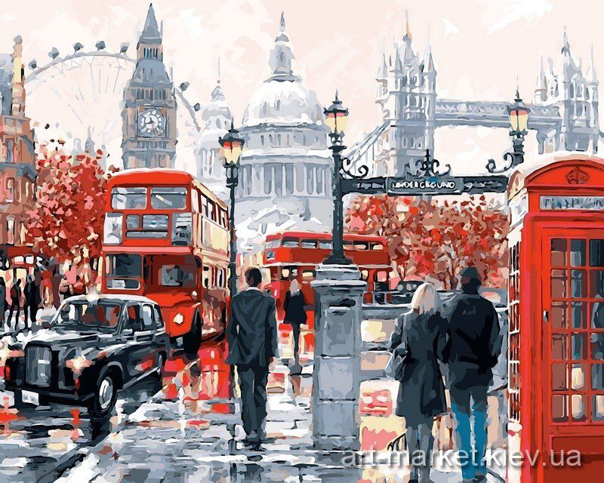
Complete each sentence with a suitable phrasal verb
takes up put out headed for put up try out
pick up showing off looking forward keep up
- I’m really ______ to going to vacation in Spain next week.
- I can’t wait to _____ my new car!
- Why are you always _____ your yacht? You had better sell it and give money to charity.
- A fire engine was able to _____ the fire despite all the difficulties.
- _____ me ___ tomorrow at 7 pm. I’ll be waiting for you.
- How can you _____ with all those traffic jams, exhaust fumes and noise?
- We _____ the airport after dealing with all our duties.
- Useless stuff _____ most of space in your garage. Why don’t you throw it away?
- I can’t _____ with you! Slow down!

Key
Exercise 2.
Fill in the gaps in the text with suitable words
Boeing has announced that it is 1. _______ collaborating with artificial intelligence (AI) technology leader, SparkCognition, to deliver 2. _______ unmanned aircraft system traffic management solutions.
Boeing and SparkCognition will use artificial intelligence and blockchain technologies to 3. _______ track unmanned air vehicles in flight and 4. _______ allocate traffic corridors and routes to ensure safe, secure transportation. 5. _______ Estimated by some analysts at $3 trillion, the urban aerial mobility opportunity will lead to the creation of the largest new market in our lifetimes. The world’s number one aviation leader partnering with the world’s most innovative industrial AI company means that 6. _______ unparalleled experience in safety, innovation, 7. _______ scale, and reliability will be brought to bear to address this monumental opportunity. “By taking a 8. _______ holistic approach that combines Boeing’s strength in technological innovation with new business models and nontraditional partnerships, we are laying the foundation for the future commercial mobility ecosystem,” said Steve Nordlund, who will lead Boeing NeXt in addition to his role as vice president of Boeing HorizonX. “We are shaping the physical and connectivity infrastructure to ensure new air vehicles safely 9. _______ operate in the global air space”.
Exercise 3
Choose the most suitable word to fill each space
- A hundred years ago, most people travelled ______ foot, by train, pr on horseback.
- By
- On
- With
- To
- ______ had made it possible to travel rapidly over long distances.
- Tracks
- Lines
- Ways
- Railways
- Bicycles were also becoming ______after the invention of the air-filled tire.
- Popular
- Invented
- Then
- Handlebars
- Buses, trams and ______railways had already been invented.
- Metro
- Buried
- Underground
- Submerged
- Cities all over the world had traffic ______.
- Blocks
- Sticks
- Knots
- Jams
- There were very few private cars, and city ______ were still full of horses.
- Streets
- Pavements
- Lawns
- Carts
- What a difference a hundred years have ______!
- Taken
- Done
- Made
- Got
- ______ we have got used to the problem of private cars.
- Presently
- Nowadays
- Then
- later
- Some cities are so noisy and ______.
- Even
- Polluted
- So
- Poisoned
- In many places ______ have been banned from the city centre.
- Vehicles
- Traffic
- Transport
- Trips
- Perhaps ______ then there will be only personal helicopters.
- Cars
- By
- Even
- Transport
- There may be no need to ______ to work or school in the future, since everyone will have a computer at home.
- Have
- Transport
- Decide
- Commute
- There might even be more people walking and horse-riding, for pleasure and ______.
- Exercise
- Keep fit
- Energy
- healthy

Exercise 4
Choose the right answer
- Cargo shipping has seen positive growth _______ in the first six months of the year, with 254.8 million tonnes handled via the country’s seaports, up 17 per cent on last year.
- He was walking to and fro, nervously looking at his phone every second.
- A poorly considered or mistakenly implemented railway timetable can have serious consequences, worse even _______ than the recent sights of platforms crowded with disconsolate commuters who wait for trains that run late or never come at all.
- We have run out of gas. _____ Where is the nearest filling station?
- Although _______ there are many startups and established aerospace companies competing to develop electric vertical take-off and landing taxis – including Uber, Airbus and Boeing – Kitty Hawk and Joby are among the furthest along.
- Four weekends in front of us ______ will be marked with crowds and frequent traffic jams on our roads.
- A six-vehicle crash blocked the A2 for around 30 minutes. A Lamborghini sports car _______ was among the cars involved in the pile-up, which happened at Watling Street.
- Emergency services ______ are at the scene of a head-on collision in Polegate this afternoon (Saturday).
- ______ I have been here and there, but I like being home most of all.
Exercise 5
Complete each sentence with a suitable phrasal verb
- I’m really ______ looking forward to going to vacation in Spain next week.
- I can’t wait to _____ try out my new car!
- Why are you always _____ showing off your yacht? You had better sell it and give money to charity.
- A fire engine was able to _____ put out the fire despite all the difficulties.
- _____ Pick me up tomorrow at 7 pm. I’ll be waiting for you.
- How can you _____ put up with all those traffic jams, exhaust fumes and noise?
- We _____headed for the airport after dealing with all our duties.
- Useless stuff _____ takes up most of space in your garage. Why don’t you throw it away?
- I can’t _____ keep up with you! Slow down!

