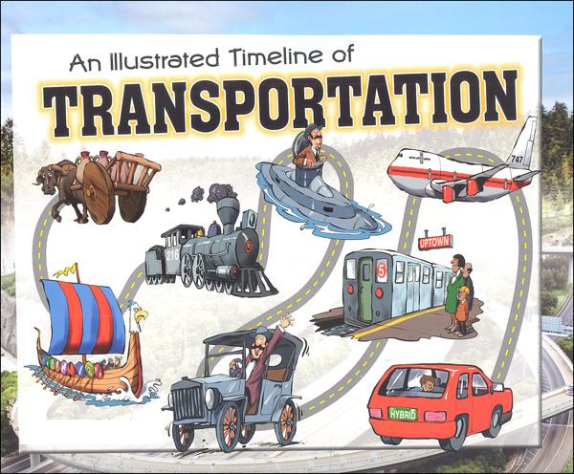
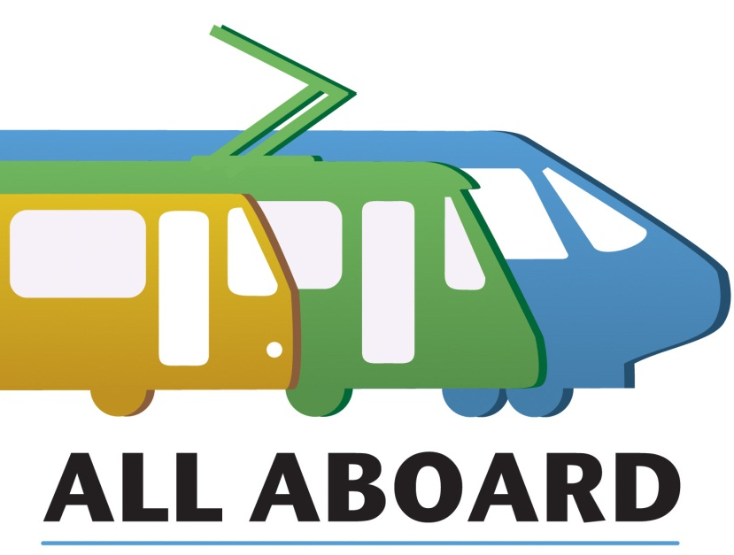
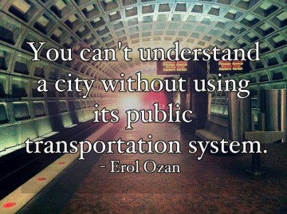
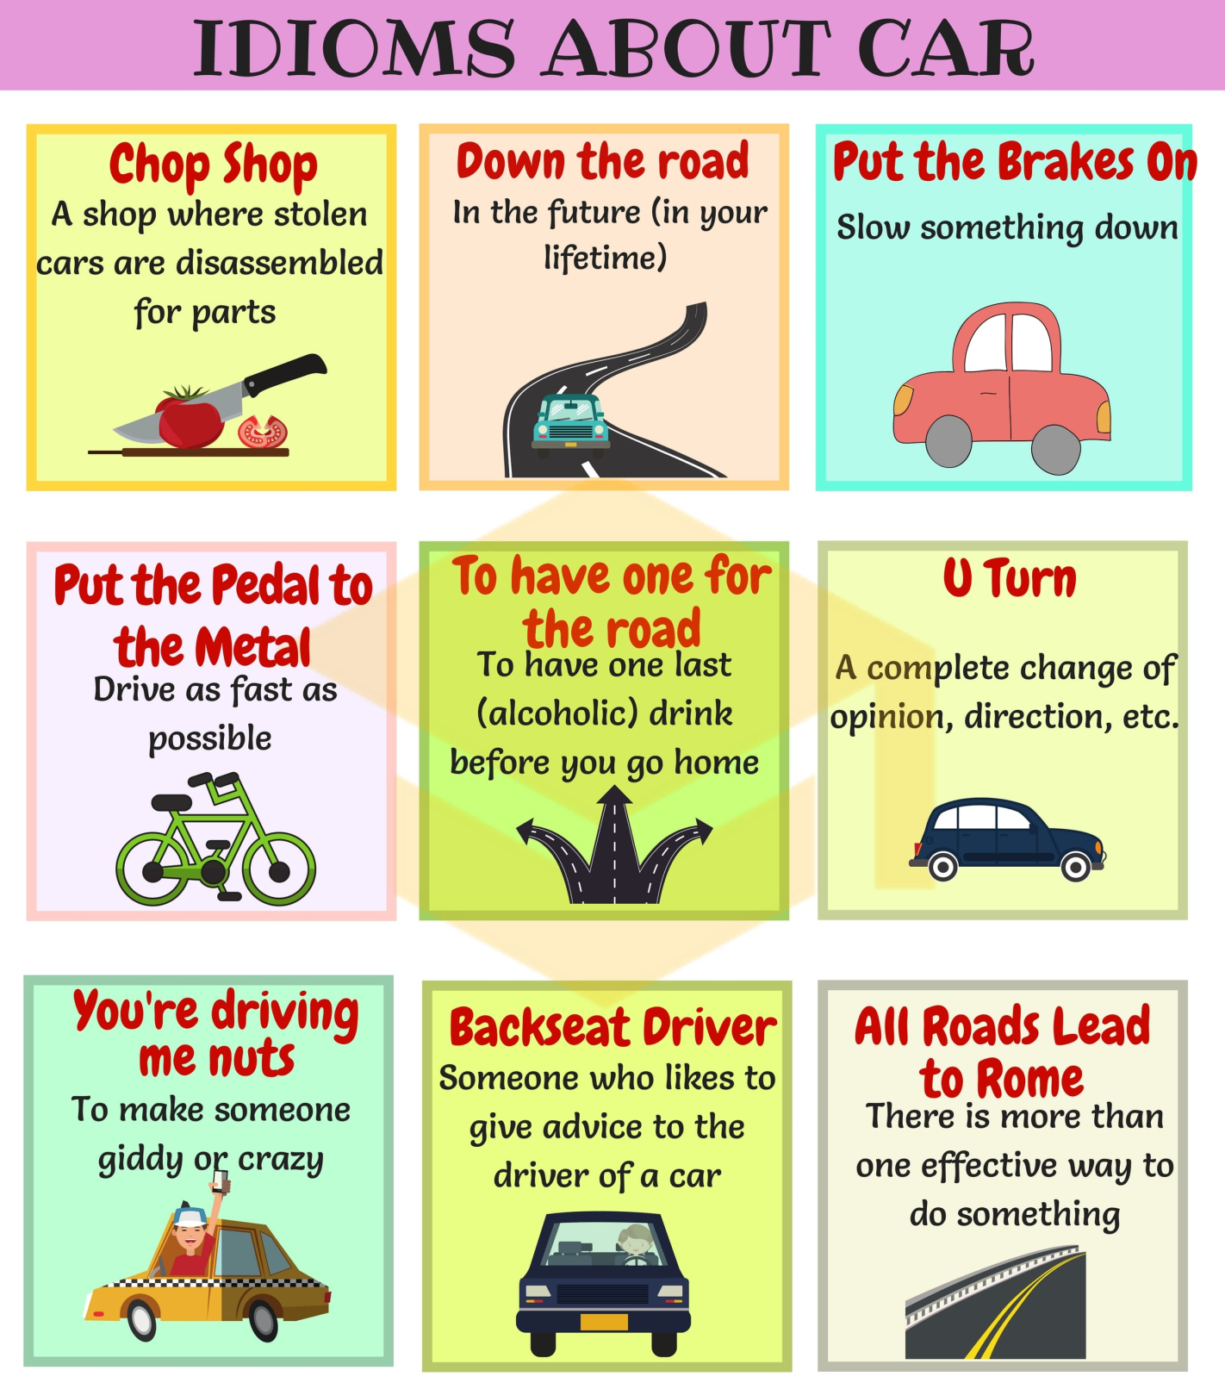
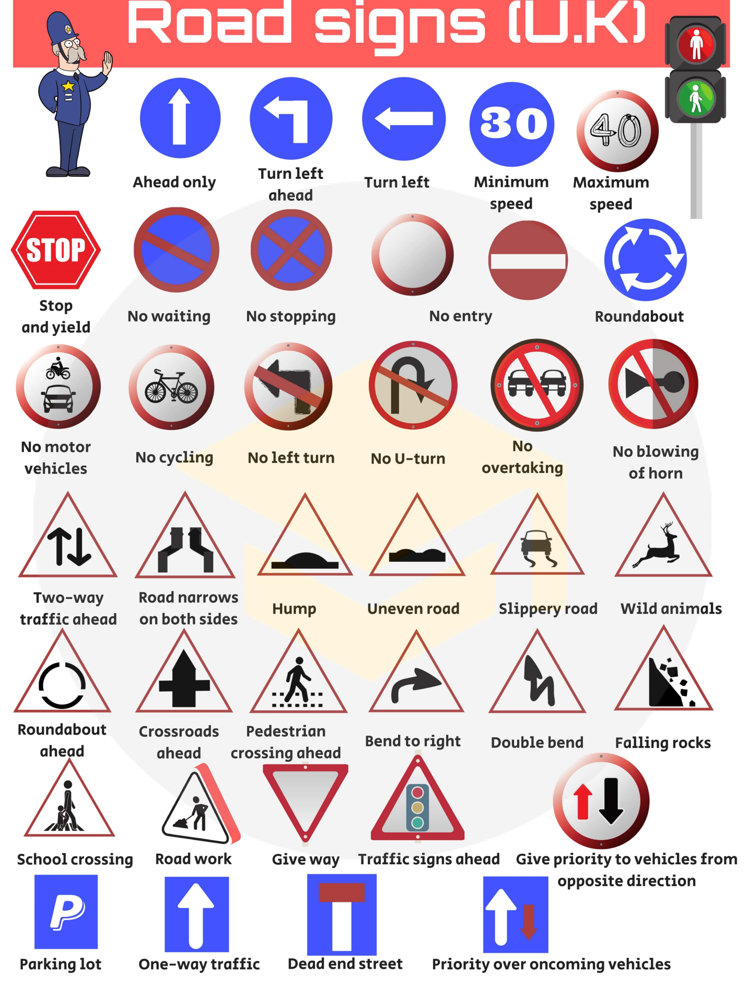
What are some basic rules of the road you need to know when taking a road test to obtain a driver's license in your country?
Think about topics such as parking, speeding, passing, yielding the right of way, and obeying traffic signs and signals.
I. Describe a transport problem in your town or city.
You should say:
- what the problem is
- what the causes are
- how it affects you
- explain how you think it might be solved.

II. Private cars.
- Do you think everyone has the right to have their own private transport?
- What do you think the effects would be if everybody had their own car?
- What measures, if any, should the government take to restrict the use of private cars?

III. Transport systems.
- How have transport systems changed in the last 50 years?
- Have these been positive or negative developments?
- What kind of transport systems do you think might be developed in the future?

IV. Transport problems.
- How have methods of transport changed?
- Are there any problems that have been created by new transport systems?
- How can these problems be solved?

V. Describe your journey to school or work.
You should say:
- what forms of transport are involved
- how long it takes
- whether it is enjoyable or not
- explain how you would make your journey more pleasant if you could.
