Cities in the UK
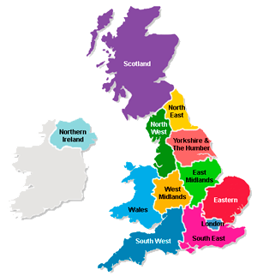

Exercise 1
Study the following words and expressions
https://quizlet.com/324476221/flashcards
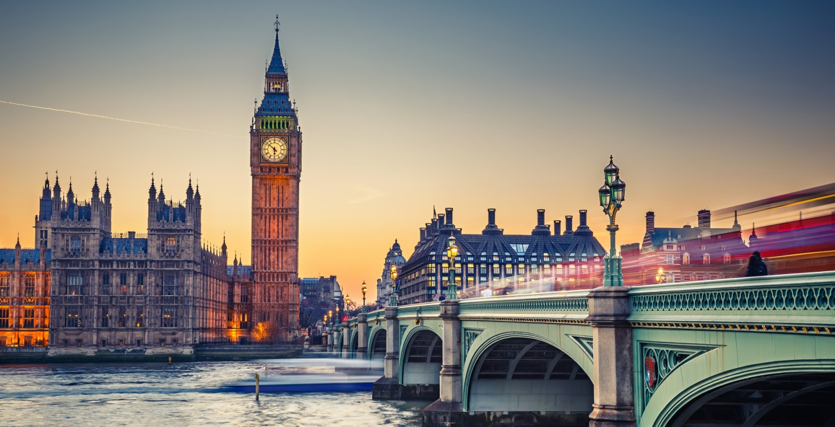Exercise 2
Fill in the gaps
upstream threaded around by far spanning
settlement cosmopolitan vantage points ring highway resembles skyline
London, city, capital of the United Kingdom. It is among the oldest of the world’s great cities—its history _____ nearly two millennia—and one of the most _____. _____ Britain’s largest metropolis, it is also the country’s economic, transportation, and cultural centre. London is situated in southeastern England, lying astride the River Thames some 50 miles (80 km) _____ from its estuary on the North Sea. In satellite photographs the metropolis can be seen to sit compactly in a Green Belt of open land, with its principal _____ (the M25 motorway) _____ it at a radius of about 20 miles (30 km) from the city centre. Historically, London grew from three distinct centres: the walled _____ founded by the Romans on the banks of the Thames in the 1st century CE, today known as the City of London. London can be appreciated from several public _____. Hampstead Heath offers the finest panorama over the central basin of the metropolis. But from Shooters Hill, Upper Norwood, or Alexandra Palace one has a choice of views: inward to the crowded _____ of the City and West End or out to the open expanses of the Home Counties, the Thames estuary, the South Downs, and the Weald. Such panoramas show that London, for all its immensity, _____ more closely the limited metropolises of the early 20th century than the amorphous and sprawling megalopolises of today, such as Tokyo or Los Angeles.
Now watch the video about London. Name what you can see as you watch it
https://www.youtube.com/watch?v=T5Ryf--3hMc
Exercise 3
Watch the video about Edinburg. Explain what you saw, where you would like to go and what you liked the most
https://www.youtube.com/watch?v=lBrCn8-LYxQ
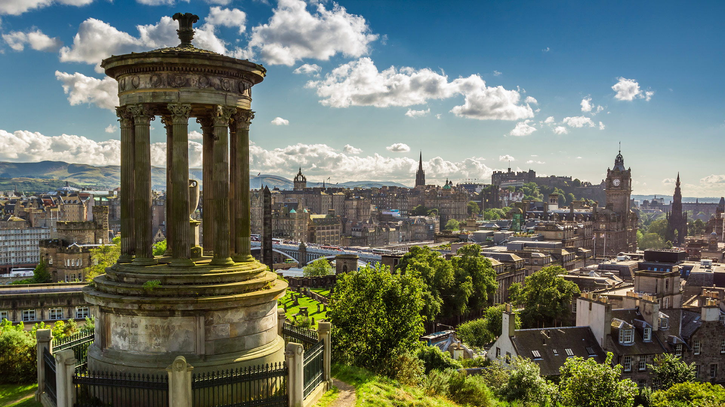
Exercise 4
Choose the correct answer
1. Edinburgh has been a military _____, the capital of an independent country, and a centre of intellectual activity.
a) forth
b) stronghold
c) construction
2. Today it is the seat of the Scottish Parliament and the Scottish Executive, and it remains a _____ centre for finance, law, tourism, education, and cultural affairs.
a) major
b) extensive
c) vast
3. Although Edinburgh absorbed surrounding villages, its political heart still _____ in its small historic core, comprising the Old Town and the New Town.
a) lay
b) lies
c) rests
4. The Old Town, built up in the Middle Ages when the fear of attack was constant, huddles high on the Castle Rock _____ the surrounding plain.
a) overlooking
b) overseeing
c) overhanging
5. The New Town, in contrast, _____ in a magnificent succession of streets, crescents, and terraces.
a) bursts out
b) spreads out
c) turns out
6. The medieval Old Town and the Neoclassical New Town were designated a UNESCO World _____ site in 1995.
a) Heritage
b) Inheritance
c) Legacy
7. For the first 100 years of its existence, West Princes Street Gardens was the private amenity of Princes Street _____.
a) debtors
b) representatives
c) proprietors
8. In 1876 this tract was opened to the public, which had always had _____ to the eastern gardens.
a) access
b) excess
c) exempt
9. At the east end of Princes Street, Calton Hill rises _____ the central government office of St. Andrew’s House (1939) and the adjacent Royal High School (1825–29).
a) along
b) above
c) upstream
10. Construction of the memorial to the Scots who died in the Napoleonic Wars was _____ when funds fell short in 1830.
a) abashed
b) abandoned
c) abducted
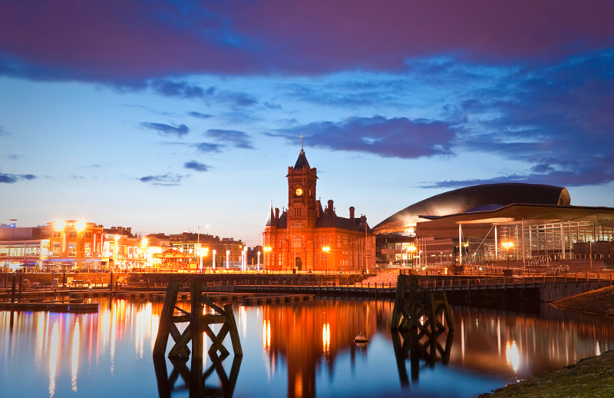Exercise 5
Fill in the gaps
Cardiff’s expansion stemmed from the development of coal and iron ore _____ mines around Merthyr Tydfil, to the north, beginning in the second half of the 18th century. In 1794 the Glamorganshire Canal opened _____ between Merthyr Tydfil and Cardiff, and in 1798 the first dock was built at the canal’s Cardiff terminus. In 1801 Cardiff’s population was only 1,870, but the town developed _____ rapidly and continuously over the next 100 years as an exporter of coal from South Wales, so that its population had reached 164,000 by 1901. Cardiff’s port was repeatedly _____ expanded, and by 1913 Cardiff had become the largest coal-exporting port in the world.
The port’s coal trade fell off _____ dramatically after 1918 and ceased altogether in 1963, but Cardiff remained the largest city in Wales. It was officially recognized as the capital of Wales in 1955. Cardiff is the most important administrative, shopping, and cultural centre in the country, as well as the _____ headquarters for many national organizations and government departments. It is also an important _____ industrial centre — _____mainly for food processing, engineering, and other light industries—and a hub for commerce, law, higher education, media, and independent film production. In the early 21st century Cardiff also became an important centre of television production, most _____ notably as the home base for the popular long-running BBC series Doctor Who.

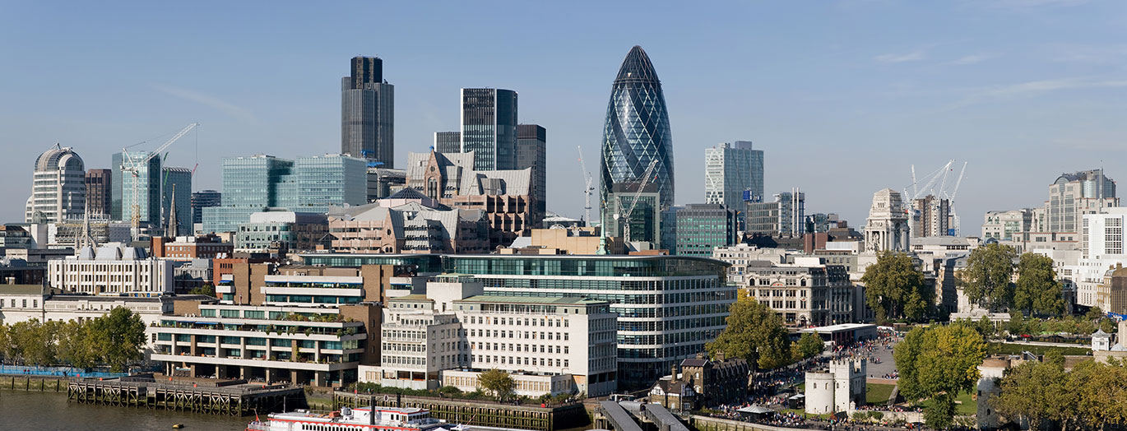
Exercise 6
Fill in the gaps
conqueror shipbuilding decline commemorate seat the Grand Opera House charter severely retail chief
Belfast, capital of Northern Ireland, is situated on the River Lagan. It became a city by royal _____ in 1888. After the passing of the Government of Ireland Act, 1920, it became the seat of the government of Northern Ireland. The district of Belfast has an area of 44 square miles (115 square km). A castle, probably built there about 1177 by John de Courci, the Norman _____ of Ulster, seems to have survived until the beginning of the 17th century. By the 17th century, the town was a busy port with small _____ interests, which became firmly established after William Ritchie founded a shipyard (1791) and a graving (dry) dock (1796). Since the Industrial Revolution, the _____ shipbuilding firm has been Harland and Wolff (builders of the ill-fated Titanic). The city was damaged by air raids in 1941 during World War II. Beginning in the 1970s, Belfast’s traditional manufacturing specialties, linen and shipbuilding, began a long _____. These sectors are now overshadowed by service activities, food processing, and machinery manufacture. The city is the shopping, _____, educational, commercial, entertainment, and service centre for Northern Ireland and the ____ of many of its largest businesses and hospitals. Educational institutions in Belfast include Queen’s University at Belfast (founded in 1845 as the Queen’s College), the University of Ulster at Belfast (1849), and Union Theological College (1853). Tourist attractions include _____, Donegall Square, Crown Liquor Saloon, Ulster Museum, Botanic Gardens, Belfast Zoo, and Titanic Belfast, a museum inaugurated in 2012 to _____ the centenary of the sinking of the famous ship.

Key
Exercise 2
Fill in the gaps
London, city, capital of the United Kingdom. It is among the oldest of the world’s great cities—its history _____ spanning nearly two millennia—and one of the most _____ cosmopolitan. _____ By far Britain’s largest metropolis, it is also the country’s economic, transportation, and cultural centre. London is situated in southeastern England, lying astride the River Thames some 50 miles (80 km) _____ upstream from its estuary on the North Sea. In satellite photographs the metropolis can be seen to sit compactly in a Green Belt of open land, with its principal ring _____ highway (the M25 motorway) _____ threaded around it at a radius of about 20 miles (30 km) from the city centre. Historically, London grew from three distinct centres: the walled _____ settlement founded by the Romans on the banks of the Thames in the 1st century CE, today known as the City of London. London can be appreciated from several public _____ vantage points. Hampstead Heath offers the finest panorama over the central basin of the metropolis. But from Shooters Hill, Upper Norwood, or Alexandra Palace one has a choice of views: inward to the crowded _____ skyline of the City and West End or out to the open expanses of the Home Counties, the Thames estuary, the South Downs, and the Weald. Such panoramas show that London, for all its immensity, _____ resembles more closely the limited metropolises of the early 20th century than the amorphous and sprawling megalopolises of today, such as Tokyo or Los Angeles.
Exercise 4
Choose the correct answer
- Edinburgh has been a military _____, the capital of an independent country, and a centre of intellectual activity.
a) forth
b) stronghold
c) construction
2. Today it is the seat of the Scottish Parliament and the Scottish Executive, and it remains a _____ centre for finance, law, tourism, education, and cultural affairs.
a) major
b) extensive
c) vast
3. Although Edinburgh absorbed surrounding villages, its political heart still _____ in its small historic core, comprising the Old Town and the New Town.
a) lay
b) lies
c) rests
4. The Old Town, built up in the Middle Ages when the fear of attack was constant, huddles high on the Castle Rock _____ the surrounding plain.
a) overlooking
b) overseeing
c) overhanging
5. The New Town, in contrast, _____ in a magnificent succession of streets, crescents, and terraces.
a) bursts out
b) spreads out
c) turns out
6. The medieval Old Town and the Neoclassical New Town were designated a UNESCO World _____ site in 1995.
a) Heritage
b) Inheritance
c) Legacy
7. For the first 100 years of its existence, West Princes Street Gardens was the private amenity of Princes Street _____.
a) debtors
b) representatives
c) proprietors
8. In 1876 this tract was opened to the public, which had always had _____ to the eastern gardens.
a) access
b) excess
c) exempt
9. At the east end of Princes Street, Calton Hill rises _____ the central government office of St. Andrew’s House (1939) and the adjacent Royal High School (1825–29).
a) along
b) above
c) upstream
10. Construction of the memorial to the Scots who died in the Napoleonic Wars was _____ when funds fell short in 1830.
a) abashed
b) abandoned
c) abducted
Exercise 5
Fill in the gaps
Cardiff’s expansion stemmed from the development of coal and iron ore _____ mines around Merthyr Tydfil, to the north, beginning in the second half of the 18th century. In 1794 the Glamorganshire Canal opened _____ between Merthyr Tydfil and Cardiff, and in 1798 the first dock was built at the canal’s Cardiff terminus. In 1801 Cardiff’s population was only 1,870, but the town developed _____ rapidly and continuously over the next 100 years as an exporter of coal from South Wales, so that its population had reached 164,000 by 1901. Cardiff’s port was repeatedly _____ expanded, and by 1913 Cardiff had become the largest coal-exporting port in the world.
The port’s coal trade fell off _____ dramatically after 1918 and ceased altogether in 1963, but Cardiff remained the largest city in Wales. It was officially recognized as the capital of Wales in 1955. Cardiff is the most important administrative, shopping, and cultural centre in the country, as well as the _____ headquarters for many national organizations and government departments. It is also an important _____ industrial centre — _____mainly for food processing, engineering, and other light industries—and a hub for commerce, law, higher education, media, and independent film production. In the early 21st century Cardiff also became an important centre of television production, most _____ notably as the home base for the popular long-running BBC series Doctor Who.
Exercise 6
Fill in the gaps
Belfast, capital of Northern Ireland, is situated on the River Lagan. It became a city by royal _____ charter in 1888. After the passing of the Government of Ireland Act, 1920, it became the seat of the government of Northern Ireland. The district of Belfast has an area of 44 square miles (115 square km). A castle, probably built there about 1177 by John de Courci, the Norman _____ conqueror of Ulster, seems to have survived until the beginning of the 17th century. By the 17th century, the town was a busy port with small _____ shipbuilding interests, which became firmly established after William Ritchie founded a shipyard (1791) and a graving (dry) dock (1796). Since the Industrial Revolution, the _____ chief shipbuilding firm has been Harland and Wolff (builders of the ill-fated Titanic). The city was severely damaged by air raids in 1941 during World War II. Beginning in the 1970s, Belfast’s traditional manufacturing specialties, linen and shipbuilding, began a long _____ decline. These sectors are now overshadowed by service activities, food processing, and machinery manufacture. The city is the shopping, _____ retail, educational, commercial, entertainment, and service centre for Northern Ireland and the seat of many of its largest businesses and hospitals. Educational institutions in Belfast include Queen’s University at Belfast (founded in 1845 as the Queen’s College), the University of Ulster at Belfast (1849), and Union Theological College (1853). Tourist attractions include _____ the Grand Opera House, Donegall Square, Crown Liquor Saloon, Ulster Museum, Botanic Gardens, Belfast Zoo, and Titanic Belfast, a museum inaugurated in 2012 to _____ commemorate the centenary of the sinking of the famous ship.

