018_advanced_vocabulary
Cities
The USA
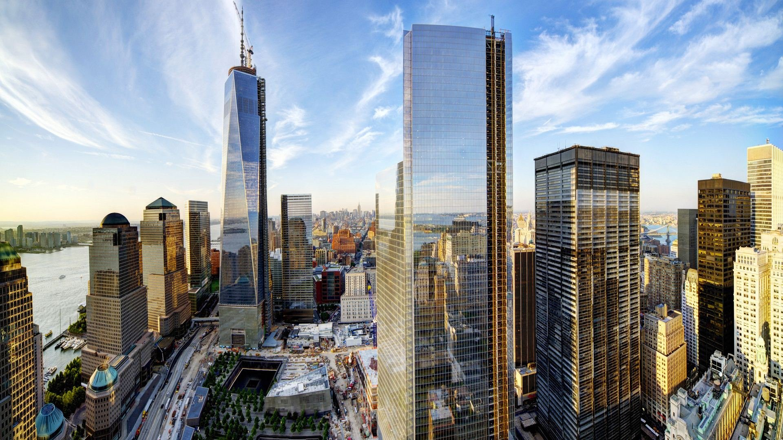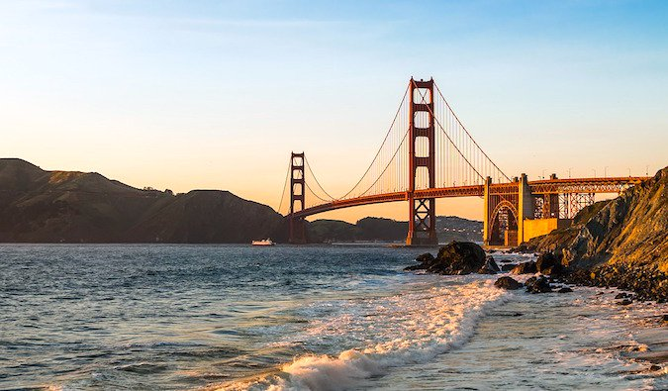
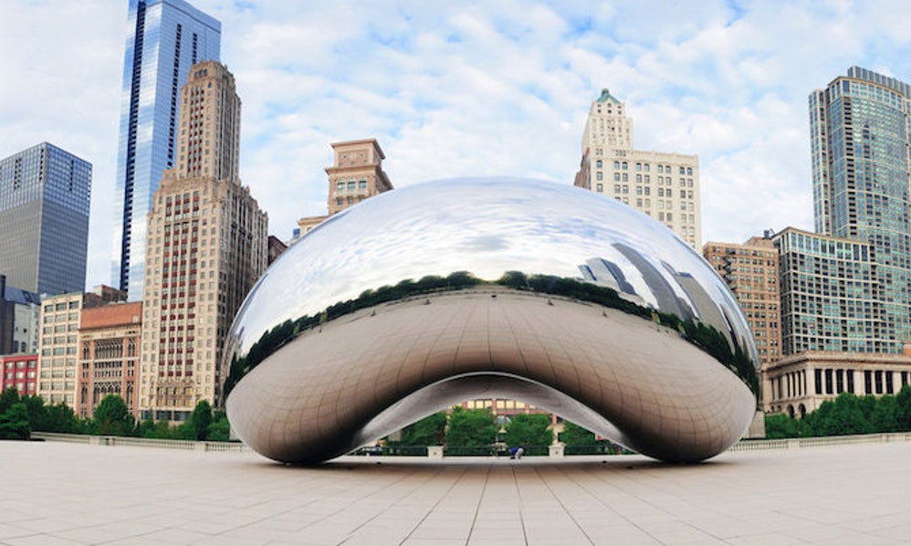

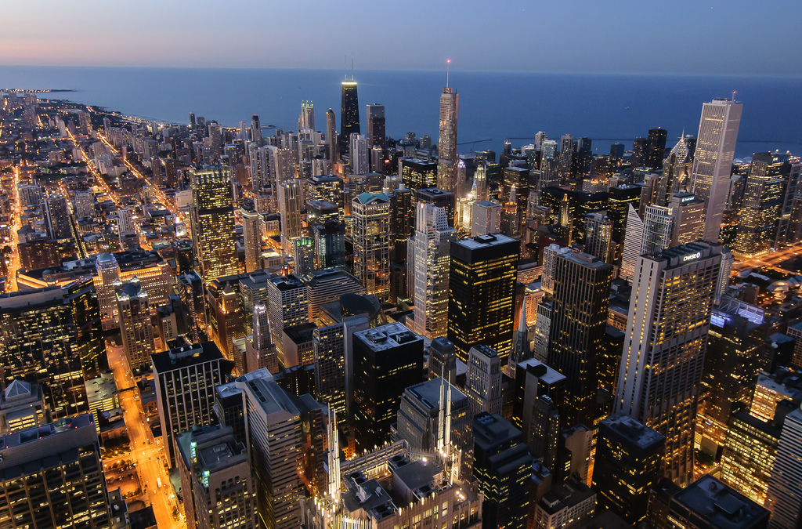

If you had a chance to live in the US, which city and state would you choose? Why?
Do you like the American culture/mentality?
What can you say about the American way of life based on the movies and TV programs that you watched? Do you think it’s different from what you saw?
What are the American cities that you dream of visiting?
Why does the US attract people so much?

Exercise 1
Match up

The US President’s residence
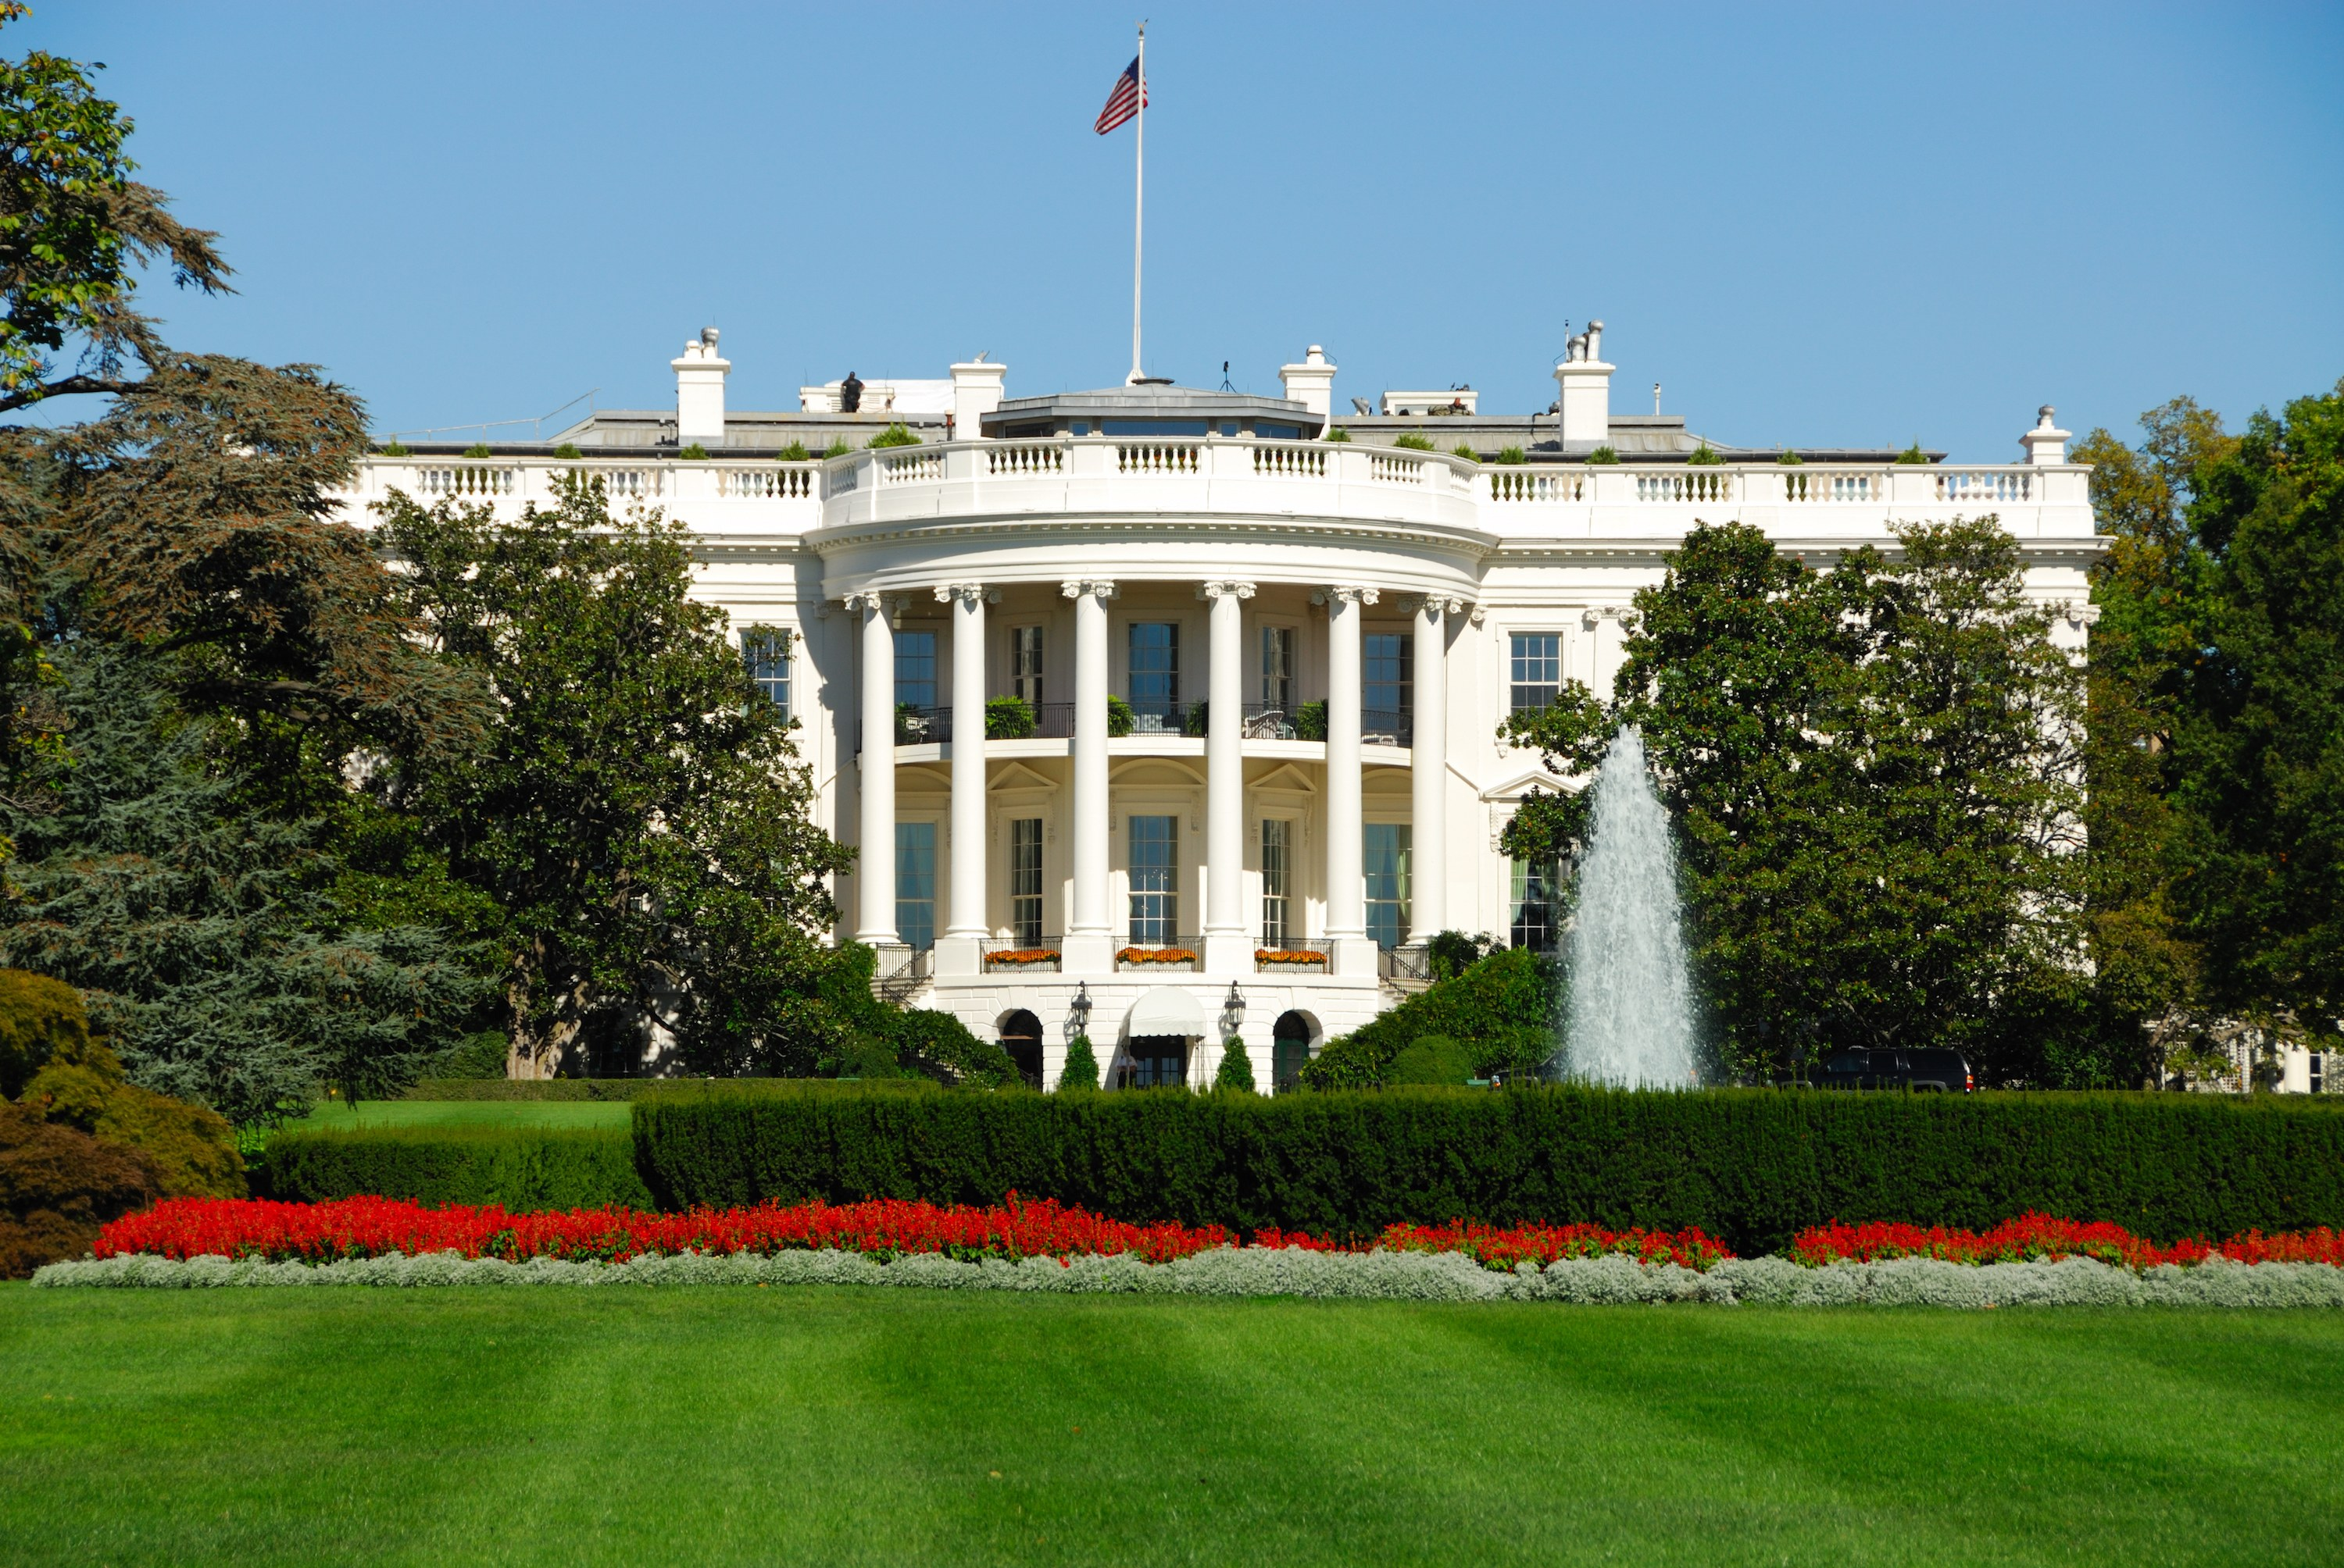

A present from France
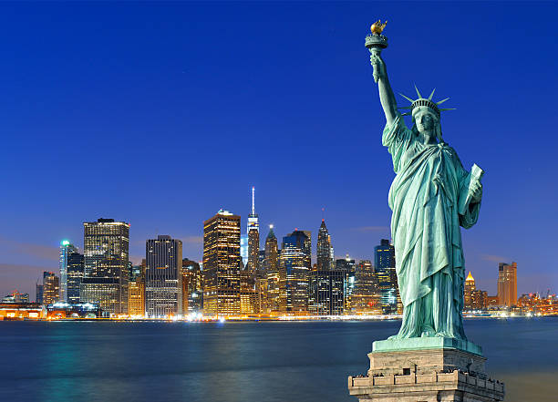

The tallest skyscraper in New York City
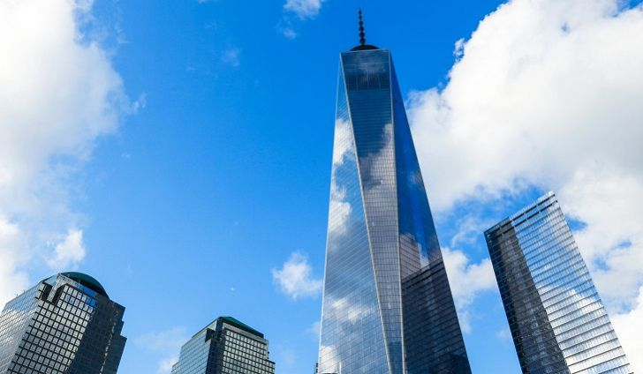

Meeting place of the US Congress
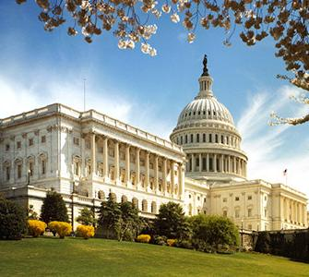

When you get hungry
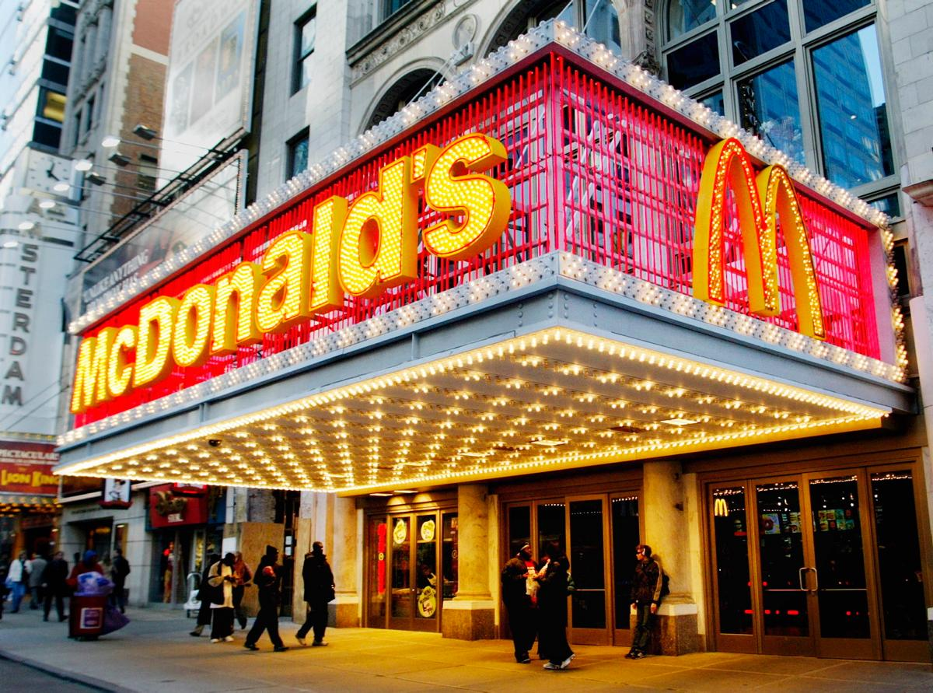

A children’s paradise
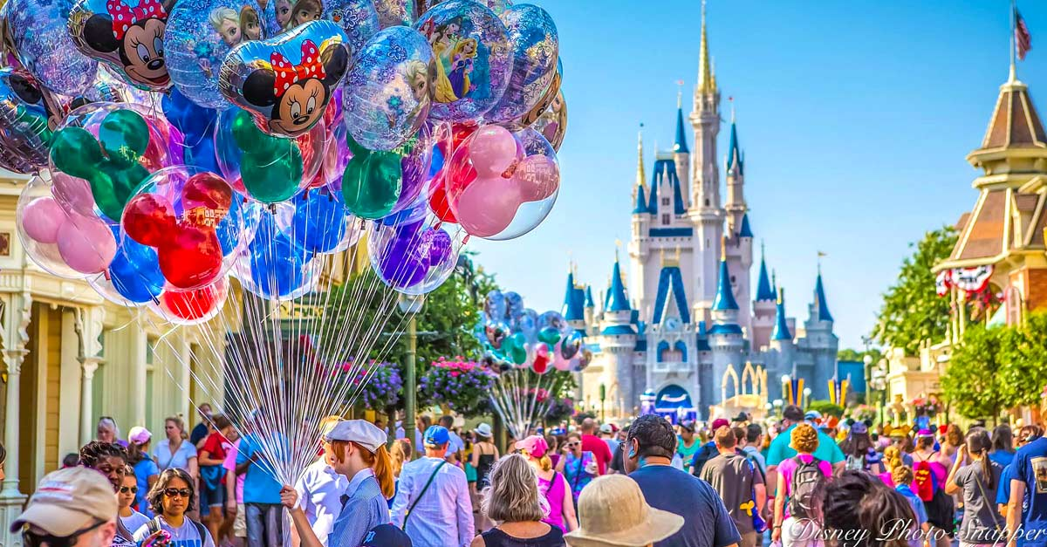

The four Presidents’ faces mountain
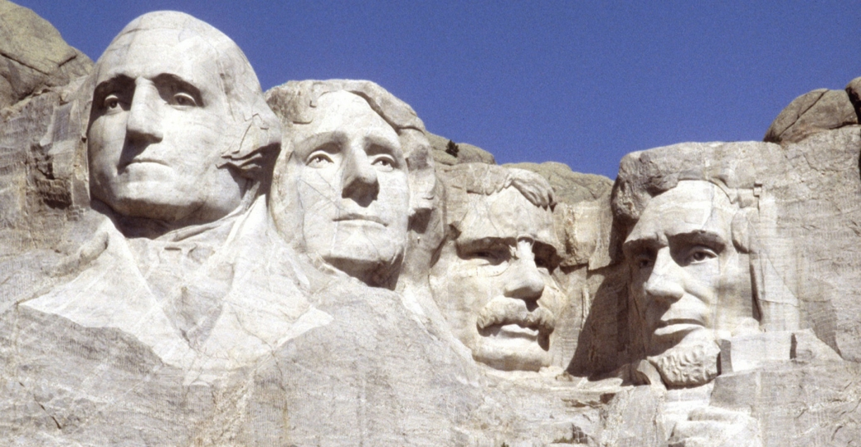

It is a national park situated in Arizona
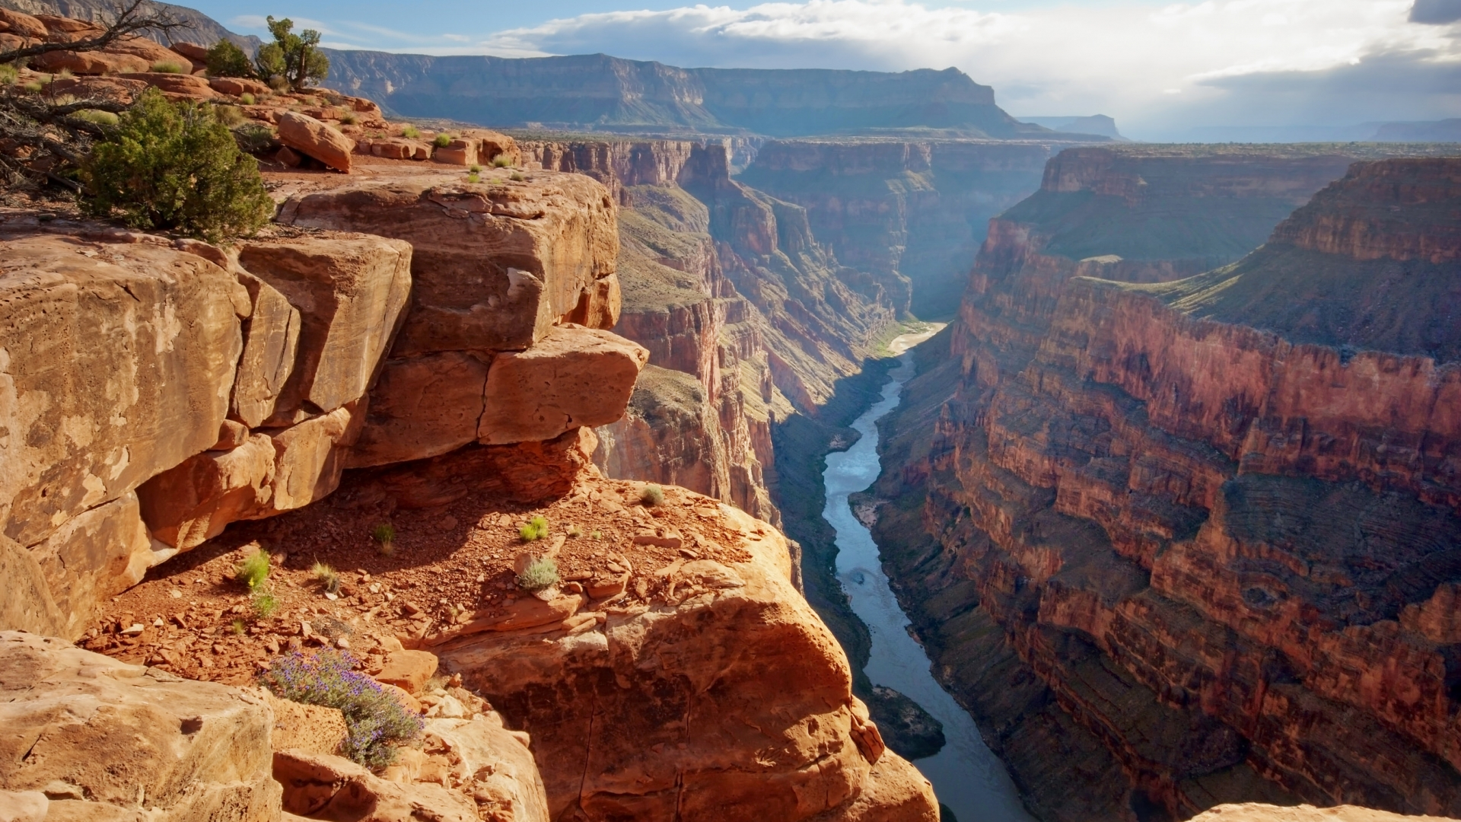

A monument commemorated to the first U.S. President
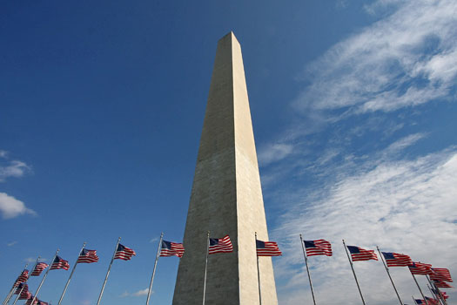

is situated in New York City, used for transportation
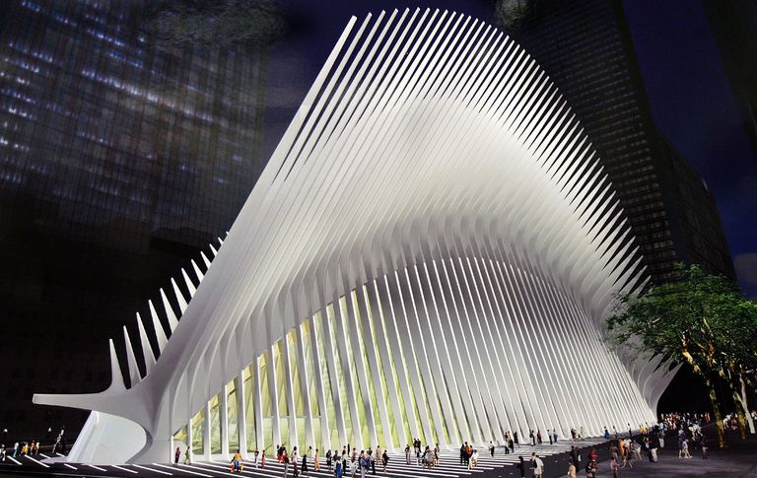

the bridge situated in San Francisco
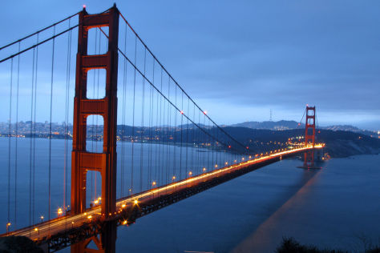

this building has 103 floors
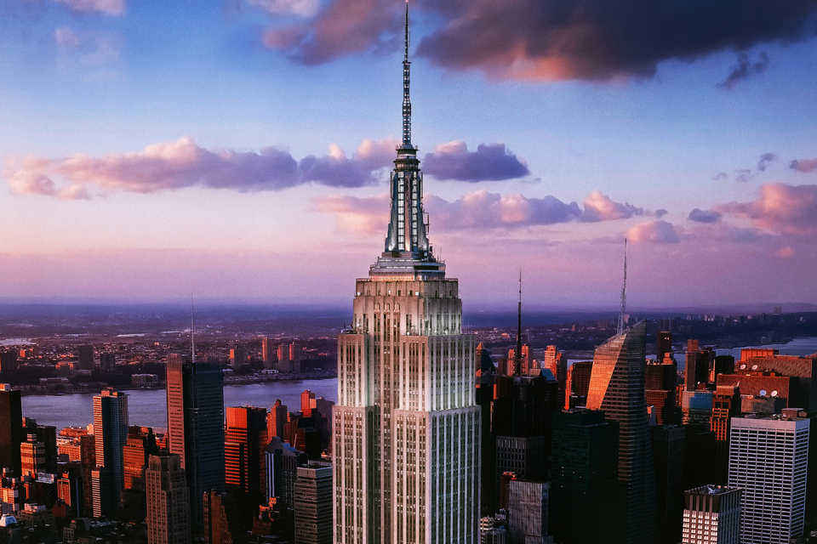

this is produced in Pennsylvania
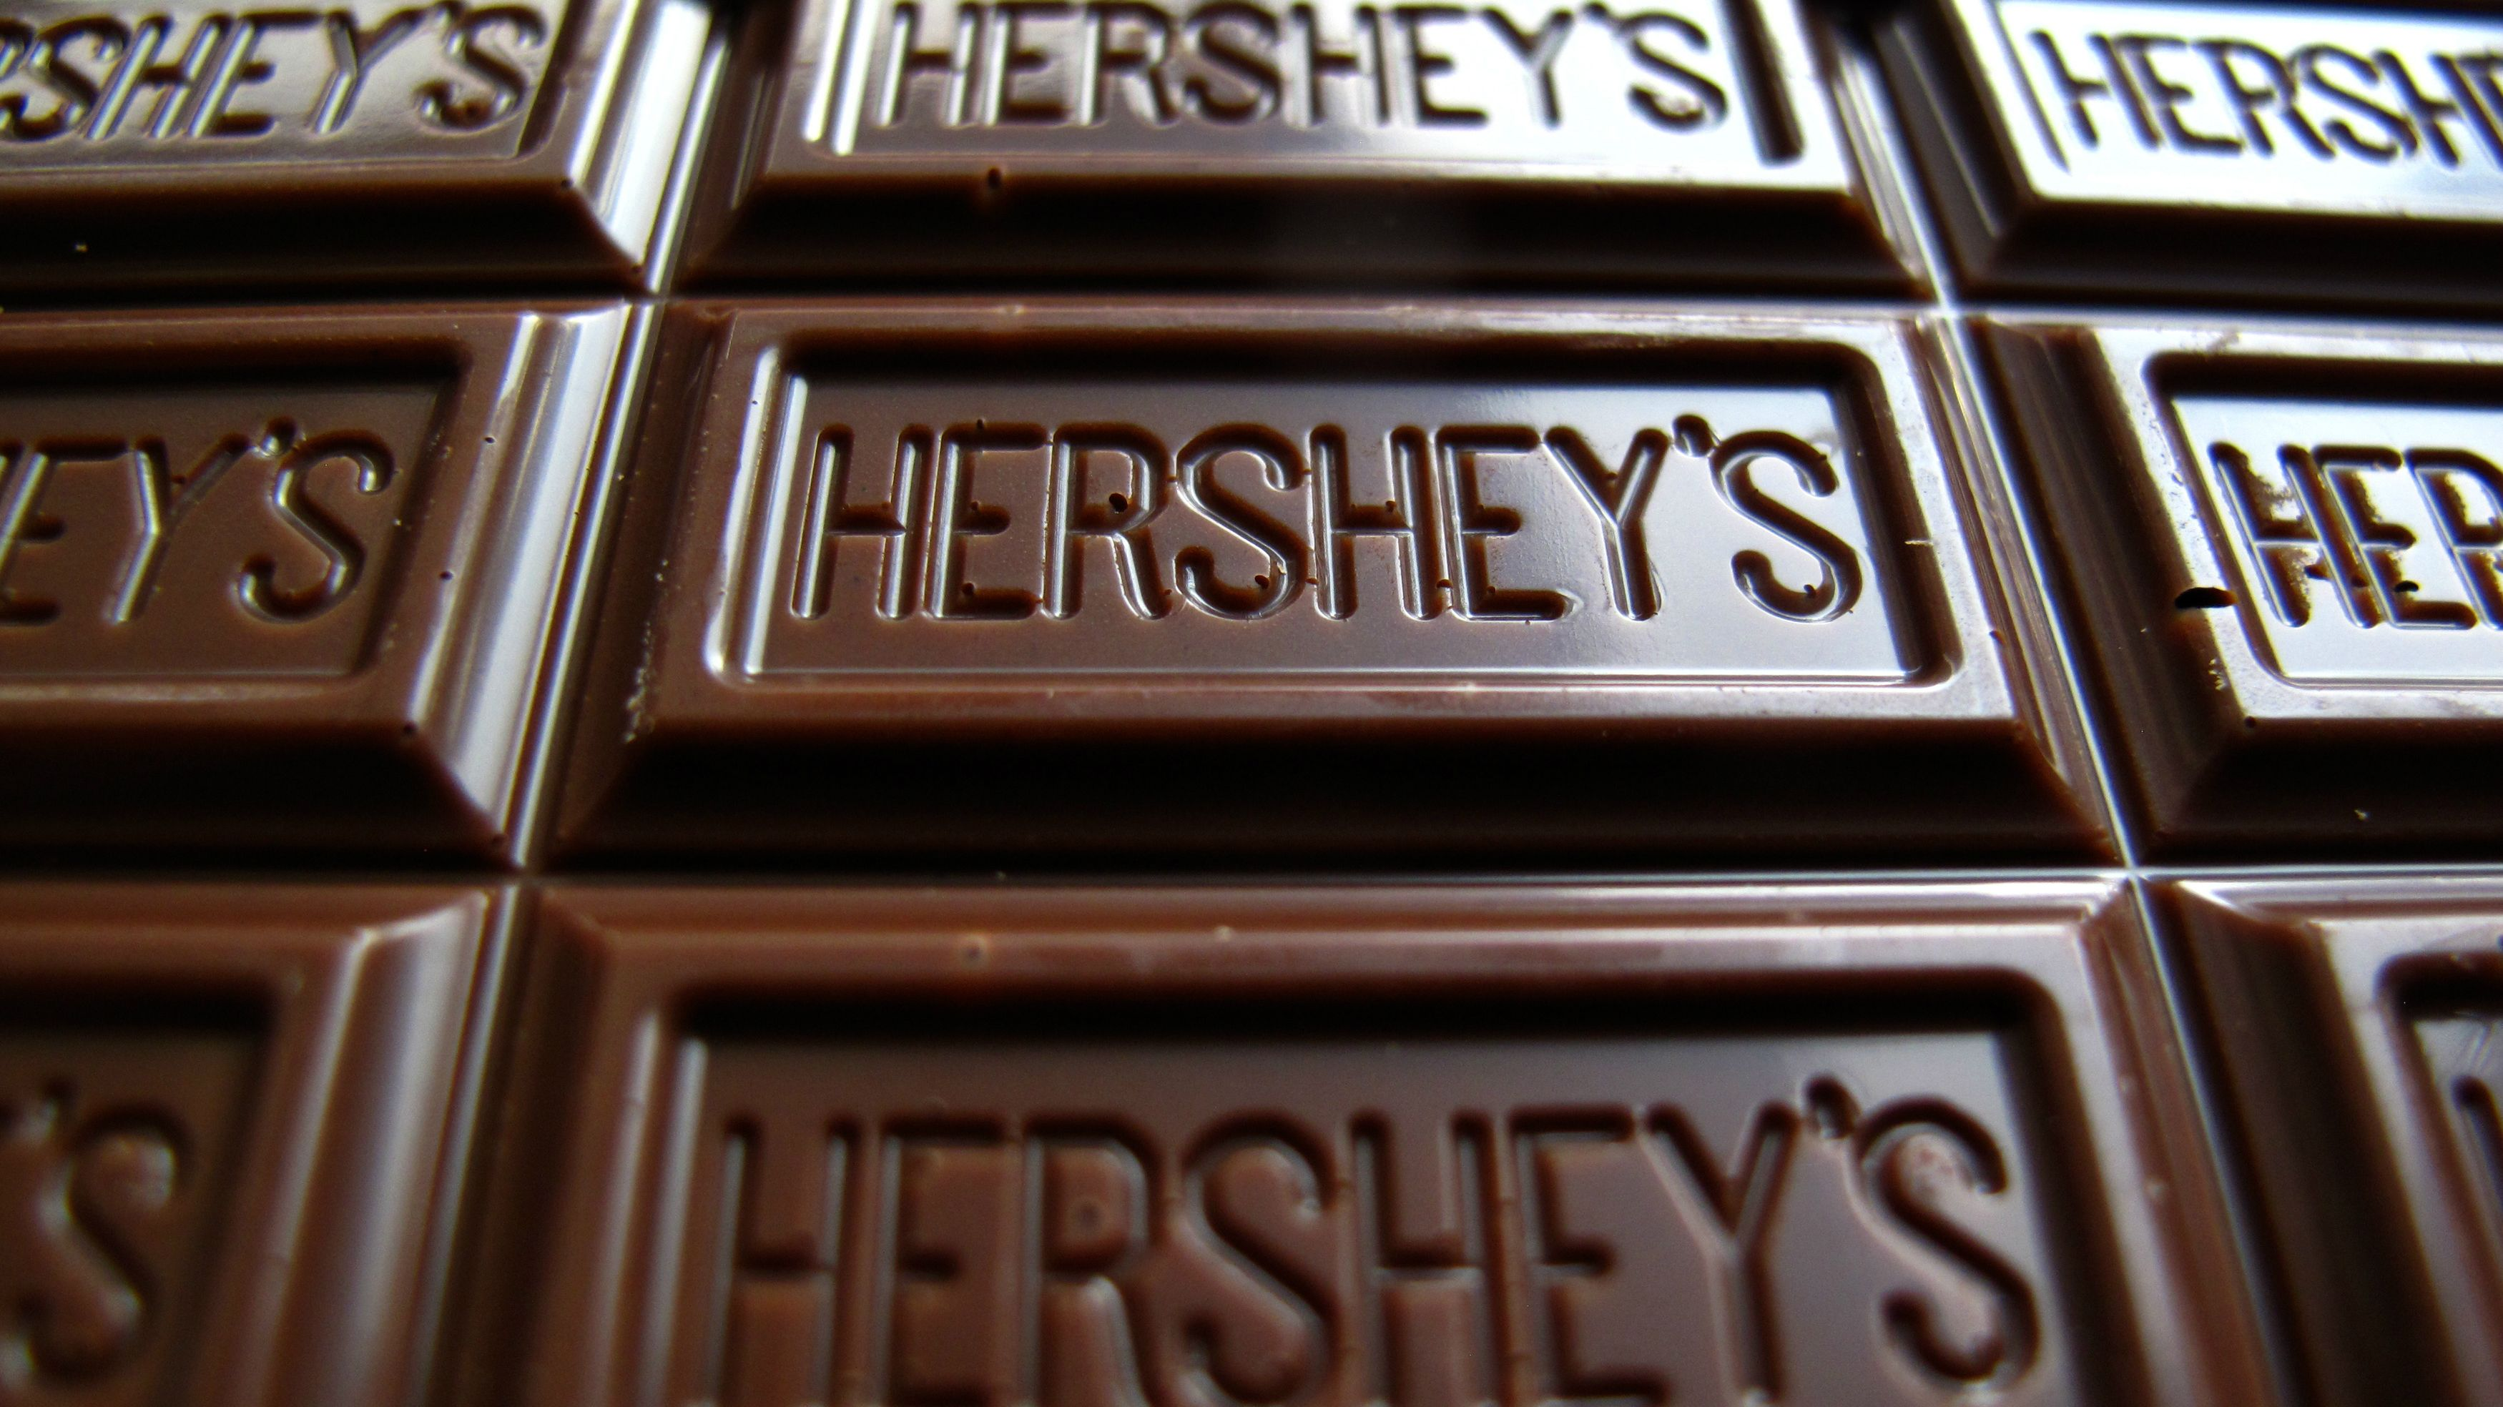

this place is six times larger than Monaco
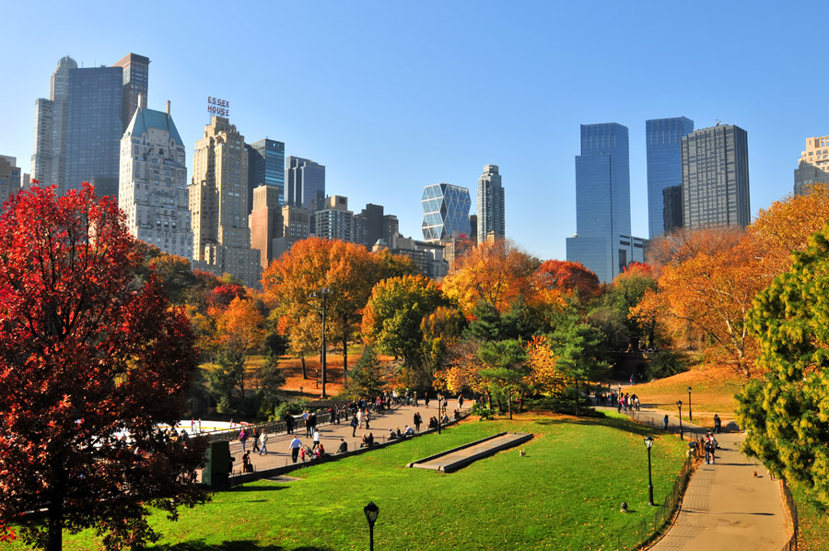

At the time, the bridge connected two different cities
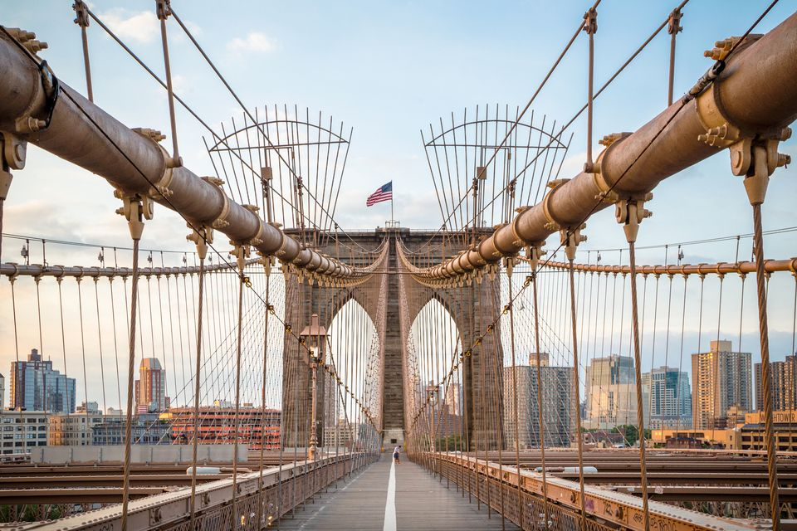

is considered to be the driest region in the United States
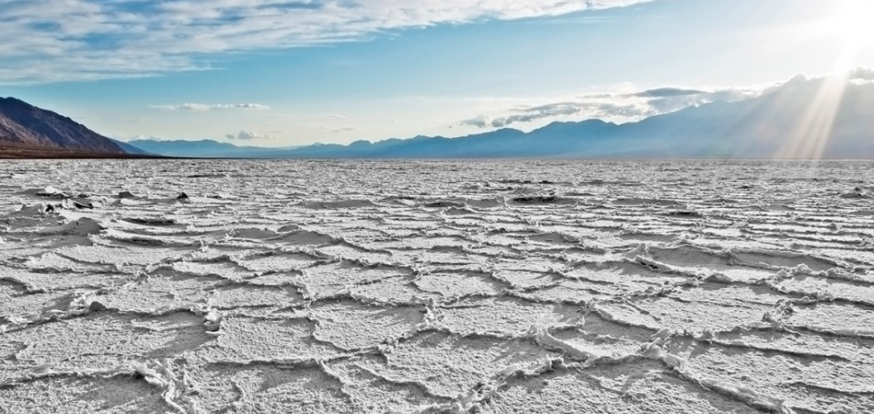

Quizlet(places and facts)- https://quizlet.com/306063924/018_advanced_vocabulary-flash-cards/?new

