Lesson 18-City-Grammar(part2)
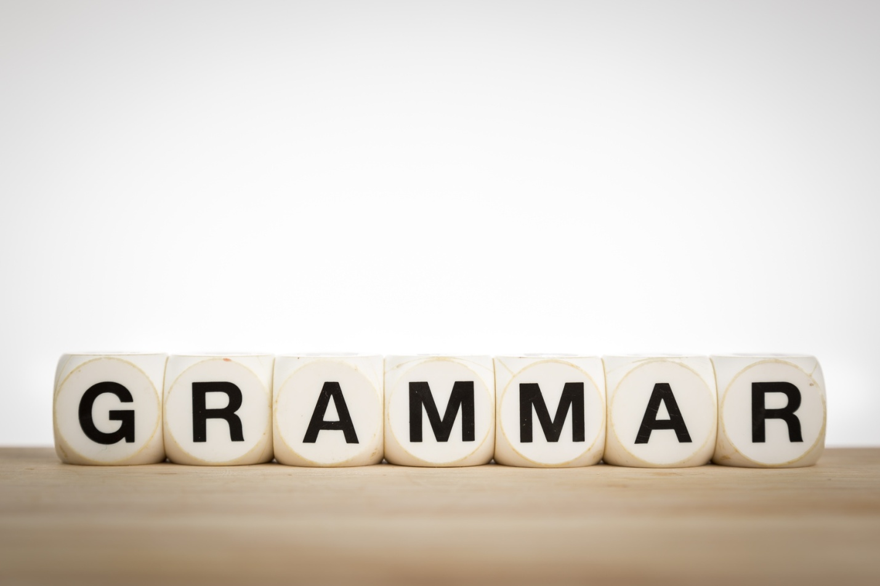
1. A typist is someone who … letters and reports
A types
B type
C are typing
D is typing
2. Would you let me have a copy of your report as soon as you … it, please?
A will finish
B will have finished
C finished
D finish
3. When Tom arrived at the boutique his wife … home
A had already gone
B has already gone
C have already gone
D already went
4. Helen made her husband … some shopping
A doing
B make
C making
D do
5. If the child … worse we shall have to take him to hospital
A are
B has
C is
D do
6. The new pair of trousers … a bit tight on me
A are
B were
C is
D am
7. When Mr.Brown … letters I was typing them
A was dictating
B has dictated
C have dictated
D had dictated
8. I … to visit this beautiful country
A always wants
B have always been wanting
C have always wanted
D always had wanted
9. The neighbours … each other since 2005
A know
B knew
C had known
D have known
10. Don’t go out! It .. hard
A rain
B rains
C had rained
D is raining
11. His money … on the shelf
A are
B have been
C is
D were
12. The coat … 20 pounds on sale last week
A cost
B costs
C will cost
D costed
13. Simon met his wife while she … at his hospital
A work
B works
C has worked
D was working
14. There … no news today
A are
B has been
C is
D have
15. He said he … in Brighton
A lives
B lived
C will live
D has lived
16. It was still light and I … to hurry
A hadn’t
B didn’t have
C had
D have
17. Who … you my phone number?
A give
B gives
C has given
D gave
18. He used …a holiday 3 times year
A having
B to have
C to having
D have
19. The boys watched the doves … to the sky, one by one
A fly
B flying
C flew
D flown
20. Jim is going to London tomorrow because his uncle … to see him
A want
B wants
C has wanted
D had wanted
21. We have never met before, … we?
A are
B haven’t
C aren’t
D have
22. Your jeans … torn. IS it the latest fashion?
A are
B has been
C is
D was
23. The traffic warden made the driver … the car
A stop
B to stop
C stops
D stopping
24. When a kid I used … a lot of chocolate
A eat
B to eat
C eating
D eats
25. The president … a fund for the homeless
A found
B finds
C founds
D founded
26. Nobody likes to be cheated, … he?
A doesn’t
B does
C is
D isn’t
27. The sun … early in this part of the world
A seats
B is seating
C has set
D sets
28. My brother ,,, music lessons for 3 years now
A have taken
B take
C has been taking
D took
29. In 3 months he … here a year
A has been
B have been
C will have been
D was
30. That … be Roger at the door. It’s too early
A can’t
B can
C shouldn’t
D mustn’t
31. You … hear this tune everywhere, it’s very popular
A can
B have to
C ought to
D must
32. Mom, … I buy an ice cream?
A may
B need
C must
D have to
33. You … not pay. It’s free
A need
B could
C ought to
D must
34. It was crazy to drive like that. You … killed somebody
A should have
B might not have
C could have
D can have
35. If you … afford this book, buy it
A can
B need to
C may
D should
36. You … not read in bed
A must
B have to
C ought to
D need
37. He … give up smoking after a heart attack
A can
B have to
C must
D mustn’t
38. They … not worry. Everything is going to be fine
A have to
B need
C could
D are to
39. What … I do to help you?
A need
B need not
C must
D must not
40. … you believe it? I’m sure it’s nonsense
A Can
B Have to
C May
D Need
41. Shall I make the final choice right now? No, you…
A might not
B can’t
C needn’t
D couldn’t
42. I … do the work today, I have plenty of time to do it later
A must not
B have to
C am to
D may not
43. She … come on holiday next month if her parents give her permission
A could
B can’t
C will be able to
D have to
44. According to the rules of the library you … keep the books for 2 weeks
A may
B must
C needn’t
D need
45. I’m looking forward … you again
A to meet
B meeting
C to meeting
D met
46. I can never stop her … pop music programs on the radio
A to listen
B listen to
C listening to
D listening
47. The drug made me … sleepy
A to feel
B feel
C feeling
D felt
48. I’ll apologize now … I don’t see her soon
A unless
B in case
C even if
D though
49. If anyone … you this news, don’t believe it
A tell
B will tell
C tells
D had told
50. I doubted if she … see my point
A will
B would
C has
D have

