Cities
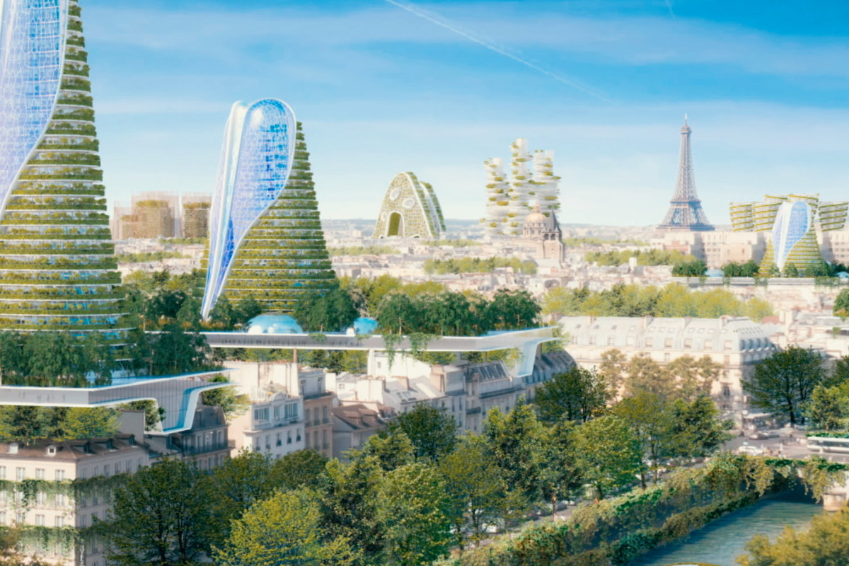
Exercise 1
Translate the following words and expressions
https://quizlet.com/318383677/flashcards
Exercise 2
Watch the video
https://www.youtube.com/watch?reload=9&v=fKnAJCSGSdk
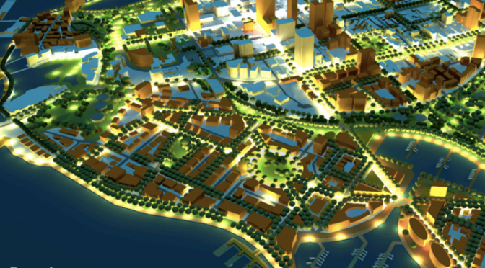
Exercise 3
Match words with their definitions
smog migrate congested shanty towns game changer
off the grid utopia ubiquitous urban sprawl infrastructure
1) overcrowded
2) an imaginary place where everything is perfect
3) air pollution
4) the way a city spreads into undeveloped land around it, often without planning permission
5) move from one place to another
6) poor communities where the houses are built out of cheap materials like corrugated iron and plastic sheeting
7) without facilities such as an electricity or water supply
8) the basic facilities a town or city needs, for example: communication, transport, water, and electricity
9) everywhere
10) significantly affecting the result of something
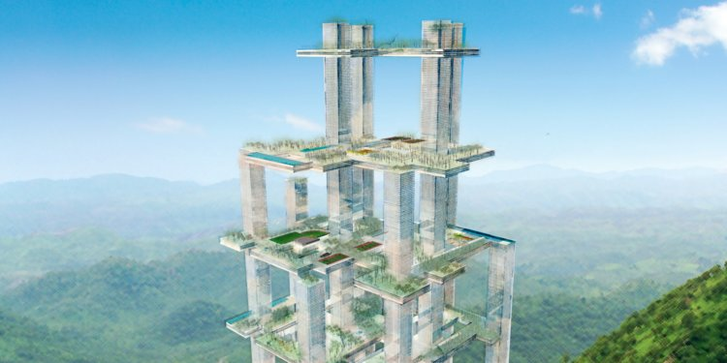
Exercise 4
Fill in the gaps
smog urban sprawl game changer ubiquitous migrate
communities off the grid shanty towns infrastructure congested
1) If people could get around easily on foot, or by bike, or by public transport, roads would be less ____– or overcrowded – and less polluted. That sounds rather utopian to me though.
2) That sounds fantastic, but what about somewhere like Beijing with its constant ____ – or air pollution – hanging over the city? A lot of people ride bikes there too. So which city is going to be the model for the future?
3) Well, today's Los Angeles has terrible urban sprawl and traffic problems.
4) ____ is the way a city spreads into undeveloped land around it, often without planning permission.
5) People ____ – or move – from the countryside to the city to get better opportunities, but end up with nowhere to live.
6) So they build their own housing on unoccupied land. These ____ – poor communities where the houses are built out of cheap materials like corrugated iron and plastic sheeting – are often ____ …
7) Which means they don't have an electricity or water supply – or access to healthcare and education. And these ____ are growing, so the problem is getting bigger. So are there any solutions?
8) Well, it's all about improving the____ . That's the basic facilities a town or city needs, for example: communication, transport, water, and electricity. But this shouldn't only mean improving housing conditions, but also promoting education and employment among the inhabitants, and building better communities.
9) - What's ____?
- It means available everywhere. So, the idea behind smart cities is to use technology to collect large amounts of data about how a city is performing.
10) - And that will be a ____– significantly affecting the way our cities function. Hope for the future?
- Fingers crossed.
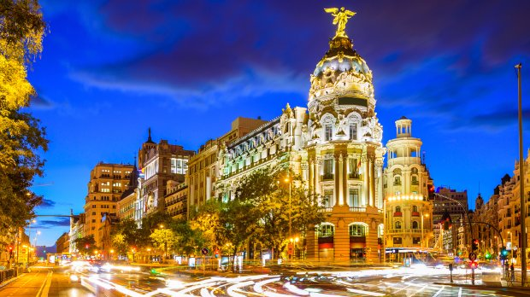
Exercise 5
Choose the right answer
1) Using this approach shows a large ____ of housing supply, in contrast with the Inspector's finding of a small shortfall.
a) degree
b) surplus
c) income
2) For the area, this will ensure the continuation of a ____ supply of quality employment opportunities.
a) steady
b) still
c) level
3) His large-scale color photographs illustrate the unbelievable ____ of Hong Kong's residential high-rises.
a) semi-permanence
b) density
c) scale
4) But he knew the power of words and ideas and he ____ them to great effect.
a) sought
b) employed
c) deployed
5) Recognizing the limitations of art education in the United States, Coleman____ training in Paris.
a) looked
b) sought
c) grid
6) Seeds and tools can be given, which allow families to grow food and become ____.
a) self-sufficient
b) semi-permanent
c) agricultural
7) Most people who are____ (at least those living in the United States), rely on some combination of alternative energy such as wind, photovoltaic or hydro.
a) off the hook
b) off the grid
c) off the table
Key
Exercise 3
Match words with their definitions
congested
overcrowded
utopia
an imaginary place where everything is perfect
smog
air pollution
urban sprawl
the way a city spreads into undeveloped land around it, often without planning permission
migrate
move from one place to another
shanty towns
poor communities where the houses are built out of cheap materials like corrugated iron and plastic sheeting
off the grid
without facilities such as an electricity or water supply
infrastructure
the basic facilities a town or city needs, for example: communication, transport, water, and electricity
ubiquitous
everywhere
game changer
significantly affecting the result of something
Exercise 4
Fill in the gaps
1) If people could get around easily on foot, or by bike, or by public transport, roads would be less ____ congested – or overcrowded – and less polluted. That sounds rather utopian to me though.
2) That sounds fantastic, but what about somewhere like Beijing with its constant ____ smog – or air pollution – hanging over the city? A lot of people ride bikes there too. So which city is going to be the model for the future?
3) Well, today's Los Angeles has terrible urban sprawl and traffic problems.
4) ____ Urban sprawl is the way a city spreads into undeveloped land around it, often without planning permission.
5) People ____ migrate – or move – from the countryside to the city to get better opportunities, but end up with nowhere to live.
6) So they build their own housing on unoccupied land. These ____ shanty towns – poor communities where the houses are built out of cheap materials like corrugated iron and plastic sheeting – are often ____ off the grid…
7) Which means they don't have an electricity or water supply – or access to healthcare and education. And these ____ communities are growing, so the problem is getting bigger. So are there any solutions?
8) Well, it's all about improving the____ infrastructure. That's the basic facilities a town or city needs, for example: communication, transport, water, and electricity. But this shouldn't only mean improving housing conditions, but also promoting education and employment among the inhabitants, and building better communities.
9) - What's ____ ubiquitous?
- It means available everywhere. So, the idea behind smart cities is to use technology to collect large amounts of data about how a city is performing.
10) - And that will be a ____ game changer – significantly affecting the way our cities function. Hope for the future?
- Fingers crossed.

Exercise 5
Choose the right answer
1) Using this approach shows a large ____ of housing supply, in contrast with the Inspector's finding of a small shortfall.
a) degree
b) surplus
c) income
2) For the area, this will ensure the continuation of a ____ supply of quality employment opportunities.
a) steady
b) still
c) level
3) His large-scale color photographs illustrate the unbelievable ____ of Hong Kong's residential high-rises.
a) semi-permanence
b) density
c) scale
4) But he knew the power of words and ideas and he ____ them to great effect.
a) sought
b) employed
c) deployed
5) Recognizing the limitations of art education in the United States, Coleman____ training in Paris.
a) looked
b) sought
c) grid
6) Seeds and tools can be given, which allow families to grow food and become ____.
a) self-sufficient
b) semi-permanent
c) agricultural
7) Most people who are____ (at least those living in the United States), rely on some combination of alternative energy such as wind, photovoltaic or hydro.
a) off the hook
b) off the grid
c) off the table

