Lesson 20-City-Grammar (part3)
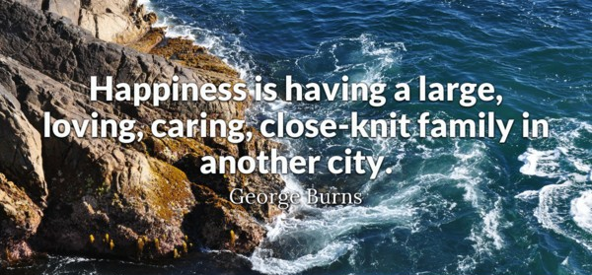
Exercise 1
Fill in who, whose, what, which, where, when, how long, how often, what time, why, how much, how many, how long ago

- … do you play football? Twice a week
- … does the train leave? Nine o’clock
- … is Martin? In the garden
- … is it? Half past ten
- … does he earn? 1000 a month
- … sisters have you got? Two
- … is this book? 5$
- … did he call? To invite me out to dinner
- … is the new driver like? He’s very friendly
- … shall we do this evening? Let’s go out
- … is the office party? On Saturday
- … have you been waiting? About half an hour
- … is that briefcase? I think it’s Tom’s
- … of these rings do you prefer? The gold one
- … spilt coffee on the desk? I did. Sorry
- … did you get your exam results? Last Friday
- … did you meet Jessie? Two years ago
- … is the easiest way to get to the cinema? Go through the city centre

Exercise 2
Write questions to which the words in bold are the answers

- Mark is decorating the living room
- She found Steven’s wallet
- Mum made these cakes
- Fiona’s dress was ruined at the party
- Melissa is wearing a blue dress
- Bob is the older of the two brothers
- Stacey has bought a new bag
- I like the blue jumper best
- The roof was blown off in the storm
- I ran into Jason the other day
- I spoke to the manager’s secretary about my complaint
- The Ethiopian runner won the 1500m race

Exercise3
Turn the following into indirect questions

- Who left this bag here?
Do you know…

- Who is that woman?
We need to find out…

- What time does the next train leave?
Can you tell me…

- How much does this dress cost?
Could you tell me …

- Where does Mary live?
I don’t know…

- Are the police investigating the robbery?
Have you any idea…

- Did the caller leave a message?
I’d like to find out

- Is he the manager?
I’d like to know

- Who reported the crime?
Do you know…

- How did they find the missing jewellery?
Have you any idea…

Exercise 5

Complete the questions
- Ryan won two races
A Who … ? Ryan
B How many …. ? Two
- Stanley goes swimming three times a week
A Who…? Stanley
B How often…? Three times a week
- There are two shirts. The yellow one is mine
A Which …? The yellow one
B Whose …? Mine
- Steven has broken Jim’s mug
A Whose…? Jim’s
B Who …? Steven
- Linda is going to the theatre this evening
A Who…? Linda
B Where …? To the theatre
- Anne bought Ralph a present yesterday
A Who…? Anne
B Who…? Ralph
- There are two bags. The one on the chair is Fay’s
A Whose …? Fay’s
B Which …? The one on the chair

Exercise 6
Choose the correct answer

1._____ do his powers come from?
A Where
B Who
C Why
2._____ one of you coming to my house later?
A Who
B Is
C Whose
3. _____ set a world record is competition?
A When
B Who
C Why
4. Let me know ... you hear from your mother.
A Who
B Which
C What
5.____ do you finish that task so quickly?
A How
B Whom
C What
6.____ is my briefcase?
A Where
B When
C How
7.____ dog is that?
A Who
B Why
C Whose
8._____ team beat Germany to win the championship?
A Which
B Whose
C Who
- _____ could you do this to me?
A How
B Whose
C Who
- _____ are you leaving?
A Who
B Why
C Where

