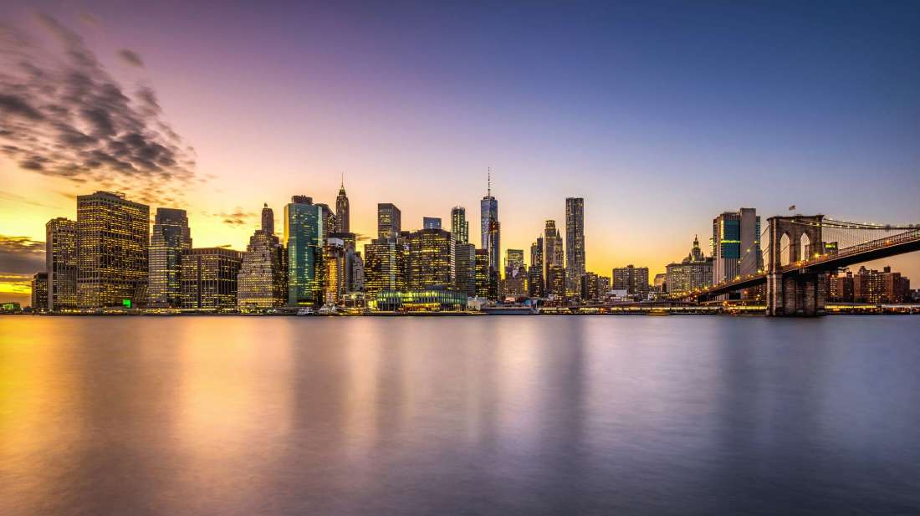

Ex.1
Watch the video. Can you name the cities in the clips? (видео называется 1)

London
New York
Prague
Rome
Sydney

Clip 1_______
Clip 2_______
Clip 3_______
Clip 4_______
Clip 5_______

Have you visited any of these cities?
Which of them would you prefer to visit?
Study the words below. In which clips did you notice these features?

high-rise buildings a double-decker bus a cobbled street a waterfront a famous landmark heavy traffic neon lights a distinctive telephone box a commercial district a pedestrian zone an opera house

Does your hometown or capital city have any of these features?

Ex. 2

Americans have different terms for some of the features of their cities. Can you match the American terms to their definitions or equivalent British/Australian English terms?

1. downtown a. a building containing flats that are owned, not rented
2. uptown b. a car park
3. a mall c. a flat
4. a condominium (condo) d. a petrol station
5. an apartment e. a shopping centre
6. a parking lot f. in the city centre
7. a gas station g. in the residential areas outside the city centre
8. the subway h. the underground, the tube (London)

In pairs, answer the questions below giving reasons.

1. Which type of city housing do you prefer?
2. Where do you go shopping when you are in the city? Which places do you avoid?
3. Which part of a city do you prefer to live in?

Ex.3
Now imagine you are travelling around the world and keeping a video blog of your journey. You decide to post the comments below next to each video clip. In pairs, study the sentences. What do you think the underlined adjectives mean?

1. This part of the city is extremely impoverished. The standard of living is very low.
2. It's totally deserted here. Where is everybody?
3. This district is very rundown. It urgently needs redevelopment.
4. It's very drab here. Looks like most of the buildings were constructed during the Soviet era.
5. What a picturesque little town! It looks just like a postcard.
6. The city centre is really overcrowded. There's no room to breathe!
7. This area is really vibrant. There's so much life.
8. This part of town is very touristy. There aren't many locals here.

Now match the comments to the video clips. (видео называется 3)
Clip 1.
Clip 2.
Clip 3.
Clip 4.
Clip 5.
Clip 6.
Clip 7.
Clip 8.

Take turns to describe a city. Other students must try to guess its name. You may find the expressions below useful.
• The city lies on ... / is situated in/on ...
• The city is considered to be ... / is regarded as ...
• The city has a population of about ...
• The city is renowned for ...
• The city is home to a number of .../several .../plenty of .../a few .../an abundance of ...
• The centre of the city features ...

