Halloween – History
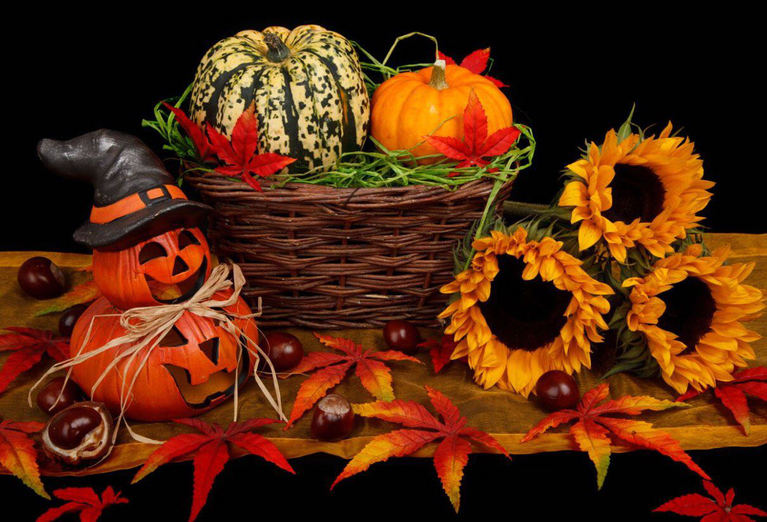
Exercise 1
Translate the following words and expressions
https://quizlet.com/318614802/flashcards
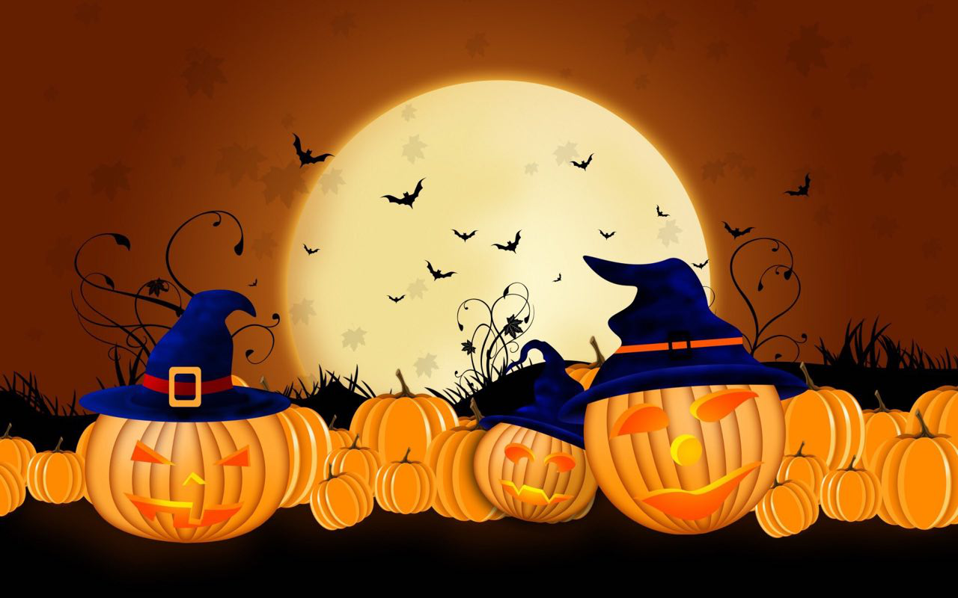
Exercise 2
Fill in the gaps
hilltops herds goddess origins associated
commemorating disguises largely divination believed favourable corresponding frighten observed
Halloween, contraction of All Hallows’ Eve, a holiday _____ on October 31, the evening before All Saints’ (or All Hallows’) Day. In much of Europe and most of North America, observance of Halloween is _____ nonreligious. Halloween had its _____ in the festival of Samhain among the Celts of ancient Britain and Ireland. On the day _____ to November 1 on contemporary calendars, the new year was believed to begin. That date was considered the beginning of the winter period, the date on which the _____ were returned from pasture and land tenures were renewed. During the Samhain festival the souls of those who had died were believed to return to visit their homes, and those who had died during the year were _____ to journey to the otherworld. People set bonfires on _____ for relighting their hearth fires for the winter and to _____ away evil spirits, and they sometimes wore masks and other _____ to avoid being recognized by the ghosts thought to be present. It was in those ways that beings such as witches, hobgoblins, fairies, and demons came to be _____ with the day. The period was also thought to be _____ for _____ on matters such as marriage, health, and death. When the Romans conquered the Celts in the 1st century, they added their own festivals of Feralia, _____ the passing of the dead, and of Pomona, the _____ of the harvest.
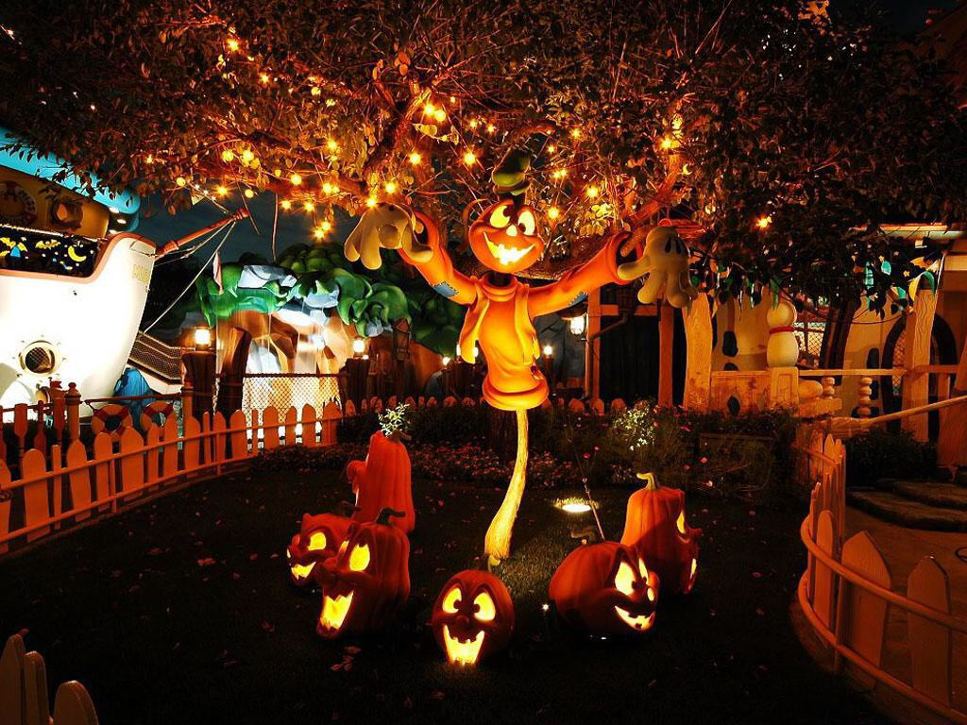Exercise 3
Choose the most appropriate answer
1. In the 7th century Pope Boniface IV established All Saints’ Day, _____ on May 13.
accordingly
originally
specially
2. In the following century, perhaps in an effort to supplant the _____ holiday with a Christian observance, it was moved to November 1.
saint
divine
pagan
3. The evening before All Saints’ Day became a holy, or hallowed, _____ and thus Halloween.
evermore
eve
event
4. By the end of the Middle Ages, the secular and the sacred days had _____.
confirmed
merged
submerged
5. The Reformation _____ put an end to the religious holiday among Protestants.
generally
essentially
especially
6. Along with other festivities, the celebration of Halloween was largely _____ among the early American colonists.
forbidden
spooked
gathered
7. When large numbers of immigrants went to the United States beginning in the mid 19th century, they took their Halloween _____ with them.
objects
customs
slanders
8. In the 20th century Halloween became one of the _____ U.S. holidays, particularly among children. permanent
particular
principal
9. Halloween is the second highest grossing_____ holiday after Christmas.
commercial
consumer
consumption
10. The word “witch” comes from the Old English wicce, _____ “wise woman.”
meaning
establishing
defining
11. According to popular_____, witches held one of their two main meetings, or sabbats, on Halloween night.
prejudice
belief
standing
12. The first known mention of trick-or-treating in print in North America _____ in 1927 in Blackie, Alberta, Canada.
originated
occurred
stated
13. Ireland is_____ believed to be the birthplace of Halloween.
graphically
typically
merely

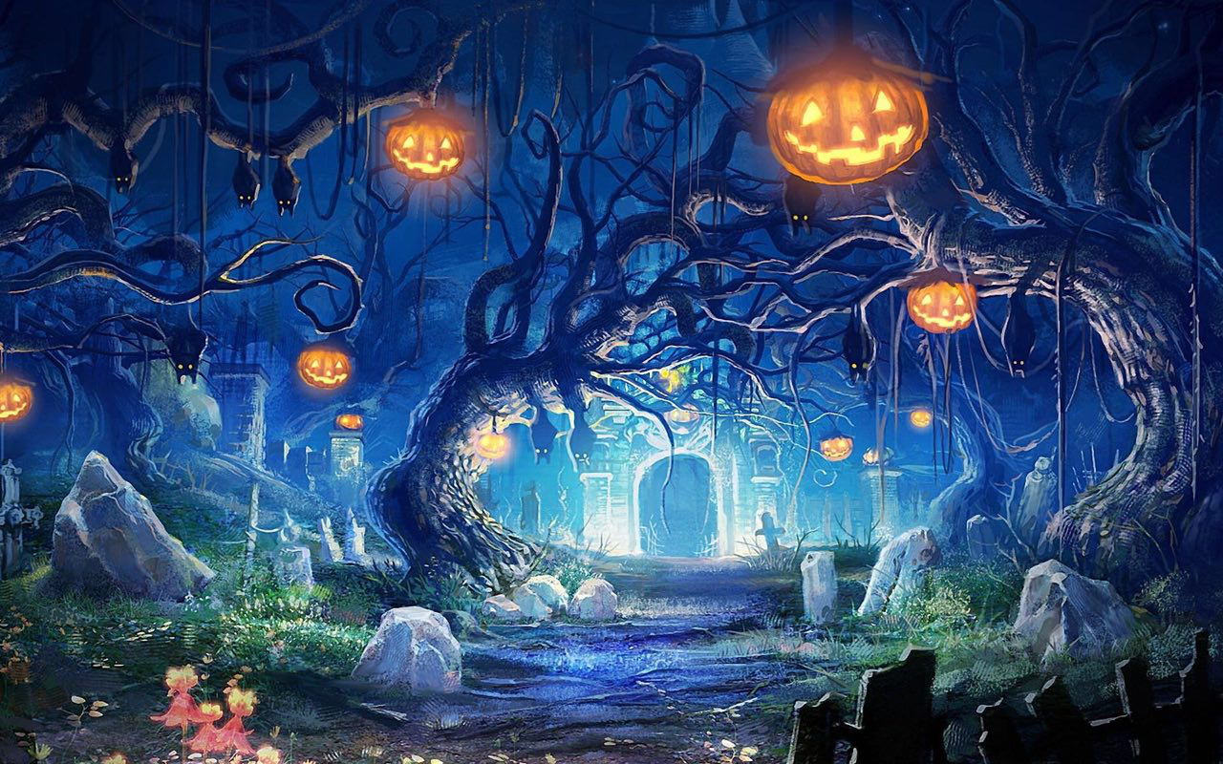
Exercise 4
Watch the video about Halloween celebration. What was of interest to you?
https://m.youtube.com/watch?v=GrdVgEOdxkU
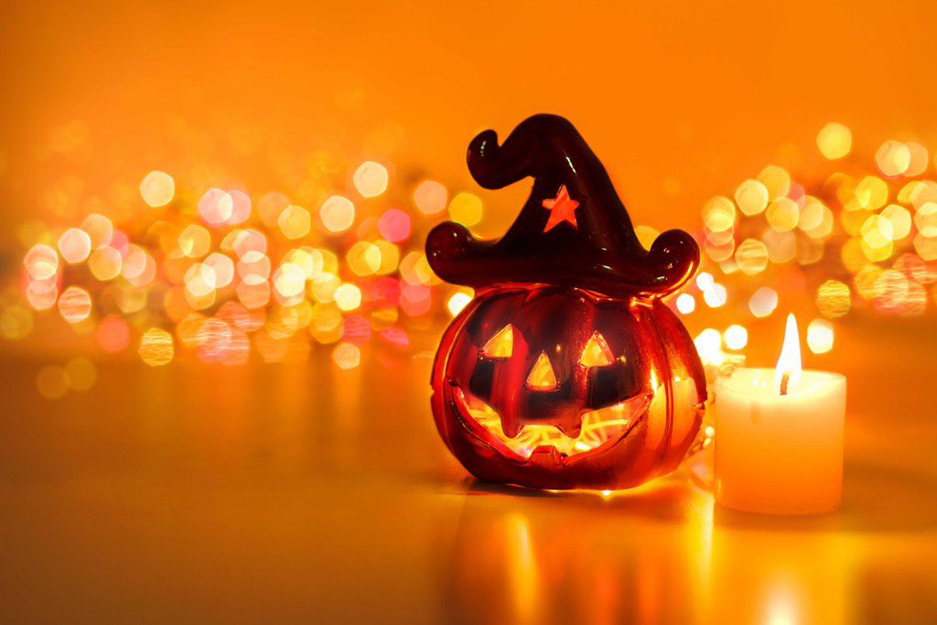 Exercise 5
Find the most appropriate ending to the sentences
(сделать выпадающий список)
if they do not receive a treat
the jack-o’-lantern
thought to have derived from the British practice
pulling usually harmless pranks
holiday has incorporated scary beings such as
associated with a number of activities
has attempted to make the collection of money for its programs
often include games such as
carved into a demonic face
As a secular holiday, Halloween has come to be _____. One is the practice of _____ . Celebrants wear masks and costumes for parties and for trick-or-treating, _____ of allowing the poor to beg for food, called “soul cakes.” Trick-or-treaters go from house to house with the threat that they will pull a trick _____, usually candy. Halloween parties _____ bobbing for apples, perhaps derived from the Roman celebration of Pomona. Along with skeletons and black cats, the _____ ghosts, witches, and vampires into the celebration. Another symbol is _____, a hollowed-out pumpkin, originally a turnip, _____ and lit with a candle inside. Since the mid-20th century the United Nations Children’s Fund (UNICEF) _____ a part of Halloween.
Key
Exercise 2
Fill in the gaps
Halloween, contraction of All Hallows’ Eve, a holiday _____ observed on October 31, the evening before All Saints’ (or All Hallows’) Day. In much of Europe and most of North America, observance of Halloween is _____ largely nonreligious. Halloween had its _____ origins in the festival of Samhain among the Celts of ancient Britain and Ireland. On the day _____ corresponding to November 1 on contemporary calendars, the new year was believed to begin. That date was considered the beginning of the winter period, the date on which the _____ herds were returned from pasture and land tenures were renewed. During the Samhain festival the souls of those who had died were believed to return to visit their homes, and those who had died during the year were _____ believed to journey to the otherworld. People set bonfires on _____ hilltops for relighting their hearth fires for the winter and to _____ frighten away evil spirits, and they sometimes wore masks and other _____ disguises to avoid being recognized by the ghosts thought to be present. It was in those ways that beings such as witches, hobgoblins, fairies, and demons came to be _____ associated with the day. The period was also thought to be _____favourable for _____ divination on matters such as marriage, health, and death. When the Romans conquered the Celts in the 1st century, they added their own festivals of Feralia, _____ commemorating the passing of the dead, and of Pomona, the _____ goddess of the harvest.
Exercise 3
Choose the most appropriate answer
1. In the 7th century Pope Boniface IV established All Saints’ Day, _____ on May 13.
accordingly
originally
specially
2. In the following century, perhaps in an effort to supplant the _____ holiday with a Christian observance, it was moved to November 1.
saint
divine
pagan
3. The evening before All Saints’ Day became a holy, or hallowed, _____ and thus Halloween.
evermore
eve
event
4. By the end of the Middle Ages, the secular and the sacred days had _____.
confirmed
merged
submerged
5. The Reformation _____ put an end to the religious holiday among Protestants.
generally
essentially
especially
6. Along with other festivities, the celebration of Halloween was largely _____ among the early American colonists.
forbidden
spooked
gathered
7. When large numbers of immigrants went to the United States beginning in the mid 19th century, they took their Halloween _____ with them.
objects
customs
slanders
8. In the 20th century Halloween became one of the _____ U.S. holidays, particularly among children. permanent
particular
principal
9. Halloween is the second highest grossing_____ holiday after Christmas.
commercial
consumer
consumption
10. The word “witch” comes from the Old English wicce, _____ “wise woman.”
meaning
establishing
defining
11. According to popular_____, witches held one of their two main meetings, or sabbats, on Halloween night.
prejudice
belief
standing
12. The first known mention of trick-or-treating in print in North America _____ in 1927 in Blackie, Alberta, Canada.
originated
occurred
stated
13. Ireland is_____ believed to be the birthplace of Halloween.
graphically
typically
merely
Exercise 5
Find the most appropriate ending to the sentences
As a secular holiday, Halloween has come to be _____ associated with a number of activities. One is the practice of _____ pulling usually harmless pranks. Celebrants wear masks and costumes for parties and for trick-or-treating, _____ thought to have derived from the British practice of allowing the poor to beg for food, called “soul cakes.” Trick-or-treaters go from house to house with the threat that they will pull a trick _____ if they do not receive a treat, usually candy. Halloween parties _____ often include games such as bobbing for apples, perhaps derived from the Roman celebration of Pomona. Along with skeletons and black cats, the _____ holiday has incorporated scary beings such as ghosts, witches, and vampires into the celebration. Another symbol is _____ the jack-o’-lantern, a hollowed-out pumpkin, originally a turnip, _____ carved into a demonic face and lit with a candle inside. Since the mid-20th century the United Nations Children’s Fund (UNICEF) _____ has attempted to make the collection of money for its programs a part of Halloween.

