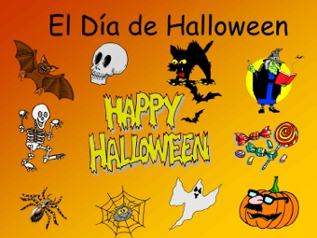
Task 1
Match the vocabulary words on the left with the definitions on the right.
1. mummy | having a ghost in the house that causes weird things to happen
2. ghost | a round, orange, stemmed vegetable that grows above ground
3. spell | a magic curse used to get a desired effect
4. mask | mystical beings who survive by feeding off other living creatures life force
5. costume | a flying mammal with webbed wings
6. vampire | a supernatural being described as being large or grotesque
7. warlock | to form or inscribe by cutting:
8. carve | a covering or disguise, often intended to hide the face
9. goblin | a mixture for drinking, esp. one that is supposed to have medicinal, magical, or poisonous effects:
10. monster | a corpse that has been brought back to life by supernatural circumstances
11. zombie (zombi) | an object or event that is frightening or causes terror
12. pumpkin | a supernatural spirit that usually carries on with bad intent
13. bat | the everlasting spirit of something deceased
14. haunted | a body that has been preserved by chemicals or room conditions to prevent decaying
15. scary | a person, usually female, who uses supernatural and magical powers
16. potion | a sorcerer who uses spiritual practices for both good and evil
17. witch | a set of clothes suited to a particular season, occasion, or activity.

Task 2
Choose the correct variant:
1. What is a large orange vegetable harvested in Fall?
A. Pumpkin
B. Jack o' Lantern
C. Scarecrow
2. What is a carved pumpkin with a light inside called?
A. Broom
B. Jack o ' Lantern
C. Haunted House
3. What is the month and day Halloween is celebrated?
A. The 4th Thursday in November
B. December 25
C. October 31
4. What do people say to each other on Halloween day?
A. Happy Halloween
B. Merry Halloween
C. Happy Harvest
5. What do children say on Halloween after knocking on a neighbor's door?
A. Jack o ' Lantern
B. Happy Thanksgiving
C. Trick or treat
6. What do people get dressed up in on Halloween?
A. Candies
B. Costumes
C. Pumpkins
7. Who is a magic woman often wearing a black hat and riding a broom?
A. Witch
B. Vampire
C. Mummy
8. The spirit of someone who is dead is called a … .
A. Zombie
B. Mummy
C. Ghost
9. What do people hand out to trick or treaters on Halloween?
A. Fruit
B. Drinks
C. Candy
10. What is another word for cemetery, or a place where people are buried after they die?
A. Mummy
B. Graveyard
C. Haunted house

Task 3
http://www.academicenglishcafe.com/uploads/1/1/9/7/11970946/halloween_bingo_game_online.pdf
Guess the word
H A L L O W E E N B I N G O

Witch
Costume
Candy
Pumpkin
October 31
Corn maze
Broom
Graveyard
Decorations
Full moon
Trick or treat
Costume party
Happy Halloween
Haunted house
Jack o' lantern
Mummy
Coffin
Candy corn
Scarecrow
Skeleton
Spider web
Tombstone
Ghost
Vampire
Bat

Directions:
To play, one person reads these bingo word definitions (in any order) so players can guess the vocabulary word on the bingo board. You can use candy corn, orange paper, or just write an X for bingo markers! The first person to mark 5 vocabulary words in a row shouts 'Bingo!' and wins that round.
1. Flying animal that is awake at night
2. What a witch rides; also an object for sweeping
3. Sweets to give and eat on Halloween
4. Sweet shaped in a triangle and eaten around Halloween
5. A box people are buried in
6. A field of corn designed as a maze to walk through
7. An outfit people wear on Halloween
8. A party where everyone dresses up in a costume
9. Objects to make the house look scary on Halloween
10.A completely round moon
11.The spirit of someone who is dead
12.Cemetery, or a place people are buried after they die
13.What people say on Halloween day
14.A house with ghosts or spirits living in it
15.A carved pumpkin for Halloween
16.A dead person wrapped in white cloth
17.The month and day Halloween is celebrated
18. A large orange vegetable harvested in Fall
19.Fake person to scare birds out of the garden
20.All the bones inside a body
21.What a spider makes to catch flies
22.The marker or headstone on top of a grave
23.The words children say on Halloween after knocking on a door
24.Dracula is one of these kinds of monsters
25.A magic woman who often wears a black hat and rides a broom

Task 4
Do this Halloween quiz:
https://bogglesworldesl.com/quizgames/halloweenquiz.php

Task 5
Play this boarding game:
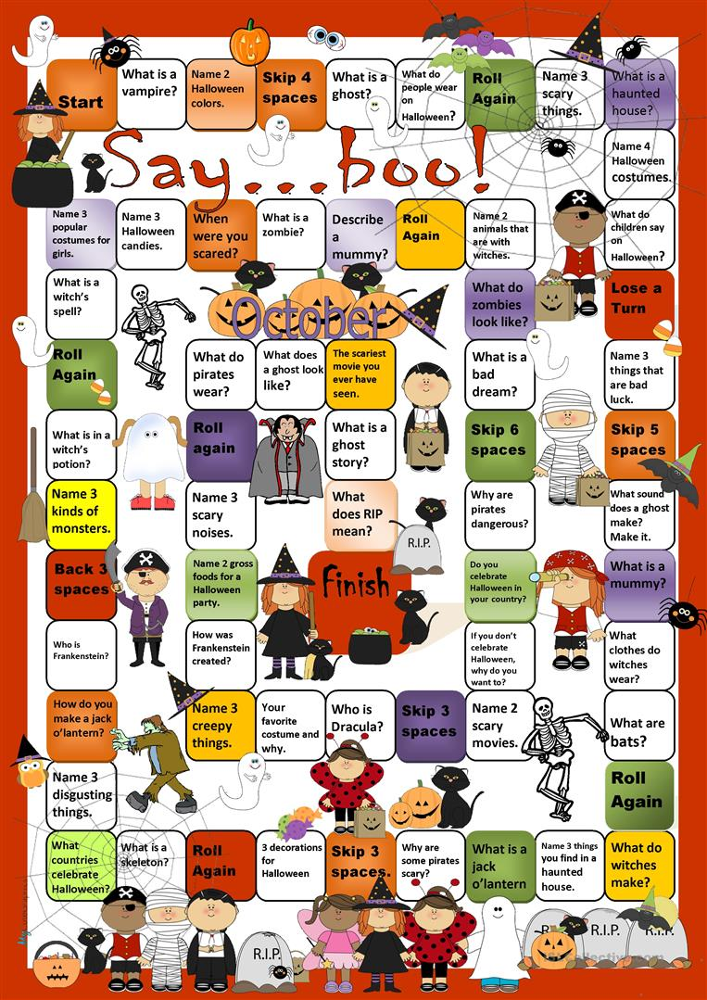
ANSWERS
Task 1
1. mummy-a body that has been preserved by chemicals or room conditions to prevent decaying
2. ghost-the everlasting spirit of something deceased
3. spell-a magic curse used to get a desired effect
4. mask-a covering or disguise, often intended to hide the face
5. costume-a set of clothes suited to a particular season, occasion, or activity.
6. vampire-mystical beings who survive by feeding off other living creatures life force
7. warlock-a sorcerer who uses spiritual practices for both good and evil
8. carve-to form or inscribe by cutting
9. goblin-a supernatural being described as being large or grotesque
10. monster- a supernatural spirit that usually carries on with bad intent
11. zombie (zombi)-a corpse that has been brought back to life by supernatural circumstances
12. pumpkin-a round, orange, stemmed vegetable that grows above ground
13. bat-a flying mammal with webbed wings
14. haunted-having a ghost in the house that causes weird things to happen
15. scary-an object or event that is frightening or causes terror
16. potion-a mixture for drinking, esp. one that is supposed to have medicinal, magical, or poisonous effects
17. witch-a person, usually female, who uses supernatural and magical powers

Task 2
1. What is a large orange vegetable harvested in Fall?
A. Pumpkin
B. Jack o' Lantern
C. Scarecrow
2. What is a carved pumpkin with a light inside called?
A. Broom
B. Jack o ' Lantern
C. Haunted House
3. What is the month and day Halloween is celebrated?
A. The 4th Thursday in November
B. December 25
C. October 31
4. What do people say to each other on Halloween day?
A. Happy Halloween
B. Merry Halloween
C. Happy Harvest
5. What do children say on Halloween after knocking on a neighbor's door?
A. Jack o ' Lantern
B. Happy Thanksgiving
C. Trick or treat
6. What do people get dressed up in on Halloween?
A. Candies
B. Costumes
C. Pumpkins
7. Who is a magic woman often wearing a black hat and riding a broom?
A. Witch
B. Vampire
C. Mummy
8. The spirit of someone who is dead is called a … .
A. Zombie
B. Mummy
C. Ghost
9. What do people hand out to trick or treaters on Halloween?
A. Fruit
B. Drinks
C. Candy
10. What is another word for cemetery, or a place where people are buried after they die?
A. Mummy
B. Graveyard
C. Haunted house

Task 3
1. Flying animal that is awake at night (bat)
2. What a witch rides; also an object for sweeping (broom)
3. Sweets to give and eat on Halloween (candy)
4. Sweet shaped in a triangle and eaten around Halloween (candy corn)
5. A box people are buried in (coffin)
6. A field of corn designed as a maze to walk through (corn maze)
7. An outfit people wear on Halloween (costume)
8. A party where everyone dresses up in a costume (costume party)
9. Objects to make the house look scary on Halloween (decorations)
10.A completely round moon (full moon)
11.The spirit of someone who is dead (ghost)
12.Cemetery, or a place people are buried after they die (graveyard)
13.What people say on Halloween day (Happy Halloween)
14.A house with ghosts or spirits living in it (haunted house)
15.A carved pumpkin for Halloween (jack o' lantern)
16.A dead person wrapped in white cloth (mummy)
17.The month and day Halloween is celebrated (October 31)
18. A large orange vegetable harvested in Fall (pumpkin)
19.Fake person to scare birds out of the garden (scarecrow)
20.All the bones inside a body (skeleton)
21.What a spider makes to catch flies (spider web)
22.The marker or headstone on top of a grave (tombstone)
23.The words children say on Halloween after knocking on a door (trick or treat)
24.Dracula is one of these kinds of monsters (vampire)
25.A magic woman who often wears a black hat and rides a broom (witch)

