What is your attitude to Halloween? What do you know about these western holliday?

Ex.1. Check your knowledge with the help of this easy quize.

(файл halloween-quiz-fun-activities 1 – лист 1)

Ex.2 Watch the video and complete the sentences with the missing information:
https://en.islcollective.com/video-lessons/adult-students-esl-history-halloween

Ex.3 Study the facts about Halloween and complete the quize afterwards.
Trick-or-treating The main event for children on Halloween is trick-or-treating.
Children disguise themselves in costumes and go door-to-door in their neighborhoods ringing each doorbell and yelling TRICK OR TREAT !!!

Date October 31
Halloween is one of the world's oldest holidays,it is still celebrated today in a number of countries around the globe.

Also called All Hallow’s Eve.
All Saints Eve.
Samhain.
Observed by
Western Christians & many non-Christians around the world

Celebrations
Parades, festivals, costume parties, trick-or-treating/guising, carving pumpkins, ghost tours, haunted attractions, Hell houses, bonfires, divination, apple bobbing, fireworks displays

Symbols
The carved pumpkin, ghosts, witches, vampires, bats, vultures, haunted houses, black cats, spiders, goblins, aliens, monsters, mummy, skeleton.

Ex.4 Match the symbols of the Halloween with the pictures. (сделать упраженение в программе, где соединять слова и картинки в разброс)
black cat
witch
Haunted house
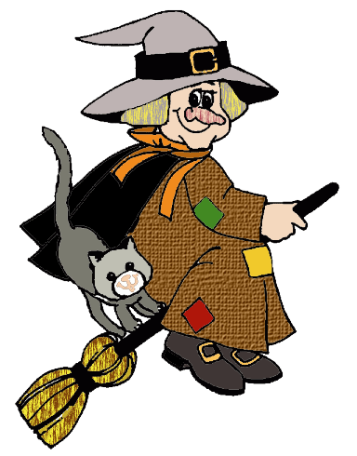
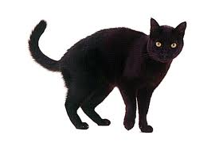
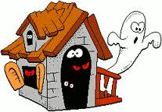

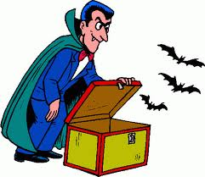
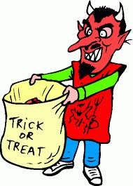
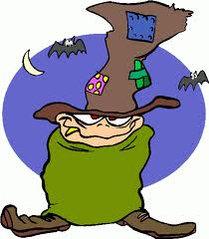

vampire
goblin

Trick or treating

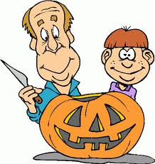
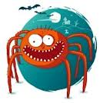
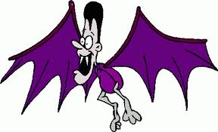

Carving the pumpkin

bat
spider

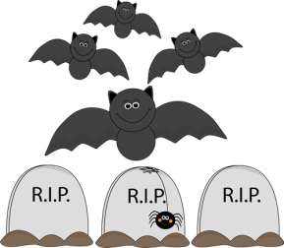
Ex.5. Now complete a short quize based on the facts

1. Halloween is celebrated on
a) October 30
b) October 31
c) November 1
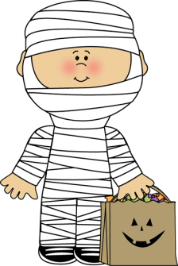
2. Witches, ghosts, and fairies are thought to be
a) very active during Halloween
b) sleeping peacefully all night long
c) teasing living souls during the night
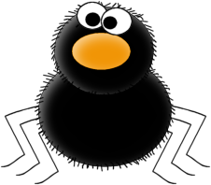
3. What is apple bobbing?
a) a dessert
b) a gift
c) a game
4. Jack-o-lanterns are
a) carved cucumbers
b) carved turnips
c) carved pumpkins
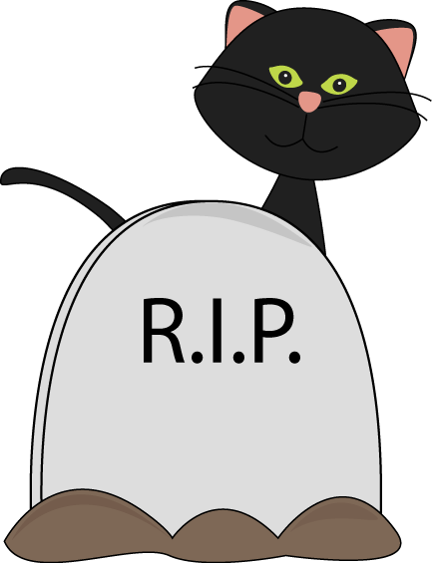
5. What do you put inside Jack-o-lanterns?
a) candy
b) candles
c) cucumbers
6. What returns to the earthly world at Halloween?
a) friendly family members
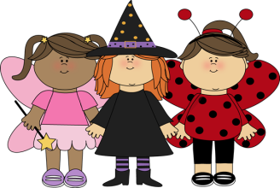
b) evil spirits
c) monsters
7. What does a ghost say?
a) Bob!
b) Bling!
c) Boo!
8. What did people do in order to not being recognized by the spirits?
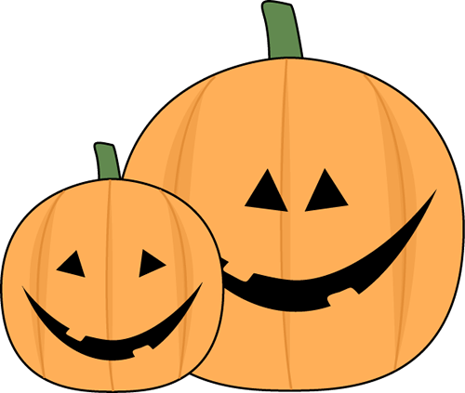
a) wore a sack over their faces
b) dressed up
c) dressed up and wore a mask
9. What are typical costumes?
a) scary monsters
b) princes and princesses
c) superheroes
10. Trick or treat is about
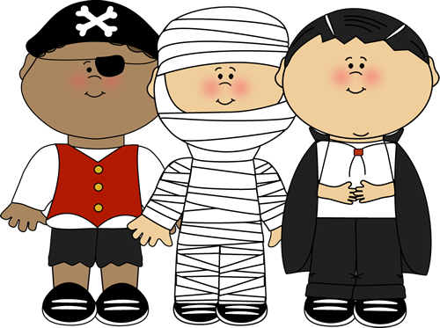
a) asking for candy
b) TP-ing houses
c) singing a song at people’s doors
11. In some countries there is a service at the church at Halloween. What is the idea of this service?
a) To get together and sing Halloween songs
b) To commemorate dead relatives
c) To fight evil spirits

Halloween is a time to watch horror movies. We offer you to watch a trailer of Crimson Peak. It is a 2015 American gothic romance film directed by Guillermo del Toro, written by del Toro and Matthew Robbinsand stars Mia Wasikowska, Tom Hiddleston, Jessica Chastain, Charlie Hunnam and Jim Beaver.

Ex.6. Watch and answer the questions.

https://www.youtube.com/watch?v=oquZifON8Eg

Word list
imagine – _представлять,_ _воображать _
lightly -_ _беспечно _
fascination -_ _очарование _
proceed with caution -_ _действовать _с _осторожностью _
link -_ _связь _
exist -_ _существовать _
manage -_ _управлять _
relinquish -_ _отказываться _
unsafe – _небезопасный _
beware -_ _берегись _
rotting -_ _гниющее _
violent – _жестокий _
living thing – _живое _существо _

1. What “Crimson peak” symbolize in this film?
2. Did Thomas’s sister give Edith the copy of the keys? Why/why not?
3. In your opinion, why the snow around the house is red?
4. In your opinion, have anyone died in that house? Who are those ghosts?
5. To your mind, will anyone from the main characters die till the end of the movie?

Ex.7 Now let’s talk about Halloween.

(файл halloween-conversation-questions-conversation-topics-dialogs-fun-activities-games-p_91758)

Answer key
Ex.5. Now complete a short quize based on the facts

1. Halloween is celebrated on
a) October 30
b) October 31
c) November 1
2. Witches, ghosts, and fairies are thought to be
a) very active during Halloween
b) sleeping peacefully all night long
c) teasing living souls during the night
3. What is apple bobbing?
a) a dessert
b) a gift
c) a game
4. Jack-o-lanterns are
a) carved cucumbers
b) carved turnips
c) carved pumpkins
5. What do you put inside Jack-o-lanterns?
a) candy
b) candles
c) cucumbers
6. What returns to the earthly world at Halloween?
a) friendly family members
b) evil spirits
c) monsters
7. What does a ghost say?
a) Bob!
b) Bling!
c) Boo!
8. What did people do in order to not being recognized by the spirits?
a) wore a sack over their faces
b) dressed up
c) dressed up and wore a mask
9. What are typical costumes?
a) scary monsters
b) princes and princesses
c) superheroes
10. Trick or treat is about
a) asking for candy
b) TP-ing houses
c) singing a song at people’s doors
11. In some countries there is a service at the church at Halloween. What is the idea of this service?
a) To get together and sing Halloween songs
b) To commemorate dead relatives
c) To fight evil spirits

