People. Parts of body
Exercise 1
Translate the following idoms
https://quizlet.com/318405291/flashcards
Look through the histiry of certain idoms
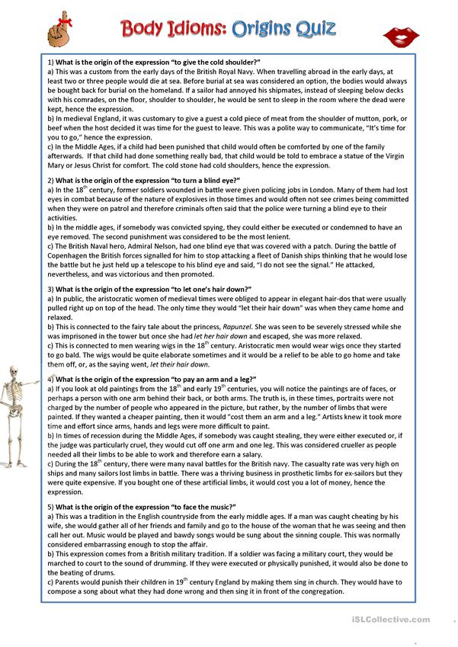
Exercise 2
Match idoms with their definitions
Part 1
make one’s blood boil by heart chin up head over heels
face the music get all off one’s chest let her hair down
get cold feet give a cold shoulder by heart
1) to allow yourself to behave much more freely than usual and enjoy yourself
2) madly in love
3) to unburden oneself; to confess something; to criticize or make a personal complaint to someone
4) to suddenly become too frightened to do something you had planned to do, especially something important
5) to make someone extremely angry
6) A phrase that encourages one to improve one's mood, especially when sad or discouraged.
all ears
7) to be waiting eagerly to hear about something
8) to accept criticism or punishment for something you have done
9) learnt in such a way that you can say it from memory
10)to intentionally ignore someone or treat someone in an unfriendly way
Part 2 сделать выпадающий список
elbow grease
foot the bill
one’s hands are tied
pay arm and leg
knuckle down
long in the tooth
turn a blind eye
1) to pay for something, esp. something expensive
2) to start working or studying hard
3) working hard at manual labour
4) to pay too much [money] for something
5) too old for a particular activity or purpose
6) to ignore something that you know is wrong
7) One is being prevented from acting, helping, or intervening as one should or desires to due to circumstances beyond one's control, such as rules, conflicting orders, or higher priorities.
Exercise 3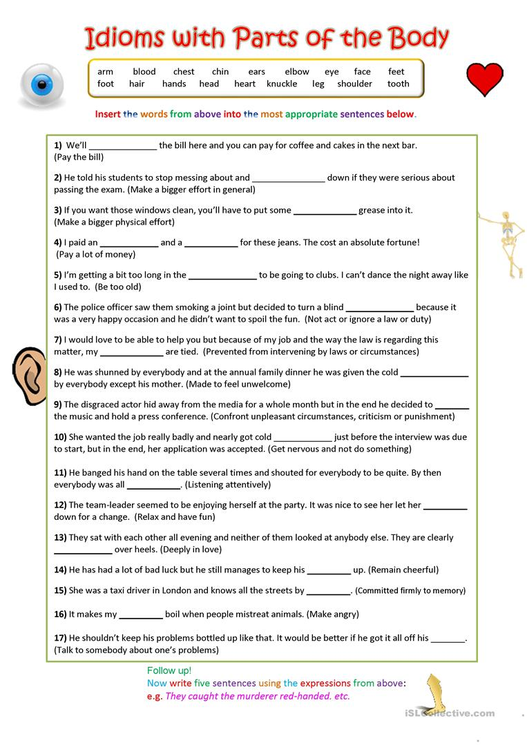
Key
Exercise 2
Match idoms with their definitions
Part 1
1) to allow yourself to behave much more freely than usual and enjoy yourself | let her hair down
2) madly in love | head over heels
3) to unburden oneself; to confess something; to criticize or make a personal complaint to someone | get all off one’s chest
4) to suddenly become too frightened to do something you had planned to do, especially something important | get cold feet
5) to make someone extremely angry | make one’s blood boil
6) A phrase that encourages one to improve one's mood, especially when sad or discouraged. | chin up
7) to be waiting eagerly to hear about something | all ears
8) to accept criticism or punishment for something you have done | face the music
9) learnt in such a way that you can say it from memory | by heart
10) to intentionally ignore someone or treat someone in an unfriendly way | give a cold shoulder
Part 2
1) to pay for something, esp. something expensive | foot the bill
2) to start working or studying hard | knuckle down
3) working hard at manual labour | elbow grease
4) to pay too much [money] for something | pay arm and leg
5) too old for a particular activity or purpose | long in the tooth
6) to ignore something that you know is wrong | turn a blind eye
7) One is being prevented from acting, helping, or intervening as one should or desires to due to circumstances beyond one's control, such as rules, conflicting orders, or higher priorities. | one’s hands are tied

Exrcise 3