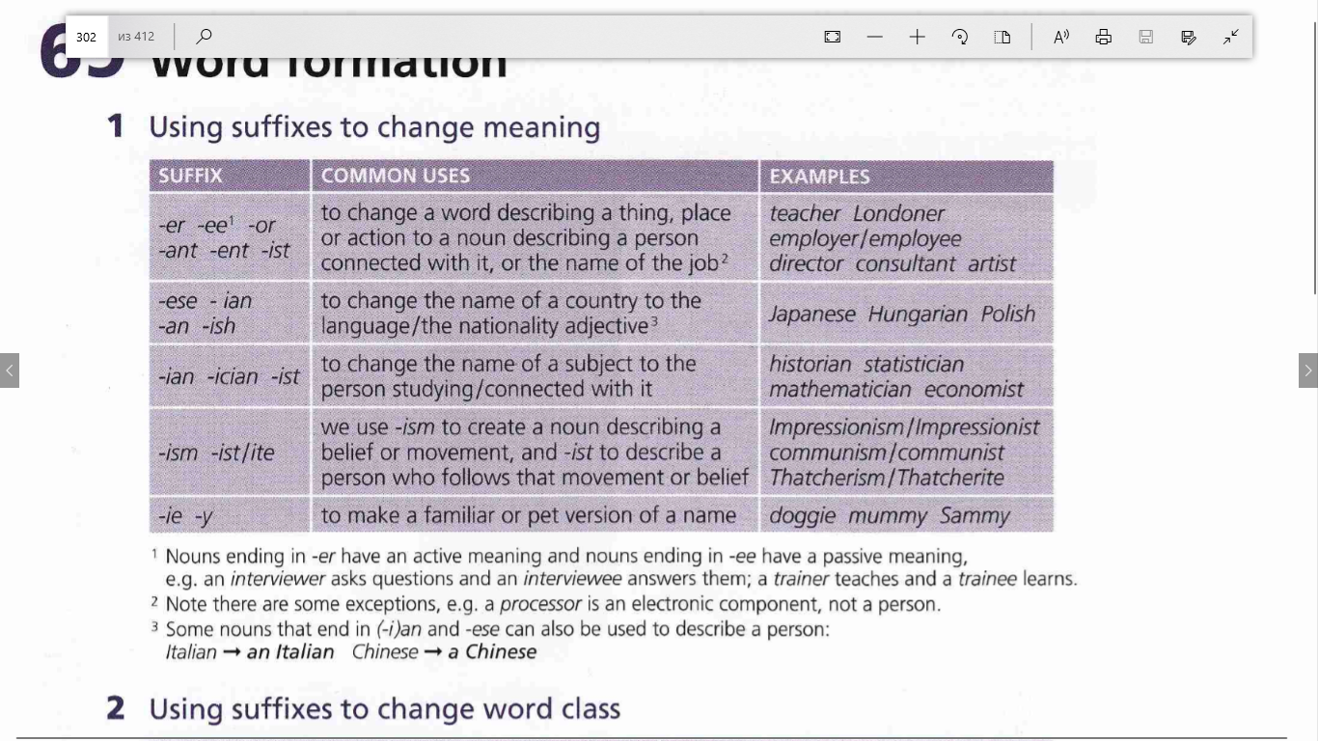

Task 1
Fill in all the gaps
Make nouns from the verbs and adjectives that are in italics !
Use the following endings : -age, -hood, -ation, -ion, -ful, -ence, -ency , -ness, -al, -(er)y, -ment , - ety, -ism , -ity , -ing , -ior
1.I decided this. It was my … .
2.Don’t be so anxious. Control your … .
3.Ann’s a socialist. She believes in … .
4.We all want to be happy. We seek … .
5.We all agree. We’re all in … .
6.Who discovered this? Who made this … ?
7.We’ll all arrive. We’ll be met on … .
8.I was a child then. It happened in my … .
9.She is absent. Can you explain her … ?
10.I’ll post this. What’s the … ?
11.Be more efficient. Improve your … .
12.Don’t be so curious. Control your … .
13.I refused their offer. My … is final.
14.I warned you. I gave you enough … .
15.Put it in your mouth. Take one … .
16.Can you explain it? Is there an … .
17.They tried him. I was at the … .
18.Don’t argue. I don’t want an … .
19.I don’t like the way you behave. Your … is impossible.
20.You can be active here. Choose any … you want.

Task 2
Complete the sentences with the suffixes below.
-able, -ist, -ing, -ive, -ic, -ment, -ful, -ient

1.It's always use… to carry some cash on you, in case of an emergency.
2.Planning a holiday can be just as excit… as going on holiday.
3.I found that this medicine is the most effect… for colds.
4.She speaks arab… very well.
5.I'm un… to work on weekends.
6.His sex… comments made him disliked by the female employees.
7.I don't want to get into an argu… with you about this.
8.Living close to the station is conven… for me.

Task 3
Try to make a word to fit into the gap using the word in capitals at the end of the sentence. You may need the opposite, or an adjective, or adverb, so read each sentence carefully.
1.John's tooth was very … so he has to go to the dentist. PAIN
2.I like that shop assistant. She's very … . HELP
3.I had to handle the machine carefully, as it was very … . BREAK
4.Jen was eating a very … apple and obviously enjoying it. CRUNCH
5.Don't forget to … your shoelaces before taking them off. TIE
6.I wasn't very happy with the hotel we were staying in. In fact I was very … . SATISFY
7.I asked Martin to … my pencil for me. SHARP
8.He gave us a great deal of … before the exam. ENCOURAGE
9.That is a terrible song. It is completely … . TUNE
10.What a … shirt! Green, yellow and purple! COLOUR

Task 4
Use the correct suffix to complete the adjectives in these sentences.
-ful -less -able -ive -ic -ly -ible
1. Your brother was very coward… . He ran away immediately.
2. That snake looks dangerous, but it's totally harm… . Don't worry!
3. To work as an acrobat in the circus, you have to be very flex… .
4. Oh, look at those ador… puppies. Can I have one?
5. He's always running about, very athlet… . He'll be in the Olympics one day.
6. What a beauti… painting. Do you know who painted it?
7. We need a full and truth… account of what happened, Jennifer. Tell us everything.
8. These animals sleep during the day and are then act… during the night.
9. It must be very lone… living on this mountain without any neighbors.
10. Betty is a very creat… little girl, always painting or drawing or something like that.

Task 5
Complete the noun with the correct suffix
1.We organised a number of fun activ… for the children.
2.The develop… of mobile phone networks in many poor countries has benefitted their economies.
3.Member… of the club is open to all residents.
4.The charity aims to reduce suffer… after natural disasters by providing food and medicines.
5.Continuing violen… in the south of the country has slowed development.
6.Male elephants will sometimes show aggress… towards human beings.
7.Increasing hostil… between the two countries has led to a reduction in trade and tourism.
8.The defendant claimed he was suffering from depress… at the time of the attack.
9.Research… at the institute now think they have discovered a link between diet and depression.
10.You must keep completely still as even the slightest move… will frighten the animals away.
11.There is absolutely no eviden… that my government has been involved in the sale of arms to terrorists.
12.This kind of anti-social behav… will not be tolerated!
13.The publi… date of the new dictionary is not yet known.
14.There has been a marked reduc… in the number of armed robberies over the past two years.

Task 6
Choose the correct variant
1.She has little aware… of the dangers she will face.
A.ment
B.ness
C.ing
2.He couldn't hide his disappoint… at his low grade.
A.ness
B.ment
C.y
3.The twins got on very well together and there was no jealous… between them.
A.y
B.ity
C. ism
4.I was shocked at her rude… .
A.ness
B.ment
C.ence
5.She's training to become a psycholog… .
A.er
B.y
C.ist
6.Exercise is good for your health… .
A.y
B.ance
C.(no suffix)
7.Many people don't trust politic… because they tell lies.
A.ists
B.ians
C.ers
8.Art classes aim to develop children's creativ… .
A.ment
B.ship
C.ity
9.She can't accept critic… from her colleagues.
A.al
B.ism
C.ing
10.Manchester United support… were delighted with their team's 3 - 0 win at the weekend.
A.ists
B.ees
C.ers

ANSWERS
Task 1
1.I decided this. It was my decision.
2.Don’t be so anxious. Control your anxiety.
3.Ann’s a socialist. She believes in socialism.
4.We all want to be happy. We seek happiness.
5.We all agree. We’re all in agreement.
6.Who discovered this? Who made this discovery?
7.We’ll all arrive. We’ll be met on arrival.
8.I was a child then. It happened in my childhood.
9.She is absent. Can you explain her absence?
10.I’ll post this. What’s the posting?
11.Be more efficient. Improve your efficiency.
12.Don’t be so curious. Control your curiosity.
13.I refused their offer. My refusal is final.
14.I warned you. I gave you enough warning.
15.Put it in your mouth. Take one mouthful.
16.Can you explain it? Is there an explanation.
17.They tried him. I was at the trial.
18.Don’t argue. I don’t want an argument.
19.I don’t like the way you behave. Your behavior is impossible.
20.You can be active here. Choose any activity you want.

Task 2

1.It's always useful to carry some cash on you, in case of an emergency.
2.Planning a holiday can be just as exciting as going on holiday.
3.I found that this medicine is the most effective for colds.
4.She speaks arabic very well.
5.I'm unable to work on weekends.
6.His sexist comments made him disliked by the female employees.
7.I don't want to get into an argument with you about this.
8.Living close to the station is convenient for me.

Task 3
1.John's tooth was very painful so he has to go to the dentist. PAIN
2.I like that shop assistant. She's very helpful. HELP
3.I had to handle the machine carefully, as it was very breakable. BREAK
4.Jen was eating a very crunchy apple and obviously enjoying it. CRUNCH
5.Don't forget to untie your shoelaces before taking them off. TIE
6.I wasn't very happy with the hotel we were staying in. In fact I was very dissatisfied. SATISFY
7.I asked Martin to sharpen my pencil for me. SHARP
8.He gave us a great deal of encouragement before the exam. ENCOURAGE
9.That is a terrible song. It is completely tuneless. TUNE
10.What a colourful shirt! Green, yellow and purple! COLOUR

Task 4
1. Your brother was very cowardly. He ran away immediately.
2. That snake looks dangerous, but it's totally harmless. Don't worry!
3. To work as an acrobat in the circus, you have to be very flexible.
4. Oh, look at those adorable puppies. Can I have one?
5. He's always running about, very athletic. He'll be in the Olympics one day.
6. What a beautiful painting. Do you know who painted it?
7. We need a full and truthful account of what happened, Jennifer. Tell us everything.
8. These animals sleep during the day and are then active during the night.
9. It must be very lonely living on this mountain without any neighbors.
10. Betty is a very creative little girl, always painting or drawing or something like that.

Task 5
1.We organised a number of fun activities for the children.
2.The development of mobile phone networks in many poor countries has benefitted their economies.
3.Membership of the club is open to all residents.
4.The charity aims to reduce suffering after natural disasters by providing food and medicines.
5.Continuing violence in the south of the country has slowed development.
6.Male elephants will sometimes show aggression towards human beings.
7.Increasing hostility between the two countries has led to a reduction in trade and tourism.
8.The defendant claimed he was suffering from depression at the time of the attack.
9.Researchers at the institute now think they have discovered a link between diet and depression.
10.You must keep completely still as even the slightest movement will frighten the animals away.
11.There is absolutely no evidence that my government has been involved in the sale of arms to terrorists.
12.This kind of anti-social behaviour will not be tolerated!
13.The publication date of the new dictionary is not yet known.
14.There has been a marked reduction in the number of armed robberies over the past two years.

Task 6
1.She has little aware… of the dangers she will face.
A.ment
B.ness
C.ing
2.He couldn't hide his disappoint… at his low grade.
A.ness
B.ment
C.y
3.The twins got on very well together and there was no jealous… between them.
A.y
B.ity
C. ism
4.I was shocked at her rude… .
A.ness
B.ment
C.ence
5.She's training to become a psycholog… .
A.er
B.y
C.ist
6.Exercise is good for your health… .
A.y
B.ance
C.(no suffix)
7.Many people don't trust politic… because they tell lies.
A.ists
B.ians
C.ers
8.Art classes aim to develop children's creativ… .
A.ment
B.ship
C.ity
9.She can't accept critic… from her colleagues.
A.al
B.ism
C.ing
10.Manchester United support… were delighted with their team's 3 - 0 win at the weekend.
A.ists
B.ees
C.ers

