Parts of the body - 2
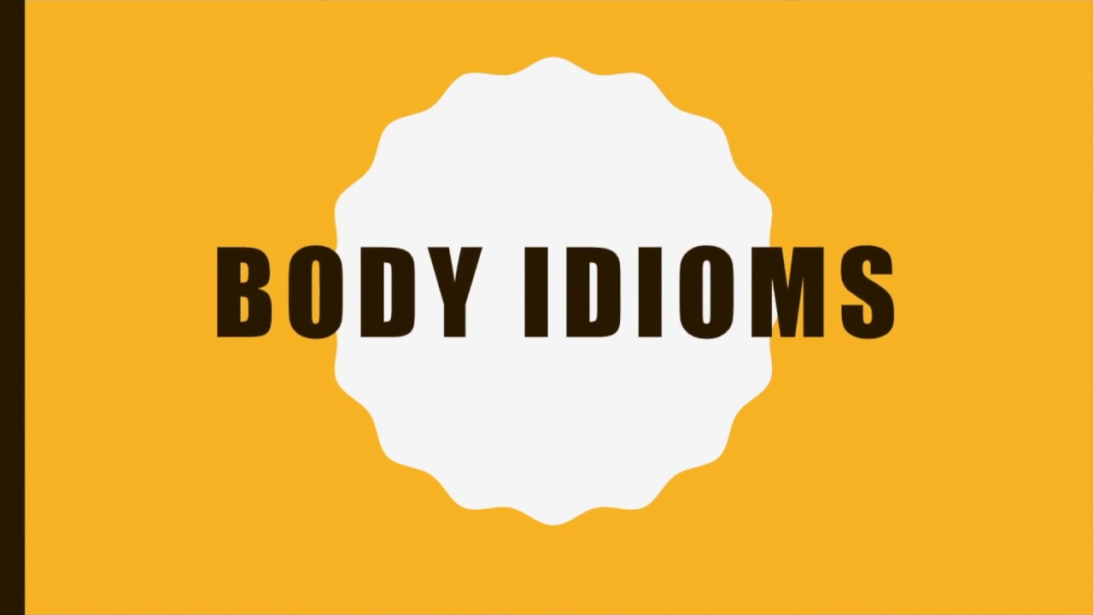
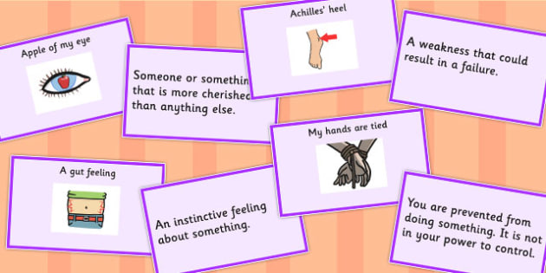
Exercise 1
Translate the following words and expressions
https://quizlet.com/318523520/flashcards
Exercise 2
Match idioms with their definitions
Сделать выпадающий список
- be unaware or unrealistic about something
- an advantage that someone has over other people in something such as a competition or race
- nearby location or region
- taking on a task that you can't handle
- recognition or a thank-you
- not very intelligent
- promise to keep a secret
- just barely
- do something without a plan
- an experienced person (by the) skin of one's teeth
head start
lips are sealed
play something by ear
thick in the head
have one's head in the clouds
neck of the woods
in over one's head
pat on the back
(an) old hand
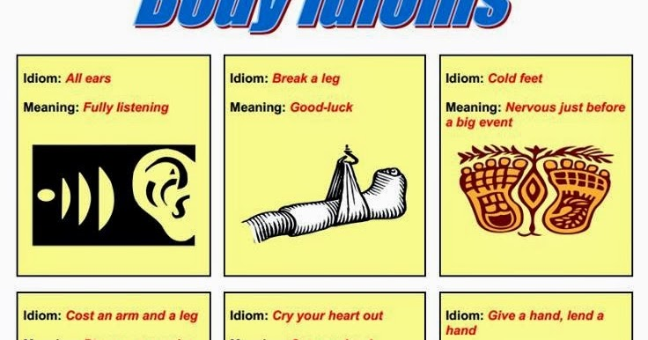
Exercise 3
Fill in the gaps
head start my flesh and blood give you a hand
in over my head pulling your leg cried my heart out
break a leg my lips are sealed has her head in the clouds
Today's the big game, eh? _____!
I _____ when my best friend moved away.
I was surprised at how much I cared for this girl who wasn't even _____.
I can_____ when you move if you like.
Amy _____ if she thinks she's going to pass her exams without studying.
I was just _____. I'm not really a police officer.
The kids gave Anthony a _____ in the bicycle race because he was the youngest.
I was _____ when I agreed to babysit the triplets and the dogs.
Don't worry, I won't tell your mother how much you spent. _____.
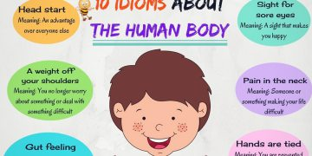
Exercise 4
Choose the right idiom
1. It was such a sad movie that I _____.
cried my heart out
got cold feet
was in over my head
2. He's got long hair because the hairdresser costs _____.
an old hand
an arm and a leg
a head start
3. I'm sure someone will find your kitten, so _____.
see eye to eye
stick your neck out
keep your chin up
4. She loves cakes and ice-cream. She's got a real sweet _____.
mouth
tongue
tooth
5. I'm just _______ your leg. I didn't really dye my hair blue.
shaking
breaking
pulling
6. I like to drink wine and _______ on Saturday nights.
make my blood boil
go head over heels
let my hair down
7. Let's get together in my _______ of the woods for once.
neck
hand
foot
8. We're going away for the week. Can you keep _______ on our house?
an eye
a hair
a foot
9. It makes my _______ when people try to cheat.
teeth ache
head start
blood boil
10. She knows of all her friends' phone numbers by ______.
mind
heart
eye
11. I'll ______ on the dinner while you're on the phone.
keep an eye
head start
keep the chin up
12. My uncle's ______ at car repair. He'll know what the problem is.
too long in the tooth
an old hand
head over heels
13. My daughter wants a tattoo. I told her she'd get one ______.
over my dead body
in the neck of woods
long in the tooth
14. The conference organizers deserve ______ for a job well done.
head start
rule of thumb
a pat on the back
15. We don't know if the weather will be good enough for camping. We'll have to ______.
see eye to eye
play it by ear
face the music
16. The ______ is that the students wear black pants and white shirts.
rule of thumb
neck of woods
elbow grease
17. The couple don't ______ on how to raise their children.
face the music
give a cold shoulder
see eye to eye
18. I______ Bessie when she was thrown out of her house.
washed my hands of
stuck my neck out for
was thick in the head

Exercise 5
Make your own sentences using the idioms you know
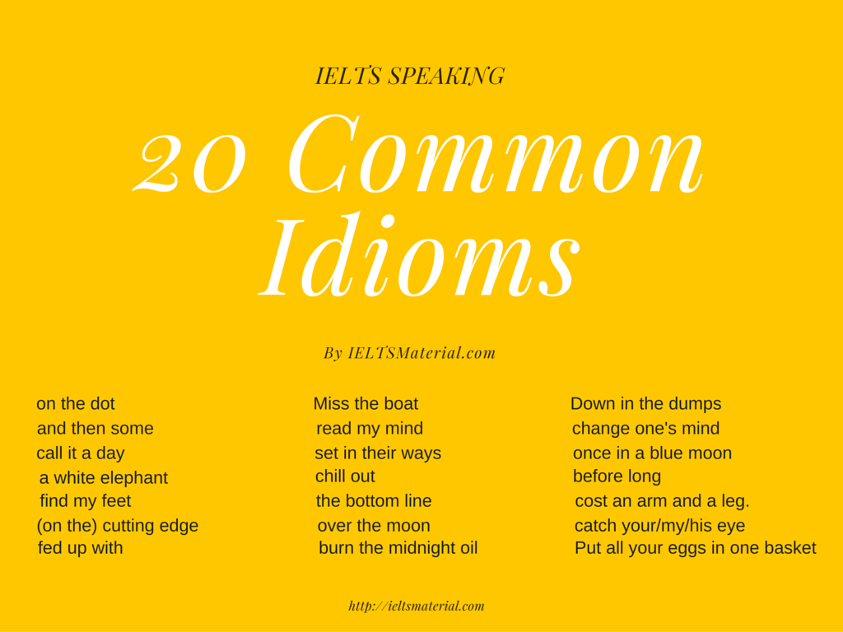
Key
Exercise 2
Match idioms with their definitions
be unaware or unrealistic about something | have one's head in the clouds
an advantage that someone has over other people in something such as a competition or race | head start
nearby location or region | neck of the woods
taking on a task that you can't handle | in over one's head
recognition or a thank-you | pat on the back
not very intelligent | thick in the head
promise to keep a secret | lips are sealed
just barely | (by the) skin of one's teeth
do something without a plan | play something by ear
an experienced person | (an) old hand

Exercise 3
Fill in the gaps
Today's the big game, eh? _____ break a leg!
I _____ cried my heart out when my best friend moved away.
I was surprised at how much I cared for this girl who wasn't even _____ my flesh and blood.
I can_____ give you a hand when you move if you like.
Amy _____ has her head in the clouds if she thinks she's going to pass her exams without studying.
I was just _____ pulling your leg. I'm not really a police officer.
The kids gave Anthony a _____ head start in the bicycle race because he was the youngest.
I was _____ in over my head when I agreed to babysit the triplets and the dogs.
Don't worry, I won't tell your mother how much you spent. _____ my lips are sealed.
Exercise 4
Choose the right idiom
1. It was such a sad movie that I _____.
cried my heart out
got cold feet
was in over my head
2. He's got long hair because the hairdresser costs _____.
an old hand
an arm and a leg
a head start
3. I'm sure someone will find your kitten, so _____.
see eye to eye
stick your neck out
keep your chin up
4. She loves cakes and ice-cream. She's got a real sweet _____.
mouth
tongue
tooth
5. I'm just _______ your leg. I didn't really dye my hair blue.
shaking
breaking
pulling
6. I like to drink wine and _______ on Saturday nights.
make my blood boil
go head over heels
let my hair down
7. Let's get together in my _______ of the woods for once.
neck
hand
foot
8. We're going away for the week. Can you keep _______ on our house?
an eye
a hair
a foot
9. It makes my _______ when people try to cheat.
teeth ache
head start
blood boil
10. She knows of all her friends' phone numbers by ______.
mind
heart
eye
11. I'll ______ on the dinner while you're on the phone.
keep an eye
head start
keep the chin up
12. My uncle's ______ at car repair. He'll know what the problem is.
too long in the tooth
an old hand
head over heels
13. My daughter wants a tattoo. I told her she'd get one ______.
over my dead body
in the neck of woods
long in the tooth
14. The conference organizers deserve ______ for a job well done.
head start
rule of thumb
a pat on the back
15. We don't know if the weather will be good enough for camping. We'll have to ______.
see eye to eye
play it by ear
face the music
16. The ______ is that the students wear black pants and white shirts.
rule of thumb
neck of woods
elbow grease
17. The couple don't ______ on how to raise their children.
face the music
give a cold shoulder
see eye to eye
18. I______ Bessie when she was thrown out of her house.
washed my hands of
stuck my neck out for
was thick in the head

