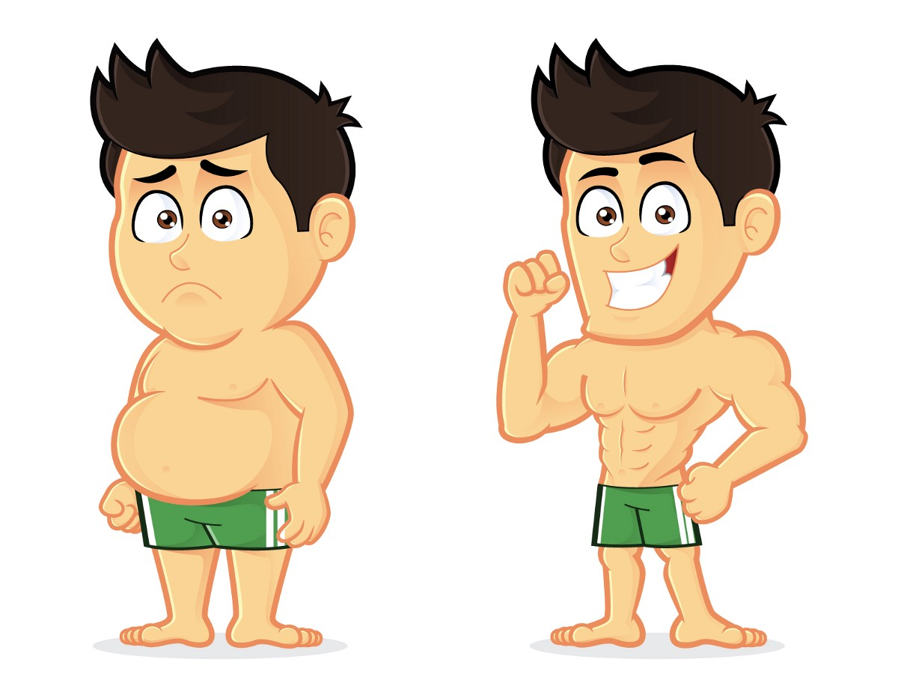

Task 1
Use the present simple or continuous tenses and future forms to complete this text.
1.I ... (not do) housework on Sundays normally.
2.But tomorrow I ... (tidy) my room, because my boyfriend Jim ... (come). 3.The bus ... (arrive) at 10.
4.I think Jim ... (come) on time as usual, because he ... (like) to be punctual.
5.I ... (look) forward to him.
6.We ... (have) a date every Sunday and I ... (always look) forward to him. 7.Tomorrow we ... (have) a special date.
8.We .... (go) to see his parents.
9.We ... (have) a good time, I hope.

Task 2
Choose the correct tenses.
1....Frank in Toronto? a) Did you meet b) Have you met c) Were you meeting
2.He had a break after he ... for two hours. a) was walking b) had been walking c) has walked
3.I ... her for a long time. a) know b) have known c) have been knowing
4.We ... the windows and the car on Saturday morning. a) were cleaning b) cleaned c) have been cleaning
5.I ... in York for a week in 1998. a) worked b) have been working c) have worked
6.I ... you in your office with a girl! Really? We ... . a) saw - 've just talked b) 've seen - just talked c) saw - were just talking
7.How many cupboards … since yesterday? a) did they move b) have they moved c) have they been moving
8.As he ... a bike, a dog … him. a) was riding - bit b) rode - bit c) was riding - has bitten
9.When the dog ... him, he ... his bike. a) was biting - fell off b) bit - was falling off c) bit - fell off
10.I didn't notice that you … . a) had come b) came c) have been coming
11.I can't stand it anymore. I ... the furniture since breakfast. a) am polishing b) have been polishing c) have polished
12.... the dishes yet? a) Has he washed b) Has he been washing c) Did he wash
13.They ... a hotel in York, but then they ... it. a) have bought - sold b) bought - have sold c) bought - sold
14.She couldn't play yesterday because she ... her ankle the day before. a) have sprained b) sprained c) had sprained I can't find Todd.
15.Where is he? - He ... in the garage. a) 's been working b) worked c) was working
16.She ... books on the shelves all day. That's why she is so exhausted. a) was putting b) has put c) has been putting
17.The sun ... and we ... on the white sand. a) shone - were lying b) was shining - were lying c) shined - lay
18.You ... at last! Where ... so long? a) arrived - have you been b) have arrived - have you been c) arrived - were you
19.I was so relaxed because I ... anything all day. a) have not been doing b) didn't do c) had not been doing
20.What's your teaching experience? ... anyone? a) Have you ever taught b) Did you ever teach c) Have you ever been teaching
21.She's hurt her arm. - When ... it? a) has she hurt b) has she hurted c) did she hurt
22.Where is Mum? - She ... the shopping all the morning. a) has done b) has been doing c) was doing
23.At 9.30 I ... a documentary on TV. It ... at 9.20. a) was watching - had started b) watched - has started c) watched – started

Task 3
Use the words in brackets and write the sentences in the future continuous or future perfect simple and continuous tenses. Keep similar meaning.
Example: I'll be on the 10.25 train to London. (travel) At 10.25 I'll be travelling to London.
1.The tickets will be available on Tuesday. (printed) The tickets ... by Tuesday.
2.I must replace the lock after lunch. (repairing) I … the lock after lunch.
3.Bruce is not willing to give us a hand on Saturday morning. (help) Bruce ... us on Saturday morning.
4.There's a film on our programme tonight. (be) We ... a film tonight.
5.I like this pen. Will you need it today? (using) I like this pen. ... ?
6.In ten years' time most teenagers will have their own cars. (driving) In ten years' time more and more teenagers ... their own cars.
7.We will have a new motorway this year. (built) They ... a new motorway by the end of this year.
8.They started to build this motorway two years ago. (building) By the end of this year they ... this motorway for three years.
9.I have a lot of texts to translate for tomorrow. (be) I … a lot of texts today.
10.By the year 2020 there will be no water in this lake. (disappeared) By the year 2020 all the water ... from this lake.
11.This is my fifth day in bed. (lying) Tonight I ... in my bed for five days.
Task 4
Read the first sentence and find a sentence with similar meaning in part A or B.
1. In a couple of hours there will be no goods on the shelves.
A. In a couple of hours all goods on the shelves will be disappearing.
B. In a couple of hours all goods on the shelves will have disappeared.
2. This is my second year at university.
A. This year I'll have been studying at university for two years.
B. This year I'll be studying at university for two years.
3. Please, don't call me while I'm driving to work in the morning.
A. I'll have been driving to work at seven, so don't call me.
B. I'll be driving to work at seven, so don't call me.
4. Five years from now, companies will have most customers on the Internet.
A. In five years' time, most people in the world will be shopping on the Internet.
B. In five years' time, most people in the world will have shopped on the Internet.
5. We started our journey two weeks ago and we'll reach our destination in a week.
A. We will have travelled for two weeks now.
B. We will have been travelling for two weeks now.
6. He is going to finish his work at the end of November.
A. He'll be finishing his work at the end of November.
B. He'll have been finishing his work at the end of November.
7. We'll have the new laptop on Saturday.
A. We'll have been buying the new laptop on Saturday.
B. We'll have bought the new laptop by the end of this week.
8. One week from today we will be in Paris.
A. This time next week we'll be visiting Paris.
B. This time next week we'll have visited Paris.
9. In the year 2100 people will be computer literate for more than a hundred years.
A. In the year 2 100 people will be using computers for more than a century.
B. In the year 2 100 people will have been using computers for more than a century.
Task 5
Translate the affirmative and negative sentences by using appropriate verb tenses.
1. Каждое утро солнце светит в окно моей спальни и будит меня.
2. Обычно Сэм сидит во время урока в первом ряду, но сегодня он сидит в последнем ряду.
3. Он уже разговаривал с юристом по телефону.
4. Лина сказала, что ждала тебя с утра.
5. Мы занимаемся английским два месяца.
6. Мы закончим нашу работу к 2 часам дня.
7. Когда она пришла, Петр смотрел телевизор.
8. Он сказал, что сделал всю работу.
9. Он будет работать два часа к тому времени, как мы придём ему помогать.
10. Вчера он ответил на ваш вопрос.
11. Я буду ждать тебя ровно в десять.
12. Я здесь с девяти утра.
13. Вор просто вошёл. Кто-то забыл запереть дверь.
14. Он работает в одном и том же магазине пять лет.
15. Маргарет приехала в Лондон в 1990 году. К 2010 году она проживет там 20 лет.
16. Анна переводит статью, поэтому её не беспокой.
17. Сегодня тоже занятий нет. Можно пойти погулять.
18. Я отправила сообщение моему другу на прошлой неделе. Он ещё не ответил. Я всё ещё жду ответа.
19. В прошлом году в это время я уже не посещал школу.
20. Не звони мне в десять. Меня не будет дома. Я буду заниматься в библиотеке.

ANSWERS
Task 1
1.I don't do housework
2.I am going to tidy, Jim is coming
3.the bus arrives
4.Jim will come, he likes to be
5.I am looking
6.we have a date, I always look forward
7.we are having
8.we are going to see
9.we will have
Task 2
1.a Did you meet
2.b had been walking
3.b have known
4.b cleaned
5.a worked
6.c saw - were just talking
7.b have they moved
8.a was riding - bit
9.c bit - fell off
10.a had come
11.b have been polishing
12.a has he washed
13.c bought - sold
14.c had sprained
15.a 's been working
16.c has been putting
17.b was shining - were lying
18.b have arrived-have you been
19.c had not been doing
20.a have you ever taught
21.c did she hurt
22.b has been doing
23.a was watching – started

Task 3
1.The tickets will have been printed
2.I'll be repairing
3.Bruce will not be helping us
4.We will be watching
5.Will you be using it today?
6.most teenagers will be driving
7.They will have built
8.they will have been building
9.I'll be translating
10.water will have disappeared
11.I'll have been lying

Task 4
1. B In a couple of hours all goods on the shelves will have disappeared.
2. A This year I'll have been studying at university for two years.
3. B I'll be driving to work at seven, so don't call me.
4. A In five years' time, most people in the world will be shopping on the Internet.
5. B We will have been travelling for two weeks now.
6. A He'll be finishing his work at the end of November.
7. B We'll have bought the new laptop by the end of this week.
8. A This time next week we'll be visiting Paris.
9. B In the year 2 100 people will have been using computers for more than a century.

Task 5
1. Every morning the sun shines in my bedroom window and wakes me up.
2. Sam usually sits in the front row during class, but today he is sitting in the last row.
3. He has already talked to (spoken with/to) the lawyer on the phone.
4. Lina said (that) she had been waiting for you since morning. (Lina has said she has been waiting...)}
5. We have been studying (learning) English for two months.
6. We will have finished (colloq. We will finish...) our work by 2 p.m.
7. When she came, Peter was watching TV (television).}
8. He said (that) he had done all (of) the work. (He has said he has done...)
9. He will have been working for two hours by the time we come to help him. (colloq. He will be working...)
10. Yesterday he answered (replied to) your question.
11. I will be waiting for you at exactly ten (at ten o’clock sharp).
12. I have been here since 9 a.m.
13. The thief simply walked in (entered). Someone had forgotten to lock the door.
14. He has been working (has worked) at the same store for five years.
15. Margaret came to London in 1990. By the year 2010 she will have been living (will have lived) there for 20 years.
16. Ann is translating the article, so don’t bother (disturb) her!
17. There are no classes today either. You (we) can go for (take) a walk.
18. I sent a message to my friend last week. He has not answered yet. I am still waiting for a reply.
19. Last year at this time I was no longer attending school.
20. Don’t call me at ten. I will not (won’t) be (at) home. I will be studying at the library.

