**Lesson 25 Six Senses**



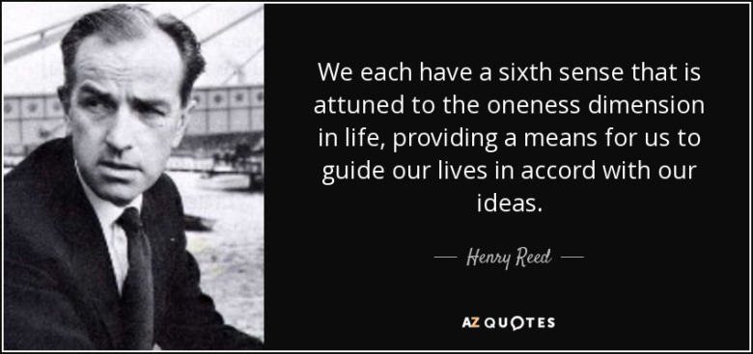

**Exercise 1**

**Translate the following words and expressions**

<https://quizlet.com/115603277/flashcards/starred>

**Note:**

Our basic five senses are **sight, hearing, taste, touch and smell**. What is sometimes referred to as a 'sixth sense' is a power to be aware of things independently of the five physical senses, a kind of supernatural sense.  
The five basic verbs referring to the senses are modified by an adjective rather than an adverb.

***Example:***

He ***looks*** dreadful.   
The trip ***sounds*** marvelous.

The cake ***tastes*** good.

It ***felt*** strange.   
The soup ***smelt*** delicious.

**Exercise 2**

**Match sentences 1-8 with sentences a-h**

1. You come downstairs in the morning and smell fresh coffee.
2. A friend has just had her hair cut.
3. You hear the record that is top of the pops.
4. A friend, an excellent cook, tries a new soup recipe.
5. A friend asks how you feel today.
6. A little boy asks you to listen to his first attempts at the piano.
7. You see a friend of yours with a very worried look on her face.
8. Someone you are working with smells strongly of cigarettes.

a) You look upset. What's the matter?  
b) Your hair looks great.  
c) It sounds brilliant.   
d) I feel great.  
e) This tastes delicious  
f) He smells disgusting.  
g) That smells wonderful.   
h) That sounds fantastic.

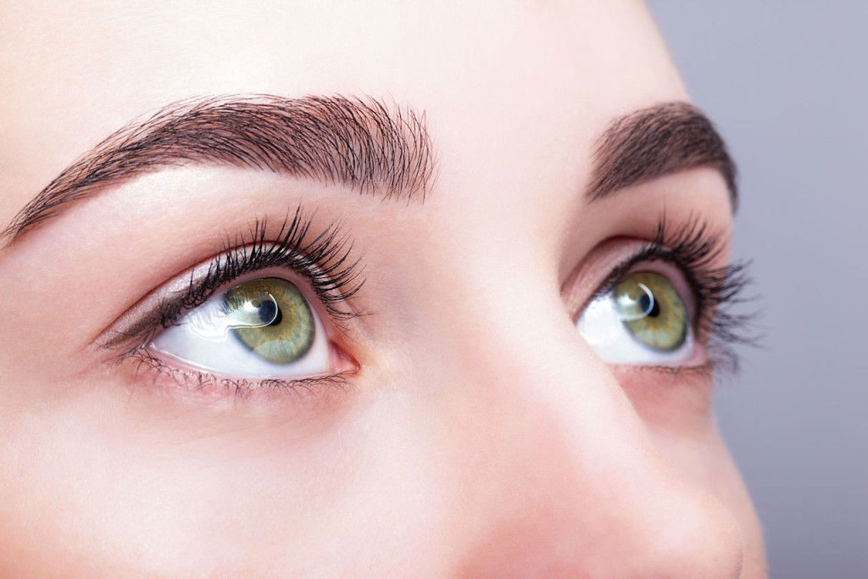

**Exercise 3**

**Fill in the gaps. Pay attention to the description of the words in brackets glimpsed saw**  **peering**  **noticed** **gazed   
observing** **witnessed staring** **glanced**

Yesterday I _____ *(look quickly)* out of the window and _____ *(pay attention to something)* a man _____ *(look in a scientific kind of way)* a house opposite through a telescope. I thought I _____ *(see or perceive briefly of partially)* a woman inside the house. Then I _____ *(perceive with the eyes)* someone else _____ *(look closely, finding it hard to make things out)* into the window of the same house. I _____*(look steadily and intently, esp. with thought)* at them wondering what they were doing. Suddenly the first man stopped _____ *(look fixedly)* through his telescope. He went and hit the other one on the head with the telescope and I realized that I had _____ *(look as a crime or accident occurs)* a crime.



**Exercise 4**

**Replace the underlined words with a more interesting and precise verb**

1. I saw a crime.   
a) glanced  
b) observed

c) witnessed

2. He looked fixedly at me.   
a) glimpsed  
b) stared  
c) noticed

3**.** She took my hand firmly.   
a) stroked  
b) grasped  
c) handled

4. Touch the button to start.   
a) press

b) tap  
c) snatch

***5.*** He touched the cat affectionately.   
a) tapped  
b) patted  
c) stroked

6. The zoologist looked at the lion's behavior.   
a) glimpsed  
b) observed  
c) peered

7. The robber took the money and ran.  
a) grabbed  
b) handled  
c) pawed

8. I quickly looked at my watch.  
a) tapped  
b) glanced  
c) patted

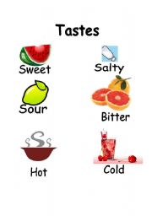

**Exercise 5**

**Match items1-6 with types of taste a-f**

1 unsweetened coffee

2 pineapple

3 chilli

4 lime

5 Chinese cooking

6 sea water

a) sweet  
b) salty   
c) bitter   
d) sour   
e) spicy  
f) hot

**Touch**

Some good verbs for describing different ways of touching.

She nervously **fingered** her collar.   
He **stroked** the cat and **patted** the dog.

She **tapped** him on the shoulder.   
He **grasped** my hand and we ran.

She **grabbed** her bag and ran.   
It's rude to **snatch**.   
**Press** the button.

Please **handle** the goods with great care.

The secretaries complained that their boss was always **pawing** them.

Exercise 6

**Exercise 6**

**Match the verbs used with these definitions.**

1 to take something very quickly

2 to move between the fingers  
**3** to touch with the hands   
4 to touch in an offensive way

a) handle

b) paw  
c) snatch  
d) finger



**Exercise 7**

**Which of the adjectives in describes best for you the smell of the following?**

1 herbs in a kitchen   
a) aromatic  
b) smelly  
c) scented

2 old socks   
a) fragrant   
b) smelly  
c) scented

3rotten eggs   
a) sweet-smelling  
b) fragrant  
c) evil-smelling

4 roses

a) stinking  
b) fragrant   
c) scented

5 a hairdresser's  
a) scented  
b) evil-smelling  
c) smelly



**Exercise 8   
Which of the phenomena mentioned in have you experienced if you:**

1 see a flying saucer?

2 suddenly think of someone two minutes before they phone you?

3 see someone in white disappearing into a wall?

4 feel certain someone cannot be trusted although you have no real reason to believe so?

5 walk into a strange room and feel you have been there before?

6 refuse to travel on a plane because you feel something bad is going to happen?

a) telepathy   
b) ghosts   
c) UFOs   
d) premonitions   
e) intuition   
f) déjà vu

**Key**

**Exercise 2**

**Match sentences 1-8 with sentences a-h**

1. You come downstairs in the morning and smell fresh coffee.  
    **g) That smells wonderful.**
2. A friend has just had her hair cut.   
   **b) Your hair looks great.**
3. You hear the record that is top of the pops. **c) It sounds brilliant.**
4. A friend, an excellent cook, tries a new soup recipe. **e) This tastes delicious**
5. A friend asks how you feel today.  
    **d) I feel great.**
6. A little boy asks you to listen to his first attempts at the piano. **h) That sounds fantastic.**
7. You see a friend of yours with a very worried look on her face. **a) You look upset. What's the matter?**
8. Someone you are working with smells strongly of cigarettes. **f) He smells disgusting.**

**Exercise 3**

**Fill in the gaps. Pay attention to the description of the words in brackets**

Yesterday I _____ **glanced** *(look quickly)* out of the window and _____**noticed** *(pay attention to something)* a man _____ **observing** *(look in a scientific kind of way)* a house opposite through a telescope. I thought I _____**glimpsed** *(see or perceive briefly of partially)* a woman inside the house. Then I _____**saw** *(perceive with the eyes)* someone else _____**peering** *(look closely, finding it hard to make things out)* into the window of the same house. I _____**gazed** *(look steadily and intently, esp. with thought)* at them wondering what they were doing. Suddenly the first man stopped _____ **staring** *(look fixedly)* through his telescope. He went and hit the other one on the head with the telescope and I realized that I had _____**witnessed** *(look as a crime or accident occurs)* a crime.

**Exercise 4**

**Replace the underlined words with a more interesting and precise verb**

1. I saw a crime.   
a) glanced  
b) observed

**c)** **witnessed**

2. He looked fixedly at me.   
a) glimpsed  
**b) stared**  
c) noticed

3**.** She took my hand firmly.   
a) stroked  
**b) grasped**  
c) handled

4. Touch the button to start.   
**a) press**

b) tap  
c) snatch

***5.*** He touched the cat affectionately.   
a) tapped  
b) patted  
**c) stroked**

6. The zoologist looked at the lion's behavior.   
a) glimpsed  
**b) observed**  
c) peered

7. The robber took the money and ran.  
**a) grabbed**  
b) handled  
c) pawed

8. I quickly looked at my watch.  
a) tapped  
**b) glanced**  
c) patted

**Exercise 5**

**Match items1-6 with types of taste a-f**

1 unsweetened coffee c) bitter

2 pineapple a) sweet

3 chilli f) hot

4 lime d) sour

5 Chinese cooking e) spicy

6 sea water b) salty

**Exercise 6**

**Match the verbs used with these definitions.**

1 to take something very quickly c) snatch

2 to move between the fingers d) finger  
3to touch with the hands a) handle  
4 to touch in an offensive way b) paw

**Exercise 7**

**Which of the adjectives in describes best for you the smell of the following?**

1 herbs in a kitchen   
**a) aromatic**  
b) smelly  
c) scented

2 old socks   
a) fragrant   
**b) smelly**c) scented

3rotten eggs   
a) sweet-smelling  
b) fragrant  
**c) evil-smelling**

4 roses

a) stinking  
**b) fragrant**   
c) scented

5 a hairdresser's  
**a) scented**  
b) evil-smelling  
c) smelly

**Exercise 8   
Which of the phenomena mentioned in have you experienced if you:**

1 see a flying saucer?   
**c) UFOs**

2 suddenly think of someone two minutes before they phone you? **a) telepathy**

3 see someone in white disappearing into a wall? **b) ghosts**

4 feel certain someone cannot be trusted although you have no real reason to believe so? **e) intuition**

5 walk into a strange room and feel you have been there before? **f) déjà vu**

6 refuse to travel on a plane because you feel something bad is going to happen? **d) premonitions**