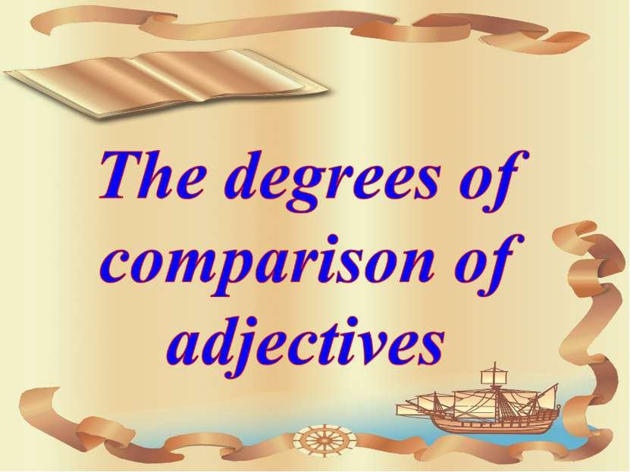
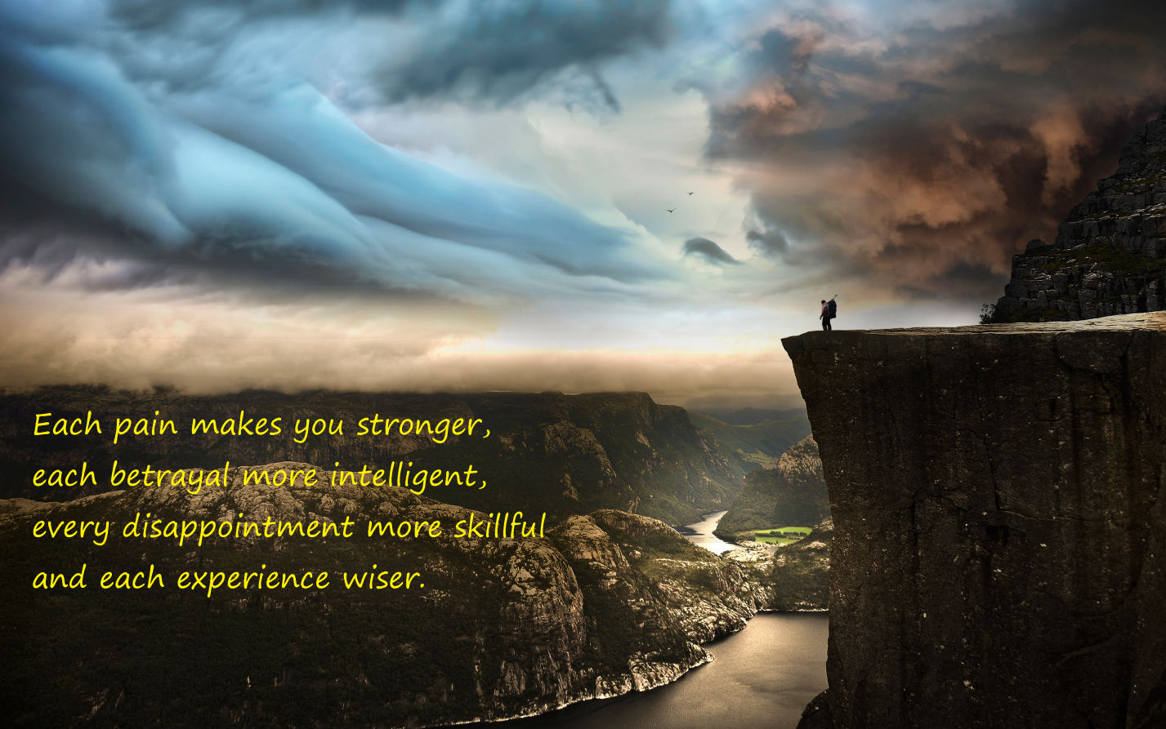

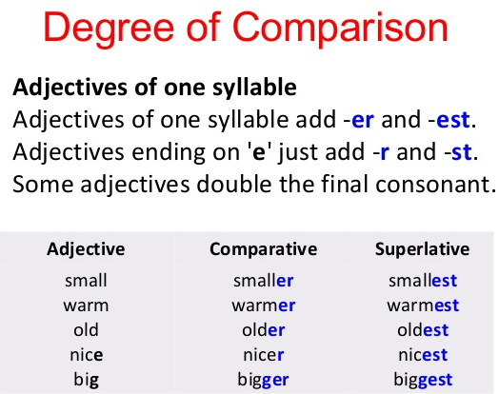

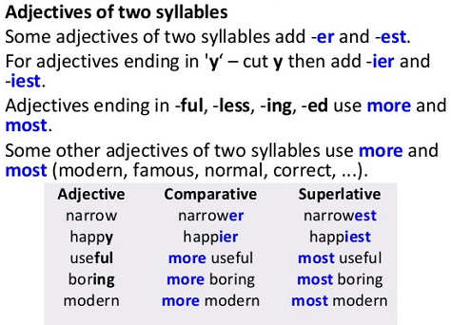

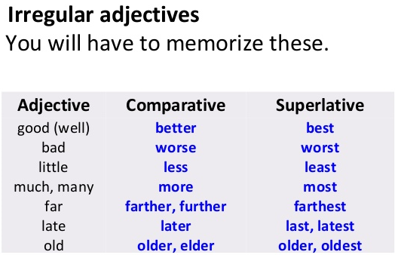
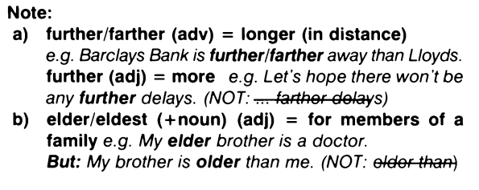

I. Put the adjectives in brackets into the comparative or superlative form.
1. Did you enjoy the film?
Yes. It was funnier / the funniest film I've ever seen.

2. James is very tall.
Yes. He's taller / the tallest boy in our class.

3. Was it a good party?
Yes. I left far later / the latest than I had intended to.

4. Did you like the black dress?
Yes, but it was far expensiver / more expensive than the blue one.

5. Why do you want to go to Spain?
Because it's much warmer / the warmest than England.

6. Do you enjoy your job?
Oh, yes. It's the best / gooder / better job I've ever had.

7. If you need any farther / further help. Just ask me.
Thank you. That‘s very kind of you.

8. My teacher is very clever.
Yes. She’s the most intelligent / more intelligent woman I've ever met.

9. Dinosaurs were biger / biggest / bigger than houses.
I know. They were enormous.

10. How much did you pay for that bag?
£ 5. It was the cheapest / cheapest / cheaper one I could find.

11. That exam was really difficult.
I agree. It was a lot the most difficult / more difficult than I had expected.

12. Have you heard James playing the piano lately?
Yes, but he doesn't seem to be getting any gooder / better / best.

II. Choose the correct answer.

1) I've never drunk a better beer.
- This is one of the most good beers I've ever drank.
- This is one of the best beers I've ever drunk.
- This is one of the goodest beers I've ever drunk.

2) I've never seen a prettier girl.
- This is one of the prettiest girls I've ever seen.
- This is one of the best girls I've ever seen.
- This is one of the most pretty girls I've ever seen.

3) I've never met a wiser man.
- This is one of the most wise men I've ever met.
- This is one of the wisest men I've ever met.
- This is one of the wisest men I've never meeted.

4) I've never seen a more careful woman.
- This is one of the most careful women I've ever seen.
- This is one of the carefullest women I've ever seen.
- This is one of the carefulest women I've ever seen.

5) I've never had a more reliable car.
- This is one of the most reliable cars I've ever had.
- This is one of the reliabler cars I've ever have.
- This is one of the reliablest cars I've ever had.

6) I've never had a more trustworthy friend.
- This is one of the trustworthiest friends I've ever had.
- This is one of the trustworthy friends I've ever had.
- This is one of the most trustworthy friends I've ever had.

7) I've never experienced a happier moment.
- This is one of the happier moments I've ever experienced.
- This is one of the most happy moments I've ever experienced.
- This is one of the happiest moments I've ever experienced.

8) I've never done a more difficult exercise.
- This is one of the difficultest exercises I've ever done.
- This is one of the most difficult exercises I've ever done.
- This is one of the most difficult exercises I've ever did.

9) They've never been to a more expensive restaurant.
- This is of the most expensive restaurants they've ever been.
- This is one of the expensivest restaurants they've ever been to.
- This is one of the most expensive restaurants they've ever been to.

10) Linda has never lived in a hotter country.
- This is one of the most hot countries Linda has ever lived in.
- This is one of the hottest countries Linda've ever lived in.
- This is one of the hottest countries Linda's ever lived in.

III. Correct the mistakes.
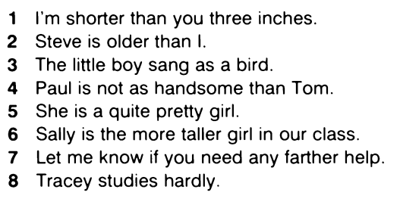

IV. Compare the following hobbies using the adjectives from the list.
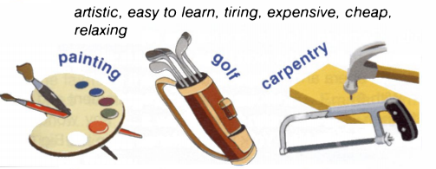

V. Choose the correct form of the comparative or superlative and complete the sentences with your own ideas.
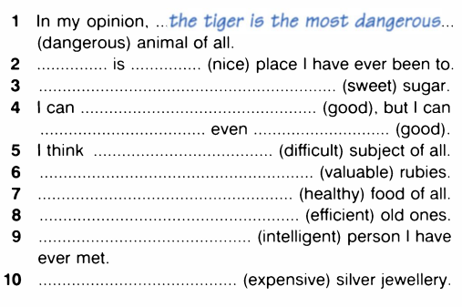

Answers:

I. Put the adjectives in brackets into the comparative or superlative form.
1. Did you enjoy the film?
Yes. It was funnier / the funniest film I've ever seen.

2. James is very tall.
Yes. He's taller / the tallest boy in our class.

3. Was it a good party?
Yes. I left far later / the latest than I had intended to.

4. Did you like the black dress?
Yes, but it was far expensiver / more expensive than the blue one.

5. Why do you want to go to Spain?
Because it's much warmer / the warmest than England.

6. Do you enjoy your job?
Oh, yes. It's the best / gooder / better job I've ever had.

7. If you need any farther / further help. Just ask me.
Thank you. That‘s very kind of you.

8. My teacher is very clever.
Yes. She’s the most intelligent / more intelligent woman I've ever met.

9. Dinosaurs were biger / biggest / bigger than houses.
I know. They were enormous.

10. How much did you pay for that bag?
£ 5. It was the cheapest / cheapest / cheaper one I could find.

11. That exam was really difficult.
I agree. It was a lot the most difficult / more difficult than I had expected.

12. Have you heard James playing the piano lately?
Yes, but he doesn't seem to be getting any gooder / better / best.

II. Choose the correct answer.

1) I've never drunk a better beer.
- This is one of the most good beers I've ever drank.
- This is one of the best beers I've ever drunk.
- This is one of the goodest beers I've ever drunk.

2) I've never seen a prettier girl.
- This is one of the prettiest girls I've ever seen.
- This is one of the best girls I've ever seen.
- This is one of the most pretty girls I've ever seen.

3) I've never met a wiser man.
- This is one of the most wise men I've ever met.
- This is one of the wisest men I've ever met.
- This is one of the wisest men I've never meeted.

4) I've never seen a more careful woman.
- This is one of the most careful women I've ever seen.
- This is one of the carefullest women I've ever seen.
- This is one of the carefulest women I've ever seen.

5) I've never had a more reliable car.
- This is one of the most reliable cars I've ever had.
- This is one of the reliabler cars I've ever have.
- This is one of the reliablest cars I've ever had.

6) I've never had a more trustworthy friend.
- This is one of the trustworthiest friends I've ever had.
- This is one of the trustworthy friends I've ever had.
- This is one of the most trustworthy friends I've ever had.

7) I've never experienced a happier moment.
- This is one of the happier moments I've ever experienced.
- This is one of the most happy moments I've ever experienced.
- This is one of the happiest moments I've ever experienced.

8) I've never done a more difficult exercise.
- This is one of the difficultest exercises I've ever done.
- This is one of the most difficult exercises I've ever done.
- This is one of the most difficult exercises I've ever did.

9) They've never been to a more expensive restaurant.
- This is of the most expensive restaurants they've ever been.
- This is one of the expensivest restaurants they've ever been to.
- This is one of the most expensive restaurants they've ever been to.

10) Linda has never lived in a hotter country.
- This is one of the most hot countries Linda has ever lived in.
- This is one of the hottest countries Linda've ever lived in.
- This is one of the hottest countries Linda's ever lived in.

III. Correct the mistakes.
