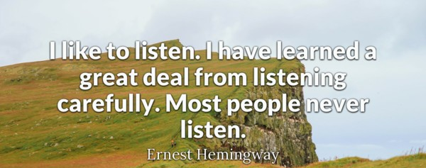
advanced_lesson_25_listening_part_3

Exercise 1
Listen to the audio and answer the questions
https://listenaminute.com/s/senses.html
- What is the sixth sense?
- sight
- the feeling of equilibrium
- the ability to predict future
- Which sense is the most important for the speaker?
- Taste
- Sight
- hearing

Exercise 2
Listen to the audio and answer the questions
Quizlet
https://quizlet.com/308422424/listening-25-adv-six-senses-flash-cards/?new

http://http-ws.bbc.co.uk.edgesuite.net/mp3/learningenglish/2009/04/090430_6min_smells_audio_for_web_2_au_bb.mp3
- The synonym for the word trigger can be..
- turn up
- evoke
- disappear

- What does lavender remind the speaker of?
- A house she used to live in
- Her grandma
- Her hometown
- Smelling influences our memories more emotionally intense.
- True
- False
- A word scent has a negative meaning.
- True
- False
- A word odour can be related to some pleasant food or drinks.
- True
- False
- As we get older our sense of smelling gets..
- Better
- worse

Exercise 3
Choose the correct word to describe the smell
fragrance - odour – stink - aroma
- fresh lemonade with mint
- rotten onion
- vanilla soap
- sweaty T-shirt

Exercise 4
Watch the video and answer the questions
https://www.youtube.com/watch?v=yJBWjmAfBOs
- Where did the story about Titanic first appear?
- In the movie
- In the book
- In the newspaper
- What is premonition?
- The ability to see the past
- The ability to predict the future
- When a person has no senses
- What kind of premonition is the most common mentioned in the video?
- About natural disasters
- About political situations
- About health problems
- What do people feel having premonition?
- Frustration
- Fatigue
- Anxiety
- How many accidents did the Wall Street Executive predict?
- Three
- One
- Two
- What does the Wall Street Executive regret?
- Not going to the city center
- Not warning others about the probable accidents
- Ignoring his premonition

