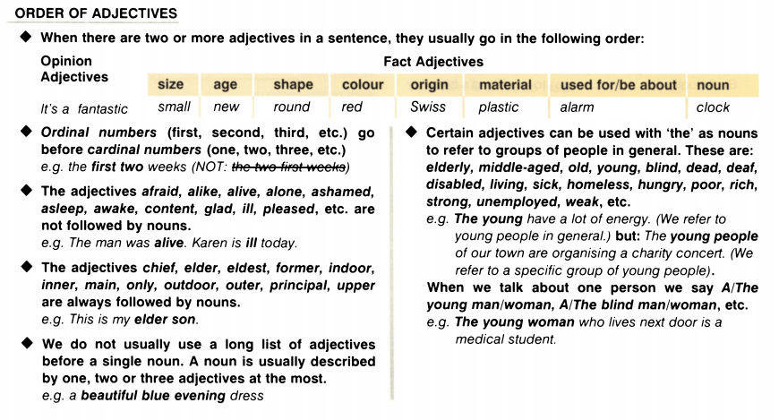

I. Put in order.
1. lovely | A | red | cotton | dress. |
2. An | amazing | American | big | car. | new | Ford |
3. knife. | A | long | butcher’s | steel |
4. An | young | English | slim | starlet. | attractive |
5. dog. | spotty | cute | brown | little | A |
6. clever | A | African | man. | middle-aged |
7. Siamese | grey | nice | cat. | A |
8. expensive | table. | wooden | Indian | old | An |
9. An | lady. | old | elegant | English |
10. fashionable | green | A | woolen | pullover. |
11. striped | scarf. | silk | square | chic | A |

II. Choose the correct answer.
1) They were the __________________ months of the year.
a) last sunny three
b) last three sunny
c) three last sunny
2) I broke her __________________ glasses.
a) two last crystal
b) last two crystal
c) crystal last two
3) What is Mike going to do in the __________________ ?
a) four next days
b) four days next
c) next four days
4) What a __________________ sculpture!
a) beautiful ivory Japanese
b) Japanese beautiful ivory
c) beautiful Japanese ivory
5) The big __________________ chairs were my grandfather's.
a) light red leather
b) red light leather
c) leather light red
6) John has bought a __________________ car
a) nice sporting red
b) nice red sporting
c) red nice sporting
7) These people live in a __________________ house.
a) big old brick
b) old big brick
c) brick old big
8) I won't be here for the __________________ of August.
a) two weeks first
b) first two weeks
c) two first weeks

III. Put the sentences in order.
1. town. | in | I | a | old, | live | Irish | small, |
2. house | see | building | is | over | pink | you’ll | that | there. | small | Her |
3. has | a | puppy. | brown | got | cute | She |
4. is | wearing | pair | large | a | plastic | shoes. | Betty | of |
5. attractive | old | him, | saw | he | was | slim | Italian. | I | an |
6. was | suit. | wearing | he | brother | black | fashionable | My | leather | a | came | in, |
7. delicious | loved | English | cakes | those | you | I | made. |
8. hat | in | funny | found | at | Look | cotton | blue | the | I | market! | the |
9. such | a | fell | we | with | it. | was | that | idea | in | It | lovely |
10. of | only | Don’t | is | so | week! | awful | the | one | day | be | rainy | nasty, | and | the | this |

IV. Describe the pictures using the correct order of adjectives.
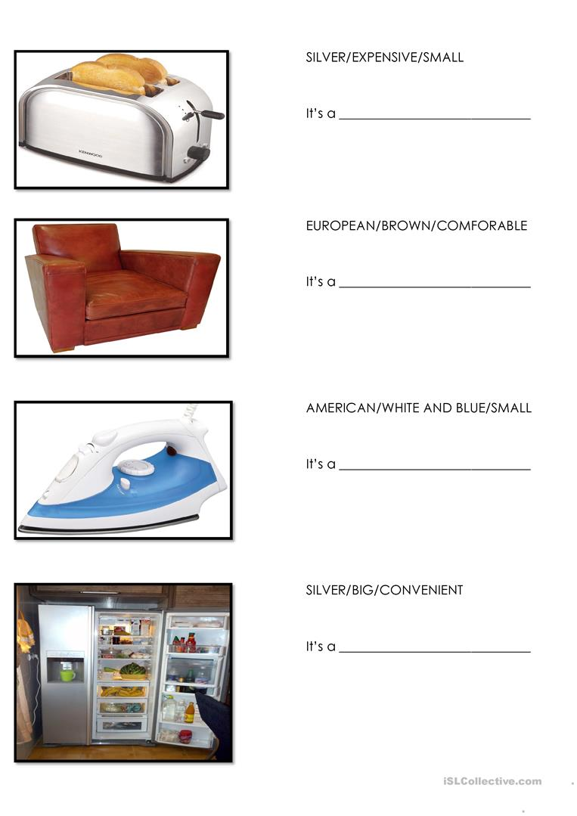

V. Put the sentences in order.
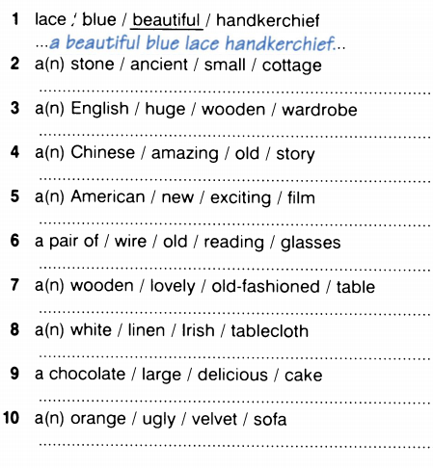

Answers:
I. Put in order.
1. A lovely red cotton dress.
2. An amazing big new American Ford car.
3. A long steel butcher's knife.
4. An attractive slim young English starlet.
5. A cute little brown spotty dog.
6. A clever middle-aged African man.
7. A nice grey Siamese cat.
8. An expensive old Indian wooden table.
9. An elegant old English lady.
10. A fashionable green woolen pullover.
11. A chic square striped silk scarf.

II. Choose the correct answer.
1) They were the __________________ months of the year.
a) last sunny three
b) last three sunny
c) three last sunny
2) I broke her __________________ glasses.
a) two last crystal
b) last two crystal
c) crystal last two
3) What is Mike going to do in the __________________ ?
a) four next days
b) four days next
c) next four days
4) What a __________________ sculpture!
a) beautiful ivory Japanese
b) Japanese beautiful ivory
c) beautiful Japanese ivory
5) The big __________________ chairs were my grandfather's.
a) light red leather
b) red light leather
c) leather light red
6) John has bought a __________________ car
a) nice sporting red
b) nice red sporting
c) red nice sporting
7) These people live in a __________________ house.
a) big old brick
b) old big brick
c) brick old big
8) I won't be here for the __________________ of August.
a) two weeks first
b) first two weeks
c) two first weeks

III. Put the sentences in order.
1. I live in a small, old, Irish town.
2. Her house is that small pink building you'll see over there.
3. She has got a cute brown puppy.
4. Betty is wearing a pair of large plastic shoes.
5. I saw him, he was an attractive slim old Italian.
6. My brother came in, he was wearing a fashionable black leather suit.
7. I loved those delicious English cakes you made.
8. Look at the funny blue cotton hat I found in the market!
9. It was such a lovely idea that we fell in with it.
10. Don't be so nasty, this is the one and only awful rainy day of the week!

