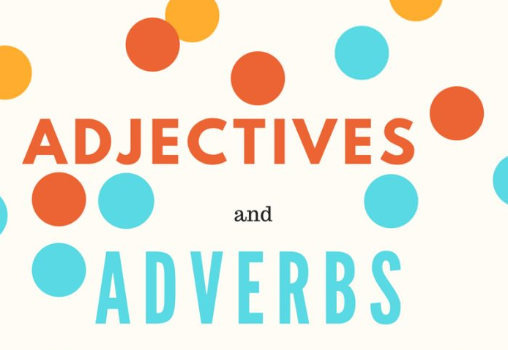
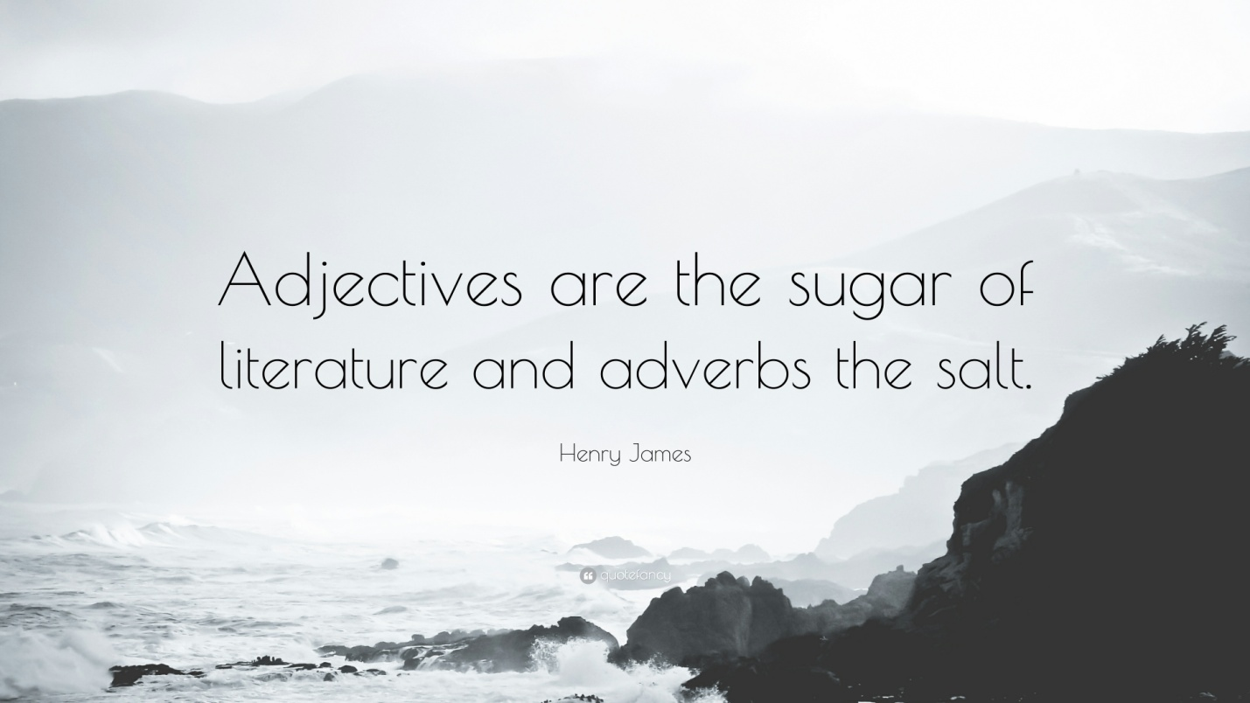

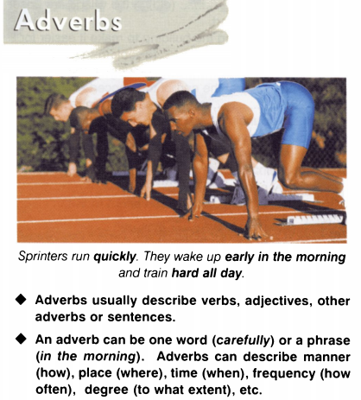
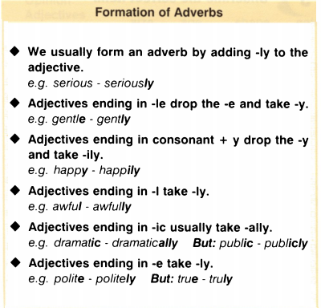

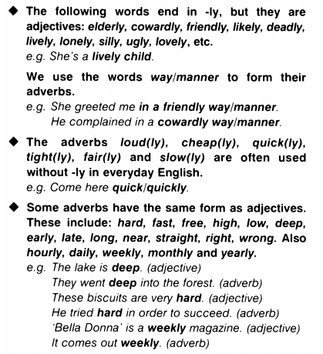
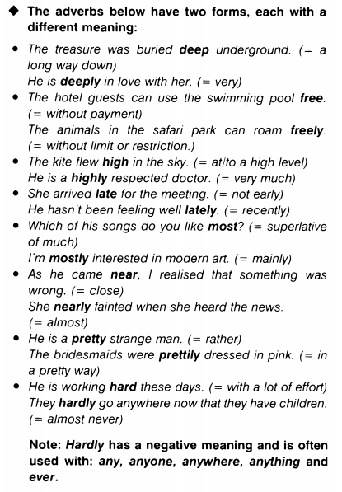
I. Choose the correct answer.
1. This is a pretty/prettily complicated situation.

2. They had hard/hardly been home for a minute when the phone rang.

3. My friends are most/mostly vegetarians.

4. Her loose outfit allowed her to move free/freely.

5. The shelf was so high/highly that he couldn't reach it.

6. John may be late/lately home tonight, as he has a lot of work to do.

7. The room was pretty/prettily decorated.

8. Children under five years old travel free/freely.

9. Sue has near/nearly finished her homework.

10. They have been going out a lot late/lately.

11. This college is high/highly recommended for its range of courses.

12. The miners dug deep/deeply to find coal.

13. The new supermarket is very near/nearly our house.

14. He is deep/deeply involved in the scandal.

15. We found it hard/hardly to get used to living in a foreign country.

16. Which of Mel Gibson's films do you like most/mostly?

II. Choose the correct item.
It was Lucy's birthday and she was very 1)sad/sadly. She had been waiting
2) hopeful/hopefully all morning for the postman to arrive. 3) Sudden/Suddenly, the letterbox rattled 4) gentle/gently and an envelope fell 5) soft/softly onto the
doormat. Picking it up, Lucy noticed 6) miserable/miserably that It was a bill. There were no cards, no presents and no 7) pretty/prettily bouquets of flowers. Lucy 8) near/nearly burst into tears. Just then, there was a 9) loud/ loudly knock
on the door. Opening the door 10) slow/ slowly, Lucy saw all her friends holding 11) brightly/bright wrapped gifts and shouting "Happy Birthday'. Lucy
12) immediate/immediately cheered up and greeted her friends 13) warm/warmly.

III. Choose the right answer.
1. He kicked the ball high adjective / adverb into the air.
How high adjective / adverb is the Eiffel Tower?

2. My brother loves fast adjective / adverb cars.
My mother is often anxious because he drives too fast adjective / adverb.

3. Mozart learnt how to play the harpsichord at an early adjective / adverb age.
He started writing music as early adjective / adverb as 6.

4. Mary has to work late adjective / adverb tomorrow.
It was late adjective / adverb summer and the sun was still hot.

5. My mother has bought this beautiful dress at a low adjective / adverb price.
The plane was flying too low adjective / adverb above the houses.

6. If you want to pass this difficult exam you will have to work very hard adjective / adverb.
It was hard adjective / adverb work to repaint the whole house.

7. Freddie reads quite well adjective / adverb for his age.
Frank hasn't been too well adjective / adverb lately.

8. The Times is published daily adjective / adverb.
There are daily adjective / adverb flights to San Francisco.
9. This exercise is harder adjective / adverb than I thought.
I hope you will try harder adjective / adverb next time.

IV. Choose the adverb or the adjective.
1. As the play unfolds, the audience is (subtle / subtly) brought into the grip of an awful evil.
2. In a bold, sometimes (careless / carelessly), form there is nothing academic.
3. The (clever / cleverly) updated detective tale succeeded despite a serious flirt with cliché.
4. Last week we buried my closest friend, and it was a (deep / deeply) moving service.
5. She straightened up and looked out the window (direct / directly) at him.
6. In times gone by, the paddle steamers docked to pick up their loads of (fresh / freshly) bailed cotton.
7. All goes ( good / well), and after some time he feels relaxed enough to go for a walk.
8. Your trigger – (happy / happily) friend isn't in the house.
9. The gulf between the 'rich' and the 'poor' has narrowed, to the point that the word 'poor' is (hard / hardly) applicable.
10. (Interesting / Interestingly), the changes the adapter has made seem designed to make the story even more frightening.
11. He joined dozens of others that sailed (lazy / lazily) toward the surface.
12. He swore so (loud / loudly) at the top of his voice, that she didn't get any sleep all the next night.
13. Frankly, it is very ( clever / cleverly) done.
14. Such (nice / nicely) balances of economic integration are hard to sustain for more than a single generation.
15. There are already rumors that publishers are feeling (nervous / nervously).
16. Children should be cared for by a (normal / normally) and healthy family.
17. We hoped this war could be resolved both (quick / quickly) and with as few civilian casualties as possible.
18. All we wanted to do was to stand very (quiet / quietly) and look and look and look.
19. He wanted to pat her neck (most / mostly) because she was so wonderful to touch.
20. It was (nice / nicely) packaged and wrapped in pretty, recycled paper.

V. You are interviewing people for a position within your company. Look at rhe information below and make comparisons using the adjectives and adverbs in the list, as in the example.
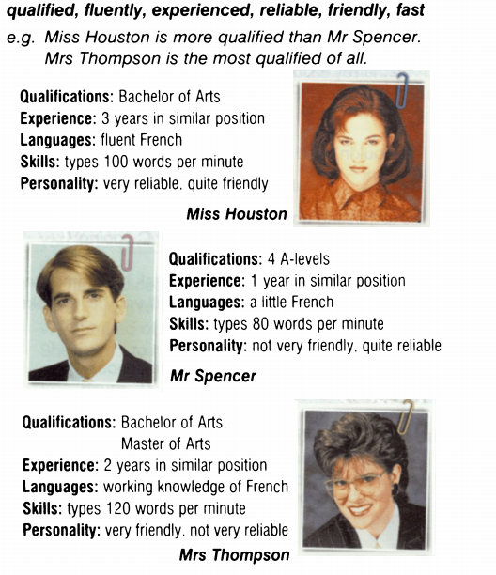

Answers:
I. Choose the correct item.
1. This is a pretty/prettily complicated situation.

2. They had hard/hardly been home for a minute when the phone rang.

3. My friends are most/mostly vegetarians.

4. Her loose outfit allowed her to move free/freely.

5. The shelf was so high/highly that he couldn't reach it.

6. John may be late/lately home tonight, as he has a lot of work to do.

7. The room was pretty/prettily decorated.

8. Children under five years old travel free/freely.

9. Sue has near/nearly finished her homework.

10. They have been going out a lot late/lately.

11. This college is high/highly recommended for its range of courses.

12. The miners dug deep/deeply to find coal.

13. The new supermarket is very near/nearly our house.

14. He is deep/deeply involved in the scandal.

15. We found it hard/hardly to get used to living in a foreign country.

16. Which of Mel Gibson's films do you like most/mostly?

II. Choose the correct item.
It was Lucy's birthday and she was very 1)sad/sadly. She had been waiting
2) hopeful/hopefully all morning for the postman to arrive. 3) Sudden/Suddenly, the letterbox rattled 4) gentle/gently and an envelope fell 5) soft/softly onto the
doormat. Picking it up, Lucy noticed 6) miserable/miserably that It was a bill. There were no cards, no presents and no 7) pretty/prettily bouquets of flowers. Lucy 8) near/nearly burst into tears. Just then, there was a 9) loud/ loudly knock
on the door. Opening the door 10) slow/ slowly, Lucy saw all her friends holding 11) brightly/bright wrapped gifts and shouting "Happy Birthday'. Lucy
12) immediate/immediately cheered up and greeted her friends 13) warm/warmly.

III. Choose the right answer.
1. He kicked the ball high adjective / adverb into the air.
How high adjective / adverb is the Eiffel Tower?

2. My brother loves fast adjective / adverb cars.
My mother is often anxious because he drives too fast adjective / adverb.

3. Mozart learnt how to play the harpsichord at an early adjective / adverb age.
He started writing music as early adjective / adverb as 6.

4. Mary has to work late adjective / adverb tomorrow.
It was late adjective / adverb summer and the sun was still hot.

5. My mother has bought this beautiful dress at a low adjective / adverb price.
The plane was flying too low adjective / adverb above the houses.

6. If you want to pass this difficult exam you will have to work very hard adjective / adverb.
It was hard adjective / adverb work to repaint the whole house.

7. Freddie reads quite well adjective / adverb for his age.
Frank hasn't been too well adjective / adverb lately.

8. The Times is published daily adjective / adverb.
There are daily adjective / adverb flights to San Francisco.
9. This exercise is harder adjective / adverb than I thought.
I hope you will try harder adjective / adverb next time.

IV. Choose the adverb or the adjective.
1. As the play unfolds, the audience is (subtle / subtly) brought into the grip of an awful evil.
2. In a bold, sometimes (careless / carelessly), form there is nothing academic.
3. The (clever / cleverly) updated detective tale succeeded despite a serious flirt with cliché.
4. Last week we buried my closest friend, and it was a (deep / deeply) moving service.
5. She straightened up and looked out the window (direct / directly) at him.
6. In times gone by, the paddle steamers docked to pick up their loads of (fresh / freshly) bailed cotton.
7. All goes ( good / well), and after some time he feels relaxed enough to go for a walk.
8. Your trigger – (happy / happily) friend isn't in the house.
9. The gulf between the 'rich' and the 'poor' has narrowed, to the point that the word 'poor' is (hard / hardly) applicable.
10. (Interesting / Interestingly), the changes the adapter has made seem designed to make the story even more frightening.
11. He joined dozens of others that sailed (lazy / lazily) toward the surface.
12. He swore so (loud / loudly) at the top of his voice, that she didn't get any sleep all the next night.
13. Frankly, it is very ( clever / cleverly) done.
14. Such (nice / nicely) balances of economic integration are hard to sustain for more than a single generation.
15. There are already rumors that publishers are feeling (nervous / nervously).
16. Children should be cared for by a (normal / normally) and healthy family.
17. We hoped this war could be resolved both (quick / quickly) and with as few civilian casualties as possible.
18. All we wanted to do was to stand very (quiet / quietly) and look and look and look.
19. He wanted to pat her neck (most / mostly) because she was so wonderful to touch.
20. It was (nice / nicely) packaged and wrapped in pretty, recycled paper.

