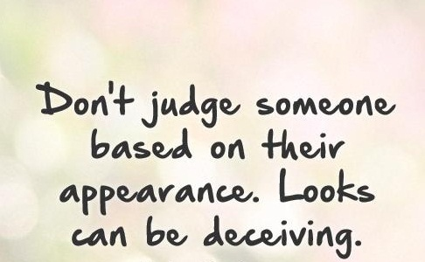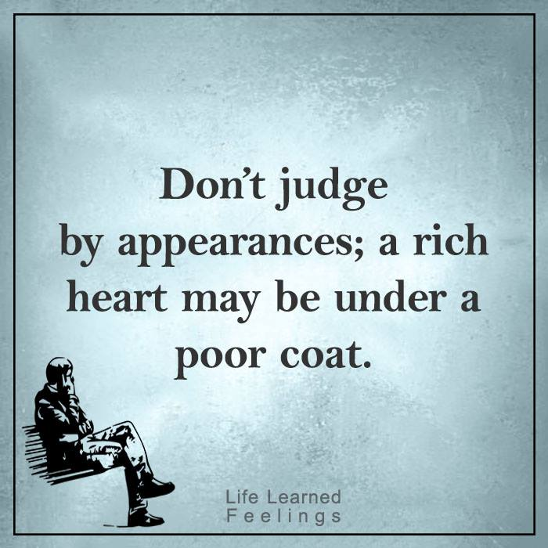advanced_appearance_lesson_28_speakng_part_3

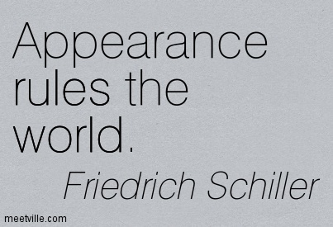

**Discuss these disputable quotes. Express your opinion.**

**Quizlet**

<https://quizlet.com/311201887/28-speaking-adv-flash-cards/?new>

**Exercise 1**

**Which of the following people could these words be used to describe?**

curvy - lanky – wiry - stocky – petite - slender

a. a strong, thin

b. a small, thin woman

c. a tall, thin man

d. a small, fat, strong man

e. an attractive woman with broad hips and a big bust

f. a tall, thin woman

**Exercise 2**

**Answer the following questions**

1. Who do you take after in your family?
2. What physical characteristics do you find attractive?
3. How would you describe the physical appearance of your ideal man/woman?
4. Do you think the way we look is important?

a) when finding a partner

b) when making friends

c) at work

5) What is beauty for you?

6) Do you think the media influences our idea of beauty?

7) How has people`s idea of beauty changed over the last few decades?

8) Do you think beauty only relates to a person`s appearance?

9) **Is it important to dress well whenever we go out?**

10) Do people worry too much about their appearance as they get older? –

11) Is attractiveness a quality worthwhile aiming for?

**12) What is the first thing that you notice about a person?**

**13) What kind of things do you do to improve your appearance?**

**14) Are there any fashion trends that you followed in the past but you think they are silly now?**

**15) How long does it take to you to get ready in the morning?**

**16) Is it rude to tell people that they need to change their appearance?**

**17)**  Do you think we should judge people`s character by the clothes they wear?

**Ears and eyes Dictionary Quiz**

1. What do you do if you play something by ear?
2. If something catches your eye what does it mean?
3. If you don’t see eye to eye with someone, do you agree with them?

**Exercise 3**

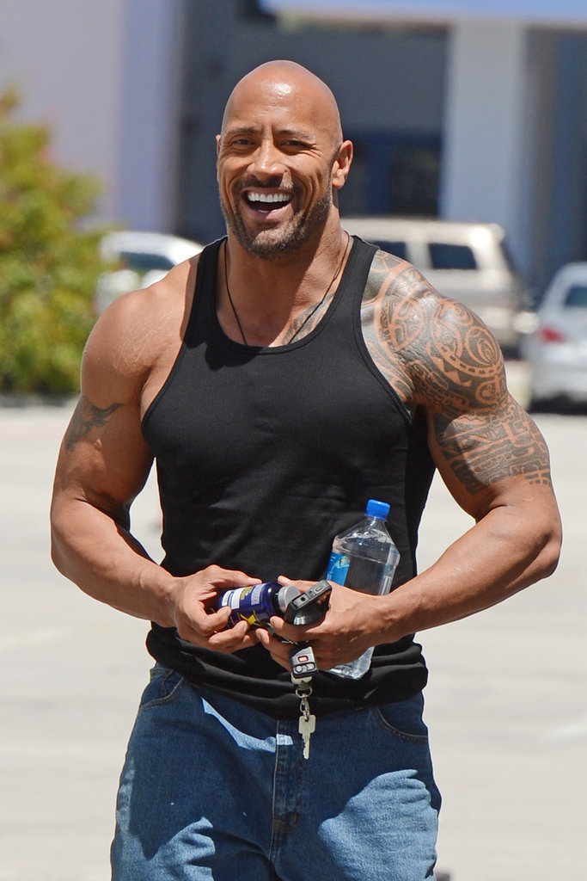**Describe the following people**

