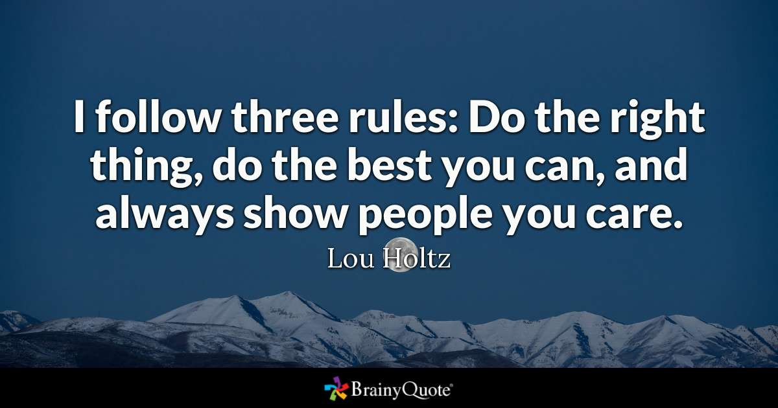

Ex. 1 Look at the pictures and try to translate words into Russian
https://drive.google.com/open?id=14bmzmAgY95LkaU1mhCHOVZNaHrn1RZrBSZfMc2ftURY

Ex 2. Match the people 1-12 with the correct definitions a-m.

1 A big shot J a. has a lot more capabilities than he or she shows or that people are aware of.
2 A busybody C b is usually expected to lose in a competition with someone else.
3 A chatterbox G c always wants to know about other people's private lives.
4 A daredevil L
5 A dark horse A d is a very selfish and careless driver.
6 A gatecrasher M E is a real nuisance and most people can't stand him or her.
F is someone who spoils the atmosphere or prevents others from enjoying themselves by being very boring and negative about everything.
7 A guinea pig K G can't stop talking.
H is someone with lots of modern ideas, energy and enthusiasm and who achieves a lot while still young
8 A pain in the neck E J is a very important or influential person.
9 A road hog D K is used as a subject in medical or other experiments.
10 An underdog B L loves taking dangerous risks
11 A wet blanket F
12 A whizz kid H M turns up at parties without being invited to them.

Ex. 3. End the sentance with the most suitable word

adult
colleague
nephew
toddler
best man
fiancé
niece
twin
bride
neighbour
sister-in-law
widow

a) The son of your brother or sister nephew
b) A woman on the day of her marriage bride
c) A young child who is learning to walk toddler
d) What a woman calls the man she is engaged to fiancé
e) One of two children born at the same time twin
f) A person who lives near you neighbour
g) The daughter of your brother or sister niece
h) A person who is fully grown adult
i) A woman whose husband has died widow
j) At a wedding, the friend of the bridegroom best man
k) The sister of the person you marry sister-in-law
l) A person you work with colleague

Ex. 4. Write a word at the end of the line to describe each of these people. (перемешать варианты ответов)
snob idealist
gossip hypocrite
rebel despicable
bully

1 He looks down on other people. He's a snob
2 She's always talking about others behind their back. She's a gossip
3 She's against anyone in a position of power or authority. She's a rebel
4 He's horrible to anyone he sees as smaller or weaker. He's a bully
5 She believes everything in the world can be perfect. She's an idealist
6 He tells us it's wrong to swear, then he uses bad language. He's a hypocrite
7 I'm afraid he's got bad manners and he's very rude. He's despicable

Ex. 5. Look at the picture. Discuss the picture and the questions below

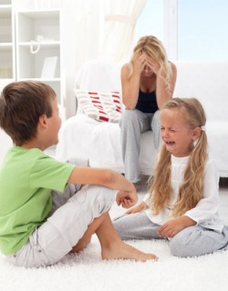

- Why do some children seem naturally well-mannered, while others seem difficult?
- Were you a well-behaved child?
- How do you raise well-behaved children?
- Is there any behavior that you would not find acceptable?
- What are some examples of bad behavior?
- What is he worst behavior you have seen?

- Can you influence your friends?
- Is it important to surround yourself with good people?
- How can friends have a bad influence on you?

