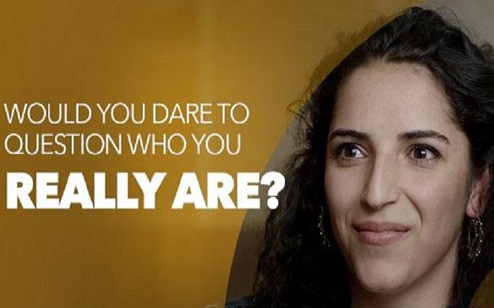
Talk about:
- your family
- your family’s nationality and/or ethnic group.

You are going to watch the start of a video in which several people are asked about their national and/or ethnic identity. Your task is to answer the following questions about each person:
- What does he/she say his/her nationality or ethnic group is?
- Which nationality or ethnic group does the person feel hostile towards?

https://vimeo.com/169077423
Pause at 01:10.
Watch the first part of the video again, this time pausing after each person. Identify the person’s national or ethnic identity, and the nationality or ethnic group he/she feels hostile to. Discuss the following questions:
- How do these people earn their living? What style of life do they lead?
- Is there any nationality or ethnic group your nationality feels hostile to?
- Why do they feel this hostility?

The same people they saw in the first part of the video took the DNA Journey in which they gave a sample of their saliva to be tested to see what their DNA told them about their national and ethnic characteristics. You are going to watch the second part of the video in which the people are told about the test and after answer the following questions:
- How does the person react?
- What does the person think the result of the DNA test will show?

Watch the video until 02:14.
- What is going to happen next?
- What will be the results of DNA testing?

Watch the video until 03:54. Talk about whether your predictions were correct or not.

- What different nationalities or ethnic groups are shown in each person’s DNA?
- How does each person react to the news?

Discuss the captions and say what you think about each one:

“I think everybody should have this test.”
“You have more in common than you think”
“An open world begins with an open mind”

