Lesson 31- Human feelings- Vocabulary (part 1)

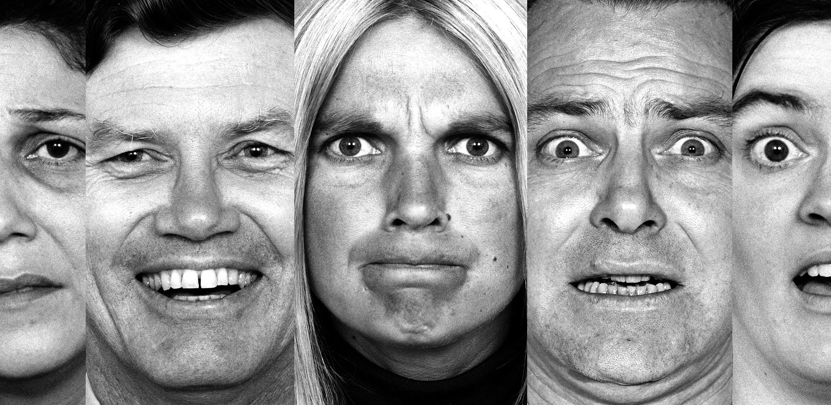

Exercise 1

https://quizlet.com/152843214/feelings-15-oxford-3-flash-cards/

Exercise 2
Complete the sentences

Are you the kind of person who … ? Or do you …? As a journalist, I’m aware that if you … too much about yourself, you could make yourself rather ... And if I’m honest, as a man I feel a bit … when people … their… to me. My own … is to be quite … and not … too much about how I feel. On the other hand, psychologists say it’s unhealthy to … It can lead to severe anxiety and depression if you don’t learn how to release your … emotions.

Exercise 3
Replace the underlined word with a word that has a similar meaning

- I felt uncomfortable when he talked about his marriage problems.
- He wouldn’t disclose information if he thought it was secret
- I think it’s dangerous to bottle up your feelings
- It’s a difficult time for him and he’s very weak and easily hurt
- She’s a bit cautious if you ask about her private life
- He’s happy to tell anyone his most personal and private thoughts

Exercise 4
Complete the dialogues by repeating what the speaker says in a different way

- I should think she was gobsmacked. -She was – absolutely …
- Did he get very angry?- Yes, I’m afraid he lost …
- Had he given up hope of being rescued?- Yes. It was an act of …
- Was he terribly upset? –Yes, he was absolutely …
- He must’ve gone mad. –He did. He hit …
- I bet they were over the moon. – Yes, they were absolutely …
- She was really emotional, wasn’t she? – Yes, she was in …
- Were the children overexcited?- Yes, they were …

Exercise 5
Complete the sentences

- I knew he would be upset and I’m afraid I didn’t have the … to tell him.
- She took part in the dancing competition, but you could tell her heart …
- The wedding date was meant to be a secret, but I’m afraid he … it …
- Maxine’s problem is that she wears her heart …, whereas the Gavin’s the opposite: he has all these … emotions which he can’t express.
- I should consider this more carefully, but my … says it’s the right thing to do.

