**Grammar**

**Verbs + prepositions**

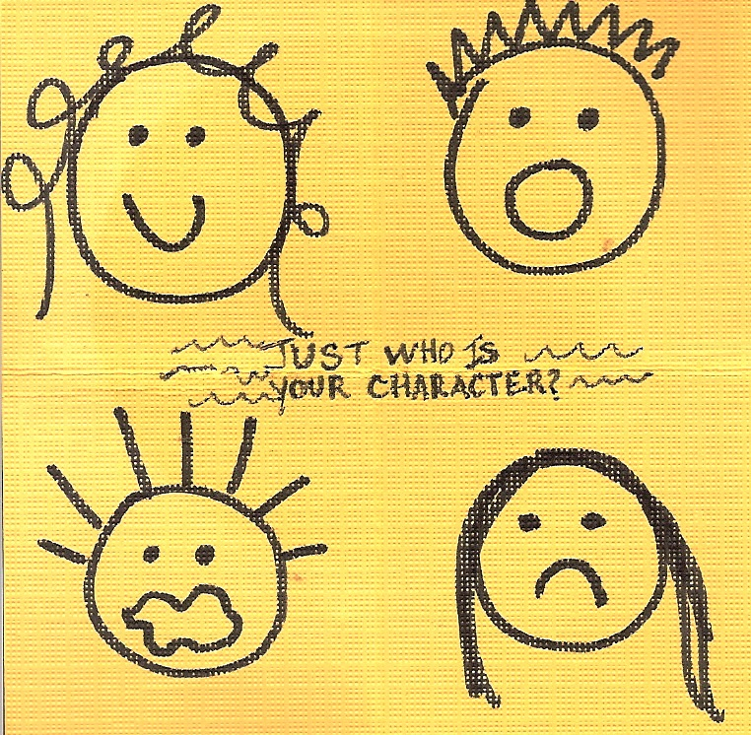





**Exercise 1**

**Choose the appropriate answer.**

1. When I phoned the hospital to enquire _____ Ricky, I was told that he’s gone home.  
a) after  
b) on  
c) about

2. I only advertised the car for sale on Wednesday, but by the end of the week ten people had phoned to ask _____ it.  
a) after  
b) for  
c) about

3. We can learn a great deal _____ the oceans by studying even a small piece of coral.  
a) after  
b) of  
c) about

4. I did not agree _____ a word of what she said.  
a) to  
b) with  
c) for

5. Professor Owen is giving a talk _____ the Romans in Lecture Hall 1.  
a) of  
b) with  
c) on

6. I had to care _____ my elderly parents when they both became ill.  
a) for  
b) after  
c) about

7. For many years we have been arguing _____ changes in the way the college is managed.  
a) for  
b) on  
c) with

8. She didn’t know _____ her stepbrother’s existence until her mother died.  
a) off  
b) about  
c) on  
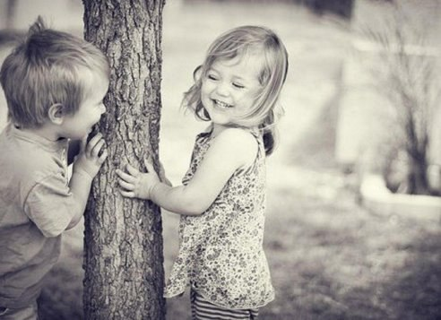

**Exercise 2**

**Fill in the gaps**

**of about of with for on** **after**

**with/to of/** **about on/to after/about**

1. ‘If you want to enquire _____ a motor insurance quotation, please press 1.’
2. I hope you’re brothers feeling better soon. When you see him, tell him I asked _____ him.
3. I first learnt _____ his decision to resign when it was announced on the radio last night.
4. We’re going to talk _____ the council about the possibility of planting some new trees in the park.
5. I don’t care _____ pop music at all. I much prefer classical music.
6. The teacher says we’ve got to do the test, so there’s no point in arguing _____ it.
7. The government has agreed _____ a public inquiry into the helicopter crash.
8. If you know _____ any reasons why you should not be given medical insurance, you must declare then here.
9. “John can be really stupid sometimes.” You should not talk _____ your brother like that.”
10. I’m calling to enquire _____ Mr Dawes, who was operated on last night.
11. She’s always arguing _____ her parents about what to watch on television.
12. I know it’s a lot to ask ______ you, but would you look after the children while I’m in Japan on business?
13. The course was brilliant. We learnt _____ using the Internet in language learning.
14. Dan said he’ll try to fix my car. “What does he know _____ cars?”
15. I don’t think the government cares enough _______ nursery education to fund it properly.
16. After hours of discussion, the committee finally agreed _____ the amount of money to donate.



**Exercise 3**

**Choose the appropriate answer**

1. What's happened ______ Mike? He should be here.

a) about

b) with

c) to

2.’Do you know a band called Glass Onion?’

‘ I've never heard ____ them.’

a) from

b) about

c) of

3. The course consists _________ ten two-hour lessons plus a tutorial.

a) of

b) for

c) with

4. Do you believe ______ ghosts?

a) for

b) about

c) in

5. She accused him _______ stealing her bag.

a) with

b) about

c) of

6. Who does this bag belong ________ ?

a) to

b) with

c) for

7. I complained ___________ the noise that the builders were making.

a) about

b) for

c) to

8. I agree _________ Martha. She's absolutely right.

a) to

b) on

c) with

9. We divided the cake _______ five pieces - one piece for each of us.

a) into

b) between

c) among

10. We may go hiking on Sunday. It depends _________ the weather.

a) about

b) on

c) for

11. 'Why are you laughing ____ me? ‘

‘You've got your shirt on inside out.'

a) to

b) on

c) at

12. She suffers ______ headaches.

a) on

b) from

c) about

13. 'What do you know _________ electronics?'

'Not much.'

a) on

b) about

c) of

14. They blamed the pilot _____ the crash.

a) for

b) about

c) with

15. I got _________ the bus and walked to my office.

a) out

b) away

c) off

**Exercise 4**

**Gap-fill**

**coming wrapped turn** **kicks** **spread** **come** **took** **picked** **put pass**

1. I seem to have _____ out in a rash.
2. This is urgent, so don’t _____ it off.
3. I fill tired and achy, I must be _____ down with flu.
4. It’s too good an offer to _____ down.
5. The plane _____ off smoothly.
6. The search party _____ out over the fields.
7. Henry _____ up a hitchhiker on his way to London.
8. Please don’t _____ this information on to anyone else.
9. Lesley is completely _____ up in her studies at the moment.
10. The match _____ off at 10 pm.

**Exercise 5**

**Put in the correct preposition**

1. Please come ______ once. We have a big problem.

2. She worked very hard and ______ last she managed to pass the exam.

3. We need to be ______ time or my grandmother will start to get anxious.

4. It feels like owning a house is ______ the ordinary. I'll never be able to do it.

5. We thought about it a lot and ______ last we decided to buy a new flat.

6. We watched a film ______ a change. Usually we read.

7. She was really ______ danger for a few minutes in the rough sea, but luckily a lifeguard saw her.

8. I went to the bookshop and ______ chance I found a really interesting book about Switzerland.

9. He walked into the kitchen and ______ his surprise there was food all over the floor.

1. She drinks a litre of water every day _____ fail.

11. The little girl broke the toy ______ purpose because she was so angry.

**Key**

**Exercise 1**

**Choose the appropriate answer.**

1. When I phoned the hospital to enquire _____ Ricky, I was told that he’s gone home.  
a) after  
b) on  
**c) about**

2. I only advertised the car for sale on Wednesday, but by the end of the week ten people had phoned to ask _____ it.  
a) after  
b) for  
**c) about**

3. We can learn a great deal _____ the oceans by studying even a small piece of coral.  
a) after  
b) of  
**c) about**

4. I did not agree _____ a word of what she said.  
a) to  
**b) with**  
c) for

5. Professor Owen is giving a talk _____ the Romans in Lecture Hall 1.  
a) of  
b) with  
**c) on**

6. I had to care _____ my elderly parents when they both became ill.  
**a) for**  
b) after  
c) about

7. For many years we have been arguing _____ changes in the way the college is managed.  
**a) for**  
b) on  
c) with

8. She didn’t know _____ her stepbrother’s existence until her mother died.  
a) off  
**b) about**  
c) on

**Exercise 2**

**Fill in the gaps**

1. ‘If you want to enquire _____ **about** a motor insurance quotation, please press 1.’
2. I hope you’re brothers feeling better soon. When you see him, tell him I asked _____ **after** him.
3. I first learnt _____ **of/** **about** his decision to resign when it was announced on the radio last night.
4. We’re going to talk _____ **with/to** the council about the possibility of planting some new trees in the park.
5. I don’t care _____ **for** pop music at all. I much prefer classical music.
6. The teacher says we’ve got to do the test, so there’s no point in arguing _____**about** it.
7. The government has agreed _____ **on/to** a public inquiry into the helicopter crash.
8. If you know _____ **of** any reasons why you should not be given medical insurance, you must declare then here.
9. “John can be really stupid sometimes.” You should not talk _____ **about** your brother like that.”
10. I’m calling to enquire _____ **after/about** Mr Dawes, who was operated on last night.
11. She’s always arguing _____**with** her parents about what to watch on television.
12. I know it’s a lot to ask ______ **of** you, but would you look after the children while I’m in Japan on business?
13. The course was brilliant. We learnt _____ **about** using the Internet in language learning.
14. Dan said he’ll try to fix my car. “What does he know _____ **about** cars?”
15. I don’t think the government cares enough _______ **about** nursery education to fund it properly.
16. After hours of discussion, the committee finally agreed _____ **on** the amount of money to donate.

**Exercise 3**

**Choose the appropriate answer**

1. What's happened ______ Mike? He should be here.

a) about

b) with

**c) to**

2.’Do you know a band called Glass Onion?’

‘ I've never heard ____ them.’

a) from

**b) about**

c) of

3. The course consists _________ ten two-hour lessons plus a tutorial.

**a) of**

b) for

c) with

4. Do you believe ______ ghosts?

a) for

b) about

**c) in**

5. She accused him _______ stealing her bag.

a) with

b) about

**c) of**

6. Who does this bag belong ________ ?

**a) to**

b) with

c) for

7. I complained ___________ the noise that the builders were making.

**a) about**

b) for

c) to

8. I agree _________ Martha. She's absolutely right.

a) to

b) on

**c) with**

9. We divided the cake _______ five pieces - one piece for each of us.

**a) into**

b) between

c) among

10. We may go hiking on Sunday. It depends _________ the weather.

a) about

**b) on**

c) for

11. 'Why are you laughing ____ me? ‘

‘You've got your shirt on inside out.'

a) to

b) on

**c) at**

12. She suffers ______ headaches.

a) on

**b) from**

c) about

13. 'What do you know _________ electronics?'

'Not much.'

a) on

**b) about**

c) of

14. They blamed the pilot _____ the crash.

**a) for**

b) about

c) with

15. I got _________ the bus and walked to my office.

**a) out**

b) away

c) off

**Exercise 4**

**Gap-fill**

1. I seem to have _____ **come** out in a rash.

2. This is urgent, so don’t _____ **put** it off.

3. I fill tired and achy, I must be _____ **coming** down with flu.

4. It’s too good an offer to _____ **turn** down.

5. The plane _____ **took** off smoothly.

6. The search party _____ **spread** out over the fields.

7. Henry _____ **picked** up a hitchhiker on his way to London.

8. Please don’t _____ **pass** this information on to anyone else.

9. Lesley is completely _____ **wrapped** up in her studies at the moment.

10. The match _____ **kicks** off at 10 pm.

**Exercise 5**

**Put in the correct preposition**

1. Please come ______ **at** once. We have a big problem.

2. She worked very hard and ______ **at** last she managed to pass the exam.

3. We need to be ______ **in** time or my grandmother will start to get anxious.

4. It feels like owning a house is ______ **out of** the ordinary. I'll never be able to do it.

5. We thought about it a lot and ______**at** last we decided to buy a new flat.

6. We watched a film ______**for** a change. Usually we read.

7. She was really ______ **in** danger for a few minutes in the rough sea, but luckily a lifeguard saw her.

8. I went to the bookshop and ______**by** chance I found a really interesting book about Switzerland.

9. He walked into the kitchen and ______**to** his surprise there was food all over the floor.

10. She drinks a litre of water every day _____ **without** fail.

11. The little girl broke the toy ______ **on** purpose because she was so angry.