Lesson 32 Grammar Test
Everything + Preposition
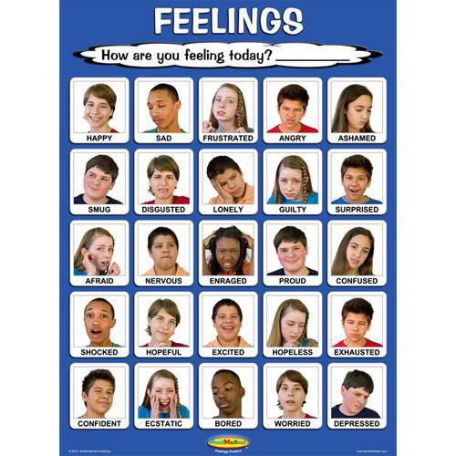
Exercise 1
Gap-fill
for in of to at
- She had great difficulty _____ not showing her feelings.
- She looked upon life as an opportunity _____ writing novels.
- “There doesn’t seem to be much point _____ my coming down if he’s not well,” said Lou.
- There isn’t much sense _____ my going through all the reasons why a young man of twenty-two, without any money, should not marry.
- Blair raised no objection _____ going back to London.
- She has a wonderful talent _____ getting the best out of people.
- The girl took a biscuit in her tiny hand and made a feeble attempt _____ gnawing it.
- Mel saw their social life a means _____ fulfilling his professional ambitions.
- There could be no doubt ______ there being something on between her and Hugh.
- For one reason or another there was difficulty _____ finding an evening when we were both free.
- She had a pleasant gift _____ keeping the conversation general.
- I’m a great believer ______ being prepared.
- She cherished her delight ______ calling a woman of title by her Christian name.
- I repeat, that was one of my reasons _____ giving you this news today.

Exercise 2
Choose the appropriate answer
1. I’m not enthusiastic ____ fishing, but I’ll come anyway.
a) in
b) about
c) with
d) to
2. We were all pleased _____ our exam results.
a) with
b) to
c) in
d) of
3. Malta is famous _____ its great weather.
a) about
b) for
c) to
d) at
4. Although we look the same, she’s not related _____ me.
a) for
b) by
c) to
d) about
5. We’ve become very attached _____ this house. We don’t want to move.
a) at
b) in
c) about
d) to
6. He looks mean, but he’s capable _____ great generosity.
a) at
b) for
c) of
d) to
7. Can you recommend a book that’s suitable _____ her.
a) by
b)for
c) about
d) in
8. Tom is hopeless _____ remembering birthdays.
a) in
b)at
c) for
d) to
9. Her dress is very similar _____ mine .
a) from
b) to
c) about
d) of
10. The streets were crowed _____ people.
a) to
b) with
c) about
d) at
11. She is a very popular actress especially _____ young people.
a) to
b) with
c) about
d) at
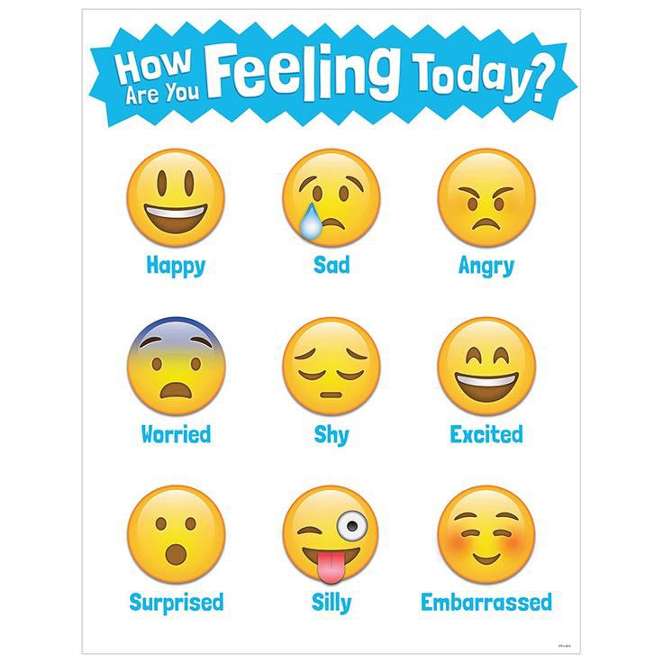
Exercise 3
For each gap, fill in the text with one of the following prepositions: about, around, at, for, in, of, to, with or leave empty if no preposition is required.
Rome As a rule, Italians are very conscious _____ their dress and have a great sense _____ style. Casual dress is fine _____ most occasions, but a suit and tie are recommended _____ business meetings. _____ summer, locals will not be seen wearing shorts the city. When visiting the Vatican or any major cathedral, men should wear long pants and women skirts or long pants. Sleeveless shirts and shorts are not permitted _____ churches and the Vatican, including _____ the Vatican museums. Tipping is not mandatory. _____ times a service charge (servizio) is included _____ your restaurant bill. This should not be confused ______ the cover charge (coperta), which is a _____ charge _____ bread and table settings. If the service charge is included and you are pleased ______ the service, it’s customary to leave ______ an additional 5%; if the service charge is not included, leave a 10% tip. ______ the porter and cleaning lady of the hotel you should give ______ 10,000 lire, ______ room service ______ 5,000 lire. Tipping _____ taxis is not obligatory either, but 1,000 to 2,000 lire is usually given ______ the driver.

Exercise 4
Put in the correct preposition

1. She paid for lunch _____ advance, so we don't need to pay now.

2. I went to the wrong house _____ mistake.

3. Please make sure that you're ______ time for the class.

4. I was walking to the station and ______ chance I saw the glove that I'd lost on the ground.

5. I love eating out in London. ______ instance, one of my favourite restaurants has amazing Japanese food.
6. I think the cat is _____ danger on that high roof.
7. I picked up the laptop and ______ my surprise it fell apart in my hands.

8. I have a lot ______ common with my cousin. We both like many of the same things.

9. If the baby starts to cry, pick her up ______ once.

10. Did you forget your purse ______ purpose so you wouldn't have to pay?

11. It's best to arrive ______ foot because there is nowhere to park.

12. What do a whale and a dolphin have ______ common?

13. He added salt instead of sugar ______ mistake.

14. What's your favourite thing to do? ______ instance, do you like sport?

15. The book was ______ reach on a high shelf.

16. I want to go to Germany ______ a change. I've never been there.

17. Please let me know ______ advance if you can't come to the meeting.

18. She often goes to school ______ foot.

19. Do you always brush your teeth before bed ______ fail?

Exercise 5
Gap-fill
was called after acted on worked for counts for called for thinking about
counting on acted for think works with
1. The police ______ the information very quickly.
2. I couldn’t be at the meeting, so my solicitor _____ me.
3. I’ve been _____ a lot ______ your idea and I’ve decided I’d like to support you.
4. What do you ______ of the color in the bedroom?
5. Sam _____ my grandfather.
6. Campaigners have _____ a referendum on the issue.
7. They say he ______ the CIA in the 1970s.
8. She _____ computer.
9. We’re _____ Mike to supply the food for the party.
10. Playing exciting football _____ little if the team isn’t winning.

Key
Exercise 1
Gap-fill
- She had great difficulty _____in not showing her feelings.
- She looked upon life as an opportunity _____for writing novels.
- “There doesn’t seem to be much point _____ in my coming down if he’s not well,” said Lou.
- There isn’t much sense _____ in my going through all the reasons why a young man of twenty-two, without any money, should not marry.
- Blair raised no objection _____ to going back to London.
- She has a wonderful talent _____ for getting the best out of people.
- The girl took a biscuit in her tiny hand and made a feeble attempt _____ at gnawing it.
- Mel saw their social life a means _____ of fulfilling his professional ambitions.
- There could be no doubt ______in there being something on between her and Hugh.
- For one reason or another there was difficulty _____ in finding an evening when we were both free.
- She had a pleasant gift _____ for keeping the conversation general.
- I’m a great believer ______ in being prepared.
- She cherished her delight ______ at calling a woman of title by her Christian name.
- I repeat, that was one of my reasons _____ for giving you this news today.

Exercise 2
Choose the appropriate answer
1. I’m not enthusiastic ____ fishing, but I’ll come anyway.
a) in
b) about
c) with
d) to
2. We were all pleased _____ our exam results.
a) with
b) to
c) in
d) of
3. Malta is famous _____ its great weather.
a) about
b) for
c) to
d) at
4. Although we look the same, she’s not related _____ me.
a) for
b) by
c) to
d) about
5. We’ve become very attached _____ this house. We don’t want to move.
a) at
b) in
c) about
d) to
6. He looks mean, but he’s capable _____ great generosity.
a) at
b) for
c) of
d) to
7. Can you recommend a book that’s suitable _____ her.
a) by
b)for
c) about
d) in
8. Tom is hopeless _____ remembering birthdays.
a) in
b)at
c) for
d) to
9. Her dress is very similar _____ mine .
a) from
b) to
c) about
d) of
10. The streets were crowed _____ people.
a) to
b) with
c) about
d) at
11. She is a very popular actress especially _____ young people.
a) to
b) with
c) about
d) at

Exercise 3
For each gap, fill in the text with one of the following prepositions: about, around, at, for, in, of, to, with or leave empty if no preposition is required.
Rome As a rule, Italians are very conscious _____of their dress and have a great sense _____ of style. Casual dress is fine _____ for most occasions, but a suit and tie are recommended _____ for business meetings. _____in summer, locals will not be seen wearing shorts _____ in the city. When visiting the Vatican or any major cathedral, men should wear long pants and women skirts or long pants. Sleeveless shirts and shorts are not permitted _____ in churches and the Vatican, including _NO PREPOSITON_ the Vatican museums. Tipping is not mandatory. ______ At times a service charge (servizio) is included _____in your restaurant bill. This should not be confused ______ with the cover charge (coperta), which is a charge _____ for bread and table settings. If the service charge is included and you are pleased ______ with the service, it’s customary to leave ____ NO PREPOSITON __ an additional 5%; if the service charge is not included, leave a 10% tip. ______ to the porter and cleaning lady of the hotel you should give ______ around 10,000 lire, ______ for room service ______ around 5,000 lire. Tipping _____ in taxis is not obligatory either, but 1,000 to 2,000 lire is usually given ______ to the driver.
Put in the correct preposition

Exercise 4
Put in the correct preposition

1. She paid for lunch _____ in advance, so we don't need to pay now.

2. I went to the wrong house _____ by mistake.

3. Please make sure that you're ______ in time for the class.

4. I was walking to the station and ______ by chance I saw the glove that I'd lost on the ground.

5. I love eating out in London. ______. For instance, one of my favourite restaurants has amazing Japanese food.
6. I think the cat is _____ in danger on that high roof.
7. I picked up the laptop and ______ to my surprise it fell apart in my hands.

8. I have a lot ______ in common with my cousin. We both like many of the same things.

9. If the baby starts to cry, pick her up ______ at once.

10. Did you forget your purse ______ on purpose so you wouldn't have to pay?

11. It's best to arrive ______ on foot because there is nowhere to park.

12. What do a whale and a dolphin have ______in common?

13. He added salt instead of sugar ______ by mistake.

14. What's your favourite thing to do? ______for instance, do you like sport?

15. The book was ______ out of reach on a high shelf.

16. I want to go to Germany ______ for a change. I've never been there.

17. Please let me know ______ in advance if you can't come to the meeting.

18. She often goes to school ______on foot.

19. Do you always brush your teeth before bed ______without fail?
Exercise 5
Gap-fill
1. The police ______ acted on the information very quickly.
2. I couldn’t be at the meeting, so my solicitor _____ acted for me.
3. I’ve been _____ thinking a lot ______ about your idea and I’ve decided I’d like to support you.
4. What do you ______ think of the color in the bedroom?
5. Sam _____ was called after my grandfather.
6. Campaigners have _____ called for a referendum on the issue.
7. They say he ______ worked for the CIA in the 1970s.
8. She _____ works with computer.
9. We’re _____ counting on Mike to supply the food for the party.
10. Playing exciting football _____ counts for little if the team isn’t winning.

