Think about your best friend. How are you different from each other? Define the differences between you and your best friend at least in five sentences. Describe the best features of your friend.

You are going to watch but not hear a short video in which pairs of best friends are asked the question “What makes you two different from each other?” As you watch you should focus on how each pair of best friends is different from each other.
Watch the video with no sound and pause at 01:45.
https://www.youtube.com/watch?time_continue=44&v=1MJrRvpjB1I
Now discuss how each pair of friends is different.
Look at the snapshots from the video and comment on each photo and what the children say.

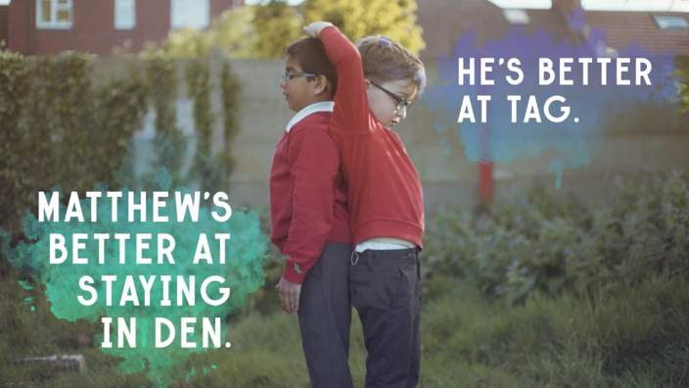

“den” is a secret place where children usually play
“tag” is a playground game that involves two or players chasing other players in an attempt to “tag” or touch them, usually with their hands.
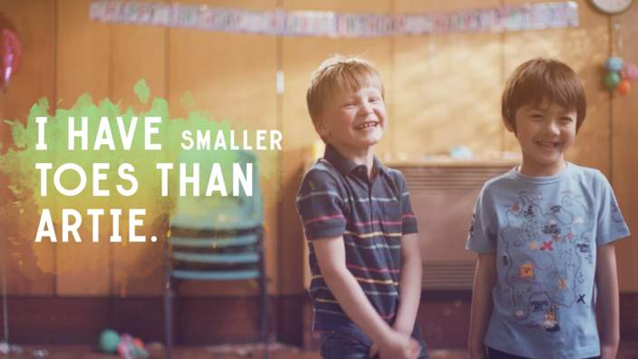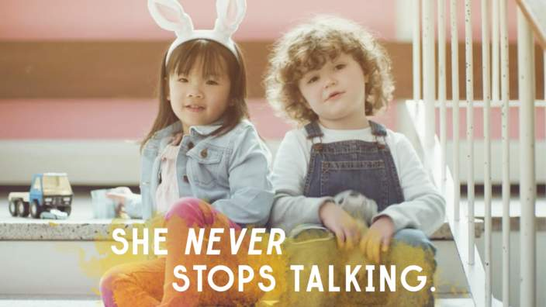

You are now going to watch the video with sound. As you watch and listen you should compare what you thought the children said with what they actually say.
Watch with sound twice.
- What have you understood?
Now look at the closing caption at 01:50:
“When it comes to difference,
Children see things differently.”
Discuss the meaning of this sentence in relation to the video.

