Таблица 1. Согласование времен.
Переход из одного времени в другое | Пример
Present Simple » Past Simple | He can speak French – Он говорит по-французски. Boris said that he could speak French – Борис сказал, что он говорит по-французски.
Present Continuous » Past Continuous | They are listening to him – Они слушают его. I thought they were listening to him – Я думал, они слушают его.
Present Perfect » Past Perfect | Our teacher has asked my parents to help him – Наш учитель попросил моих родителей помочь ему. Mary told me that our teacher had asked my parents to help him – Мария сказала мне, что наш учитель попросил моих родителей помочь ему.
Past Simple » Past Perfect | I invited her – Я пригласил ее. Peter didn't know that I had invited her – Петр не знал, что я пригласил ее.
Past Continuous » Past Perfect Continuous | She was crying – Она плакала. John said that she had been crying – Джон сказал, что она плакала.
Present Perfect Continuous » Past Perfect Continuous | It has been raining for an hour – Дождь идет уже час. He said that it had been raining for an hour – Он сказал, что уже час шел дождь.
Future Simple » Future in the Past | She will show us the map – Она покажет нам карту. I didn't expect she would show us the map – Я не ожидал, что она покажет нам карту.

Таблица 2. Случаи, когда согласование времен не употребляется.
1. Если в придаточном предложении сообщается общеизвестное положение или факт. | - We convinced him how important learning English is – Мы убедили его, насколько важно изучение английского.  - Even the early doctors knew that the washing of hands prevents infection – Еще издавна врачи знали, что мытье рук препятствует распространению инфекции.
2. Если в придаточном предложении сказуемое выражено глаголом в сослагательном наклонении. | - If your father were kind, he would let us stay here – Если бы твой отец был добрым, он бы разрешил нам остаться здесь.  - Boris would not lend us money, if we asked him – Борис не одолжил бы нам деньги, если бы мы его попросили.
3. Если в состав сказуемого придаточного предложения входит модальный глагол must, need, should или ought, согласование времен не употребляется.  Однако can меняется на could, а may меняетсяна might. | - Mary said that he must call her – Мария сказала, что он должен позвонить ей.  - They said they might come back early – Они сказали, что, может быть, вернутся рано.  - Boris said that he could speak French – Борис сказал, что он говорит по-французски.

Task 1

Transform the sentences using sequence of tenses:
Example: I think I know the answer. I thought… – I thought I knew the answer.
- He realizes he will be alone. He realized…
- We hope she will be waiting for us at six o'clock. We hoped…
- He proves he is the best. He proved…
- She imagines she can do that. She imagined…
- We understand we need more money. We understood…
Task 2
Fill in the blanks with an appropriate tense form.
1. She noticed she … already late.
is
was
had been
2. She said that it ... her an hour to finish the report.
takes
took
has taken
3. She asked him if he ... her name.
knows
knew
had known
4. What did you do with the money you ... from me?
borrowed
have borrowed
borrow
5. When I opened the door, the cat ... out.
jump
jumped
had jumped
6. When I was ten I already ... I wanted to be a scientist.
know
knew
had known
7. I went to see if she ... up yet.
woke
has woken
had woken
8. I ... 80 kilos three months ago.
was weighing
have weighed
weighed
9. As soon as I ... the phone down, it rang again.
put
have put
had put
10. I ... that I would get the promotion but it is beginning to look difficult now.
hoped
have hoped
had hoped
11. When I arrived at the party, they ... home.
already went
have already gone
had already gone
12. I was hot because I ... in the sun for a long time.
was walking
walked
had been walking
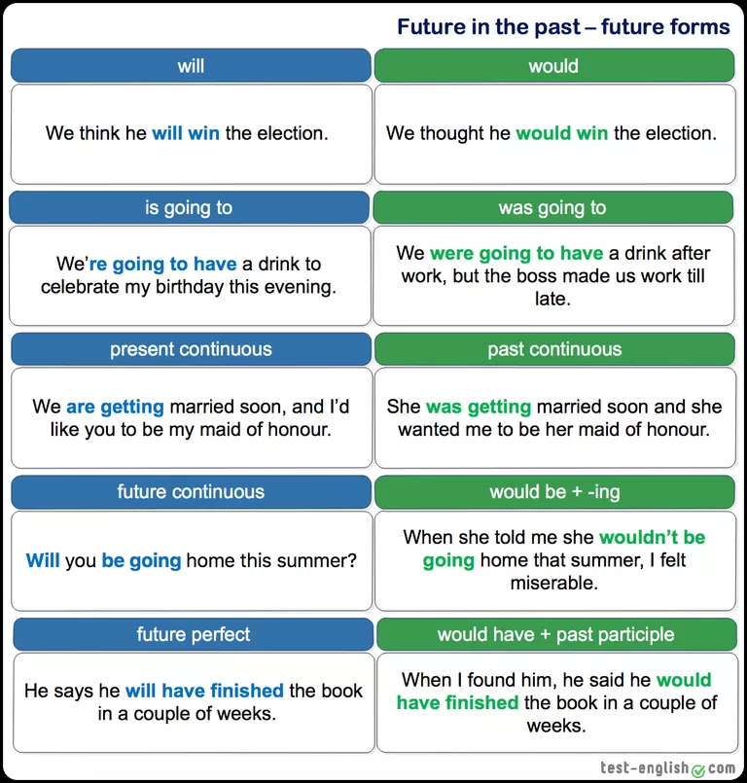
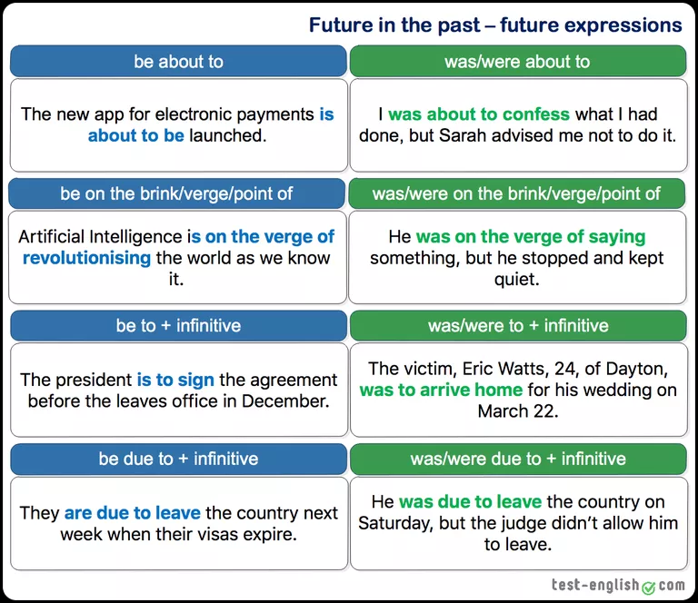
Task 3
Choose the most appropriate form to refer to the future in the past to complete the sentences below.
1.I saw he had a gun, but I didn’t think he .
2.I knew you the exam. You didn’t make any effort!
3.I lost my passport the day before we for our honeymoon.
4.Sorry, I you today, but I forgot.
5.She promised she an end to the situation, but failed to do so.
6.He asked whether I him, but there was nothing I could do.
7.He to Iraq, but he came down with an infection before the trip.
8.That night I was very excited because the next morning I back home on the first train.
9.I told him not to call me that evening, because I for my finals all night.
10.I the car, but I thought I didn’t really need it and decided not to do it.

Task 4
Choose the correct or most appropriate form/s to refer to the future in the past for the sentences below.
1.I ______ Sam for money, but I didn’t because I don’t want to own him anything.
- a. was asking
- b. would ask
- c. will ask
- d. was going to ask
2.I had a feeling that the party ______ a disaster. Choose TWO correct options
- a. would be
- b. was being
- c. was to be
- d. was going to be
3.We didn’t expect that he ______ like that.
- a. would react
- b. was reacting
- c. would be reacted
- d. will react
4.She ______ her speech when someone threw an egg at her. Choose TWO correct options
- a. would finish
- b. was about to finish
- c. was going to finish
- d. would be finishing
5.I told you she ______ everybody. She can’t keep a secret.
- a. was going to tell
- b. was telling
- c. will tell
- d. told
6.After finishing his last book, I asked him what he ______ next, but he just didn’t know. Choose TWO correct options
- a. was doing
- b. would be doing
- c. did
- d. was going to do
7.The baby ______ be born in March, but it was finally born in April.
- a. was about to
- b. was due to
- c. would
- d. was on the verge of
8.The couple who died in the fire ______ married at the end of the month. Choose TWO correct options
- a. were getting
- b. would get
- c. were due to get
- d. are getting
9.The next day we ______ to Germany where we ______ a press conference.
- a. would fly / attended
- b. were going to fly / attended
- c. will fly / would attend
- d. were flying / were due to attend
10.A family of six, who ______ the following week, died when the building collapsed. Choose TWO correct options
- a. were to move out
- b. would be moved out
- c. moved out
- d. were going to move out

Task 5
Fill in the gaps using the verb in brackets in a future form so that it expresses the idea suggested above. Do NOT use contractions.
1.intention or plan
The last time I spoke to you, you (start) a business. Did you do it?
2.arrangement
Sorry, I forgot we (have) dinner together today.
3.prediction
I knew you (get) upset.
4.arrangement
I’m sorry I didn’t stop to say hi yesterday, but I (meet) my boss at 7.
5.action in progress
We knew that in a week’s time we (lie) on the beach.
6.intention or plan
When (you/tell) us?
7.promise
You assured us that (there/be) no delays.
8.timetabled event
The train (depart) at 8, so we had to hurry to the station.
9.action in progress
I knew if I didn’t call, he (try) to contact me all day.
10.intention or plan
If she knew Sam (leave), she could have told us.

ANSWERS
Task 1
- He realized he would be alone.
- We hoped she would be waiting for us at six o'clock.
- He proved he was the best.
- She imagined she could do that.
- We understood we needed more money.
Task 2
1. She noticed she was already late.
2. She said that it took her an hour to finish the report.
3. She asked him if he knew her name.
4. What did you do with the money you borrowed from me?
5. When I opened the door, the cat jumped out.
6. When I was ten I already knew I wanted to be a scientist.
7. I went to see if she had woken up yet.
8. I weighed 80 kilos three months ago.
9. As soon as I put / had put the phone down, it rang again.
10. I had hoped that I would get the promotion but it is beginning to look difficult now.
11. When I arrived at the party, they had already gone home.
12. I was hot because I had been walking in the sun for a long time.
Task 3
1.I saw he had a gun, but I didn’t think he was going to shoot.
2.I knew you would fail the exam. You didn’t make any effort!
3.I lost my passport the day before we were leaving for our honeymoon.
4.Sorry, I was going to call you today, but I forgot.
5.She promised she would put an end to the situation, but failed to do so.
6.He asked whether I would help him, but there was nothing I could do.
7.He was going to be sent to Iraq, but he came down with an infection before the trip.
8.That night I was very excited because the next morning I was going back home on the first train.
9.I told him not to call me that evening, because I would be studying for my finals all night.
10.I was going to buy the car, but I thought I didn’t really need it and decided not to do it.
Task 4
1I ______ Sam for money, but I didn’t because I don’t want to own him anything.
- a. was asking
- b. would ask
- c. will ask
- d. was going to ask
2I had a feeling that the party ______ a disaster. Choose TWO correct options
- a. would be
- b. was being
- c. was to be
- d. was going to be
3We didn’t expect that he ______ like that.
- a. would react
- b. was reacting
- c. would be reacted
- d. will react
4She ______ her speech when someone threw an egg at her. Choose TWO correct options
- a. would finish
- b. was about to finish
- c. was going to finish
- d. would be finishing
5I told you she ______ everybody. She can’t keep a secret.
- a. was going to tell
- b. was telling
- c. will tell
- d. told
6After finishing his last book, I asked him what he ______ next, but he just didn’t know. Choose TWO correct options
- a. was doing
- b. would be doing
- c. did
- d. was going to do
7The baby ______ be born in March, but it was finally born in April.
- a. was about to
- b. was due to
- c. would
- d. was on the verge of
8The couple who died in the fire ______ married at the end of the month. Choose TWO correct options
- a. were getting
- b. would get
- c. were due to get
- d. are getting
9The next day we ______ to Germany where we ______ a press conference.
- a. would fly / attended
- b. were going to fly / attended
- c. will fly / would attend
- d. were flying / were due to attend
10A family of six, who ______ the following week, died when the building collapsed. Choose TWO correct options
- a. were to move out
- b. would be moved out
- c. moved out
- d. were going to move out

Task 5
1. The last time I spoke to you, you were going to start a business. Did you do it?
2. Sorry, I forgot we were having dinner together today.
3. I knew you would get upset.
4. I’m sorry I didn’t stop to say hi yesterday, but I was meeting my boss at 7.
5. We knew that in a week’s time we would be lying on the beach.
6. When were you going to tell us?
7. You assured us that there would be no delays.
8. The train departed at 8, so we had to hurry to the station.
9. I knew if I didn’t call, he would be trying to contact me all day.
10. If she knew Sam was going to leave, she could have told us.

