https://quizlet.com/324359743/english-work-un-7-cambridge-4-flash-cards/?new

Now study these words in context

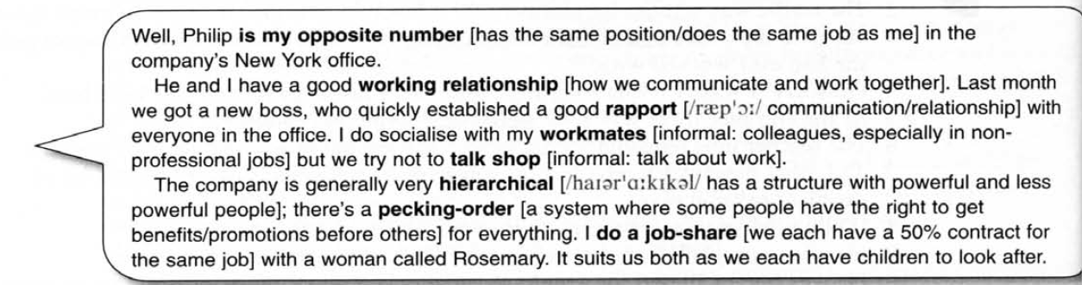
Ex. 1 Correct the mistakes in this paragraph. (не тест)

I think I have a good relationship with most of my colleagues. I tried to establish a good report with them from the very beginning. The person I like most in my opposite member in our office in Paris. Generally, when I socialize to my colleagues outside of work, we try not to talk about shop, but it’s not easy and sometimes we have a good gossip about people who are not there.

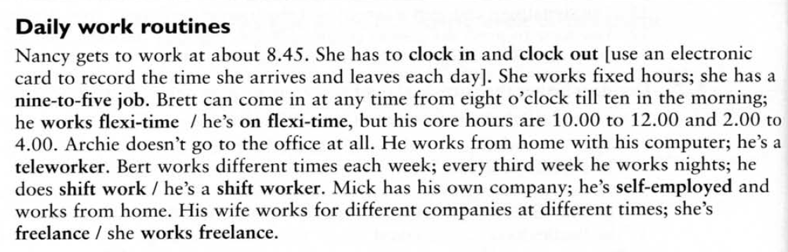

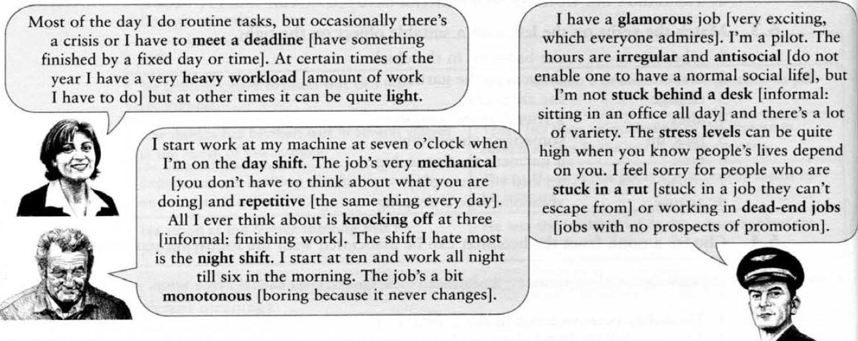

Ex.2 Use words and phrases from B and C on the opposite page to complete these sentences.
1 I would get bored if I had a nine _______.
2 When I arrive in the morning and leave the office in the evening I use this card to _______.
3 I'm very tired; recently I've had a very heavy _______.
4 I don't want an office job. I don't want to spend all day stuck_______.
5 I can clock in any time between eight and ten and clock out between four and six; I'm on _______.
6 I'd hate to feel trapped in my job and to be stuck in _______.
7 He's not here this evening, he's working nights; you see, he does _______.
8 I work for different companies at different times as it suits me. I'm _______.
9 I used to work for someone else, but now I'm my own boss; I'm _______.
10 I stopped working in the hamburger restaurant. It was just a dead-_______.
11 When I was working in the factory, all I could think of all day was the moment when I could knock_______.
12 Being a nurse is a good job, but you can't go out much with friends. The hours are a bit _______.

Ex.3 Read the text in the box below and match the words in bold with their definitions underneath. Use your dictionary to check your answers.

Brian James left University and decided to apply for a job which he saw advertised in the paper. He filled in the application forms and, a few weeks later, was asked to attend an interview. He was offered the job that same day.
As he lived in a small town outside the city, he had to commute every day. He was good at his job and very soon was promoted. However, the company he worked for was having problems. Two people were dismissed for stealing and two of their friends resigned in sympathy, the directors decided to lay off five more because the company couldn't afford to keep them, and the managing director decided to retire early. The atmosphere was so bad that Brian eventually decided to hand in his notice.

1. to give up a job.
2. to ask for a job, usually by writing a letter.
3. to be removed from a job, usually because you have done something bad.
4. same as 1.
5. to stop work and take a pension, usually when you are in late middle age.
6. to write in the empty spaces on a form.
7. to be given a better job in the organization you work for.
8. to be questioned by one or more people when you are applying for a job so that they can decide if
you are suitable for that job.
9. to travel to work from home each day, usually from one town to another.
10. to be dismissed from your job for a time until more work is available.

Ex.4 Read the text which follows and fill in the gaps with an appropriate word from the box below. Use your dictionary to help you. In some cases, more than one answer is possible.

commission • prospects • candidates • references • manager • salary • promotion • applicants • increment • vacancy • employee •perks • qualifications • shortlist • pension • salesman

A computer company had a (1)__________ for position of (2)__________, and decided to advertise for a new (3)__________. A lot of (4)__________ with good (5)__________ and (6)__________ applied for the job, and after all the interviews had finished, the directors made a (7)__________ of the best (8)__________, then invited them to come back for another interview.
The person who eventually got the job was very happy. After all, he would receive an annual
(9)__________ of £25,000, with a 5% (10)__________ twice a year, a 15% (11) __________ for each computer he managed to sell, excellent (12)__________ such as private health insurance and a company car, a company (13)__________ to make sure he would be well-off when he retired, and the chance of (14)__________ from salesman to sales (15)__________ if he was successful. All in all, his future (16)__________ looked very good.

Describe these pictures using new vocabulary. What is similar between them? What different features have you noticed?

Answer key

Ex.1
I think I have a good working relationship with most of my colleagues. I tried to establish a good rapport with them from the very beginning. The person I like most in my opposite number in our office in Paris. Generally, when I socialize with my colleagues outside of work, we try not to talk shop, but it’s not easy and sometimes we have a good gossip about people who are not there.

Ex.2

- –to-five
- clock in and out
- workload
- behind a desk
- flexi – time
- a rut
- shift work
- freelance
- self-employed
- end job
- off
- antisocial

Ex. 3
1. hand in his notice
2. apply for
3. dismissed
4.resign
5. retire
6. filled in
7. promoted
8. attend an interview
9. commute
10. laid off

Ex.4
1. vacancy
2. salesperson
3. employee
4.candidates
5. qualifications / references
6. qualifications / references
7. short-list
8.candidates
9. salary
10. increment
11. commission
12. perks
13. pension
14. promotion
15. manager
16. prospects

