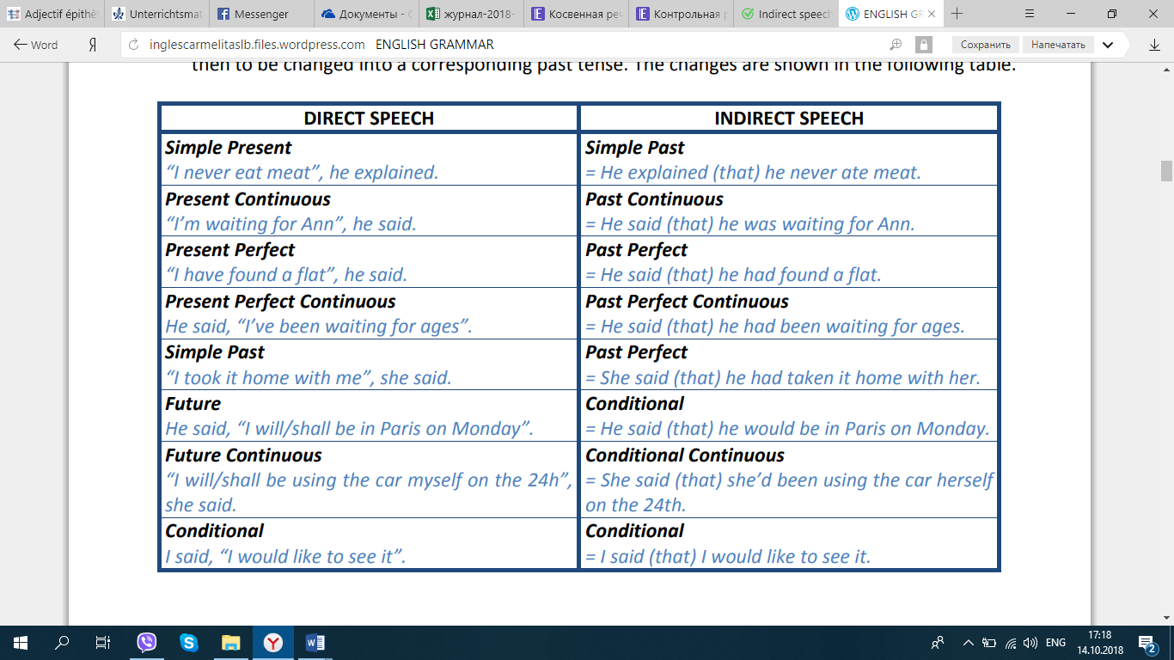

Task 1
Complete the sentences below:
1. She said, “I am so happy!” She said __.
2. Tom said, “I cooked dinner last night”. Tom said __.
3. They said, “We are going to the football match”. They said __.
4. He said, “Kevin is training for the marathon”. He said __.
5. I said, “the shop closes at 7 p.m. tonight”. I said __.
6. The teacher said, “You will have a test tomorrow”. The teacher said __.
7. “She had forgotten her homework,” she said. She said __.
8. “It has been raining all day, today,” he said. He said __.

Task 2
Complete the sentences using modal verbs:
1. Jane said, “I can’t go to the party tonight”. Jane said __.
2. He said, “I may move to Canada next year”. He said __.
3. They said, “We should go to the cinema next week”. They said __.
4. She said, “Kate ought to go to the doctor tomorrow”. She said __.
5. “We can drive to the exam centre together,” the students said. The students said __.
6. Gerry said, “I would go to the theatre if I had money”. Gerry said __.
7. “We ought to clean the house before our parents come home,” they said. They said __.
8. He said, “I must check how much the tickets cost” He said __.
Task 3
Choose the correct variant.
1. He says, “You are right.”
a) he says that I am right
b) he says which I right
c) he says I was right
d) he said I are right
2. She says to him, “I have a right to know.”
a) she tells him that she would have a right to know
b) she tell him she have a right to know
c) she says him she has a right to know
d) she tells him that she has a right to know
3. We said to them, “We have no money.”
a) we told them that we have no money
b) we told them that we had no money
c) we told them we have no money
d) we told to them that we had no money
4. He said, “I have changed my opinion.”
a) he said that he had changed his opinion
b) he said that he have changed his opinion
c) he said that he would have changed his opinion
d) he said that he changed his opinion
5. He said, “I will bring you a book tomorrow”.
a) he said that he would bring me a book the next day
b) he said that he will bring me a book the next day
c) he said that he brings me a book tomorrow
d) he said that he would bring me a book tomorrow
6. They said, “We were in the USA the day before yesterday”.
a) they said that they had been in the USA two days after
b) they said that they had been in the USA the days before yesterday
c) they said that they have been in the USA two days before
d) they said that they had been in the USA two days before
7. She said to me, “Don’t talk to me”.
a) she told me not to talk to her
b) she told me to not talk to her
c) she told me not to talk to me
d) she told me do not to talk to her

Task 4
Choose the correct form for each gap below.
1‘I need to see Sarah this weekend.’ ⇒ George said that ______.
a. he needed to see Sally this weekend
b. he was needing to see Sally that weekend
c. he needed to see Sally that weekend
2‘I’m reading now.’ ⇒ Sally told me ______.
a. that she was reading at that moment
b. that she read now
c. that she was reading now
3‘I haven’t seen Barbara since last year.’ ⇒ Brendan told me ______.
a. he didn’t see Barbara since last year
b. he hadn’t seen Barbara since the year before
c. he hadn’t seen Barbara since last year
4‘I’m living in Australia.’ Sarah told me ______. Choose TWO correct options
a. she is living in Australia
b. she lived in Australia
c. she was living in Australia
5‘Please, sit here.’ ⇒ She ______.
a. asked me to sit there
b. said to sit there
c. told me to sit here

Task 5
Transform the following sentences into reported speech.
a. “Don’t try to be funny.”
b. “Wait here till I come.”
c. “Go to bed and don’t get up till you’re called.”
d. “Be a good girl and sit quietly for five minutes.”
e. “Watch the milk and don’t let it boil over.”
f. “Don’t take your coat off.”
g. “Don’t forget to thank Mrs Jones when you’re saying good bye to her.”
h. “Stop that dog.”

Task 6
Choose the correct reporting verb from this list and finish the reported speech for each example.

told,said,advised,warned,suggested,asked,offered,ordered
1. "I'd go and see a doctor if I were you," Julie said to me.
Julie me to go and see a doctor.
2. "Can you come and help me with this box?"
John me to help him with the box.
3. "This is an exam Mr. Jenkins!! Shut up now!!!"
The headmaster Mr. Jenkins to shut up.
4. "That road is very dangerous so just be very careful!"
His mother him that the road was very dangerous and to be careful.
5. "Liverpool won the match last night."
The journalist that Liverpool had won the match the previous night.
6. "Why don't we go and see that new film at the cinema."
Bill going to see the new film at the cinema.
7. "I can come and look after the children tomorrow night."
Jane to come and look after the children the following day.
8. "The lesson starts at six o'clock in the evening."
The teacher us that the lesson started at six in the evening.

ANSWERS
Task 1
1. She exclaimed that she was so happy.
2. Tom complained that he had cooked dinner the night before.
3. They said that they were going to the football match.
4. He said that Kevin was training for the marathon.
5. I said that the shop closed at 7 P.M. last night.
6. The teacher told me that I would have a test the next day.
7. She said that she had forgotten her homework.
8. He commented that is had been raining all day, that day.
Task 2
1. Jane said that she couldn’t go to the party last night.
2. He said that he might move to Canada next year.
3. They said that they should go to the cinema next week.
4. She said that Kate ought to go to the doctor today.
5. The students said that they could drive to the exam centre together.
6. Gerry said that he would go to the theatre if he had money.
7. They said that they ought to clean the house before their parents came home.
8. He said that he had to check how much the tickets cost.
Task 3
1. a, 2. d, 3. b, 4. a, 5. a, 6. d, 7. a
Task 4
1‘I need to see Sarah this weekend.’ ⇒ George said that ______.
- a. he needed to see Sally this weekend
- b. he was needing to see Sally that weekend
- c. he needed to see Sally that weekend
2‘I’m reading now.’ ⇒ Sally told me ______.
- a. that she was reading at that moment
- b. that she read now
- c. that she was reading now
3‘I haven’t seen Barbara since last year.’ ⇒ Brendan told me ______.
- a. he didn’t see Barbara since last year
- b. he hadn’t seen Barbara since the year before
- c. he hadn’t seen Barbara since last year
4‘I’m living in Australia.’ Sarah told me ______. Choose TWO correct options
- a. she is living in Australia
- b. she lived in Australia
- c. she was living in Australia
5‘Please, sit here.’ ⇒ She ______.
- a. asked me to sit there
- b. said to sit there
- c. told me to sit here

Task 6
1 advised, 2 asked, 3 ordered, 4 warned, 5 said, 6 suggested, 7 offered, 8 told.

