https://quizlet.com/326563237/english-job-benefits-oxford-4-un-44-flash-cards/

Ex. 1 Complete the dialogues.
1 A Your office is moving to Milan, isn't it?
B Yes, and I've got a generous _________ allowance, which is great.
2 A Does your company have a bonus?
B Yeah, and it's _________-related, which is why I put in such long hours.
3 A When does your maternity ________ start?
B Next month. And when I come back there is childcare _______.
4 A Do you use the company ________ at lunchtime?
B Yes, and it's _______, so you can get a good meal for €2.
5 A How much holiday are you _________to?
B I get 30 days off, but I believe it will increase to 32 days next year.

Discussion

- Is it common for men and women to have the same jobs in your country?
- Name three occupations that you could never do?
- What plans have you made for your retirement?

Ex. 2 Replace the underlined words with a word or phrase that has a similar meaning.
1 I experienced a few problems.
2 There is a certain amount of stress.
3 I was my own boss.
4 It gave me an understanding how the company works.
5 Initially she had to balance a full-time career with looking after a family.
6 There are various advantages and disadvantages.
Ex.3 Complete the text with suitable words.
I was a freelance designer for 10 years. I liked being my own (1)________ and enjoyed the fact that I was (2) ________responsible for everything I did. Like all freelancers, I (3)_________ a certain (4) _________ of isolation, but I didn't mind that, and the work was quite (5)__________ so I was able to buy a nice house. However, once I had children the work did (6) _________ upon my family life, so in the end I went back to a regular job with a (7) ________ income, plus the(8) ________ benefits of a company car and pension.

Ex. 4 Tick the words, which are correct. One, two, or three may be correct.

1 There has always been a lot of mutual trust ❑ confidence ❑ respect ❑.
2 There are several additional ❑ extra ❑ further ❑ factors to consider.
3 It's hard to juggle❑ encroach upon❑ encounter❑ work and family responsibilities.
4 Teamwork requires a degree ❑ an extent ❑ an insight ❑ of respect between colleagues.
5 Colleagues who don't fit in can undermine ❑ pool ❑ disrupt ❑ the work of the team.
6 The project has helped to foster ❑ promote ❑ encroach upon ❑ team spirit.

Discussion

- How have working conditions changed in recent years?
- Do you think that working conditions have improved? If so, in what ways?
- If you had to choose between a satisfying job and a well-paid one, which would you choose?

Ex.5 Choose the best word to complete sentences.

1. Well, you drive a hard bargain, but ______________.
a. we've agreed
b. let's deal
c. it's a deal
2. After a shaky start earlier this financial year, the business has really ______________.
a. grown up
b. taken off
c. gone up
3. I've been ______________ this business for over thirty years, so don't tell me what to do!
a. running
b. leading
c. bossing
4. Nick's got a very good ______________.
a. business head
b. head for business
c. sense of business
5. His two sons work ______________.
a. for their family's firm
b. in the family company
c. in the family business
6. Diana's got a job with a ______________ of lawyers.
a. big business
b. large firm
c. large business
7. This advertising campaign has done nothing to improve our ______________.
a. corporate image
b. business appearance
c. company look
8. Ben's ambition was to ______________ a career in advertising.
a. get
b. pursue
c take
9. Sally was feeling stressed so she asked her boss for some ______________ work .
a. time out of
b. time off
c. break from
10. How long have you been working ______________ this project?
d. on
b. in
c. for
11. Unfortunately there are over ten thousand people ______________ work in the area.
a. without some
b. out of
c. away from
12. It's a nightmare ______________ every day by bus.
a. travelling to my job
b. going to work
c. getting into work
13. A: So what do you do ______________.
B: I work in a supermarket.
a. to win money
b. to earn
c. for a living
14. I won't be able to leave the office early - I've got too much ______________ to get through.
a. work
b. job
c. working
15. Greg's ______________ business in Japan at the moment.
a. in
b. at
c. on

Ex.6 Choose the best word to complete sentences.

- My daughter Emma has a good job / good work in politics.
- The successful applicant for this position will have good / high qualifications and adequate / relevant experience.
- The workman did a really good job / work on the plumbing.
- You deserve a break - you've worked without end / non-stop on this project.
- He spent the summer earning his money / living as a street musician.
- In exhausted. I've been hard at / of work all day.
- How did the interview go? Did you have / get the job?
- Most days I get home from work / the work by 7.00pm.
- I'm going to ask / apply for a job in the local shop.

Ex.7 Solve the crossword. (нужно сделать кроссворд, как на картинке ниже, что б студент мог сам его разгадывать)

- A hundred workers were made ________.
- I work in the finance _________.
- The company mostly employs white-collar _______.
- He works for a multi-national _________.
- She-s a senior sales _________.
- We’ll have to advertise to fill the vacant ________.
- CEO stands for chief executive _________.
- The job comes with a very attractive _________.

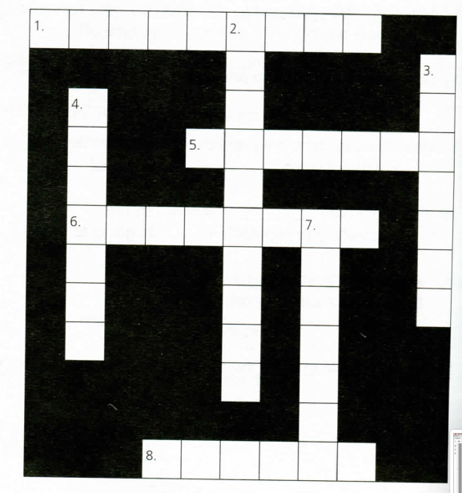

Answer key

Ex.1
- relocation
- scheme, performance
- leave, provision
- canteen, subsidized
- entitled, entitlement

Ex.2
- encountered
- degree
- was accountable to no one / wasn't accountable to anyone
- insight into
- juggle
- pros and cons

Ex.3
- boss
- solely
- encountered
- degree
- lucrative
- encroach
- guaranteed
- additional/extra/further

Ex.4
- trust, respect
- all three are possible
- juggle
- a degree
- undermine, disrupt
- foster, promote

Ex.5
- с
- b
- a
- b
- c
- b
- a
- b
- b
- a
- b
- c
- c
- a
- b

Ex.6
- the office
- a good job
- good/relevant
- job
- non-stop
- living
- at
- get
- work
- apply

Ex.7
- redundant
- department
- workers
- company
- managers
- position
- officer
- salary

