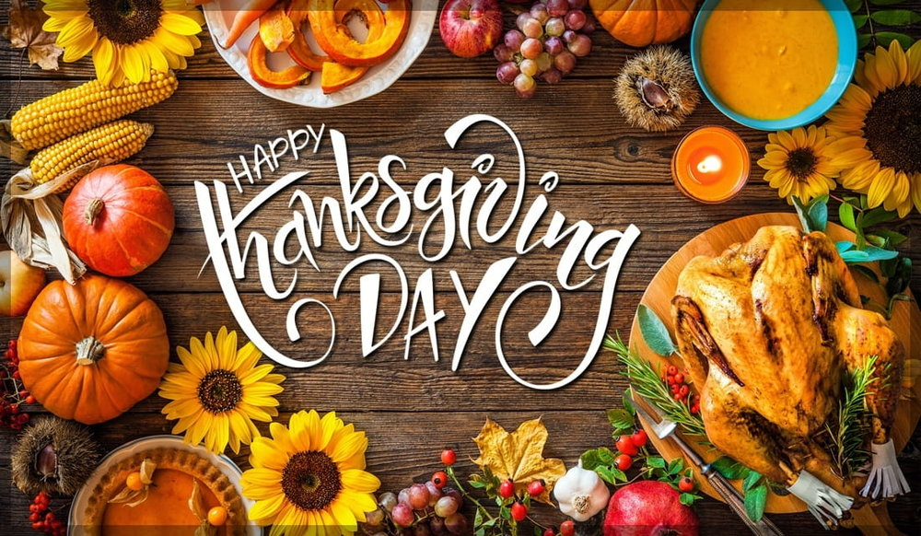
advanced_lesson_37_thanksgiving_vocabulary_part_1

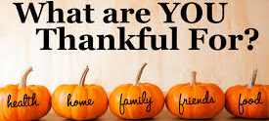

Quizlet
https://quizlet.com/335638404/thanksgiving-vocab-advanced-flash-cards/?new

Exercise 1
Watch the video and answer the questions
https://www.youtube.com/watch?v=CzVXun4Uyp0

- What was the reason that the Pilgrims migrated from England to the new land?
- to escape from the government
- to find religious freedom
- to conquer the new land

- Which president was the first to make Thanksgiving a national holiday?
- Abraham Lincoln
- George Washington
- Woodrow Wilson

2. What was the name of the Pilgrims' ship?
a) Mayflower
b) Plymouth
c) Wampanoag

3. When did Thanksgiving Day become an official national holiday?
a) 1621
b) 1860
c) 1941

4. What time of year was it when the Pilgrims arrived in America?
a) late fall
b) spring
c) late winter

5. When was the first Thanksgiving?
a) 1620
b) 1621
c) 1861

6. Why did half the Pilgrims die their first winter in America?
a) They suffered from famine.
b) They were killed by English soldiers.
c) They drowned.

7. What food did the Pilgrims manage to harvest due to Native Americans?
a) eggplant
b) squash and pumpkin
c) asparagus

Exercise 2
Fill in the gaps choosing the correct words

- Friends and families gather on the fourth Thursday in November in a that occurs across America. A) feast b) festive c) carnival

- Grandma prepared a huge turkey filled with that was made with seasoned cornbread, onions, raisins and butter. A) icing b) stuffing c) beverage

3) Does Sue even imagine eating a turkey dinner without delicious served on the side? A) dressing b) adding c) portion
4) The of Thanksgiving Day is a national holiday for Americans young and old. A) celebration b) celebrated c) celebrity

5) The President Abraham Lincoln _________ the last Thursday of November as a national holiday. a) arranged b) managed c) proclaimed

6) After the Pilgrims had arrived to the new land, they were suffering from _______. A) diseases b) famine c) severe weather conditions

7) On Thanksgiving`s Day the Americans express their ________. A) modesty b) hatred c) gratitude

Exercise 3
Match the definitions with the words
cornucopia – Mayflower - settlers - stuffing - maize - dressing - blessing – harvest - cranberry
1) season when crops are collected
2) group of people who form in a new land
3) valued praise or benefit
4) a horn stuffed with foods, berries etc.
5) small, sour and dark red berry
6) filling inside poultry
7) name of ship that sailed to the New World (1620)
8) synonym for corn; pale yellow
9) a sauce for salads etc.

Exercise 4
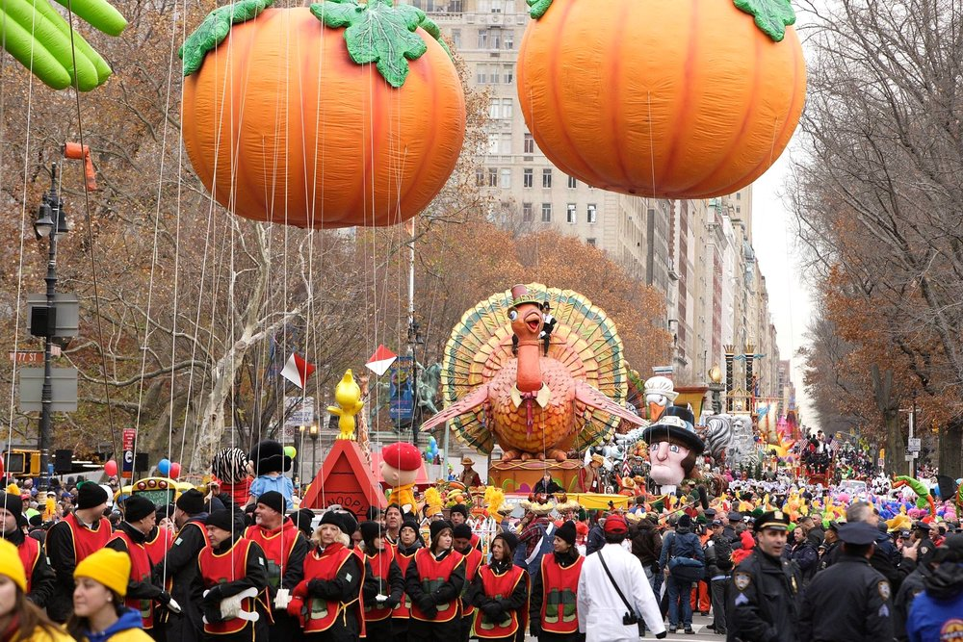
Describe the following pictures

