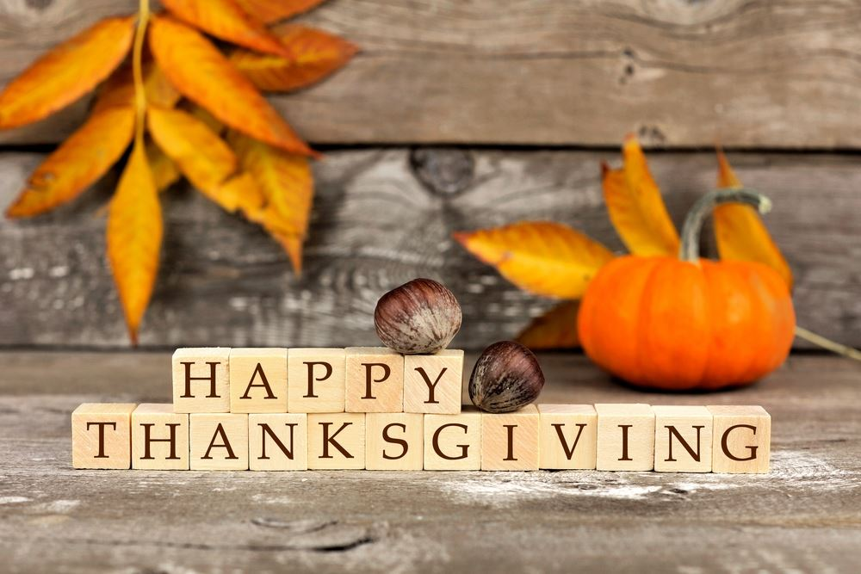
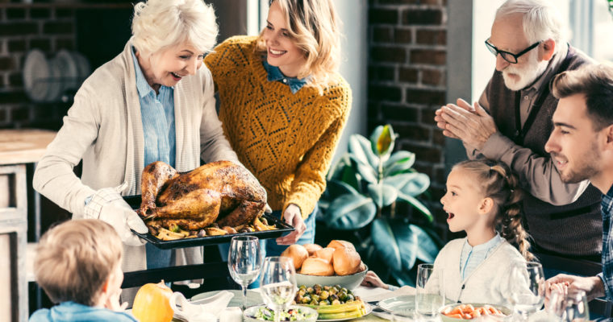

I. Listen to the article about Thanksgiving and answer the questions.
1: When was the first Thanksgiving?
2: What do teachers explain about the holiday?
3: What's the reason behind the fictional elements in the story of the first Thanksgiving?
4: Why did the pilgrims come to the New World?
5: How are fact and fiction different regarding the first Thanksgiving?
6: When is Thanksgiving held every year now?
7: What's the nickname of Thanksgiving?
8: What kind of food do people eat on Thanksgiving?
9: According to the article, what's the parade like?
10: What happens after dinner?

II. Watch the video and answer the questions.
<iframe width='640' height='480' src='https://en.islcollective.com/video-lessons/embed/27766' frameborder='0' allowfullscreen></iframe>

III. Watch the video and answer the questions.
<iframe width='640' height='480' src='https://en.islcollective.com/video-lessons/embed/73358' frameborder='0' allowfullscreen></iframe>

IV. Answer the questions.
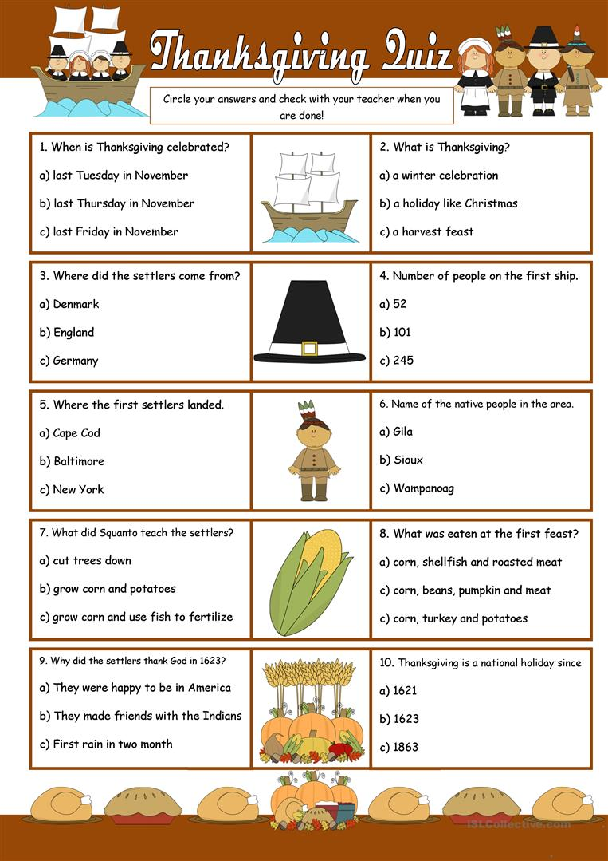

Answers:
I. Listen to the article about Thanksgiving and answer the questions.
1: The first Thanksgiving in America was in 1621.
2: Teachers tell of the pilgrims' arrival, of how they survived due to the generosity of a local Native American tribe, and of how the two different peoples sat down and shared the new harvest meal in friendship.
3: With numerous immigrants arriving from all over the world, the tale helped provide a common national identity.
4: The pilgrims had fled religious persecution back in England.
5: The first Thanksgiving was simply an autumn festival, which many cultures have celebrated throughout history. Contrary to popular stories, the festival lasted nearly a week instead of one day. It also consisted of many meals, not just one.
6: The holiday always falls on the fourth Thursday of November.
7: The holiday has picked up the name "Turkey Day."
8: People eat turkey, mashed potatoes, sweet potatoes, corn, stuffing, cranberry sauce, and pumpkin pie.
9: There is a three-hour parade with floats, giant balloons of cartoon characters, and marching bands.
10: After dinner, families glue themselves to the TV for football.

IV. Answer the questions.
