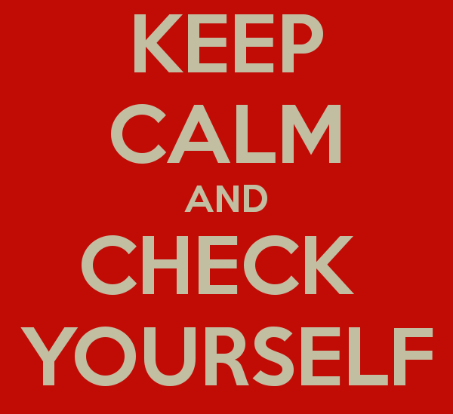
advanced_lesson_39_test _vocabulary _part_1

Exercise 1
Choose the correct word to give the OPPOSITE meaning
- critical b) didn’t see eye to eye
c) discord d) never e) split up f) turned sour

1) Rick and his sister (shared the same opinion on) a lot of things. _______
2) Her affection for Andrew has (grown stronger) _________ lately. I expect they'll (get engaged). ____
3) Our relationship (stayed firm)_____ because we (always) _____understood each other
4) They had a (sweet talk) _______yesterday.
5) He is very (supportive) _______ of his friends.

Exercise 2
Decide what kind of party you might be invited to if ...
- a fancy dress party b) a housewarming party c) a launch party d) a reception e) a stag party/a hen party f) a wedding reception

- a friend of yours is about to get married and is having a party before the wedding. _____
- you are going to help a friend celebrate on the day of their wedding. ______
- some friends have just moved into a new flat. ______
- a friend has just had a book published. ______
- your local council is arranging for important people in the area to meet a visiting dignitary. ____
- you have friends who love dressing up as characters from famous films. ______

Exercise 3
Complete these sentences using phrasal verbs
- move out b) moved in together c) oversleeping/sleeping in d) put her up/let her sleep over e) turn in f) waiting up/staying up

I I'll be late back tonight so please don't bother
2 Kate can't afford a hotel so she's asked a friend to ____________.
3 I need an alarm dock to stop me from ____________.
4 The removal firm helped us to ____________ of our old house.
5 I'm really tired. I think I'm going to ____________ soon.
6 Gordon and Martin already knew each other well before they____________.

Exercise 4
Choose the most suitable word or phrase to complete each sentence

1) Would you prefer ______ potatoes or chips? A) poached B) ground C) mashed D) powdered
2) I bought this bread four days ago and now it's _____ A) stale B) off C) bad D) rotten
3) Don't forget to buy a packet of ______ peas. A) chilled B) frozen C) frosted D) chilly
4) Can you give me the_______ for this pie? It's delicious. A) prescription B) instructions C) receipt D) recipe
5) I'd like to eat more of this cake, but it's very ___A) fat B) fatty C) fattened D) fattening
6) Is the hamburger for you to eat here, or to _____? A) go out B) take away C) carry on D) sit down
7) That was fantastic. Could I have a second ______ , please? A) plate B) course C) helping D) service

Exercise 5
Choose the right answer
1. It was rush hour, and there was a long ________ on the motorway. a) tailback b) quay c) queue d) burst
2. The road was wet and I _____ on a bend and almost crashed. a) skidded b) glided c) slipped
3. There was a ______ involving ten cars because of the fog, so the road was closed and we were diverted on to a narrow country lane. a) collision b) clash c) pile-up
4. I fortunately stopped _______ just in time. a) on the roundabout b) at the red light c) in the queue
5. It’s impolite not ______ when you are supposed to. a) to give the right of way b) to top up the oil c) to be in tailback d) to block the doors
6. I saw two men fighting next to their cars. I think it was the case of ______ . a) injury b) hurt feelings c) road rage
7. I am _____ in this traffic jam for at least an hour, maybe more. a) held back b) c) retarded d) stuck
8. If you violate traffic regulations, this may result in a ____ (removal of driving licence) for several years. a) prohibition b) ban c) refusal d) forbiddance

Exercise 6
Choose the most suitable word to fill each space
1. A hundred years ago, most people travelled ______ foot, by train, or on horseback. a) By b) On c) With d) To
2. ______ had made it possible to travel rapidly over long distances. a) Tracks b) Lines c) Ways d) Railways
3. Bicycles were also becoming ______after the invention of the air-filled tire. a) Popular b) Invented c) Then d) Handlebars
4. Buses, trams and ______railways had already been invented. a) Metro b) Buried c) Underground
5. Cities all over the world had traffic ______. a) Blocks b) Sticks c) Knots d) Jams
6. There were very few private cars, and city ______ were still full of horses. a) Streets b) Pavements c) Lawns d) Carts
7. In many places ______ have been banned from the city centre. a) Vehicles b) Traffic c) Transport d) Trips
8 . There may be no need to ______ to work or school in the future, since everyone will have a computer at home. a) Have b) Transport c) Decide d) Commute

Exercise 7
Match words with their definitions
- wink - b) blink – c) perspire/sweat - d) grin - e) chew - f) frown - g) blush - h) hiccough – j) rumble – k) shiver

1 to go pink from embarrassment
2 to tremble especially from cold or fear
3 to hold something in the mouth and lick it, roll it about, squeeze it etc. with the tongue and teeth
4 to shut and open both eyes quickly
5 to deliberately shut and open one eye
6 Moisture exuded through the pores of the skin, typically in profuse quantities as a reaction to heat, physical exertion, fever, or fear
7 Furrow one's brows in an expression indicating disapproval, displeasure, or concentration
8 Smile broadly
9Your stomach makes a noise, especially because you are hungry
10 Sudden repeated stopping of the breath, usually caused by eating or drinking too fast

Exercise 8
Replace the words with a more suitable verb
1. I saw a crime. a) glanced b) observed c) witnessed
2. He looked fixedly at me. a) glimpsed b) stared c) noticed
3. She took my hand firmly. a) stroked b) grasped c) handled
4. Touch the button to start. a) press b) tap c) snatch
5. He touched the cat affectionately. a) tapped b) patted c) stroked
6. The zoologist looked at the lion's behavior. a) glimpsed b) observed c) peered
7. The robber took the money and ran. a) grabbed b) handled c) pawed
8. I quickly looked at my watch. a) tapped b) glanced c) patted

Exercise 9
Write the words to complete the sentences
- A part of human`s body where a watch is worn - w…………. (5 letters)
- You wear a belt on this part of the body - h ………….. ( 3 letters)
- People show this part of the hand as a sign of approval - t………... ..(4 letters)
- Place where a foot and a leg meet - a……… (5 letters)
- An organ in your mouth responsible for distinguishing tastes - t………. (6 letters)

