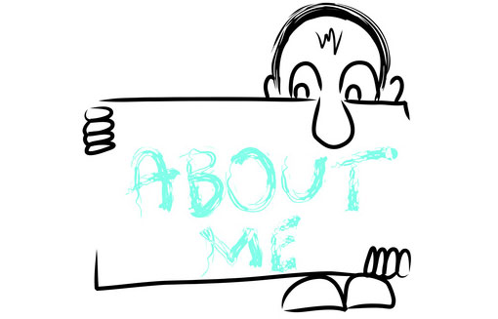

Ex. 1 Look at the words and translate them into Russian
https://quizlet.com/304959101/english-about-myself-basic-lesson-2-flash-cards/?new

Ex. 2 Read the text and choose whether the sentances true or false

My parents got married 25 years ago. Two years later, my brother Luke, was born. Then I was born a year after that. I've also got a sister, Karen, who is two years younger than me, so there are five of us in my family. Luke's got a girlfriend, Sue, and they live in a small flat. Karen and I still live with our mum and dad. We spend a lot of time together.

- Damon is Luke's older brother. F
- Damon's parents are divorced. F
- Damon was born after Luke. T
- Luke is younger than Karen. F
- Luke and Sue live together. T
- Luke's mum has two sons. T
- Damon is Sue's boyfriend. F
- There are four in Damon's family. F
- Karen is the youngest in the family. T
- Damon and Karen are often together. T

Ex. 3 Write the words in correct sentences.
1. his/ divorced/ are/parents (His parents are divorced)
2. born/I/1989/in/was. I was born in 1989
3. spend / of / together /we/ lot/time/ a We spend a lot of time together
4. older /my / than /girlfriend /me /is My girlfriend is older than me
5. in/six / my / of /are /family/ there /us There are six of us in my family
6. the /family/I/youngest/in/my /am I am the youngest in my family
7 brother/ younger/'ve got/sister /an/older /and/a/I I've got an older brother and a younger sister

Ex. 4 Underline the correct word or phrase in each question.
1. What's your name/What do you call?
2. How old / age are you?
3. Where do you stay / live?
4. What's your house / address?
5. Which country do you come/live from?
6. What's your date of birthday /birth?
7. How long do you want to stay/pass here?
8. Have you got a work/ job?

Ex. 5 Choose the most suitable word for each space.

1. What's Tim like? He's …
A high B tall C big

2. Ann … glasses.
A uses B carries C wears

3. Jane's only nine. She's…
A young B modern C new

4. Can you … Peter?
A describe B look C appear

5. How many brothers and sisters … you got
A do B have C are

6. Are you …?
A study B a student C student

7. Where do you … from?
A arrive B do C come

8. What colour … your hair?
A has B is C are

9. Are you … or single?
A doubled B married C marriage

10. I … sixteen years old.
A have B get C am

- James has … a beard.
A wears B got C carries

- … your address?
A What B What's C Where's

- What does Lucy look …?
A after B alike C like

PDF

Ex. 1 Look at the words and translate them into Russian
https://quizlet.com/304959101/english-about-myself-basic-lesson-2-flash-cards/?new

Ex. 2 Read the text and choose whether the sentances true or false

My parents got married 25 years ago. Two years later, my brother Luke, was born. Then I was born a year after that. I've also got a sister, Karen, who is two years younger than me, so there are five of us in my family. Luke's got a girlfriend, Sue, and they live in a small flat. Karen and I still live with our mum and dad. We spend a lot of time together.

- Damon is Luke's older brother.
- Damon's parents are divorced.
- Damon was born after Luke.
- Luke is younger than Karen.
- Luke and Sue live together.
- Luke's mum has two sons.
- Damon is Sue's boyfriend.
- There are four in Damon's family.
- Karen is the youngest in the family
- Damon and Karen are often together

Ex. 3 Write the words in correct sentences.
1. his/ divorced/ are/parents His parents are divorced
2. born/I/1989/in/was
3. spend / of / together /we/ lot/time/ a
4. older /my / than /girlfriend /me /is
5. in/six / my / of /are /family/ there /us
6. the /family/1/youngest/in/my /am
7 brother/ younger/'ve got/sister /an/older /and/a/I.

Ex. 4 Underline the correct word or phrase in each question.
1. What's your name/What do you call?
2. How old / age are you?
3. Where do you stay / live?
4. What's your house / address?
5. Which country do you come/live from?
6. What's your date of birthday /birth?
7. How long do you want to stay/pass here?
8. Have you got a work/ job?

Ex. 5 Choose the most suitable word for each space.

1. What's Tim like? He's …
A high B tall C big

2. Ann … glasses.
A uses B carries C wears

3. Jane's only nine. She's…
A young B modern C new

4. Can you … Peter?
A describe B look C appear

5. How many brothers and sisters … you got
A do B have C are

6. Are you …?
A study B a student C student

7. Where do you … from?
A arrive B do C come

8. What colour … your hair?
A has B is C are

9. Are you … or single?
A doubled B married C marriage

10. I … sixteen years old.
A have B get C am

- James has … a beard.
A wears B got C carries

- … your address?
A What B What's C Where's

- What does Lucy look …?
A after B alike C like

