Lesson 3 Basic Vocabulary

basic_lesson_003_days_months_seasons_vocabulary_part_1



**Days of the week**

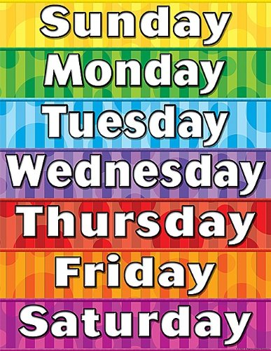



We say on + days of the week- on Monday, on Tuesday, etc.

ex. I saw her on Sunday morning.

We say **at the weekend.**

ex. We went to the movies **at the weekend.**

**Months**

January

February

March

April

May

June

July

August

September

October

November

December

**Seasons**

Spring

Summer

Autumn (Am. E. Fall)

Winter

We say in + months/seasons-ex. In July, in winter, but on July 7th.

I love doing snowboarding in winter.

My birthday is in August.

Susan’s birthday in on August 17th.

**Days**

Her birthday is on July 2. (on July second)

The 2nd of July is her birthday. (the second of July)

Quizlet

<https://quizlet.com/154114852/english-monthdays-of-the-week-flash-cards/>

Exercise 1

Complete word combinations with the numbers

There are:

__ days in a year

__ months in a year

__ weeks in a year

__ days in a week

__ weeks in a fortnight

__ hours in a day

__ minutes in an hour

__ seconds in a minute

__ years in a century

Exercise 2

These abbreviations are often used for the days of the week and months. Write the names out in full.

1. Mon.
2. Aug.
3. Oct.
4. Sat.
5. Wed.
6. Jan.
7. Apr.
8. Fri.
9. Feb.
10. Sept.
11. Tue.
12. Nov.

Exercise 3

There are six mistakes in this paragraph. Correct the mistakes.

Im going to have a party on saturday for Jill’s birthday. Her birthday is on thursday but she wanted to have the party on a Weekend. She’s having a barbecue. I think june is a good month to have a birthday because of the weather. I love going to barbecues on the summer. My birthday is in Winter and it’s too cold to eat outside!

Exercise 4

Answer the questions



LK