004 Daily routines basic
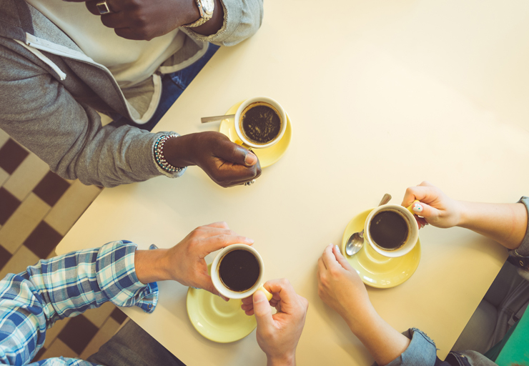
Quizlet
https://quizlet.com/304769440/004_basic_vocabulary_daily_routines-flash-cards/?new

Exercise 1
Match up the sentence with the picture
I usually get up at 7 am.
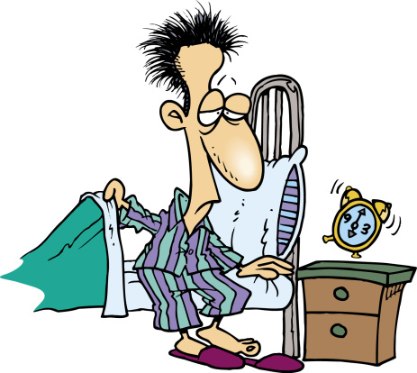

I take a shower.

I get dressed.

I have breakfast.

I usually leave home at 8 am.

I get to work at 8.30 am.
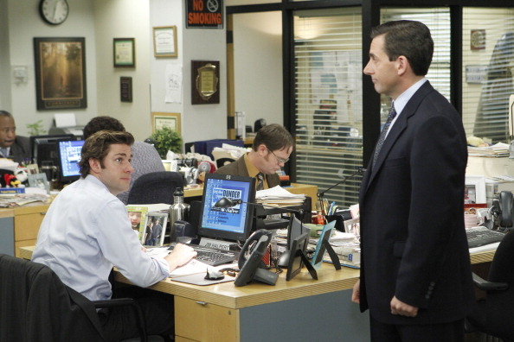

I finish work at 5 pm.

I have dinner at 8.15 pm.

I go to bed at 11.30 pm.

I sleep seven hours a night.

Exercise 2
Choose the right answer
What time do you usually __in the morning?
Do you__dressed before or after breakfast?
Do you__a shower in the morning?
What time do you__home in the morning?
Who do you__dinner with?
What time do you normally__to bed?

Quizlet
https://quizlet.com/304775788/004_basic_vocab_routines-flash-cards/?new

Read the text and translate.
During the week I usually stay in after school. I often study in the evenings, watch TV, listen to music or just talk to my family. Once or twice a week my boyfriend comes over and we have dinner together or go and see a movie. At the weekend, I go out a lot more. On Saturday morning I usually go shopping with a friend, or I go to the gym, and sometimes I study in the afternoon. I go out with my boyfriend in the evening. On Sundays I get up late. We often go for a walk and in summer we play tennis.
Exercise 3
Complete the sentences
- Do you want to __shopping?
- Come__to my apartment after work.
- I can’t__tennis this weekend.
- Do you want to go__this Saturday?
- __the week I usually stay __.
- I’m really tired today because I went to bed__last night.
- What are you doing__the weekend?
- I go to the__twice a week because I like to exercise.
- I often__the shopping very__, at 8 am.
- We often go and__a movie on Sunday.

Frequency words

Quizlet

https://quizlet.com/304778182/frequency-words-flash-cards/?new

Exercise 4
Translate the sentences

I always go shopping on Saturdays.
I sometimes work at home.
She’s hardly ever late for work.
We often finish classes early.
I never eat meat.
She always takes a shower in the morning.
In August we play tennis every day.
I occasionally eat vegetables.
She’s rarely late for classes.

